**Class Lab 10**

Use two images for each operation to do the following operations and write down their advantages and disadvantages and explain your results:

1. **Otus’s method (large_septagon_gaussian_noise_mean_0_std_50_added.pgm):**

**Algorithm:**

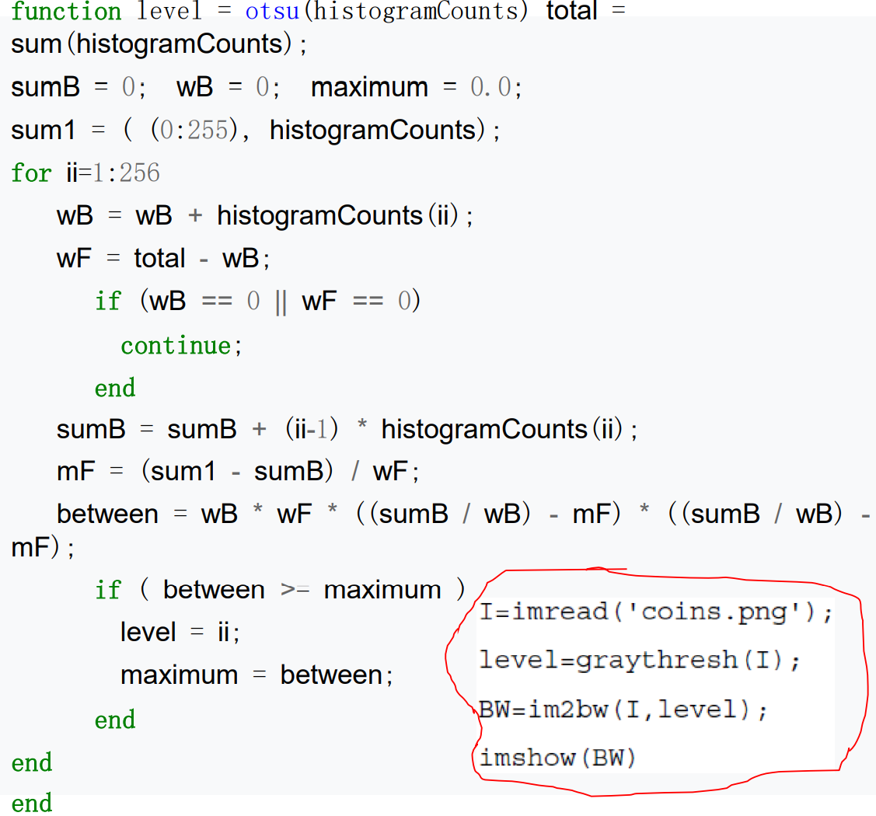

**Results (including pictures):**

Result of processing “large_septagon_gaussian_noise_mean_0_std_50_added.pgm”:

Source Image:

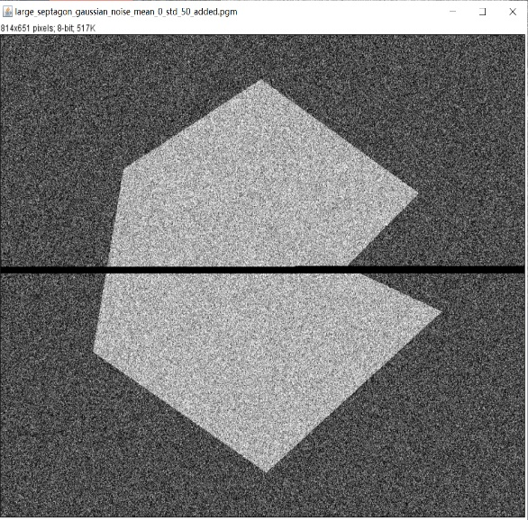

Result after Otus’s:

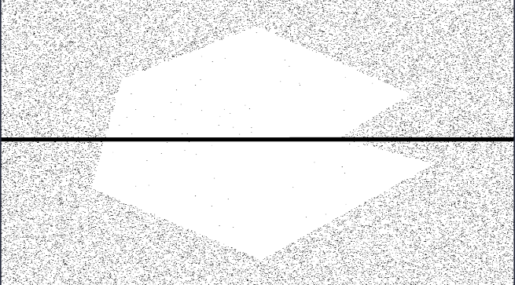

Result after 5X5 and Otus’s:

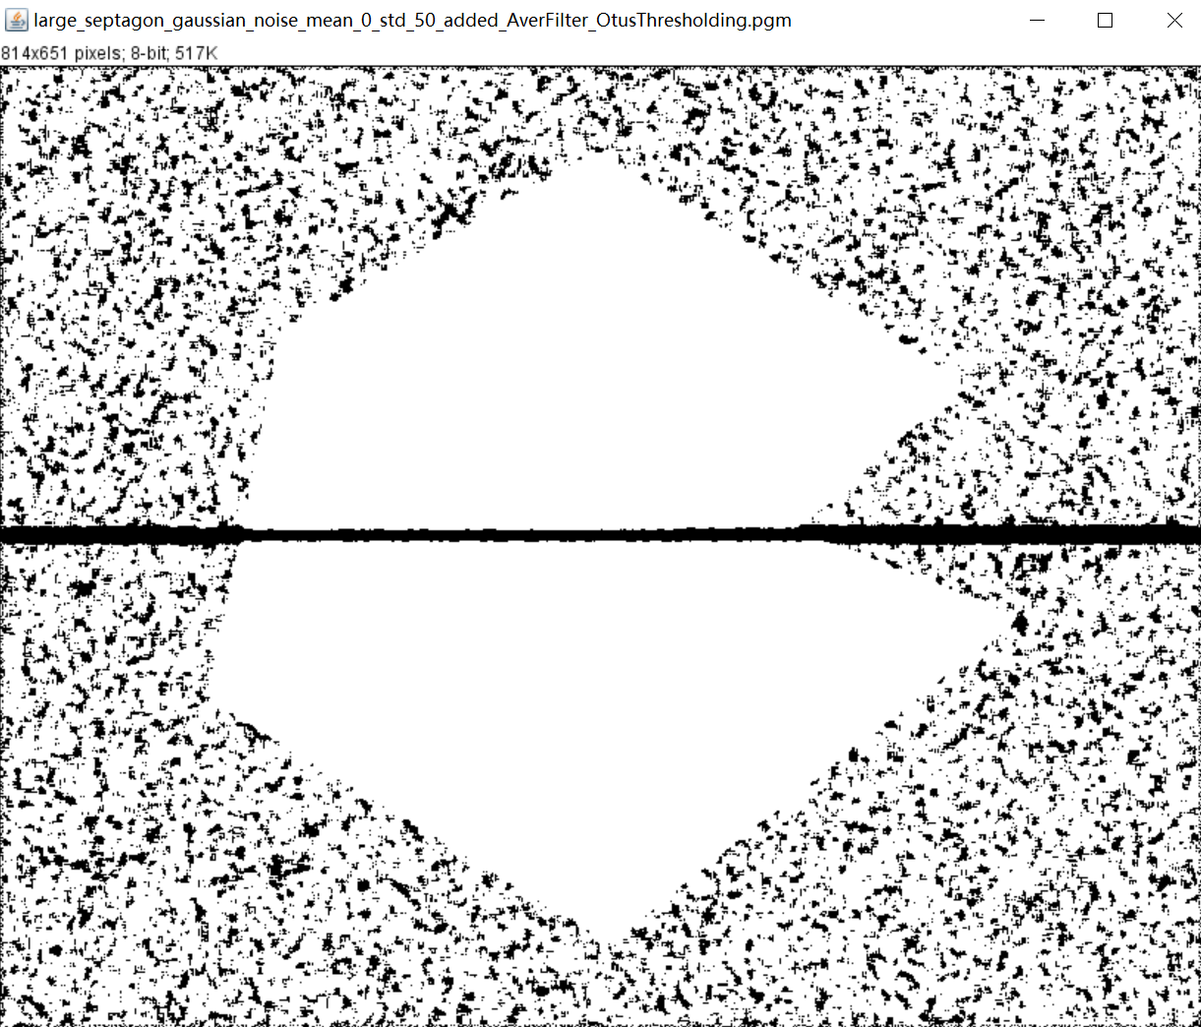

**Discussion:**

This algorithm is considered to be the best threshold selection algorithm in image segmentation. It is easy to calculate and is not affected by image brightness and contrast, so it has been widely used in digital image processing. It divides the image into background and foreground according to the gray characteristics of the image. Since variance is a measure of the uniformity of gray distribution, the greater the inter-class variance between background and foreground, the greater the difference between the two parts of the image. When part of the foreground is wrongly divided into background or part of the background is wrongly divided into foreground, the difference between the two parts will become smaller. Therefore, the segmentation that maximizes the variance between classes means the smallest misclassification probability.

**Codes:**

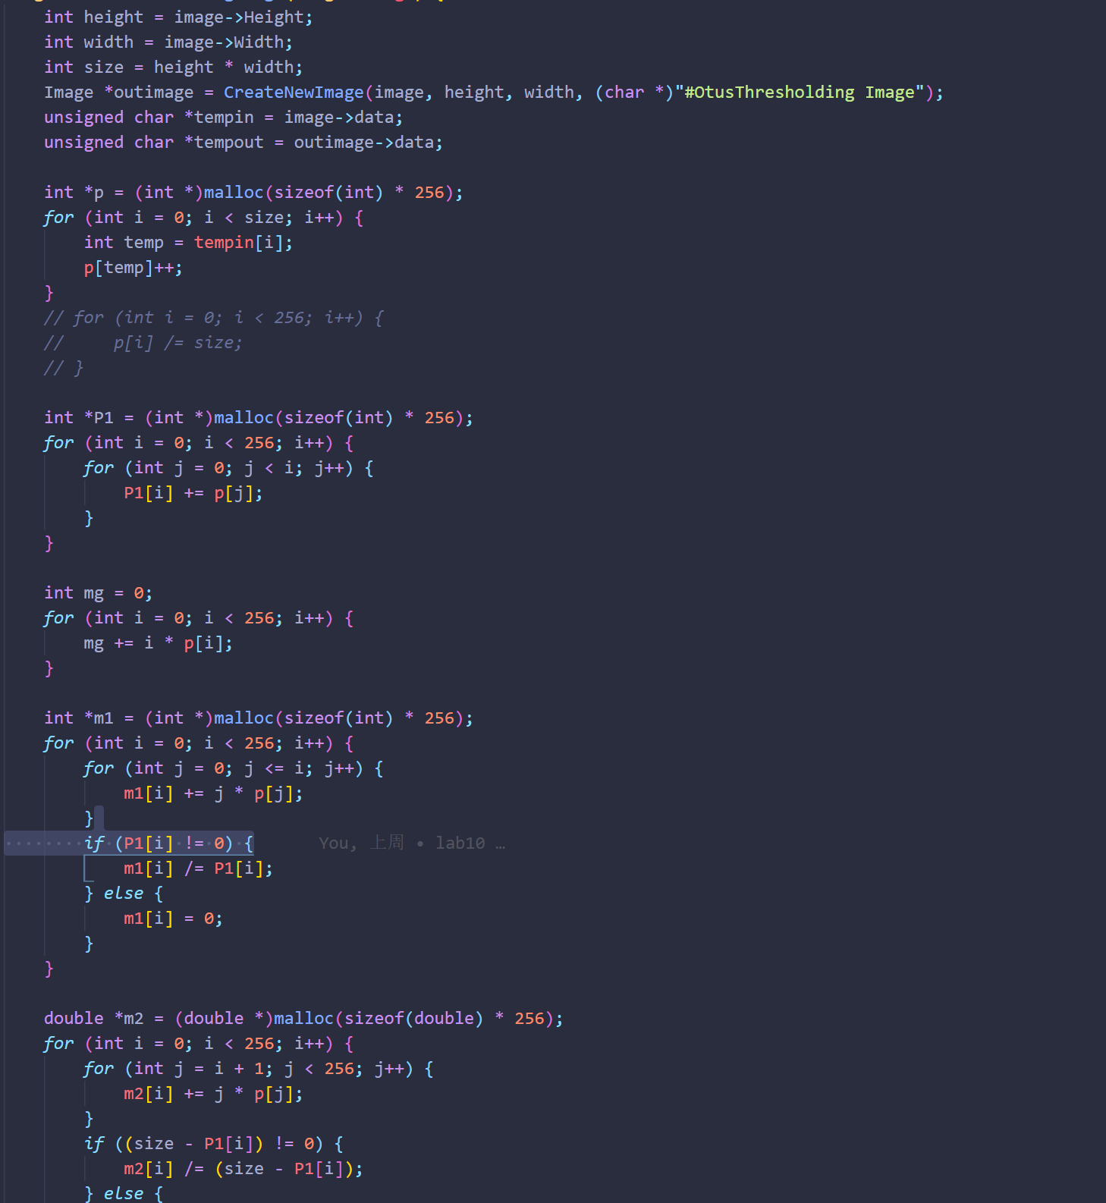

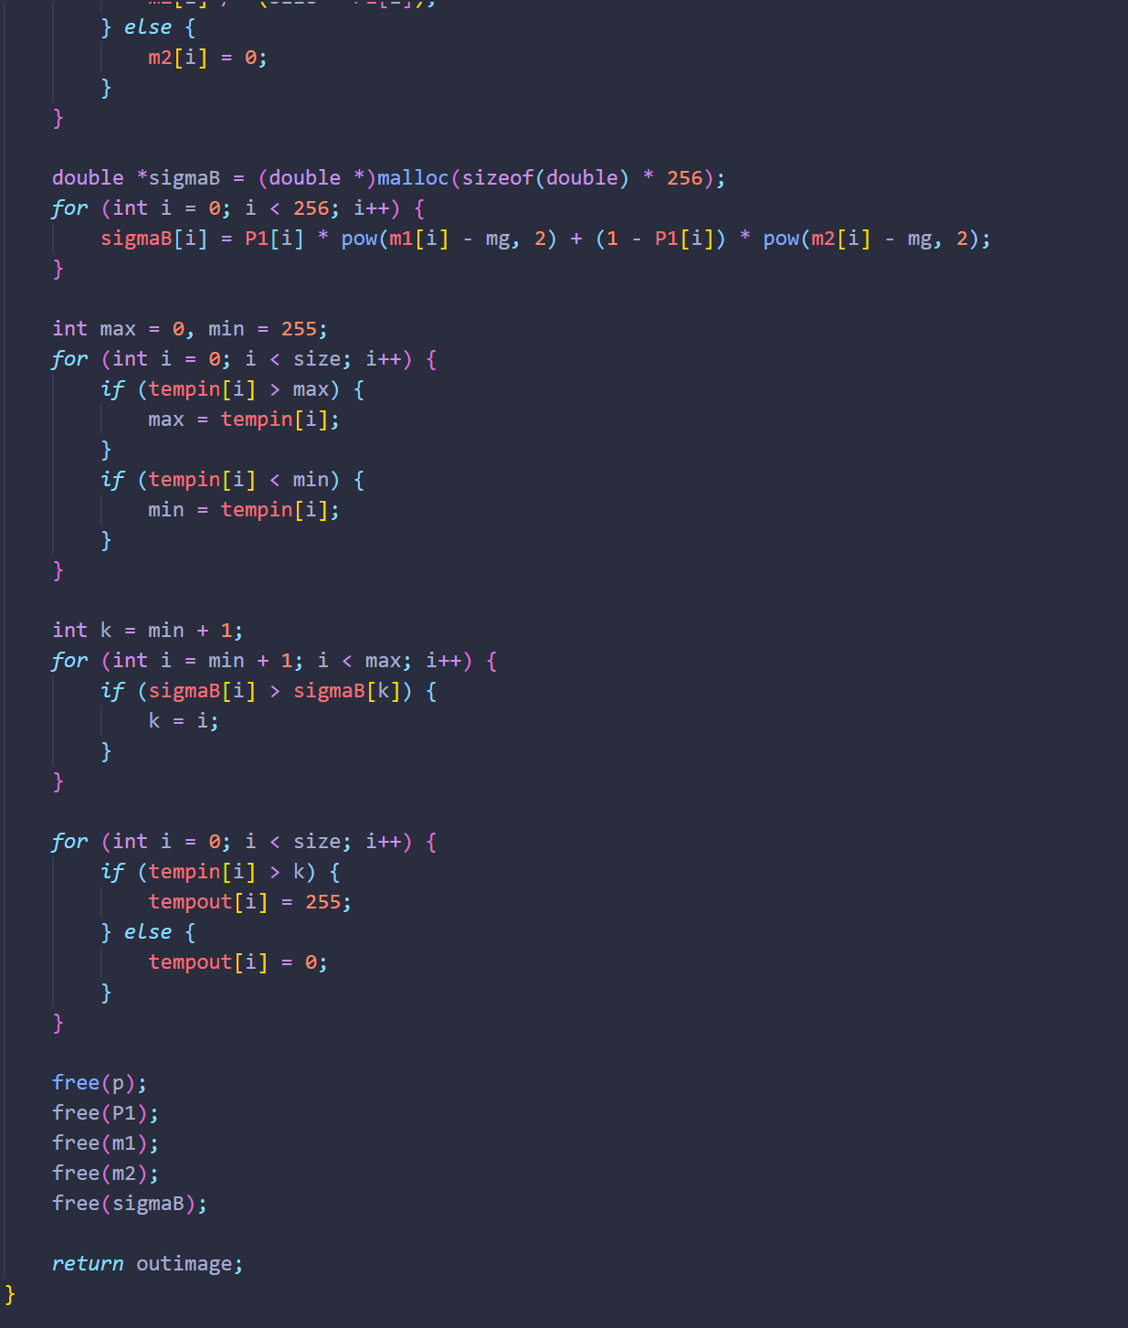

1. **Partition(septagon_noisy_shaded):**

**Algorithm:**

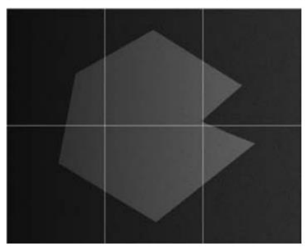

**Results (including pictures):**

Result of processing “septagon_noisy_shaded.pgm”:

Source Image:



Result after Partition:



**Discussion:**

It can be seen that the method of local statistics variable threshold processing is very effective for image segmentation. Three distinct gray levels can be completely distinguished.

**Codes:**

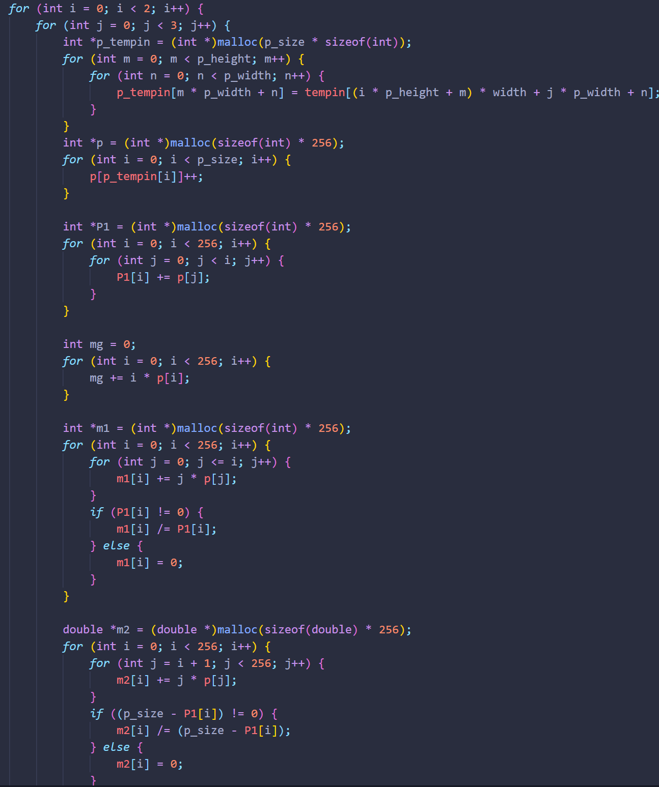

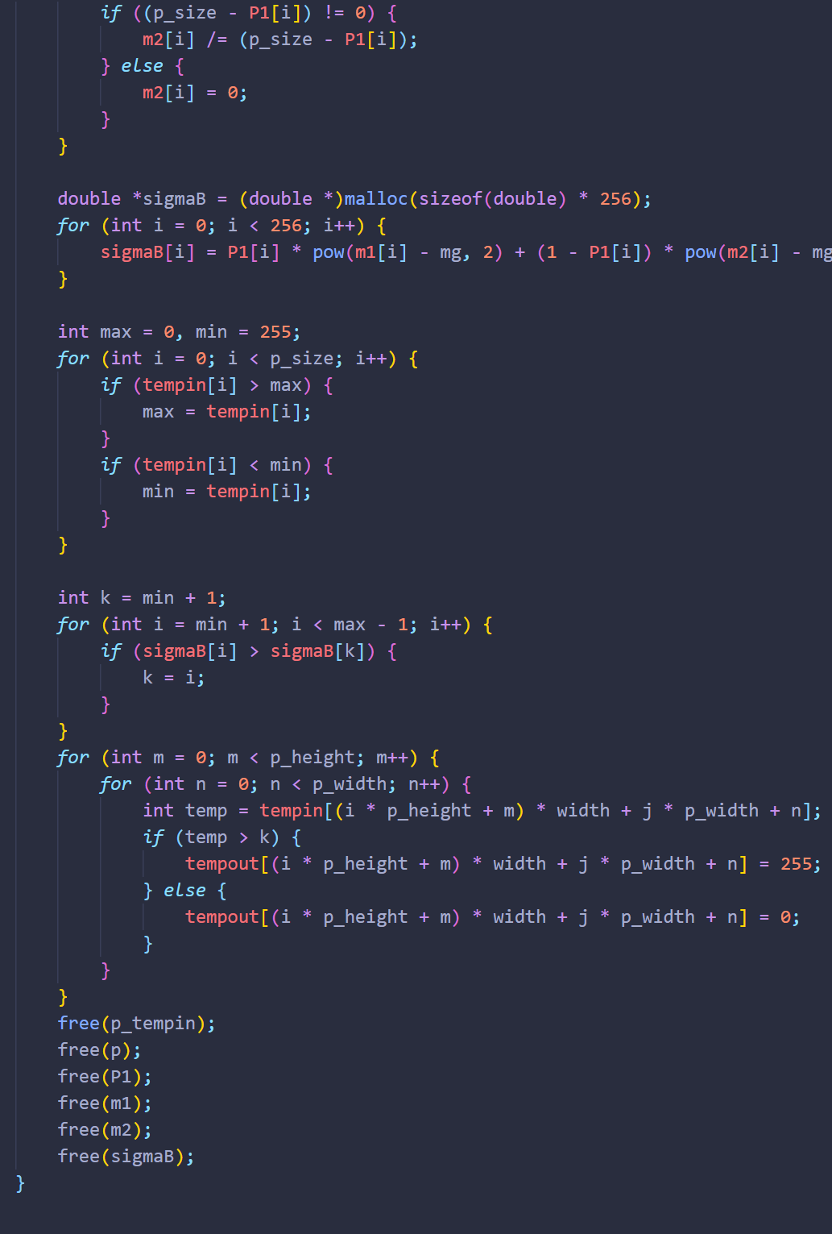

1. **moving average thresholding (spot_shaded_text_image):**

**Algorithm:**

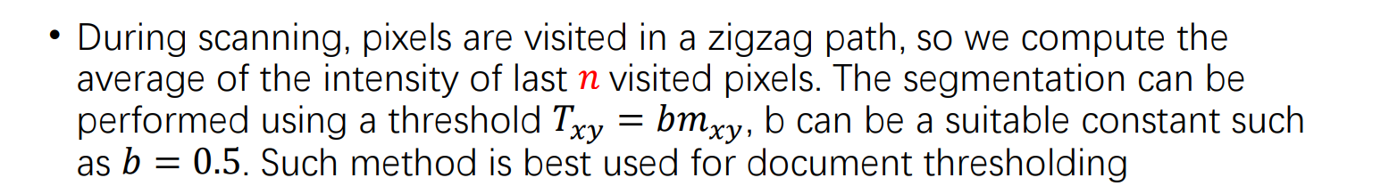

**Results (including pictures):**

Result of processing “spot_shaded_text_image”:

Source Image:

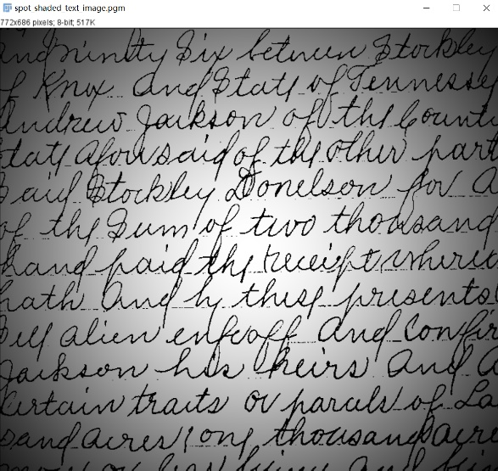

Result after moving average:

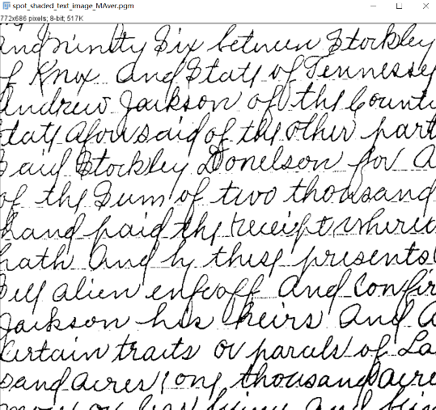

**Discussion:**

Figure shows an image of handwritten text shaded by a spot intensity pattern. This form of intensity shading is typical of images obtained using spot illumination (such as a photographic flash). Figure is the result of segmentation using the Otsu global thresholding method. It is not unexpected that global thresholding could not overcome the intensity variation because the method generally performs poorly when the areas of interest are embedded in a nonuniform illumination field. Figure shows successful segmentation with local thresholding using moving averages. For images of written material, a rule of thumb is to let n equal five times the average stroke width. In this case, the average width was 4 pixels, so we let n = 20 and used c = 0 5.

**Codes:**

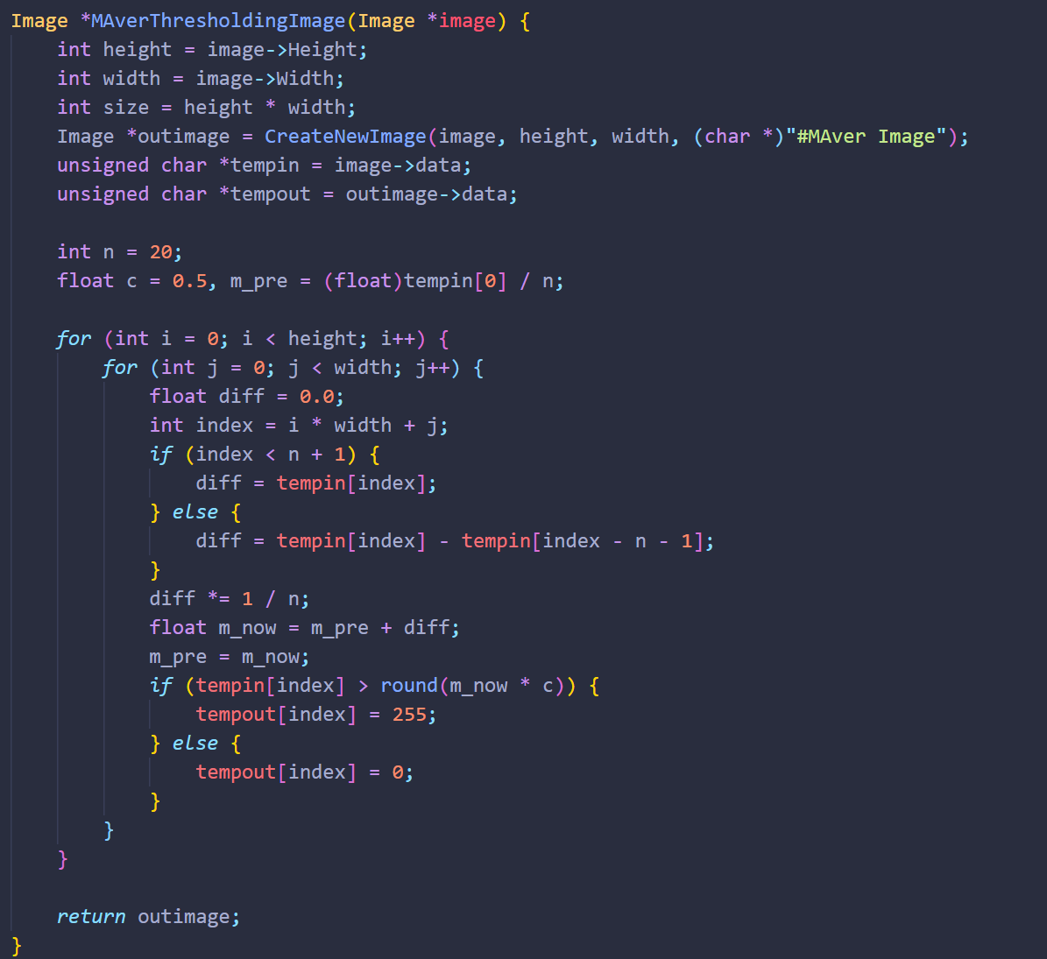

1. **region growing method (defective_weld.pgm):**

**Algorithm:**

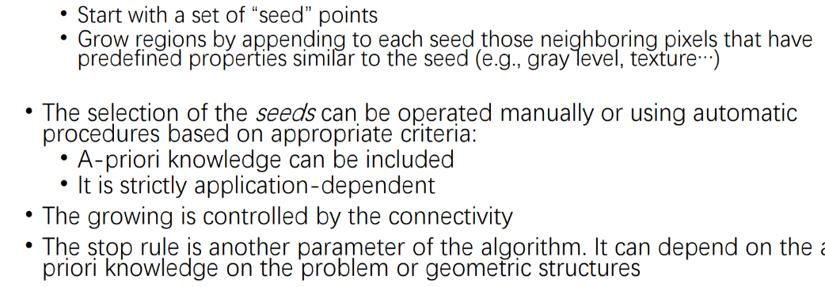

**Results (including pictures):**

Result of processing “defective_weld.pgm”:

Source Image:

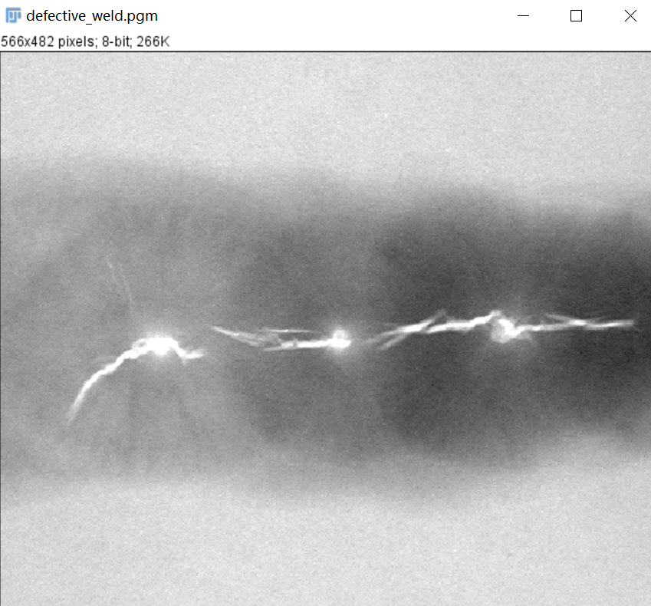

Result after region growing:

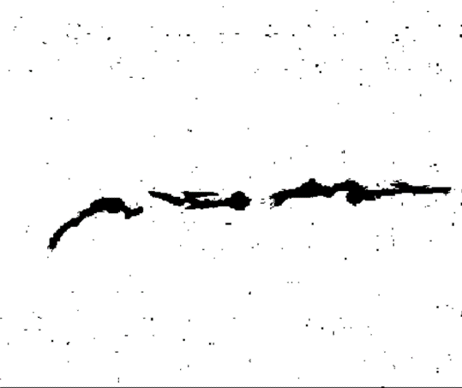

**Discussion:**

Advantages: The basic idea is relatively simple, and it can usually divide the connected regions with the same characteristics, and provide good boundary information and segmentation results. When there is no prior knowledge to use, it can achieve the best performance, and can be used to segment more complex images, such as natural scenery, coins, medical images, etc.

Disadvantages: Region growth method is an iterative method, with large space and time overhead. Uneven noise and gray scale may lead to void and over-segmentation, and it is often not very good in the processing of shadow effect in the image.

**Codes:**

