**Class Lab 2**

Use two images for each operation to do the following operations and write down their advantages and disadvantages and explain your results:

1. **Image reduction(lena, bridge):**

* Alternative line reduction

**Algorithm:**

**Results (including pictures):**

**Discussion:**

**Codes:**

* Fractional linear reduction to reduce images

**Algorithm:**

**Results (including pictures):**

**Discussion:**

**Codes:**

1. **Image reduction(lena, bridge, noise):**

* Pixel replication

**Algorithm:**

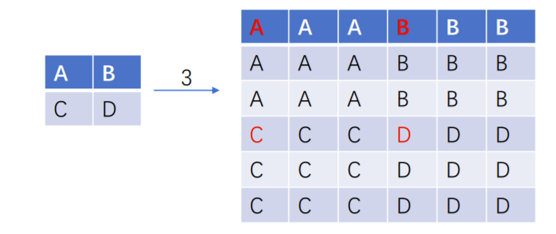

For each pixel of the new image $(x_{1},y_{1})$, we can find the mapping pixel $\left(x_{2},y_{2}\right)$ in the old image.

**Results (including pictures):**

**Discussion:**

**Codes:**

* Nearest enlargement

**Algorithm:**

**Results (including pictures):**

**Discussion:**

**Codes:**

* Bilinear interpolation

**Algorithm:**

**Results (including pictures):**

**Discussion:**

**Codes:**

* Fractional linear expansion to expand images to any larger size

**Algorithm:**

**Results (including pictures):**

**Discussion:**

**Codes:**

1. **Perform negative image operation:**

* On gray images

**Algorithm:**

**Results (including pictures):**

**Discussion:**

**Codes:**