**Class Lab 4**

Use two images for each operation to do the following operations and write down their advantages and disadvantages and explain your results:

1. **Laplacian operation (lena, bridge):**

**Algorithm:**

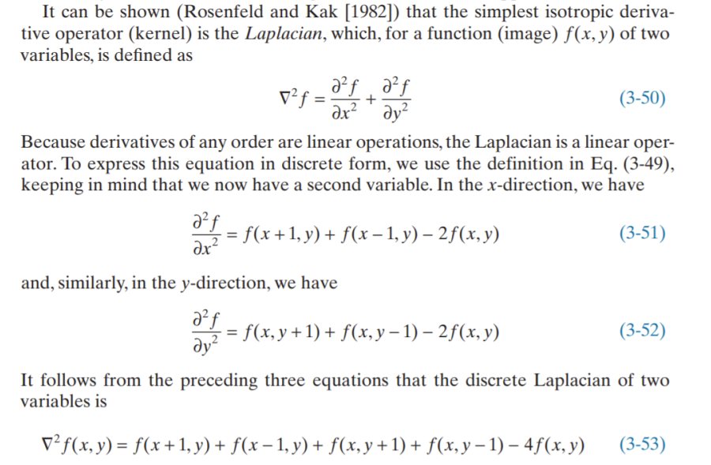

In this case, we use the filter:

Then we can get the final image:

Where .

**Results (including pictures):**

Result of processing “Lena.pgm”:

Source Image:

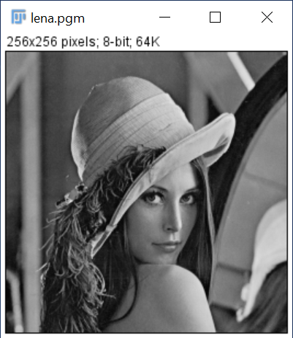

Result after Laplacian operation:

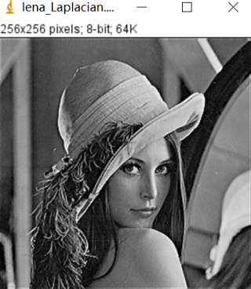

Result of processing “Bridge.pgm”:

Source Image:

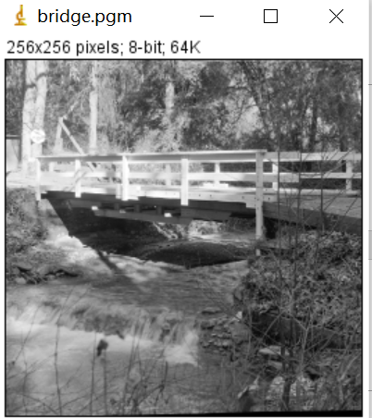

Result after Laplacian operation

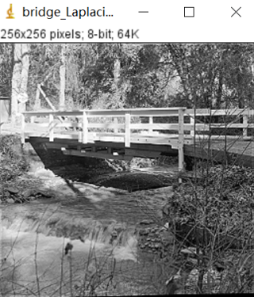

**Discussion:**

The detail in this image is unmistakably clearer and sharper than in the original image. Adding the Laplacian to the original image restored the overall intensity variations in the image. Adding the Laplacian increased the contrast at the locations of intensity discontinuities. The net result is an image in which small details were enhanced and the background tonality was reasonably preserved.

**Codes:**

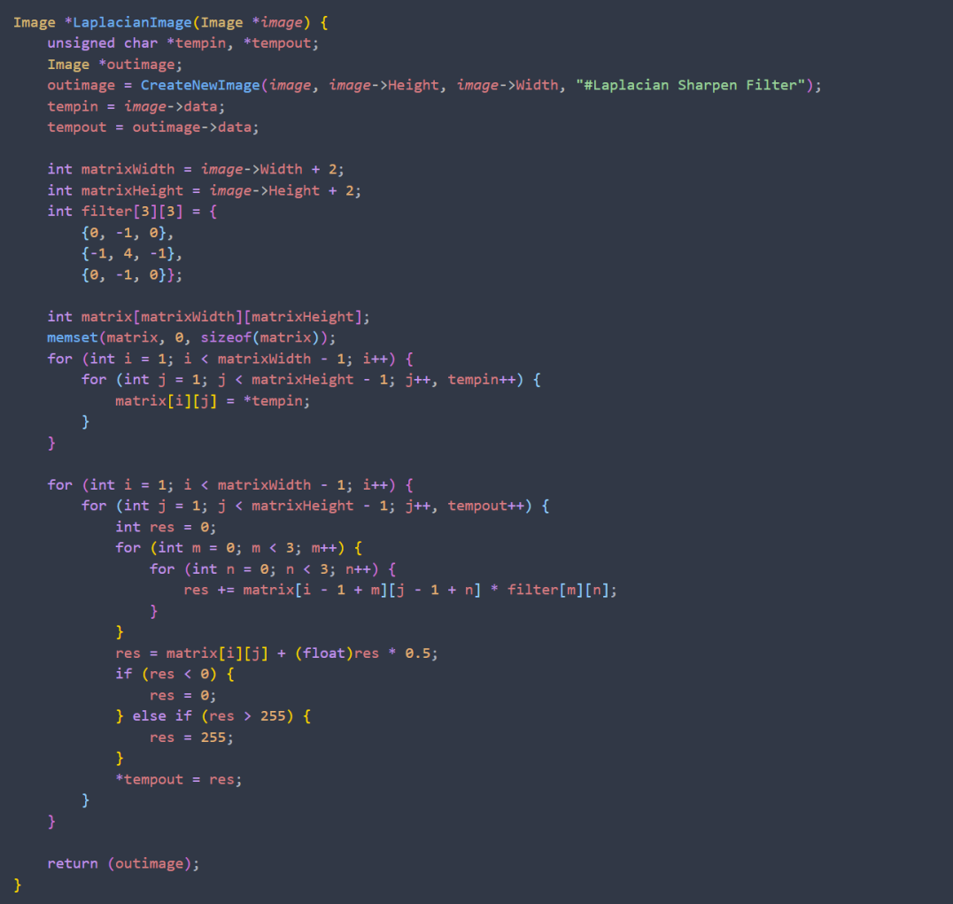

1. **Sobel operation (lena, bridge):**

**Algorithm:**

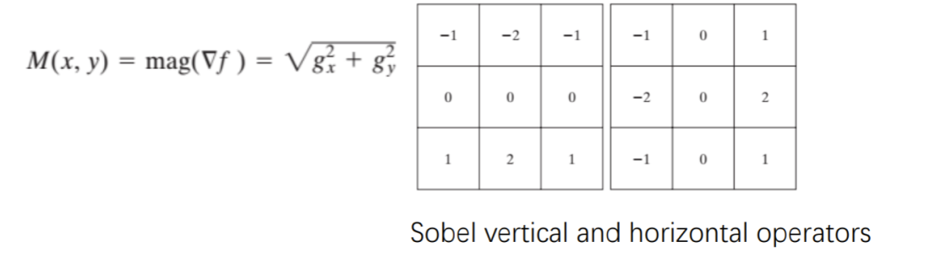**Results (including pictures):**

Result of processing “Lena.pgm”:

Source Image:



Result after Sobel operation:

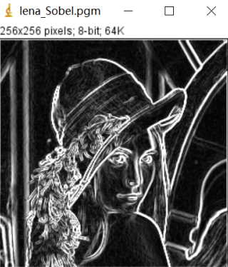

Result of processing “Bridge.pgm”:

Source Image:



Result after Sobel operation

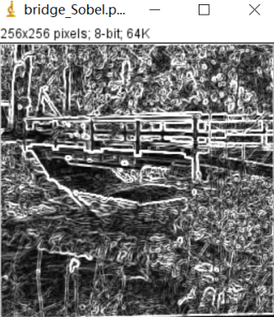

**Discussion:**

The advantage of Sobel operator is that the method is simple, the processing speed is fast, and the edge obtained is smooth and continuous. The disadvantage is that the edges are thicker.

**Codes:**

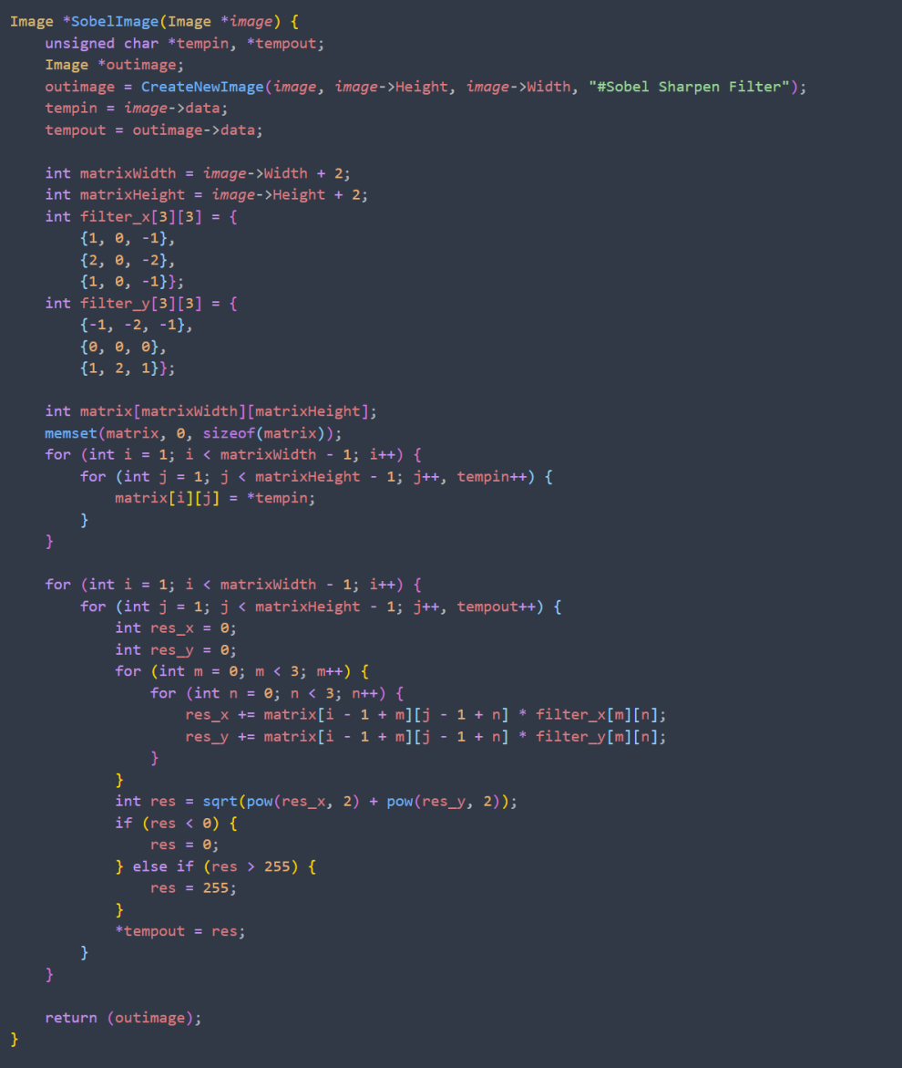

1. **Gamma correction (lena, bridge):**

**Algorithm:**

In this case, we use where is the domain of pixel. And where is the value of pixel.

**Results (including pictures):**

Result of processing “Lena.pgm”:

Source Image:



Result after Gamma correction:

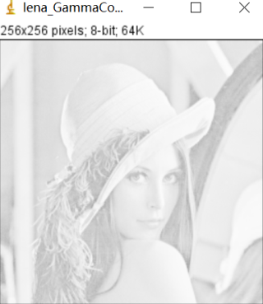

Result of processing “Bridge.pgm”:

Source Image:



Result after Gamma correction

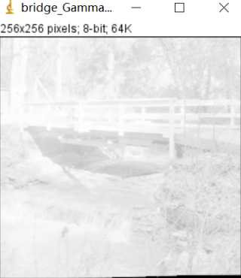

Source Image:



Result after Gamma correction:

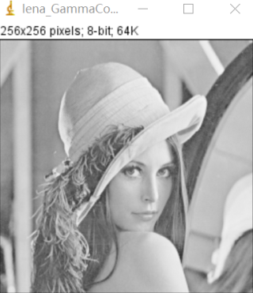

Result of processing “Bridge.pgm”:

Source Image:



Result after Gamma correction

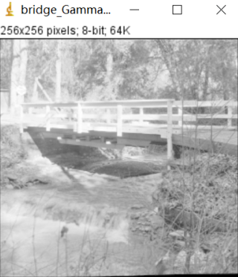

Source Image:



Result after Gamma correction:

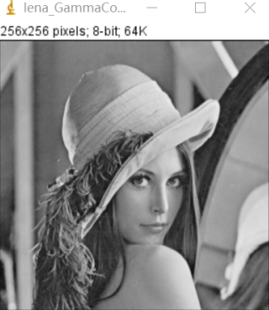

Result of processing “Bridge.pgm”:

Source Image:



Result after Gamma correction

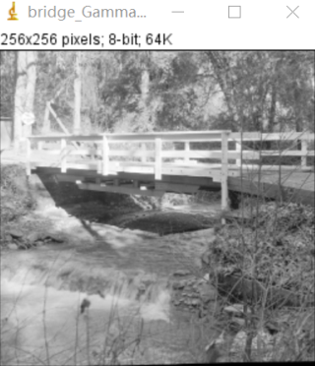

Source Image:



Result after Gamma correction:

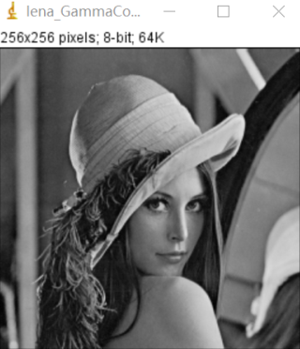

Result of processing “Bridge.pgm”:

Source Image:



Result after Gamma correction

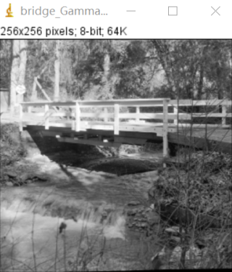

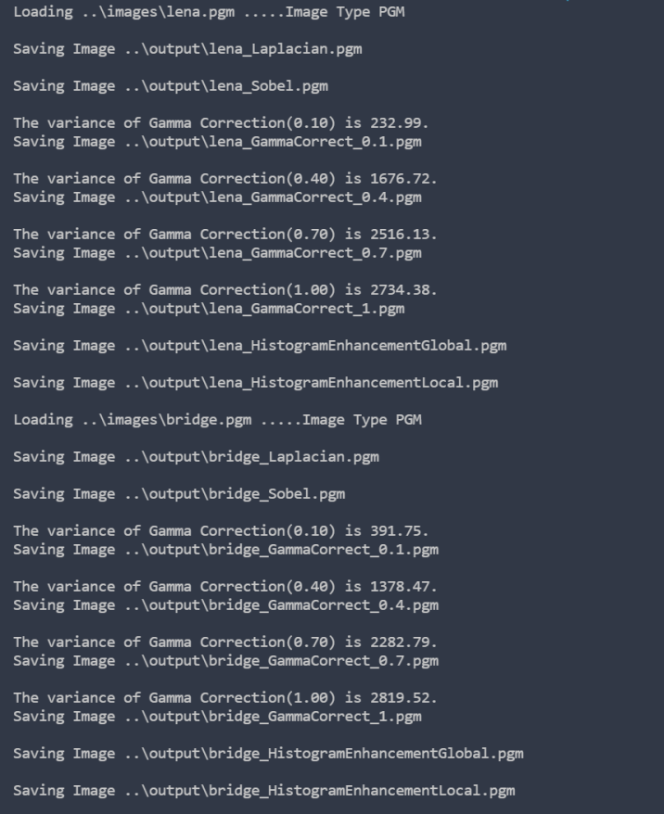

**Discussion:**

Observe that as gamma decreased from 1 to 0.4, more detail became visible. A further decrease of gamma to 0.1 enhanced a little more detail in the background, but began to reduce contrast to the point where the image started to have a very slight washed-out appearance, especially in the background. The best enhancement in terms of contrast and discernible detail was obtained with g = 0.4. A value of g = 0.1 is an approximate limit below which contrast in this particular image would be reduced to an unacceptable level. **Codes:**

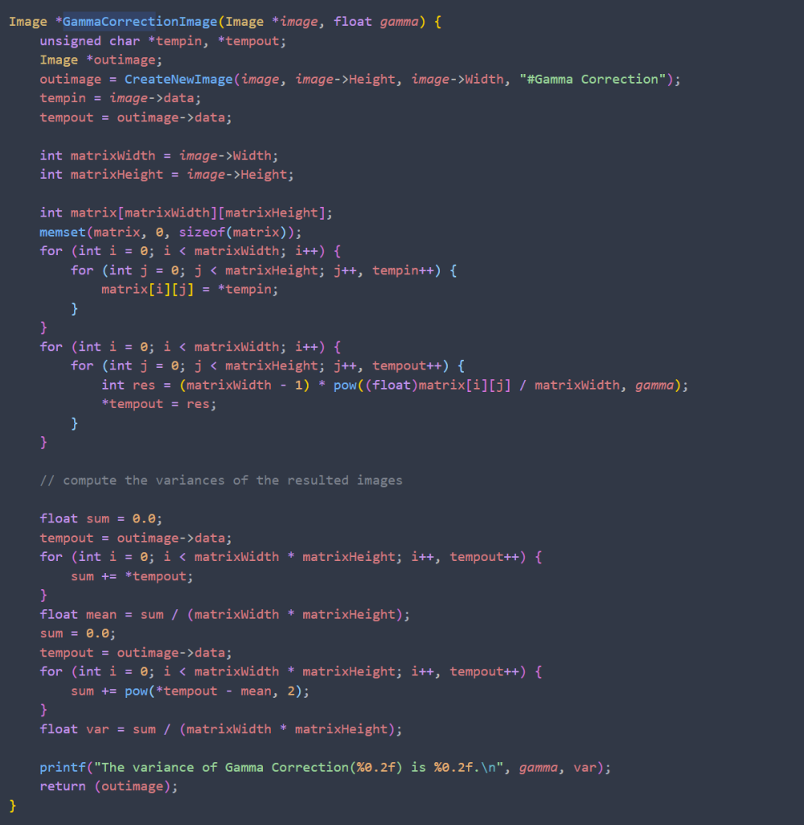

1. **Histogram enhancement Global (lena, bridge):**

**Algorithm:**

1. Count the number of values for each pixel;
2. Calculate the PDF for each gray value;
3. By using function . Get the value of histogram equalization transformation function ;
4. Round the value of , and then you could get the final result.

**Results (including pictures):**

Result of processing “Lena.pgm”:

Source Image:



Result after Histogram enhancement Global:

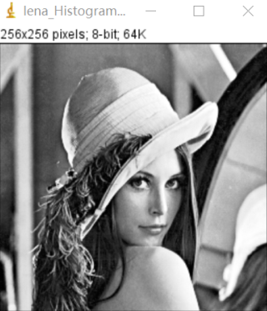

Result of processing “Bridge.pgm”:

Source Image:



Result after Histogram enhancement Global

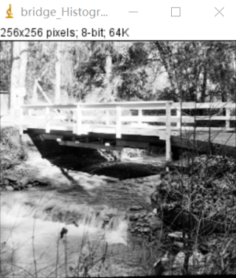

**Discussion:**

By changing the histogram of the image to change the gray of each pixel in the image, it is mainly used to enhance the contrast of the image with small dynamic range. The original image is not clear because its gray distribution may be concentrated in a narrow range. Image contrast will be improved and details will be sharper

**Codes:**

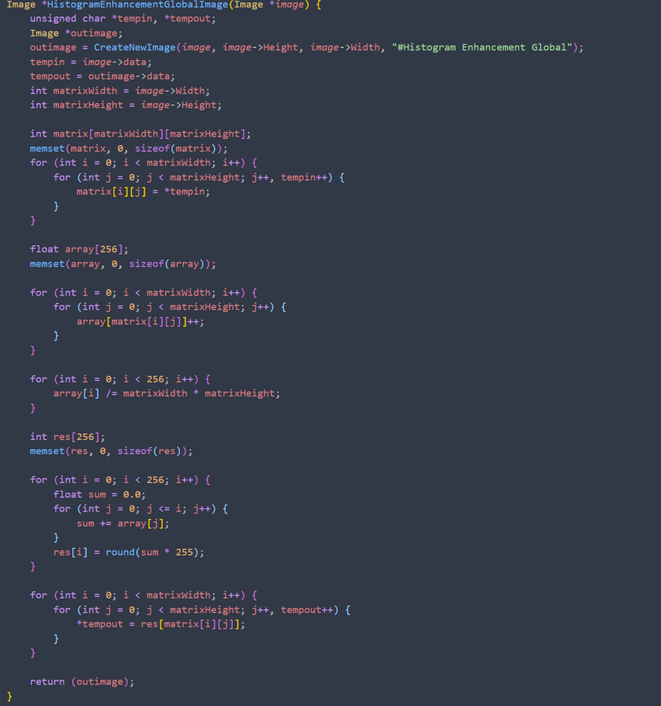

1. **Histogram enhancement local (lena, bridge):**

**Algorithm:**

Determine the kernel and size of the local processing area.

Count the number of values for each pixel;

Calculate the PDF for each gray value;

By using function . Get the value of histogram equalization transformation function ;

Round the value of , and then you could get the final result.

**Results (including pictures):**

Result of processing “Lena.pgm”:

Source Image:



Result after Histogram enhancement Global:

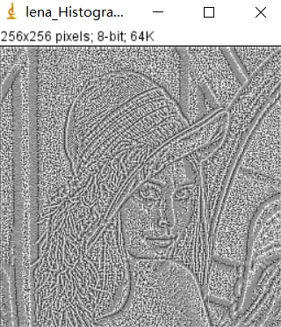

Result of processing “Bridge.pgm”:

Source Image:



Result after Histogram enhancement Global

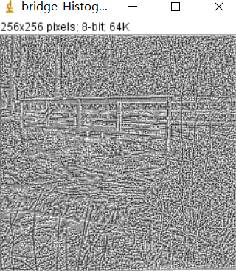

**Discussion:**

The local enhancement method enhances the edge details of the image. The influence of the number of pixels in the cell domain on the global transformation is not ignored.

**Codes:**

