**Class Lab 7**

Use two images for each operation to do the following operations and write down their advantages and disadvantages and explain your results:

1. **Homomorphic Filter (bridge, goldhill):**

**Algorithm:**

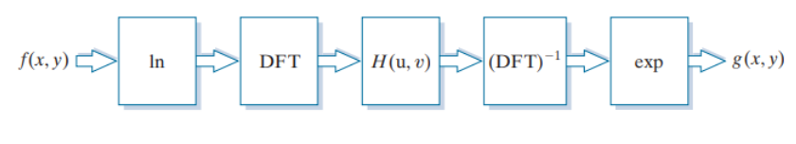

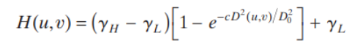

**Results (including pictures):**

Result of processing “goldhill.pgm”:

Source Image:

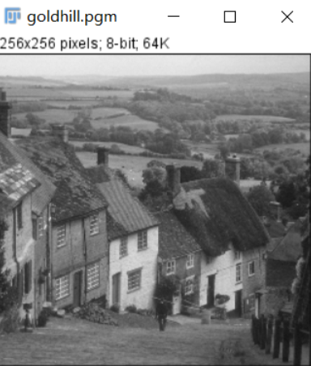

Result after homomorphic Filter:

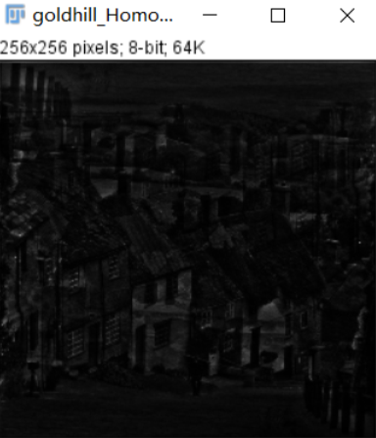

Result of processing “Bridge.pgm”:

Source Image:

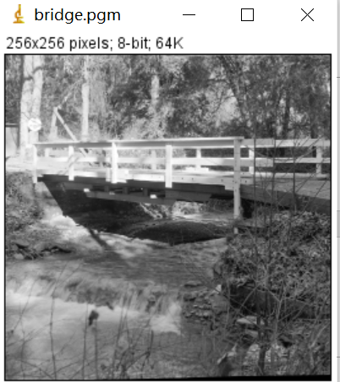

Result after homomorphic Filter:

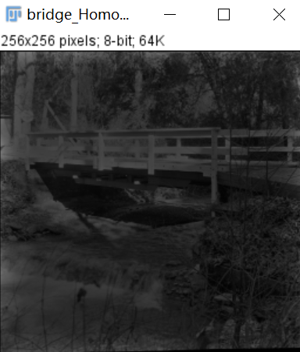

**Discussion:**

A good deal of control can be gained over the illumination and reflectance components with a homomorphic filter. This control requires specification of a filter transfer function that affects the low- and high-frequency components of the Fourier transform in different, controllable ways. The net result is simultaneous dynamic range compression and contrast enhancement.

**Codes:**

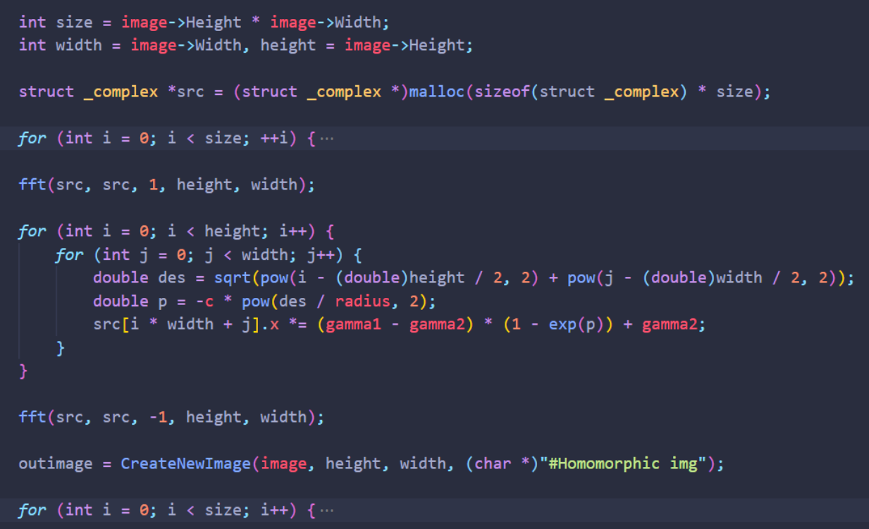

1. **Sinusoidal Noise (Lena):**

**Algorithm:**

**Results (including pictures):**

Result of processing “lena.pgm”:

Source Image:

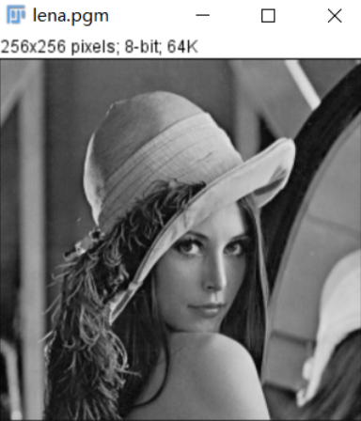

Result after add noise:

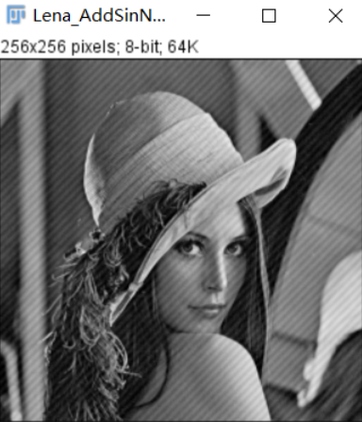

**Codes:**

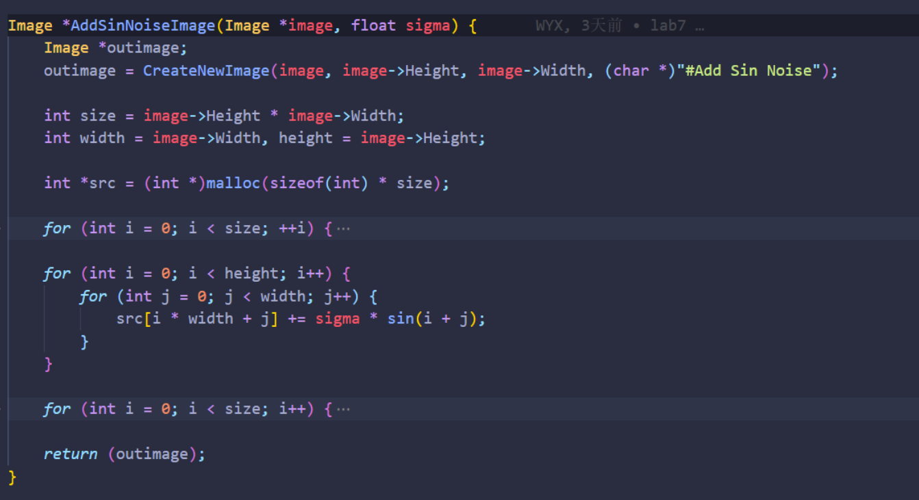

1. **Ideal Notch Band Reject Filter (lena):**

**Algorithm:**

**Results (including pictures):**

Result of processing “lena.pgm”:

Source Image:

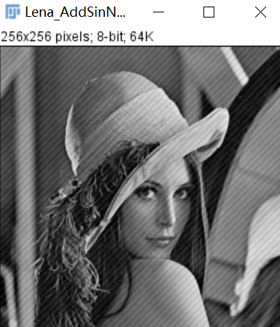

Result after IDealNotchBandreject Filter:

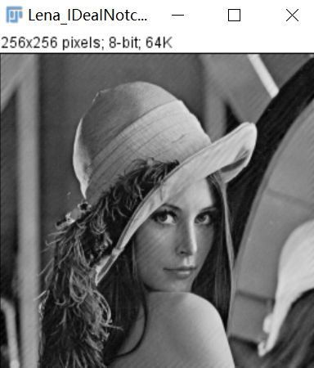

**Discussion:**

Most of the sinusoidal periodic noise can be removed by using an ideal notch filter

**Codes:**

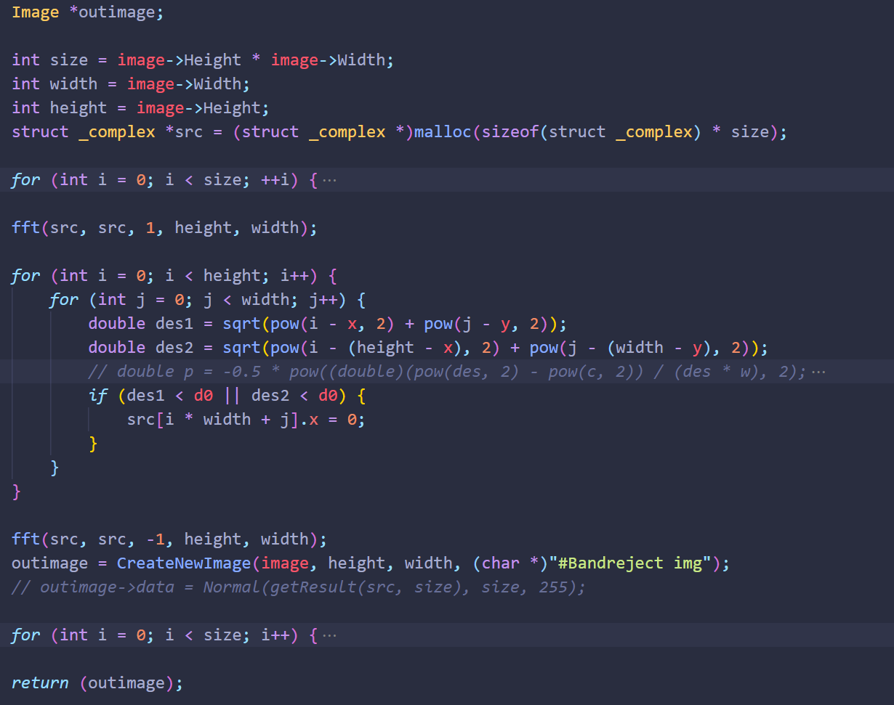

**Rectangle Notch Band reject Filter (lena,** cameraWithNoise

1. cameraWithNoise
2. cameraWithNoise
3. cameraWithNoise
4. cameraWithNoise
5. cameraWithNoise
6. cameraWithNoise
7. cameraWithNoise
8. cameraWithNoise
9. cameraWithNoise
10. cameraWithNoise
11. cameraWithNoise
12. cameraWithNoise

cameraWithNoise cameraWithNoise

1. cameraWithNoise
2. cameraWithNoise
3. cameraWithNoise
4. cameraWithNoise
5. cameraWithNoise
6. cameraWithNoise
7. cameraWithNoise
8. cameraWithNoise
9. cameraWithNoise
10. cameraWithNoise
11. cameraWithNoise
12. cameraWithNoise
13. cameraWithNoise
14. cameraWithNoise
15. cameraWithNoise
16. cameraWithNoise
17. cameraWithNoise
18. cameraWithNoise
19. cameraWithNoise
20. cameraWithNoise
21. cameraWithNoise
22. cameraWithNoise
23. cameraWithNoise
24. cameraWithNoise
25. cameraWithNoise
26. cameraWithNoise
27. cameraWithNoise
28. cameraWithNoise
29. cameraWithNoise
30. cameraWithNoise
31. cameraWithNoise
32. cameraWithNoise
33. cameraWithNoise
34. cameraWithNoise
35. cameraWithNoise
36. cameraWithNoise
37. cameraWithNoise
38. cameraWithNoise
39. cameraWithNoise
40. cameraWithNoise
41. cameraWithNoise
42. cameraWithNoise
43. cameraWithNoise
44. cameraWithNoise
45. cameraWithNoise
46. cameraWithNoise
47. cameraWithNoise
48. cameraWithNoise
49. cameraWithNoise
50. cameraWithNoise
51. cameraWithNoise
52. cameraWithNoise
53. cameraWithNoise
54. cameraWithNoise
55. cameraWithNoise
56. cameraWithNoise
57. cameraWithNoise
58. cameraWithNoise
59. cameraWithNoise
60. cameraWithNoise
61. cameraWithNoise
62. cameraWithNoise
63. cameraWithNoise
64. cameraWithNoise
65. cameraWithNoise
66. cameraWithNoise
67. cameraWithNoise
68. cameraWithNoise
69. cameraWithNoise
70. cameraWithNoise
71. cameraWithNoise
72. cameraWithNoise
73. cameraWithNoise
74. cameraWithNoise
75. cameraWithNoise
76. cameraWithNoise
77. cameraWithNoise
78. cameraWithNoise
79. cameraWithNoise
80. cameraWithNoise
81. cameraWithNoise
82. cameraWithNoise
83. cameraWithNoise
84. cameraWithNoise
85. cameraWithNoise
86. cameraWithNoise
87. cameraWithNoise
88. cameraWithNoise
89. cameraWithNoise
90. cameraWithNoise
91. cameraWithNoise
92. cameraWithNoise
93. cameraWithNoise
94. cameraWithNoise
95. cameraWithNoise
96. cameraWithNoise
97. cameraWithNoisevvvvvvvvvvvvvvvvvvvvvvvvvvvvvvvvvvvvvvvvvvvvvvvvvvvvvvvvvvvvvvvvvvvvvvvvvvvvvvvvvvvvvvvvvvvvvvvvvvvvvvvvvvvvvvvvvvvvvvvvvvvvvvvvvvvvvvvvvvvvvvvvvvvvvvvvvvvvvvv
98. cameraWithNoise
99. cameraWithNoisevvvvvvvvvvvvvvvvvvvvvvvvvvvvvvvvvvvvvvvvvvvvvvvvvvvvvvvvvvvvvvvvvvvvvvvvvvvvvvvvvvvvvvvvvvvv
100. cameraWithNoise
101. cameraWithNoise
102. cameraWithNoise
103. cameraWithNoise
104. cameraWithNoise
105. cameraWithNoise
106. cameraWithNoise
107. cameraWithNoise
108. cameraWithNoise
109. cameraWithNoise
110. vvvvvvvvvvvvvvvvvvvvvvvcameraWithNoise
111. cameraWithNoise
112. cameraWithNoise
113. cameraWithNoise

cameraWithNoisevvvvvvvvvvvvvvvvvvvvvvvvvvvvvvvvvv cameraWithNoise

1. cameraWithNoise
2. cameraWithNoise
3. cameraWithNoise
4. cameraWithNoise
5. cameraWithNoise
6. cameraWithNoise
7. cameraWithNoise
8. cameraWithNoise
9. cameraWithNoise
10. cameraWithNoise
11. cameraWithNoise
12. cameraWithNoise
13. cameraWithNoise
14. cameraWithNoise
15. cameraWithNoise
16. cameraWithNoise
17. cameraWithNoise
18. cameraWithNoise
19. cameraWithNoise
20. cameraWithNoise
21. cameraWithNoise
22. cameraWithNoise
23. cameraWithNoise
24. cameraWithNoise
25. cameraWithNoise
26. cameraWithNoise
27. vvvvvvvvvvvvvvvvvvvvvvvvvvvvvvvvvvvvvv
28. cameraWithNoise
29. cameraWithNoise
30. cameraWithNoise
31. cameraWithNoise
32. cameraWithNoisevvvvvvvvvvvvvvvvvvvvvvvvvvvvvvvvvvvvvvvvvvvvvvvvvvvvvvvvvvvv
33. cameraWithNoise
34. cameraWithNoise
35. cameraWithNoise
36. cameraWithNoisevvvvvvvvvvv
37. cameraWithNoise
38. cameraWithNoise
39. cameraWithNoisevvvvvvvvvvvvvvvvvvvvvvvvvv
40. cameraWithNoise
41. cameraWithNoise
42. cameraWithNoise
43. cameraWithNoise
44. cameraWithNoise
45. cameraWithNoisevvvvvvvvvvvvvvv
46. cameraWithNoise
47. cameraWithNoisevvvvvvvvvvvvvvvvvvvvvvvvvvvvvvv
48. **):**

**Algorithm:**

**Results (including pictures):**

Result of processing “lena.pgm”:

Source Image:



Result after IDealNotchBandreject Filter:



**Discussion:**

Most of the sinusoidal periodic noise can be removed by using an ideal notch filter

**Codes:**

