《数据库系统》课程设计报告

课程号： 311142040
课序号： 2
课程班： 上午班√ 下午班□
项目名： 商场导购系统
组号： 10
项目组长： 彭涵钧 2015141463132
项目组员： 顾家名 2015141463211
程东耀 2015141463302
杨静波 2015141463211
李雨科 2015141463099
指导教师： 龚 勋
评阅成绩：
评阅意见：

提交报告时间：2017年 6月 23日
四川大学计算机（软件）学院

各成员工作量划分表

成员姓名 | 成员学号 | 工作 | 工作量
彭涵钧 | 2015141463132 | 架构设计、核心算法开发 | 23%
顾家名 | 2015141463043 | 数据库以及服务器的搭建与维护 | 22%
程东耀 | 2015141463132 | 地图API开发 | 20%
杨静波 | 2015141463021 | 系统测试 | 15%
李雨科 | 2015141463099 | Android端开发 | 20%

一种商场导购系统

专业：软件工程

组号：12 指导老师：龚勋

摘要：随着计算机科学的发展，数据库技术,特别是简单方便的asp技术，在Internet 中的应用越来越广泛，为广大网络用户提供了更加周到和人性化的服务。本文研究了一种基于asp技术的用户个性化页面动态生成方案，此方案在 Windows XP Professional 平台上，以ASP作为前台开发工具，使用SQL Server2000数据库作为后台建库工具，为商场开发设计B/S模式的“商场导购系统”。
本文全面阐述了B/S模式的特点，对前台开发工具ASP，数据库工具SQL Server2000均作了简要介绍。详细说明了系统的业务流程和系统开发流程，重点介绍了系统各模块的功能及相关功能的具体实现。从系统的需求分析、总体设计到前台的具体实现，后台数据库的初步构思到数据表的最后成型，每一实现细节均作了详实的论述。
关键词：B/S；ASP；导购；数据库

[Abstract] Along with the development of the computer , the data bank technology,the simple convenience Active Server Pages technology, more and more is speciallywidespread in the Internet application, providing more thoughtful and humanized service for the large network customer. This article has studied one kind based on Active Server Pages technology userindividuality page dynamic production plan，This plan At platform XP Professional of Windows system regards Active Server Pages as proscenium developing tool, uses SQL Server2000 to constructthe storehouse tool as the backstage, designs the B/S mode for "the Shopping Instruction System".
This article Comprehensively elaborated the B/S mode for "the Shopping Instruction System "characteristic and service request, To Active Server Pages, database tool SQL Server2000 has made thebrief introduction. Systematic business procedure and systematic develop procedure were introduced elaboratedly. At the same time every function of this system also was introduced in detail. Detailed analyze has been done which is about overall design from systematic demand and the specific realization of proscenium and the database of backstage supporter think about data dictionary preliminarily become type finally, each realization details have been made full and accurate exposition.

Keywords：Browser/WEB Server；Active Server Pages； Shopping instruction；Database

Shopping guide system

Major: software engineering

Group Number: 12 Supervisor: Gongxun

目录
1 前言 5
1.1 选题意义 5
1.1.1 面向用户 5
1.1.2 实用意义 5
1.1.3 项目目标 5
1.2 国内外现状 5
1.3 本项目的工作 6
2 本项目主要工作 7
2.1 需求分析 7
2.1.1 系统的功能要求 7
2.1.2 系统数据库要求 7
2.1.3 系统将来可能提出的要求 7
2.1.4 百度地图API开发 7
2.2 系统设计 7
2.2.1 数据库设计 7
2.2.2 应用程序设计 28
2.3 系统实现 28
2.4 测试 33
3 总结 40
3.1 工作总结 40
3.2 问题及下一步的工作 41
参考文献 42

- 前言

选题意义

1.1.1面向用户：不熟悉商场布局的消费者

1.1.2使用意义：引导消费者按照自己的目标方便、快捷地去找相应商品的目的

1.1.3项目目标：制作一个导购系统，能够引导人们购物

国内外现状
多门数字导购系统
优点：功能较为完善。
缺点：界面不够人性化
积米
优点：可以寻找优惠产品
缺点：用户群太少，功能缺乏
共同缺点：
导购方式并不完善 ；
缺乏与顾客的交互性 ；

本项目的工作

1.3.1查找商铺：
用户通过文字输入，系统在导购地图上显示出用户当前位置和查找的商铺位置

1.3.2查找商品：
用户输入欲购商品，系统在导购地图上显示出用户当前位置和可购到指定商品的商铺位置

1.3.3指引路线：
用户选择导购地图上显示的商铺，系统在地图上显示出到达该商铺的路线

- 本项目主要工作

需求分析

2.1.1系统的功能要求
通过对公司业务流程的实际调查分析得出所需系统需要具有以下功能：
- 通过系统可以迅速地对顾客的需求构成向导 ；
- 由于操作人员的计算机知识普遍较差，要求系统良好的人机操作界面。
- 全面展示企业的形象，让顾客通过系统对企业有一个更为全面的认识。
- 方便的数据查询，满足顾客快速、准确查找商品信息的要求。
- 提供新品上市、品牌推荐、宣传海报、楼层提示等信息。
- 设置客服中心模块，帮助顾客解决问题，拉近和顾客之间的距离。
- 分类展示商品信息（或按楼层），方便顾客查看相关内容。
- 系统管理员对网站后台管理模块进行设置。
- 管理前台所展示的全部信息类内容。
- 功能完善的后台商品管理模块。
- 为了保证数据的安全性来设置数据备份功能、数据恢复功能。
- 对商品查询情况进行排行统计。
- 系统用户信息管理，用户权限设置。
- 系统注销。

2.1.2系统数据库要求
由于系统需求所以许多数据项为必须填写（在系统中已经指明），一些机动数据可以根据情况自行决定是否录入；对于一些简单的数据要进行出错检查，单据数据已经录入完毕即可提交；检验单编号自动生成；做查询时可以指定一个或若干个查询条件进行查询；预览可以直接点击进行查询预览。为保证数据库数据的可恢复性系统应具有对数据表、数据库备份功能。
。

2.1.3系统将来可能提出的要求
(1)信息统计。即对信息查询量进行统计，为商场工作的改进提供参考。
(2)对数据表中字段的数据类型和字段长度的修改。
(3)对系统操作方式的更改。如把鼠标操作改为触摸屏操作。

2.1.4百度地图API开发
在应用中完成实时显示地图的功能

系统设计

数据库设计
- 生成概念模型：重点是写出ER/EER模型（5分）
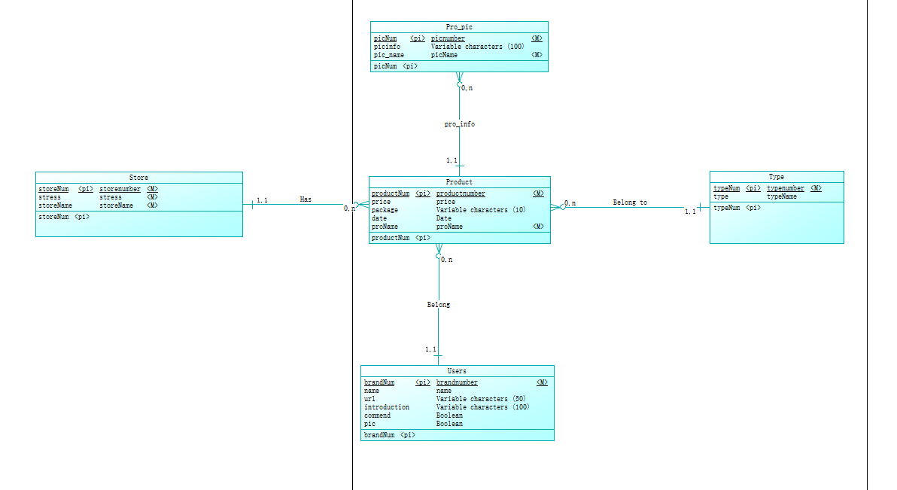
图一 E-R图
- 生成逻辑模型：重点是写出
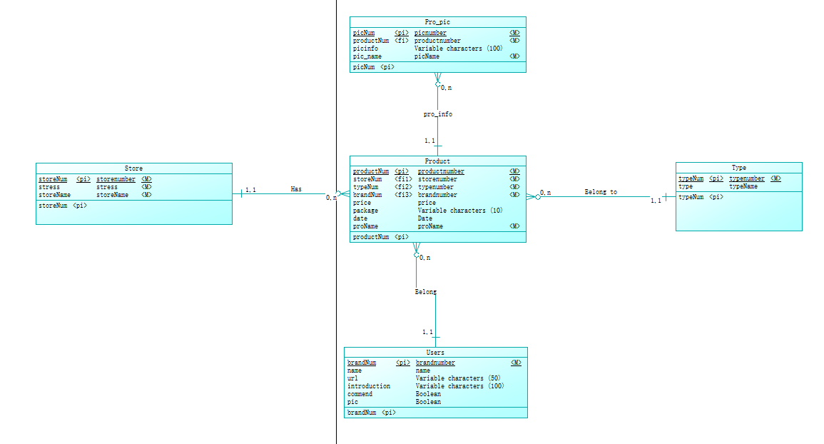
- 导出关系的过程（5分）
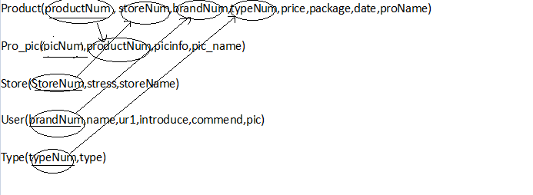
- 规范化：要求规范到BCNF范式，写出规范化的过程（5分）
a)1NF：不规则的表——〉规则的表
因为是E/R图而不是数据库表,所以不需要对表进行修平。
b)2NF：消除部分函数依赖
Product(productNum , storeNum,brandNum,typeNum,price,package,date,proName)
Pro_pic(picNum,productNum,picinfo,pic_name)
Store(StoreNum,stress,storeName)
User(brandNum,name,ur1,introduce,commend,pic)
Type(typeNum,type)
c)3NF：消除传递函数依赖
Product(productNum , storeNum,brandNum,typeNum,price,package,date,proName)
Pro_pic(picNum,productNum,picinfo,pic_name)
Store(StoreNum,stress,storeName)
User(brandNum,name,ur1,introduce,commend,pic)
Type(typeNum,type)
d)BCNF：消除决定方不是候选关键字的函数依赖
Product(productNum , storeNum,brandNum,typeNum,price,package,date,proName)
Pro_pic(picNum,productNum,picinfo,pic_name)
Store(StoreNum,stress,storeName)
User(brandNum,name,ur1,introduce,commend,pic)
Type(typeNum,type)
- 生成物理模型（3分）
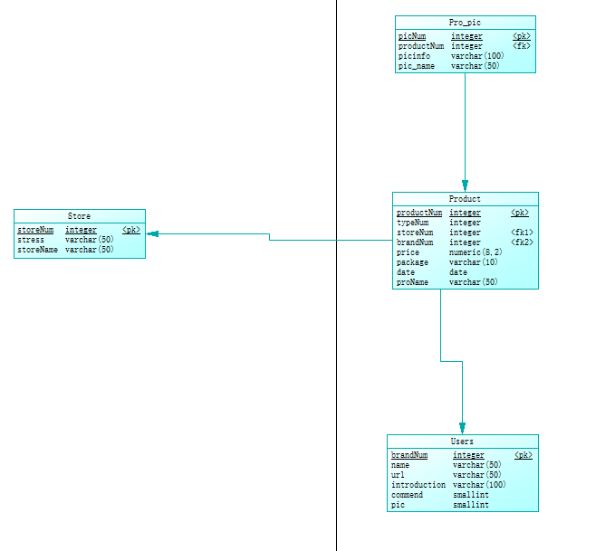
- 导出SQL脚本（2分）
/*==============================================================*/
/* DBMS name: Microsoft SQL Server 2005 */
/* Created on: 2017/6/15 14:51:51 */
/*==============================================================*/

if exists (select 1
from sys.sysreferences r join sys.sysobjects o on (o.id = r.constid and o.type = 'F')
where r.fkeyid = object_id('Bulletin') and o.name = 'FK_BULLETIN_RELEASEB_ADMIN')
alter table Bulletin
drop constraint FK_BULLETIN_RELEASEB_ADMIN
go

if exists (select 1
from sys.sysreferences r join sys.sysobjects o on (o.id = r.constid and o.type = 'F')
where r.fkeyid = object_id('Company') and o.name = 'FK_COMPANY_MANAGEC_ADMIN')
alter table Company
drop constraint FK_COMPANY_MANAGEC_ADMIN
go

if exists (select 1
from sys.sysreferences r join sys.sysobjects o on (o.id = r.constid and o.type = 'F')
where r.fkeyid = object_id('Discount') and o.name = 'FK_DISCOUNT_RELEASED_ADMIN')
alter table Discount
drop constraint FK_DISCOUNT_RELEASED_ADMIN
go

if exists (select 1
from sys.sysreferences r join sys.sysobjects o on (o.id = r.constid and o.type = 'F')
where r.fkeyid = object_id('Evaluate') and o.name = 'FK_EVALUATE_EVALUATE_COMPANY')
alter table Evaluate
drop constraint FK_EVALUATE_EVALUATE_COMPANY
go

if exists (select 1
from sys.sysreferences r join sys.sysobjects o on (o.id = r.constid and o.type = 'F')
where r.fkeyid = object_id('Evaluate') and o.name = 'FK_EVALUATE_EVALUATE2_USER')
alter table Evaluate
drop constraint FK_EVALUATE_EVALUATE2_USER
go

if exists (select 1
from sys.sysreferences r join sys.sysobjects o on (o.id = r.constid and o.type = 'F')
where r.fkeyid = object_id('Hotel') and o.name = 'FK_HOTEL_MANAGEH_ADMIN')
alter table Hotel
drop constraint FK_HOTEL_MANAGEH_ADMIN
go

if exists (select 1
from sys.sysreferences r join sys.sysobjects o on (o.id = r.constid and o.type = 'F')
where r.fkeyid = object_id('News') and o.name = 'FK_NEWS_RELEASEN_ADMIN')
alter table News
drop constraint FK_NEWS_RELEASEN_ADMIN
go

if exists (select 1
from sys.sysreferences r join sys.sysobjects o on (o.id = r.constid and o.type = 'F')
where r.fkeyid = object_id('OrderH') and o.name = 'FK_ORDERH_ORDERH_HOTEL')
alter table OrderH
drop constraint FK_ORDERH_ORDERH_HOTEL
go

if exists (select 1
from sys.sysreferences r join sys.sysobjects o on (o.id = r.constid and o.type = 'F')
where r.fkeyid = object_id('OrderH') and o.name = 'FK_ORDERH_ORDERH2_USER')
alter table OrderH
drop constraint FK_ORDERH_ORDERH2_USER
go

if exists (select 1
from sys.sysreferences r join sys.sysobjects o on (o.id = r.constid and o.type = 'F')
where r.fkeyid = object_id('OrderR') and o.name = 'FK_ORDERR_ORDERR_ROUTE')
alter table OrderR
drop constraint FK_ORDERR_ORDERR_ROUTE
go

if exists (select 1
from sys.sysreferences r join sys.sysobjects o on (o.id = r.constid and o.type = 'F')
where r.fkeyid = object_id('OrderR') and o.name = 'FK_ORDERR_ORDERR2_USER')
alter table OrderR
drop constraint FK_ORDERR_ORDERR2_USER
go

if exists (select 1
from sys.sysreferences r join sys.sysobjects o on (o.id = r.constid and o.type = 'F')
where r.fkeyid = object_id('Room') and o.name = 'FK_ROOM_HAS_HOTEL')
alter table Room
drop constraint FK_ROOM_HAS_HOTEL
go

if exists (select 1
from sys.sysreferences r join sys.sysobjects o on (o.id = r.constid and o.type = 'F')
where r.fkeyid = object_id('Route') and o.name = 'FK_ROUTE_MANAGER_ADMIN')
alter table Route
drop constraint FK_ROUTE_MANAGER_ADMIN
go

if exists (select 1
from sys.sysreferences r join sys.sysobjects o on (o.id = r.constid and o.type = 'F')
where r.fkeyid = object_id('Spot') and o.name = 'FK_SPOT_RELESES_ADMIN')
alter table Spot
drop constraint FK_SPOT_RELESES_ADMIN
go

if exists (select 1
from sys.sysreferences r join sys.sysobjects o on (o.id = r.constid and o.type = 'F')
where r.fkeyid = object_id('Ticket') and o.name = 'FK_TICKET_MANAGET_ADMIN')
alter table Ticket
drop constraint FK_TICKET_MANAGET_ADMIN
go

if exists (select 1
from sys.sysreferences r join sys.sysobjects o on (o.id = r.constid and o.type = 'F')
where r.fkeyid = object_id('Ticket') and o.name = 'FK_TICKET_ORDERT_USER')
alter table Ticket
drop constraint FK_TICKET_ORDERT_USER
go

if exists (select 1
from sys.sysreferences r join sys.sysobjects o on (o.id = r.constid and o.type = 'F')
where r.fkeyid = object_id('"User"') and o.name = 'FK_USER_MANAGEU_ADMIN')
alter table "User"
drop constraint FK_USER_MANAGEU_ADMIN
go

if exists (select 1
from sys.sysreferences r join sys.sysobjects o on (o.id = r.constid and o.type = 'F')
where r.fkeyid = object_id('Weather') and o.name = 'FK_WEATHER_RELEASEW_ADMIN')
alter table Weather
drop constraint FK_WEATHER_RELEASEW_ADMIN
go

if exists (select 1
from sysobjects
where id = object_id('Admin')
and type = 'U')
drop table Admin
go

if exists (select 1
from sysindexes
where id = object_id('Bulletin')
and name = 'ReleaseB_FK'
and indid > 0
and indid < 255)
drop index Bulletin.ReleaseB_FK
go

if exists (select 1
from sysobjects
where id = object_id('Bulletin')
and type = 'U')
drop table Bulletin
go

if exists (select 1
from sysindexes
where id = object_id('Company')
and name = 'ManageC_FK'
and indid > 0
and indid < 255)
drop index Company.ManageC_FK
go

if exists (select 1
from sysobjects
where id = object_id('Company')
and type = 'U')
drop table Company
go

if exists (select 1
from sysindexes
where id = object_id('Discount')
and name = 'ReleaseD_FK'
and indid > 0
and indid < 255)
drop index Discount.ReleaseD_FK
go

if exists (select 1
from sysobjects
where id = object_id('Discount')
and type = 'U')
drop table Discount
go

if exists (select 1
from sysobjects
where id = object_id('Evaluate')
and type = 'U')
drop table Evaluate
go

if exists (select 1
from sysindexes
where id = object_id('Hotel')
and name = 'ManageH_FK'
and indid > 0
and indid < 255)
drop index Hotel.ManageH_FK
go

if exists (select 1
from sysobjects
where id = object_id('Hotel')
and type = 'U')
drop table Hotel
go

if exists (select 1
from sysindexes
where id = object_id('News')
and name = 'ReleaseN_FK'
and indid > 0
and indid < 255)
drop index News.ReleaseN_FK
go

if exists (select 1
from sysobjects
where id = object_id('News')
and type = 'U')
drop table News
go

if exists (select 1
from sysobjects
where id = object_id('OrderH')
and type = 'U')
drop table OrderH
go

if exists (select 1
from sysobjects
where id = object_id('OrderR')
and type = 'U')
drop table OrderR
go

if exists (select 1
from sysobjects
where id = object_id('Room')
and type = 'U')
drop table Room
go

if exists (select 1
from sysindexes
where id = object_id('Route')
and name = 'ManageR_FK'
and indid > 0
and indid < 255)
drop index Route.ManageR_FK
go

if exists (select 1
from sysobjects
where id = object_id('Route')
and type = 'U')
drop table Route
go

if exists (select 1
from sysindexes
where id = object_id('Spot')
and name = 'ReleseS_FK'
and indid > 0
and indid < 255)
drop index Spot.ReleseS_FK
go

if exists (select 1
from sysobjects
where id = object_id('Spot')
and type = 'U')
drop table Spot
go

if exists (select 1
from sysindexes
where id = object_id('Ticket')
and name = 'OrderT_FK'
and indid > 0
and indid < 255)
drop index Ticket.OrderT_FK
go

if exists (select 1
from sysindexes
where id = object_id('Ticket')
and name = 'ManageT_FK'
and indid > 0
and indid < 255)
drop index Ticket.ManageT_FK
go

if exists (select 1
from sysobjects
where id = object_id('Ticket')
and type = 'U')
drop table Ticket
go

if exists (select 1
from sysindexes
where id = object_id('"User"')
and name = 'ManageU_FK'
and indid > 0
and indid < 255)
drop index "User".ManageU_FK
go

if exists (select 1
from sysobjects
where id = object_id('"User"')
and type = 'U')
drop table "User"
go

if exists (select 1
from sysindexes
where id = object_id('Weather')
and name = 'ReleaseW_FK'
and indid > 0
and indid < 255)
drop index Weather.ReleaseW_FK
go

if exists (select 1
from sysobjects
where id = object_id('Weather')
and type = 'U')
drop table Weather
go

/*==============================================================*/
/* Table: Admin */
/*==============================================================*/
create table Admin (
Name varchar(50) not null,
Password varchar(20) not null,
constraint PK_ADMIN primary key nonclustered (Name)
)
go

/*==============================================================*/
/* Table: Bulletin */
/*==============================================================*/
create table Bulletin (
B_Id int not null,
Name varchar(50) not null,
B_Title varchar(50) not null,
B_content varchar(3000) not null,
B_Time datetime not null,
constraint PK_BULLETIN primary key nonclustered (B_Id)
)
go

/*==============================================================*/
/* Index: ReleaseB_FK */
/*==============================================================*/
create index ReleaseB_FK on Bulletin (
Name ASC
)
go

/*==============================================================*/
/* Table: Company */
/*==============================================================*/
create table Company (
G_Num int not null,
Name varchar(50) not null,
G_Name varchar(50) not null,
G_Password varchar(20) not null,
G_Manager varchar(20) not null,
G_Tel int not null,
G_VIP bit not null,
G_Score int not null
constraint CKC_G_SCORE_COMPANY check (G_Score between 0 and 100),
G_Addr varchar(50) not null,
G_Isblack bit null,
constraint PK_COMPANY primary key nonclustered (G_Num)
)
go

/*==============================================================*/
/* Index: ManageC_FK */
/*==============================================================*/
create index ManageC_FK on Company (
Name ASC
)
go

/*==============================================================*/
/* Table: Discount */
/*==============================================================*/
create table Discount (
D_Id int not null,
Name varchar(50) not null,
D_Title varchar(50) not null,
D_content varchar(3000) not null,
D_Time datetime not null,
constraint PK_DISCOUNT primary key nonclustered (D_Id)
)
go

/*==============================================================*/
/* Index: ReleaseD_FK */
/*==============================================================*/
create index ReleaseD_FK on Discount (
Name ASC
)
go

/*==============================================================*/
/* Table: Evaluate */
/*==============================================================*/
create table Evaluate (
G_Num int not null,
U_ID int not null,
constraint PK_EVALUATE primary key nonclustered (G_Num, U_ID)
)
go

/*==============================================================*/
/* Table: Hotel */
/*==============================================================*/
create table Hotel (
H_Num int not null,
Name varchar(50) not null,
H_Name varchar(50) not null,
H_Password varchar(20) not null,
H_Manager varchar(20) not null,
H_Addr varchar(50) not null,
H_Tel int not null,
H_VIP bit not null,
H_Score int not null
constraint CKC_H_SCORE_HOTEL check (H_Score between 0 and 100),
H_Remainnum int not null,
H_Isblack bit not null,
constraint PK_HOTEL primary key nonclustered (H_Num)
)
go

/*==============================================================*/
/* Index: ManageH_FK */
/*==============================================================*/
create index ManageH_FK on Hotel (
Name ASC
)
go

/*==============================================================*/
/* Table: News */
/*==============================================================*/
create table News (
I_Id int not null,
Name varchar(50) not null,
N_Title varchar(50) not null,
N_content varchar(3000) not null,
N_Time datetime not null,
constraint PK_NEWS primary key nonclustered (I_Id)
)
go

/*==============================================================*/
/* Index: ReleaseN_FK */
/*==============================================================*/
create index ReleaseN_FK on News (
Name ASC
)
go

/*==============================================================*/
/* Table: OrderH */
/*==============================================================*/
create table OrderH (
H_Num int not null,
U_ID int not null,
constraint PK_ORDERH primary key nonclustered (H_Num, U_ID)
)
go

/*==============================================================*/
/* Table: OrderR */
/*==============================================================*/
create table OrderR (
R_Num int not null,
U_ID int not null,
constraint PK_ORDERR primary key nonclustered (R_Num, U_ID)
)
go

/*==============================================================*/
/* Table: Room */
/*==============================================================*/
create table Room (
H_Num int not null,
R_Num int null,
R_Price money null,
constraint PK_ROOM primary key nonclustered (H_Num)
)
go

/*==============================================================*/
/* Table: Route */
/*==============================================================*/
create table Route (
R_Num int not null,
Name varchar(50) not null,
R_Start varchar(50) not null,
R_Finish varchar(50) not null,
constraint PK_ROUTE primary key nonclustered (R_Num)
)
go

/*==============================================================*/
/* Index: ManageR_FK */
/*==============================================================*/
create index ManageR_FK on Route (
Name ASC
)
go

/*==============================================================*/
/* Table: Spot */
/*==============================================================*/
create table Spot (
S_Id int not null,
Name varchar(50) not null,
S_Title varchar(50) not null,
S_content varchar(3000) not null,
S_Time datetime not null,
constraint PK_SPOT primary key nonclustered (S_Id)
)
go

/*==============================================================*/
/* Index: ReleseS_FK */
/*==============================================================*/
create index ReleseS_FK on Spot (
Name ASC
)
go

/*==============================================================*/
/* Table: Ticket */
/*==============================================================*/
create table Ticket (
T_Num int not null,
Name varchar(50) not null,
U_ID int not null,
T_Price money not null,
T_Type9 varchar(10) not null,
T_Time datetime not null,
T_Start varchar(50) not null,
T_Destination varchar(50) not null,
constraint PK_TICKET primary key nonclustered (T_Num)
)
go

/*==============================================================*/
/* Index: ManageT_FK */
/*==============================================================*/
create index ManageT_FK on Ticket (
Name ASC
)
go

/*==============================================================*/
/* Index: OrderT_FK */
/*==============================================================*/
create index OrderT_FK on Ticket (
U_ID ASC
)
go

/*==============================================================*/
/* Table: "User" */
/*==============================================================*/
create table "User" (
U_ID int not null,
Name varchar(50) not null,
U_Name varchar(50) not null,
U_Password varchar(20) not null,
U_Sex varchar(2) not null default 'M'
constraint CKC_U_SEX_USER check (U_Sex in ('F','M')),
U_Age int not null,
U_Tel int not null,
U_Add varchar(50) not null,
U_VIP bit not null,
U_Score int not null
constraint CKC_U_SCORE_USER check (U_Score between 0 and 100),
U_Isblack bit not null,
constraint PK_USER primary key nonclustered (U_ID)
)
go

/*==============================================================*/
/* Index: ManageU_FK */
/*==============================================================*/
create index ManageU_FK on "User" (
Name ASC
)
go

/*==============================================================*/
/* Table: Weather */
/*==============================================================*/
create table Weather (
W_Id int not null,
Name varchar(50) not null,
W_Time datetime not null,
W_Place varchar(100) not null,
W_Temperature float not null,
W_State varchar(10) not null,
constraint PK_WEATHER primary key nonclustered (W_Id)
)
go

/*==============================================================*/
/* Index: ReleaseW_FK */
/*==============================================================*/
create index ReleaseW_FK on Weather (
Name ASC
)
go

alter table Bulletin
add constraint FK_BULLETIN_RELEASEB_ADMIN foreign key (Name)
references Admin (Name)
go

alter table Company
add constraint FK_COMPANY_MANAGEC_ADMIN foreign key (Name)
references Admin (Name)
go

alter table Discount
add constraint FK_DISCOUNT_RELEASED_ADMIN foreign key (Name)
references Admin (Name)
go

alter table Evaluate
add constraint FK_EVALUATE_EVALUATE_COMPANY foreign key (G_Num)
references Company (G_Num)
go

alter table Evaluate
add constraint FK_EVALUATE_EVALUATE2_USER foreign key (U_ID)
references "User" (U_ID)
go

alter table Hotel
add constraint FK_HOTEL_MANAGEH_ADMIN foreign key (Name)
references Admin (Name)
go

alter table News
add constraint FK_NEWS_RELEASEN_ADMIN foreign key (Name)
references Admin (Name)
go

alter table OrderH
add constraint FK_ORDERH_ORDERH_HOTEL foreign key (H_Num)
references Hotel (H_Num)
go

alter table OrderH
add constraint FK_ORDERH_ORDERH2_USER foreign key (U_ID)
references "User" (U_ID)
go

alter table OrderR
add constraint FK_ORDERR_ORDERR_ROUTE foreign key (R_Num)
references Route (R_Num)
go

alter table OrderR
add constraint FK_ORDERR_ORDERR2_USER foreign key (U_ID)
references "User" (U_ID)
go

alter table Room
add constraint FK_ROOM_HAS_HOTEL foreign key (H_Num)
references Hotel (H_Num)
go

alter table Route
add constraint FK_ROUTE_MANAGER_ADMIN foreign key (Name)
references Admin (Name)
go

alter table Spot
add constraint FK_SPOT_RELESES_ADMIN foreign key (Name)
references Admin (Name)
go

alter table Ticket
add constraint FK_TICKET_MANAGET_ADMIN foreign key (Name)
references Admin (Name)
go

alter table Ticket
add constraint FK_TICKET_ORDERT_USER foreign key (U_ID)
references "User" (U_ID)
go

alter table "User"
add constraint FK_USER_MANAGEU_ADMIN foreign key (Name)
references Admin (Name)
go

alter table Weather
add constraint FK_WEATHER_RELEASEW_ADMIN foreign key (Name)
references Admin (Name)
go

2.2应用程序设计
对于登录链接 导出功能，；
搭建数据库时，应注意添加用户,商场,商品。便于管理；

系统实现
2.3.1数据库连接：
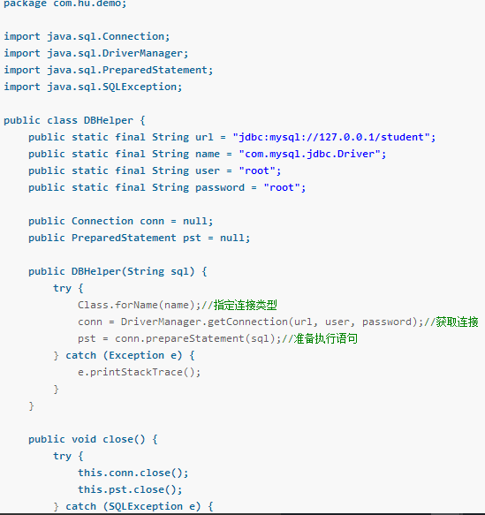

2.3.2查询：
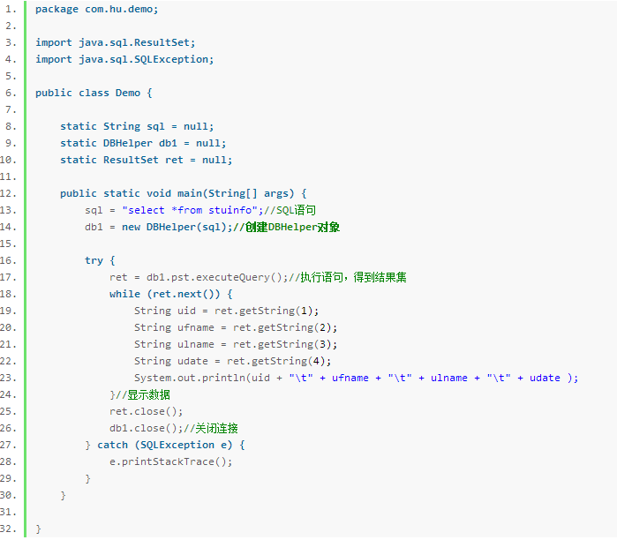

2.3.4从数据库导出：
import Java.sql.Connection;
import java.sql.DriverManager;
import java.sql.ResultSet;
import java.sql.Statement;
import java.io.BufferedReader;
import java.io.File;
import java.io.FileOutputStream;
import java.io.FileReader;
import java.io.IOException;
import java.io.OutputStreamWriter;
import java.sql.Connection;
import java.sql.DriverManager;
import java.sql.PreparedStatement;
import java.sql.ResultSet;
import java.sql.SQLException;
import java.sql.Statement;
public class TestDB {
public static void main(String[] args) {
//Test(); // 生成测试数据
//Exp();
Exp(0);
//System.out.println(readText("/opt/id.txt"));
}
/**
* 导出数据
*/
public static void Exp() {
Connection Conn=null;
try {
Class.forName("com.MySQL.jdbc.Driver").newInstance();
String jdbcUrl = "jdbc:mysql://127.0.0.1:3306/test?characterEncoding=GBK";
//String jdbcUsername = "root";
//String jdbcPassword = "mysql";
Conn = DriverManager.getConnection(jdbcUrl, "root", "mysql");
System.out.println("conn"+Conn);
Exp(Conn);
} catch (SQLException e) {
e.printStackTrace();
}
catch (InstantiationException e) {
// TODO Auto-generated catch block
e.printStackTrace();
} catch (IllegalAccessException e) {
// TODO Auto-generated catch block
e.printStackTrace();
} catch (ClassNotFoundException e) {
// TODO Auto-generated catch block
e.printStackTrace();
}
finally
{
try {
Conn.close();
} catch (SQLException e) {
// TODO Auto-generated catch block
e.printStackTrace();
}
}
}
public static void Exp(int startid) {
Connection Conn=null;
try {
Class.forName("com.mysql.jdbc.Driver").newInstance();
String jdbcUrl = "jdbc:mysql://127.0.0.1:3306/test?characterEncoding=GBK";
String jdbcUsername = "root";
String jdbcPassword = "mysql";
Conn = DriverManager.getConnection(jdbcUrl, jdbcUsername, jdbcPassword);
System.out.println("conn"+Conn);
Exp(Conn,startid);
} catch (SQLException e) {
e.printStackTrace();
}
catch (InstantiationException e) {
// TODO Auto-generated catch block
e.printStackTrace();
} catch (IllegalAccessException e) {
// TODO Auto-generated catch block
e.printStackTrace();
} catch (ClassNotFoundException e) {
// TODO Auto-generated catch block
e.printStackTrace();
}
finally
{
try {
Conn.close();
} catch (SQLException e) {
// TODO Auto-generated catch block
e.printStackTrace();
}
}
}
/**
* 导出从startid开始的数据
* @param conn
* @param start_id
*/
public static void Exp(Connection conn,int start_id) {
int counter = 0;
int startid=start_id;
boolean flag = true;
while (flag) {
flag = false;
String Sql = "SELECT * FROM t_test WHERE id>"
+ startid + " order by id asc LIMIT 50";
System.out.println("sql===" + Sql);
try {
Statement stmt = conn.createStatement();
ResultSet rs = stmt.executeQuery(Sql);
while (rs.next()) {
flag = true;
int id = rs.getInt("id");
String title = rs.getString("title");
startid = id ;
counter++;
writeContent(counter+"--id--"+id+"--title-"+title+"\r\n", "D:\\","log.txt",true);
System.out.println("i="+counter+"--id--"+id+"--title-"+title);
}
rs.close();
stmt.close();
} catch (SQLException e) {
e.printStackTrace();
}
}
writeContent(""+startid, "D:\\","id.txt",false);
}
/**
* 导出一小时内的数据
* @param conn
*/
public static void Exp(Connection conn) {
int counter = 0;
//一小时内的数据
Long timestamp = System.currentTimeMillis() - (600 * 60 * 1000);
boolean flag = true;
while (flag) {
flag = false;
String Sql = "SELECT * FROM t_test WHERE createTime>"
+ timestamp + " LIMIT 50";
System.out.println("sql===" + Sql);
try {
Statement stmt = conn.createStatement();
ResultSet rs = stmt.executeQuery(Sql);
while (rs.next()) {
flag = true;
int id = rs.getInt("id");
String title = rs.getString("title");
Long lastmodifytime = rs.getLong("createTime");
timestamp = lastmodifytime;
counter++;
System.out.println("i="+counter+"--id--"+id+"--title-"+title);
}
rs.close();
stmt.close();
} catch (SQLException e) {
e.printStackTrace();
}
}
}
public static void Test() {
Connection Conn=null;
try {
Class.forName("com.mysql.jdbc.Driver").newInstance();
String jdbcUrl = "jdbc:mysql://127.0.0.1:3306/test?characterEncoding=GBK";
String jdbcUsername = "root";
String jdbcPassword = "mysql";
Conn = DriverManager.getConnection(jdbcUrl, jdbcUsername, jdbcPassword);
System.out.println("conn"+Conn);
for(int i=1;i<=10000;i++)
{
add(Conn,"testTitle"+i+"-"+System.currentTimeMillis());
}
} catch (SQLException e) {
e.printStackTrace();
}
catch (InstantiationException e) {
// TODO Auto-generated catch block
e.printStackTrace();
} catch (IllegalAccessException e) {
// TODO Auto-generated catch block
e.printStackTrace();
} catch (ClassNotFoundException e) {
// TODO Auto-generated catch block
e.printStackTrace();
}
finally
{
try {
Conn.close();
} catch (SQLException e) {
// TODO Auto-generated catch block
e.printStackTrace();
}
}
}
public static void add(Connection conn,String title)
{
PreparedStatement pstmt = null;
String insert_sql = "insert into t_test(title,createTime) values (?,?)";
System.out.println("sql="+insert_sql);
try {
pstmt = conn.prepareStatement(insert_sql);
pstmt.setString(1,title);
pstmt.setLong(2,System.currentTimeMillis());
int ret = pstmt.executeUpdate();
} catch (SQLException e) {
// TODO Auto-generated catch block
e.printStackTrace();
}
finally{
try {
pstmt.close();
} catch (SQLException e) {
// TODO Auto-generated catch block
e.printStackTrace();
}
}
}
/**
* 写入内容到文件
*
* @param number
* @param filename
* @return
*/
public static boolean writeContent(String c, String dirname,String filename,boolean isAppend) {
File f=new File(dirname);
if (!f.exists())
{
f.mkdirs();
}
try {
FileOutputStream fos = new FileOutputStream( dirname+File.separator+filename,isAppend);
OutputStreamWriter writer = new OutputStreamWriter(fos);
writer.write(c);
writer.close();
fos.close();
} catch (IOException e) {
e.printStackTrace();
return false;
}
return true;
}
/**
* 从文件读取内容
*
* @param filename
* @return
*/
public static String readText(String filename) {
String content = "";
try {
File file = new File(filename);
if (file.exists()) {
FileReader fr = new FileReader(file);
BufferedReader br = new BufferedReader(fr);
String str = "";
String newline = "";
while ((str = br.readLine()) != null) {
content += newline + str;
newline = "\n";
}
br.close();
fr.close();
}
} catch (IOException e) {
e.printStackTrace();
}
return content;
}
}

测试
2.4.1主界面：
：
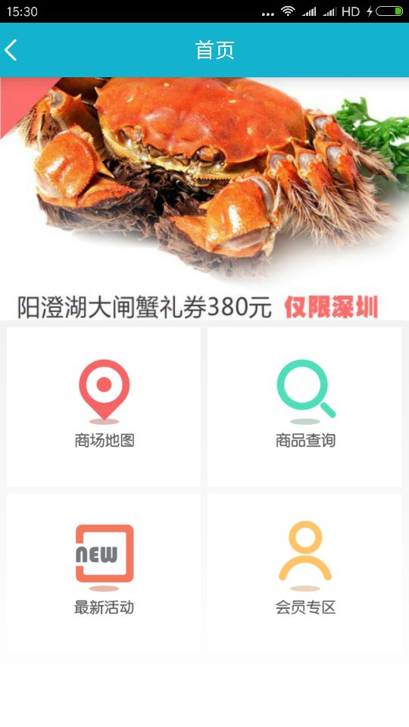
2.4.2商场地图：
：
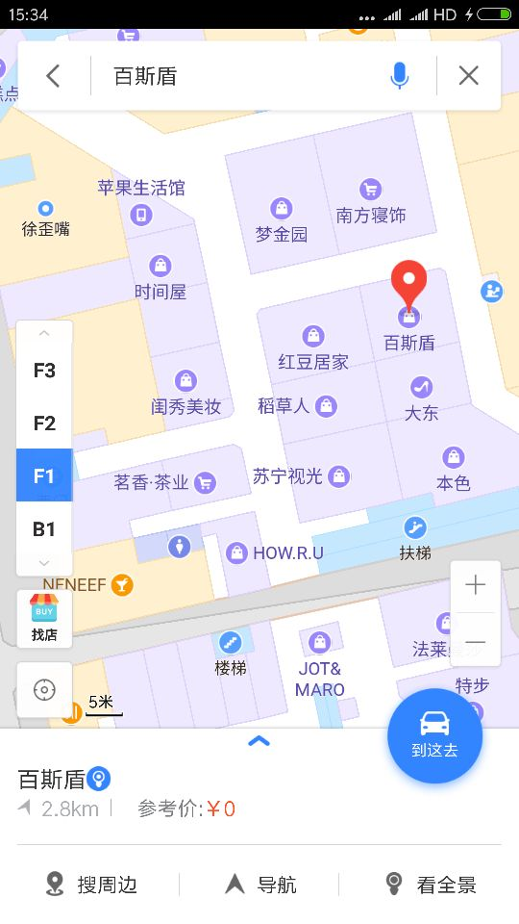
2.4.3商品查询：
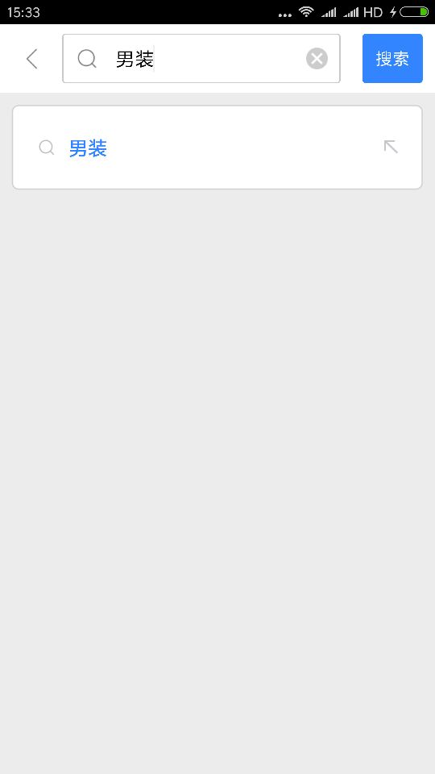

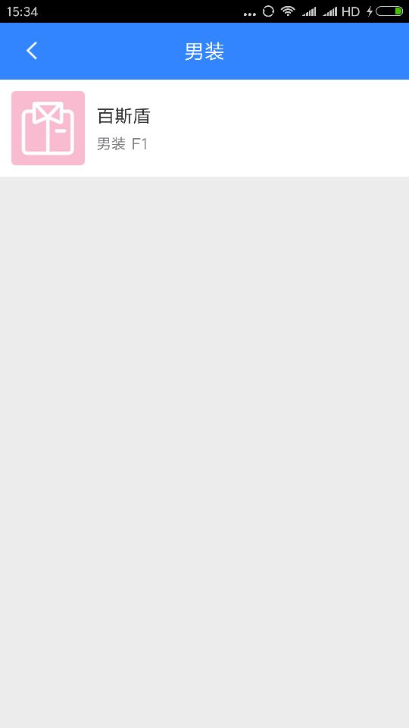
2.4.4详细信息：

- 总结

工作总结
- 本项目主要完成工作：各个基本功能的实现，包括显示商场地图、通过店铺名称进行导航、通过商品查询进行导航、连接数据库展示店铺信息等。
- 计划工作：
成员 | 内容 | 占比
彭涵钧 | 架构设计、核心算法开发 | 25%
顾家名 | 数据库以及服务器的搭建与维护 | 25%
程东耀 | 地图API开发与系统测试 | 25%
李雨科 | Android端开发 | 25%

实际工作：
成员 | 内容 | 占比
彭涵钧 | 架构设计、核心算法开发 | 20%
顾家名 | 数据库以及服务器的搭建与维护 | 20%
程东耀 | 地图API开发 | 20%
李雨科 | Android端开发 | 20%
杨静波 | 系统测试及文档编写 | 20%

问题及下一步的工作
总的来说,这次数据库项目是成功的.但是其中还有很多的不足.需要在以后的学习中逐步完善
- 在知识上的缺乏，使得系统功能还存在不完善；
- 数据库不完整，使得数据不够充足；
- 在软件开发方面经验的不足，导致需求分析做的不是太好。

参考文献
[1] 蔡毅 邓格琳， PowerBuilder9.0基础开发篇， 清华大学出版社， 2003.11
[2] 黄浩 赵宏杰， PowerBuilder9.0精彩编程百例， 中国水利水电出版社，2004.4
[3] 郭宝利 康海涛 李冬冬， PowerBuilder9.0实用解析， 电子工业出版社， 2004.3
[4] 张涛, PowerBuilder9.0 Web开发篇， 清华大学出版社， 2003.11
[5] 朱爱民 柯建勋， PowerBuilder9.0与系统开发， 清华大学出版社， 2003.11
[6] 张遂芹， PowerBuilder9.0系统开发实例， 中国水利水电出版社， 2003.9
[7] 何军， Power Script语言、时间、函数， 电子工业出版社， 2004.5
[8] 孟祥双 李宏力， PowerBuilder程序设计教程， 中国电力出版社， 2004.2
[9] 杨昭， PowerBuilder9.0基础与应用教程， 中国水利水电出版社， 2003.8
[10] 蔡毅 杨鸿雁 刘雪洁， PowerBuilder9.0案例开发篇， 清华大学出版社， 2004.9
[11] 周钢 赵永军 方小伟， PowerBuilder项目开发实践， 中国铁道出版社， 2003.8
[12] 张涛 邵亮， PowerBuilder9.0进阶开发篇， 清华大学出版社， 2003.11
[13] 鲁焱 彭木根等， PowerBuilder9.0程序设计一周通， 中国铁道出版社， 2005.4
[14] 马景涛 张军， PowerBuilder9.0使用培训教程， 清华大学出版社， 2005.3
[15] 顾泽月 吴楠 向宁， PowerBuilder9.0基础教程， 机械工业出版社， 2004.9

