* STEPS TO EXECUTE:
  + Please start two services (SOAP & REST) first by right clicking the Service.svc and Service1.svc and select “View in Browser”
  + Then enter the height and weight and click either “Call SOAP API” or “Call REST API”
* SAMPLE RESULTS:
  + Height = 75 and Weight = 175  
    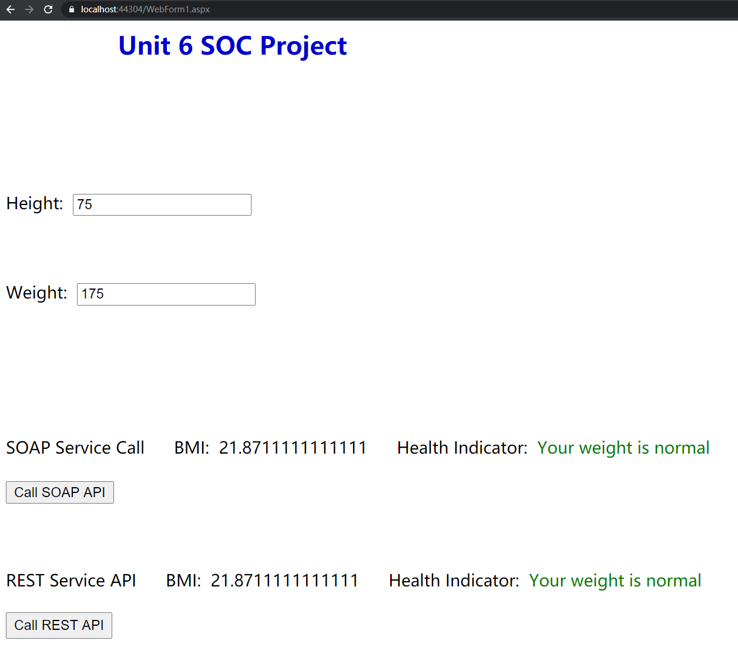
  + Height = 75 and Weight = 250  
    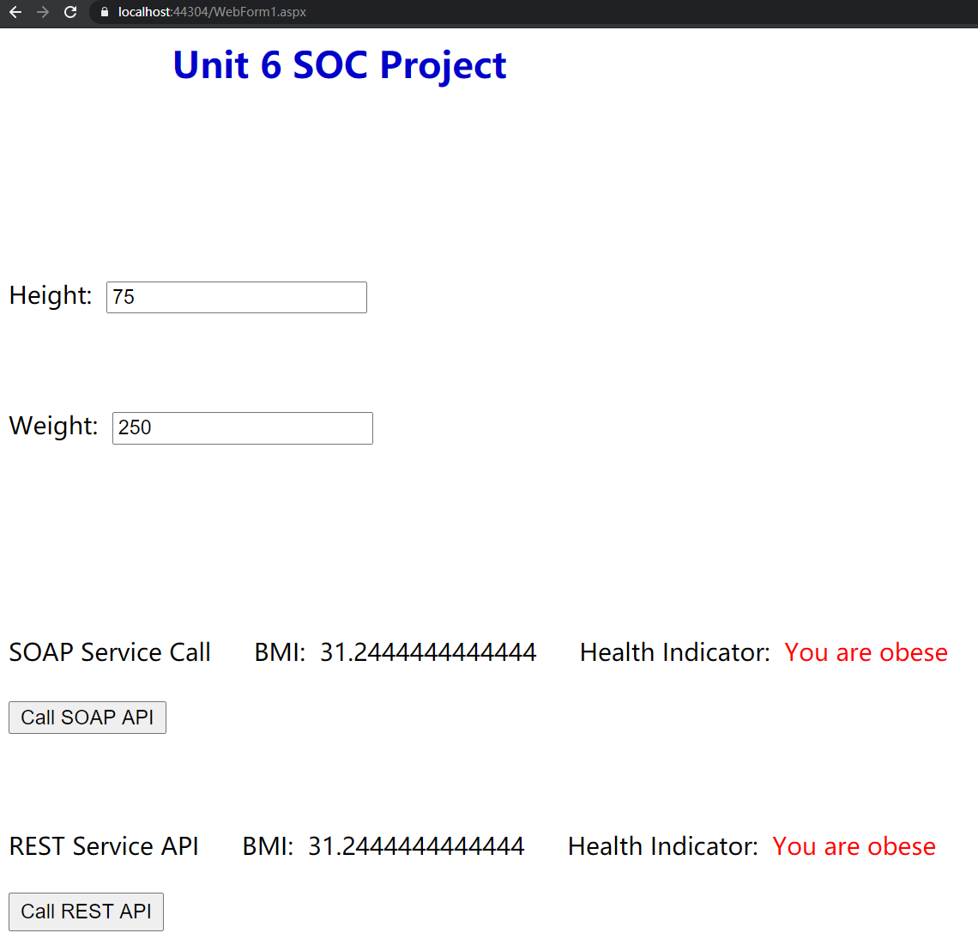
  + Error handling:  
    