|  |  |  |
| --- | --- | --- |
| **Tools Project Design Document** | |  | | --- | | *02/17/2021*  Zixiao Wang | 2022599 | |

|  |  |  |  |
| --- | --- | --- | --- |
| **Project Concept** | | | |
| **1** **Intro** |  | You create or edit a   |  | | --- | | Inventory Management System | | in this   |  |  | | --- | --- | | Visual Studio 2019 | tool | |
|  | where   |  | | --- | | User/admin user | | can add   |  | | --- | | Search, add, edit and remove products and customers | |

|  |  |  |  |  |  |  |
| --- | --- | --- | --- | --- | --- | --- |
| **2** **Who is it for?** |  | The tool is created for   |  |  | | --- | --- | | Company | to | | create/edit   |  | | --- | | A inventory management system | |
|  | and the goal of the tool is to   |  | | --- | | Manage the inventory of product | | |

|  |  |  |  |  |  |
| --- | --- | --- | --- | --- | --- |
| **3** **What game engine is it used for?** |  | The output can be used in   |  | | --- | | *JSON and txt* | | and is used for   |  | | --- | | *Output the database of product and customer* | |
|  | [*optional*] There will also be   |  | | --- | | *none* | | |

|  |  |  |  |  |  |
| --- | --- | --- | --- | --- | --- |
| **4** **File format**  **Technical Stack** |  | The tool export the data as,   |  | | --- | | JSON or SQLite | | and will be consumed with   |  | | --- | | Product, User, and Customer information will be stored | |
|  | There will also be   |  | | --- | | *none* | | |

|  |  |  |  |  |  |  |  |
| --- | --- | --- | --- | --- | --- | --- | --- |
| **5** **User**  **Interface** |  | The tool has   |  | | --- | | Graphical interface | | that will   |  | | --- | | increase | | to modify   |  | | --- | | vivid | |
|  | When we export in the tool   |  |  | | --- | --- | | JSON | will be generated | | | and we can use it for   |  | | --- | | Store products, users, customers, and orders information | |

|  |  |  |  |  |
| --- | --- | --- | --- | --- |
| **6** **Other Features** |  | |  | | --- | | Authentication required. Only admin user can edit, remove, and add the information | | *Others can only browser and search data from database* | |

|  |  |  |  |  |
| --- | --- | --- | --- | --- |
| **7** **How much will you charge for it?** |  | |  | | --- | | Free | |  | |

# **Project Timeline**

|  |  |  |
| --- | --- | --- |
| **Milestone** | **Description** | **Due** |
| **#1** | |  | | --- | | * *Inventory Management System DLL* | | |  | | --- | | *02/24* | |
| **#2** | |  | | --- | | * *WPF pages for customers* | | |  | | --- | | *03/01* | |
| **#3** | |  | | --- | | * *WPF pages for products and category* | | |  | | --- | | *03/06* | |
| **#4** | |  | | --- | | * *Authentication. Create admin and normal user* | | |  | | --- | | *03/11* | |
| **#5** | |  | | --- | | * *Connect with SQLite and revise* | | |  | | --- | | *03/15* | |
| **Backlog** | |  | | --- | |  | | |  | | --- | |  | |

# **Project Sketch**

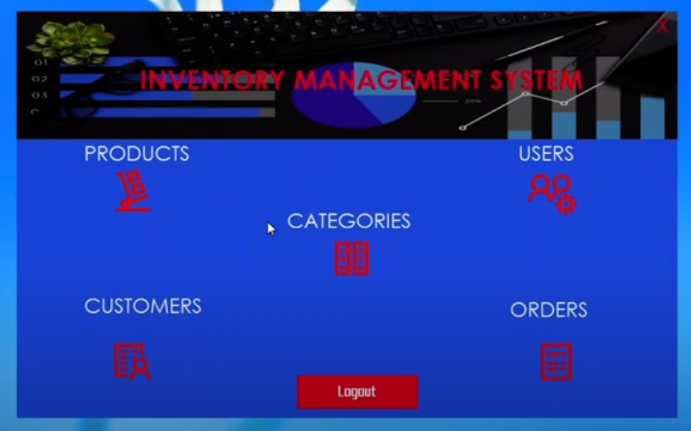

# **How to use / Instructions**

Describe how to create / open the authoring file to exporting it out as the end result

Add, edit, and remove a category

Search all products by name or category

Add, edit, and remove a product

Show all users and customers

Expert database as json or text file

Technology

Json serialization, global variables for windows, library, page navigation, database, authentication