Autonomous Connectivity Resilience Exchange
Hackathon MVP Blueprint, Architecture & 3-Person Work Plan
Speed-first • Reliability-first • A2A + Gonka + Sui
Hackathon goal
Prove that the product can detect a connectivity shortfall, protect critical traffic, autonomously select a viable recovery provider, activate a pre-connected backup path, and complete a trusted Sui-backed service agreement — with measurable recovery time and fallback behavior.

Core flow: Detect → Protect → Find → Activate → Verify → Settle

1. Product Definition
The product is a connectivity resilience layer that sits above an organisation’s existing WAN, Wi-Fi/LAN and provider contracts. It is not a replacement for ordinary failover or Wi-Fi management.
Where our value starts
Traditional failover has already happened — but the remaining network is unavailable, degraded, or insufficient for current demand. The system then acquires and activates additional capacity from pre-connected and pre-onboarded providers.

1.1 Target Customers
Segment | Customer | MVP Offer | Priority Logic
Individual | Normal user | Basic recovery queue; standard provider search; lower burst ceiling | Commercial priority P3
Individual | VIP | Faster queue; wider provider search; higher spending/burst ceiling | Commercial priority P2
Individual | VVIP | Highest commercial queue; fastest eligible provider; highest configured ceiling | Commercial priority P1
Business | SME / MNC | API/SDK integration; critical-service policies; multi-provider recovery | Business policy + service criticality
Event / Venue | Stadium / Expo / Concert | Venue gateway integration; traffic protection; surge/failure recovery | P0 emergency override + event policy
Public / Disaster | Emergency command / disaster response | Pre-authorised emergency recovery and multi-path connectivity | P0 safety override
Important priority rule
Paid plans never outrank life-safety or emergency traffic. A P0 emergency override sits above VVIP/VIP/Normal. Commercial plans only affect non-emergency queueing, search breadth, spending limits and service treatment.

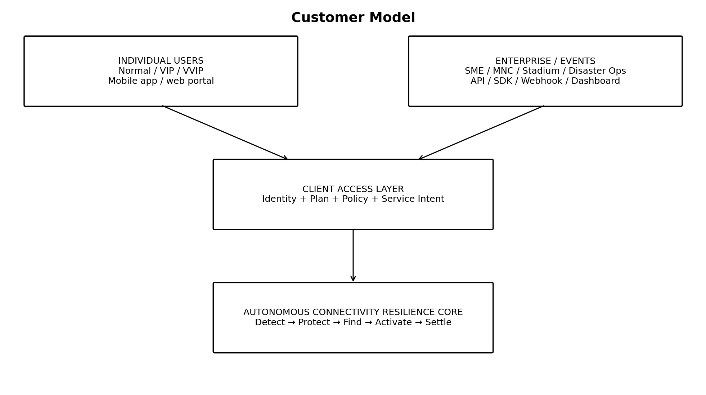

2. Client Interfaces
The MVP should expose two customer-facing entry paths while sharing the same recovery core.
Interface | Who Uses It | MVP Functions
Individual Web/Mobile UI | Normal / VIP / VVIP | Choose plan; register device/service; submit recovery intent; view queue/status, selected provider and recovery timer. Actual network switching requires a participating carrier/API or a pre-provisioned multi-SIM/eSIM/multi-access path.
Enterprise Dashboard | SME / MNC / venue operator | Configure services, priorities, budgets, providers, readiness and incident status
REST API / Webhook | Enterprise systems | Send service events; submit connectivity intent; receive recovery callbacks
Lightweight SDK / Sample Connector | Hackathon proof | Demonstrate how POS/broadcast/security systems can connect without each becoming an AI agent

2.1 Example Enterprise Intent
Example
POST /recovery/intents → service="broadcast", severity="high", min_capacity_mbps=200, max_latency_ms=80, duration_min=30, max_budget=100. The client describes the outcome it needs; it does not choose the provider itself.
Individual-user feasibility note
For the hackathon, the Individual Normal/VIP/VVIP flow proves priority, provider selection and settlement. A real consumer deployment cannot make any phone jump to any carrier by software alone; it requires operator participation (for example CAMARA/network APIs) or a pre-provisioned multi-SIM/eSIM/multi-access connectivity path. The MVP should simulate this access cleanly rather than claim arbitrary carrier switching.

3. MVP Architecture Blueprint
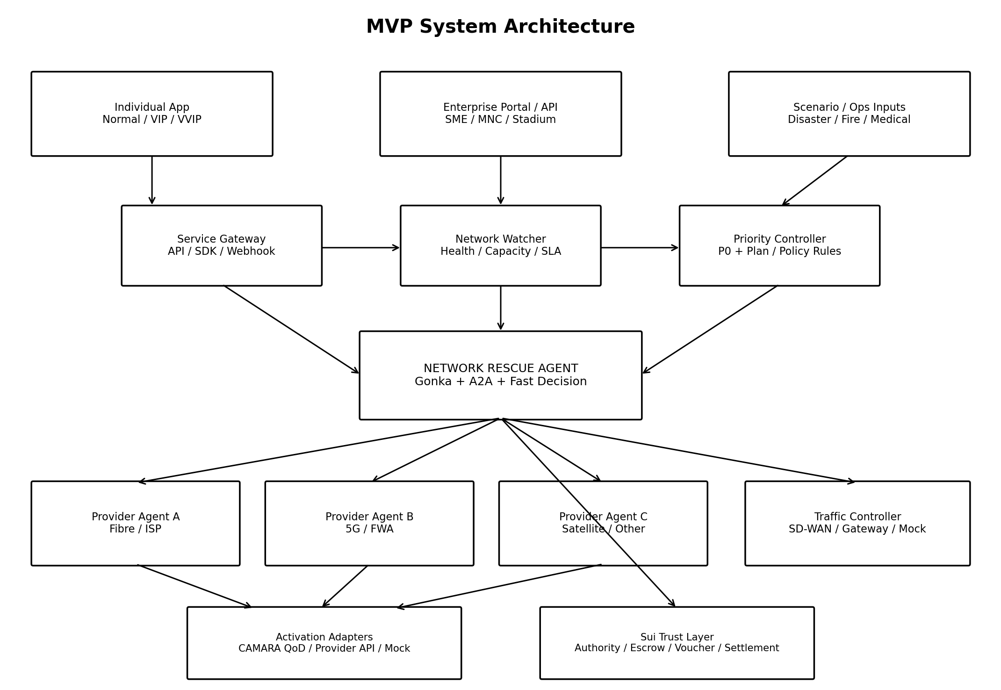

3.1 Component Responsibilities
Component | Responsibility | MVP Implementation
Service Gateway | Receive client events/intents | REST API + webhook + sample enterprise connector
Network Watcher | Detect link failure, degradation, capacity shortfall and SLA breach | Simulated metrics + real local probes where possible
Priority Controller | Apply P0 safety override, enterprise policy and Normal/VIP/VVIP queue rules | Deterministic rule engine
Network Rescue Agent | Core reasoning and orchestration | Gonka + A2A; parallel provider query and selection
Network Provider Agents | Represent providers and expose availability/price/capability | 2–3 independently deployed agents with different policies
Activation Adapter | Make the selected network action happen | CAMARA QoD sandbox/mock plus generic provider adapter
Traffic Controller | Reroute/throttle traffic after recovery selection | SD-WAN/gateway simulation or local routing demo
Sui Trust Layer | Authority, escrow, signed voucher and final settlement | Move contracts + testnet transactions
Telemetry Dashboard | Measure speed and reliability | Live incident timeline, provider state, recovery result

3.2 Where Each Technology Fits
Technology | Why We Use It
Gonka | Choose the best recovery action using availability, activation time, reliability, capacity and cost.
A2A | Provider discovery/communication and structured requests/offers between independently deployed agents.
Sui | Prepare trust before incidents: authority, pre-funded escrow, signed commitment and auditable settlement.
CAMARA QoD | When recovery uses 4G/5G, request network-managed stable latency or prioritised throughput for selected app flows.
SD-WAN / Gateway Adapter | Actually move real traffic to the chosen path; the AI does not route packets by itself.

4. End-to-End Runtime Flow
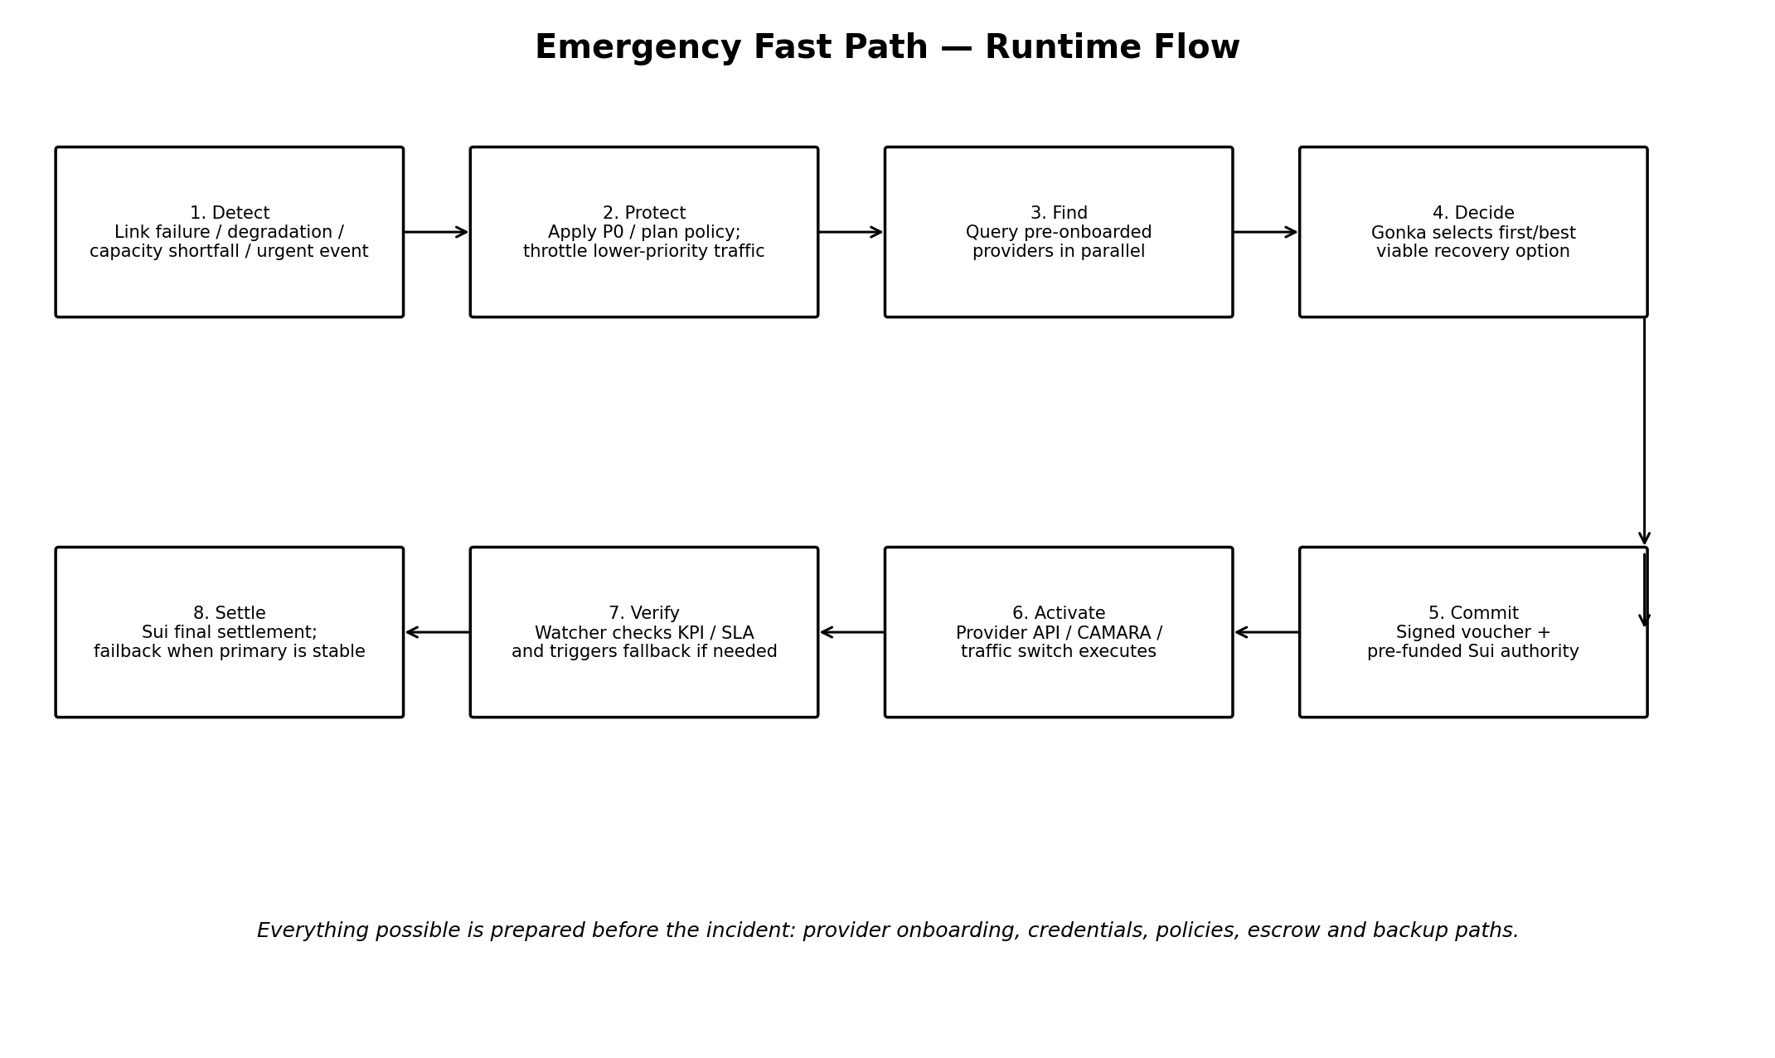

4.1 Before the Incident — Readiness Phase
- Primary and backup paths are physically reachable or emulated.
- Provider agents are onboarded and cached.
- API/OAuth credentials are valid and proactively refreshed.
- Normal/VIP/VVIP and enterprise emergency policies are configured.
- Sui emergency escrow is funded and the Rescue Agent has scoped spending authority.
- Provider health and capability are checked continuously.

4.2 During the Incident — Fast Path
- Network Watcher detects failure/degradation/shortfall or receives an authorised urgent event.
- Priority Controller applies P0 safety rules first, then enterprise/plan priority.
- Traffic Controller immediately protects critical traffic by throttling/deprioritising low-priority traffic.
- Network Rescue Agent queries all ready providers in parallel using structured A2A requests.
- Gonka selects the first/best viable offer based on emergency mode or normal mode.
- Buyer and provider sign a short-lived recovery voucher tied to pre-funded Sui authority.
- Provider activates the path through CAMARA/provider API while the Sui commitment is submitted in parallel.
- Traffic Controller moves selected traffic to the recovered path.
- Network Watcher verifies the KPI. If the path fails validation, the next provider is activated.
- After service, Sui final settlement is completed and traffic fails back only when the primary path is stable.

5. Hackathon Scenarios to Demonstrate
The MVP does not need to physically reproduce every scenario. Build one primary live scenario and use controlled simulations for the others.
Scenario | Trigger | Recommended System Response | Why It Matters
S1 — Backup Capacity Insufficient (PRIMARY DEMO) | Primary link fails; backup works but cannot serve current critical demand. | Protect P0/P1 traffic → query providers → activate extra 5G/FWA/satellite-like capacity → reroute → settle. | Best overall proof because traditional failover succeeds but is still not enough.
S2 — Provider Degradation | Primary path is still up but latency/packet loss violates service requirements. | Early warning → compare alternative path → move critical traffic before full failure. | Shows proactive reliability instead of only reacting to cable cuts.
S3 — Sudden Demand Surge | No line fails; event demand exceeds planned backhaul capacity. | Apply priority queue + throttle guest traffic + activate temporary burst capacity. | Connects directly to Stadium/concert use case.
S4 — Physical Link Failure | Fibre is cut or provider becomes unreachable. | Existing failover first; if backup is insufficient, autonomous capacity acquisition starts. | Easy to understand, but do not claim we repair physical infrastructure.
S5 — Disaster / Emergency | Multiple paths are degraded while medical/rescue traffic suddenly grows. | P0 override → pre-authorised fast path → combine remaining provider capacity → protect emergency services. | Strong social-impact extension; paid VVIP never overrides P0.
S6 — Individual Priority Queue | Many individual recovery requests compete for limited temporary capacity. | P0 override first; then VVIP → VIP → Normal subject to availability, fairness and plan ceilings. | Proves B2C package logic without mixing it with life-safety policy.

5.1 Primary Live Demo Recommendation
Demo S1: Backup Is Not Enough
Start with Primary = 1,000 Mbps and Backup = 500 Mbps. Simulate a primary failure while critical demand is 700 Mbps. The system should protect critical traffic, discover a 300 Mbps provider offer, sign/activate it, rebalance traffic to 800 Mbps total and display the measured Time-to-Recovery.

6. Speed & Reliability Feature Blueprint
Instead of treating every optimization as a separate feature, the MVP should organise them into six engineering categories.
Category | What We Build | Why It Improves Speed / Reliability
A. Provider Readiness | Pre-onboard providers; cache Agent Cards/capabilities; maintain credentials; refresh tokens; health checks; standby terms. | Removes discovery, login, onboarding and commercial setup from the urgent path.
B. Early Detection | Link probes; latency/packet-loss/capacity thresholds; service-health events; warning → prepare → activate states. | Starts recovery before complete failure when possible.
C. Fast Decision | Parallel A2A requests; structured offer schema; emergency decision mode; first-viable selection; strict timeout/fail-fast. | Avoids long LLM conversations and sequential provider waits.
D. Fast Activation | Pre-connected backup paths; warm API sessions where practical; traffic-controller adapter; idempotent activation request. | Shortens provider selection → real packet recovery.
E. Non-Blocking Trust | Pre-funded Sui escrow; scoped authority; off-chain co-signed recovery voucher; Sui submission/settlement in parallel. | Provider can act immediately without waiting for a new manual payment flow.
F. Reliability Guardrails | Provider health score; fallback order; retry to next provider; local deterministic fallback; result verification; safe failback. | The system remains useful if Gonka/cloud/provider A is unavailable.

6.1 Measurable MVP KPIs
KPI | How to Measure in Demo | Success Definition
Time-to-Detect | Incident timestamp → Watcher event | Measured, not assumed
Time-to-Decision | Watcher event → provider selected | Compare parallel vs sequential path
Time-to-Activation | Provider selected → activation acknowledgement | Show provider-specific value
End-to-End Time-to-Recovery | Incident → critical service restored | Primary headline metric
Recovery Success Rate | Successful recoveries / test runs | Run repeated scripted tests
Failover Success | Provider A unavailable → provider B successfully used | Must work without manual intervention
Duplicate-Safety | Repeated request does not create duplicate service/payment | Use incident ID + idempotency key + nonce
Do not make an unsupported speed guarantee
The hackathon should claim automation and measured prototype latency, not promise a universal fixed recovery time. External provider APIs and real network provisioning remain outside full control.

7. MVP Scope — What We Must Build

7.1 Must-Have
- Individual portal with Normal / VIP / VVIP plan selection and queue simulation.
- Enterprise dashboard/API for service intents, priority policies, provider readiness and incident state.
- Service Gateway with at least one sample enterprise connector.
- Network Watcher with scripted failure/degradation/capacity-shortfall generator.
- Priority Controller with P0 override + commercial plans + enterprise rules.
- One Network Rescue Agent using Gonka.
- At least two independently deployed Network Provider Agents; three preferred.
- Structured A2A request/offer flow with parallel provider calls.
- Provider activation adapter (CAMARA-like QoD path + generic mock path).
- Traffic Controller simulation showing which traffic moves/throttles.
- Sui testnet: authority object, escrow/funds, signed recovery commitment and final settlement.
- Live Time-to-Recovery dashboard and repeatable scenario scripts.

7.2 Nice-to-Have
- Real CAMARA sandbox call if accessible during the hackathon.
- Third-party A2A agent for a supporting capability.
- Connectivity early-warning subscription.
- Provider reputation from completed recoveries.
- Predictive pre-arm mode before a likely surge.
- Programmable tunnel/state-channel style optimisation as a future design, not a blocker.

7.3 Explicitly Out of Scope
- Building or repairing physical fibre infrastructure.
- Replacing commercial SD-WAN products.
- Guaranteeing arbitrary instant fibre from a provider with no pre-connected path.
- Building production-grade telecom OSS/BSS integration.
- Serving tens of thousands of real stadium users.
- Letting paid VVIP users override medical/fire/public-safety priority.

8. Three-Person Task Distribution
The division below is designed so each member owns one independently demonstrable workstream, while all three converge on one end-to-end demo.
Member | Primary Workstream | Owned Deliverables | Integration Contract
Person 1 — Client & Edge | Customer interfaces + detection + policy | Individual portal; Enterprise dashboard/API; Service Gateway; incident simulator; Network Watcher; Priority Controller; Normal/VIP/VVIP/P0 logic; traffic visualisation. | Outputs a standard Incident/Intent JSON to Person 2; consumes recovery status/events.
Person 2 — Agent & Provider Market | Gonka + A2A recovery orchestration | Network Rescue Agent; 2–3 Provider Agents; Agent Card/capability cache; parallel query; offer schema; normal vs emergency selection; provider health/fail-fast; provider activation adapter interface. | Consumes Incident/Intent from Person 1; returns signed selected offer to Person 3 and activation command/result to Person 1.
Person 3 — Sui & Reliability Execution | Trust/settlement + activation safety + measurement | Sui Move objects; scoped authority; pre-funded escrow; signed voucher verification; settlement; idempotency/nonce; recovery event ledger; fallback test harness; Time-to-Recovery instrumentation and final demo integration. | Consumes selected offer from Person 2; returns commitment/settlement status; publishes timing/reliability events to dashboard.

8.1 Balanced Milestones
Milestone | Person 1 | Person 2 | Person 3
M1 — Contract First | Define Incident/Intent + UI wireframe | Define A2A Request/Offer + provider schemas | Define Sui Agreement/Voucher + event/timing schema
M2 — Independent Prototype | UI + Watcher + policy works with hardcoded provider result | A2A provider selection works from CLI/API | Sui escrow/authority/settlement works on testnet
M3 — First Integration | Emit real incident to Agent layer | Use incident to query providers and select | Receive selected offer and create commitment
M4 — Recovery Loop | Show traffic throttle/recovery state | Trigger provider activation adapter | Record timing + verify/settle/fallback
M5 — Demo Hardening | Scenario buttons + clean dashboard | Timeouts, parallelism, provider failure tests | Idempotency, retry, repeated-run reliability report

8.2 Shared Responsibilities
- All three agree on API/event schemas before coding deeply.
- Every component must run as a separate service/process where A2A independence matters.
- Each person provides a one-command startup or container for their workstream.
- All three own one scripted failure test so no module becomes a black box.
- Final demo should be rehearsed with provider A failure and provider B fallback.

9. Minimal Integration Contracts
Incident / Intent
incident_id, customer_id, customer_type, plan, service, trigger_type, priority, required_capacity, max_latency, duration, max_budget, emergency_override

Provider Request
incident_id, requested_capacity, required_profile, duration, deadline, max_budget, pre_authorized=true

Provider Offer
provider_id, available, capacity, expected_activation_class, price, reliability_score, offer_expiry, signature

Recovery Result
incident_id, selected_provider, activation_status, recovered_capacity, verification_status, t_detect, t_decide, t_activate, t_recover

Sui Voucher
incident_id, buyer, provider, amount, authority_object, escrow_object, nonce, expiry, buyer_signature, provider_signature

10. Final Hackathon Demo Script
- Show Individual and Enterprise entry points. Individual has Normal/VIP/VVIP; Enterprise has configured critical services and providers.
- Open Readiness panel: provider A/B/C healthy, credentials ready, Sui escrow funded, policies loaded.
- Start Stadium S1 scenario: primary link fails and backup has only 500 Mbps while critical demand is 700 Mbps.
- Watcher detects shortfall and Priority Controller throttles Guest/AR before any purchase.
- Rescue Agent sends parallel A2A requests. Provider A fails/unavailable; Provider B offers 300 Mbps; Provider C is slower or expensive.
- Gonka selects Provider B. UI shows why: available now, enough capacity, acceptable reliability and price.
- Display signed recovery voucher and Sui authority/escrow state.
- Activation adapter returns AVAILABLE; Traffic Controller shows critical services moved/protected.
- Dashboard stops the Time-to-Recovery timer and verifies service KPIs.
- Complete Sui settlement and show provider payment.
- Run second test with Provider B forced down to prove automatic fallback to Provider C.
What the judges should remember
This is not 'AI that picks Wi-Fi'. It is a speed-first resilience exchange: trust, credentials, policies and money are prepared before the incident, so during the incident the system only needs to detect, prioritise, select, activate and verify.

11. Key Risks & Recommended Hackathon Solutions
Risk | Why It Matters | Hackathon Solution
Real provider APIs unavailable | Could block the demo | Build provider adapter interface; use CAMARA-compatible mock first; real sandbox is bonus.
Physical path cannot appear instantly | Concept could sound magical | State clearly: instant recovery only uses pre-connected paths; marketplace buys capacity/entitlement, not cables.
Sui blocks emergency activation | Hurts speed story | Pre-fund escrow; co-sign voucher; activation and Sui commitment execute in parallel.
LLM response is slow/unpredictable | Bad for urgent path | Use deterministic P0 policy + structured offers + timeout; Gonka ranks viable options, local fallback remains available.
Paid plan appears unfair in disaster | Trust/reputation issue | P0 emergency override always outranks VVIP/VIP/Normal.
Provider A fails during demo | Could break end-to-end proof | Make provider failure an expected test; automatic provider B/C fallback is a reliability feature.
Duplicate activation/payment | Retries may create double actions | Use incident ID, idempotency key and nonce throughout activation and settlement.

12. MVP Acceptance Criteria
Proof | Pass Condition
Two customer types | Individual + Enterprise/Event can both submit/trigger a recovery intent.
Priority model | P0 override + Normal/VIP/VVIP commercial queue is visible and deterministic.
A2A independence | At least two provider agents run as separate services/endpoints.
Parallel selection | Provider requests are sent concurrently and one failure does not stall the system.
Real action abstraction | Selected provider triggers an activation adapter and traffic-state change.
Sui proof | At least one authority/escrow commitment and one final settlement transaction occur on testnet.
Speed proof | Live Time-to-Recovery is measured in the UI.
Reliability proof | Forced provider failure automatically falls back to another provider.
Repeatability | Primary scenario can be run multiple times without duplicate orders or payments.

13. Technical Notes for the Team
CAMARA Quality on Demand provides a programmable API for requesting stable latency or prioritised throughput for specified application flows using provider-defined QoS profiles. It also defines session creation/status behavior and API onboarding/authentication expectations. For the hackathon, treat CAMARA as a network-capability adapter rather than as the marketplace itself.
Sui is used as the trust and settlement layer, not the routing plane. The MVP should prepare authority and funds before an incident, then use a short-lived signed voucher so activation can proceed without a manual payment flow.

