Weather Service Documentation:

Activity UML :

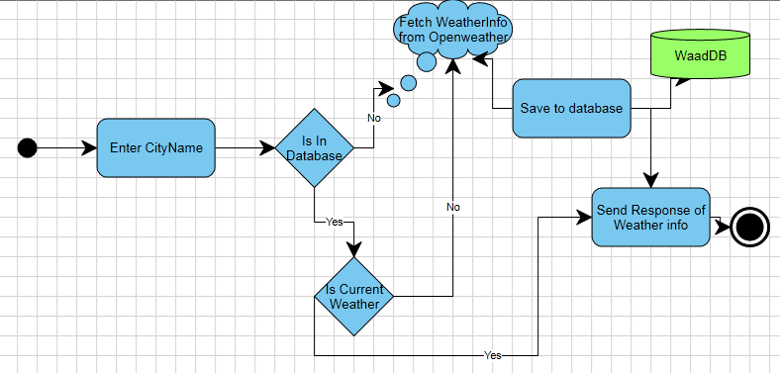

Fig(1): UML Activity

Data Base UML Design:

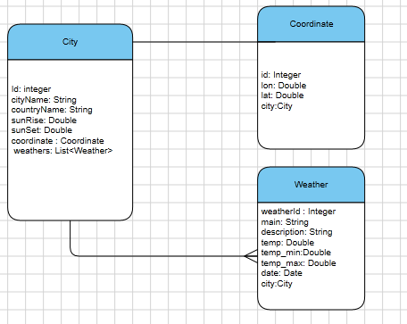

Fig(2): Data Base UML

Class UML:

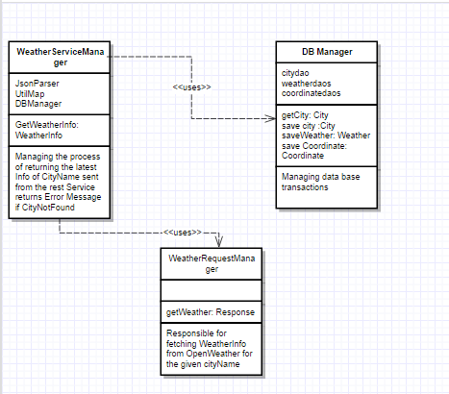

Fig(3): Class UML

Project Documentation :

* WeatherService : getWeatherInfo:

this function is responsible for managing request according to city name

* if city is not found return Error Message and set cod = 404 2.
* if city is asked for the first time retrieve it's info and save it to data base
* if city is already in data base it compare the latest weather info of

this city with the current date if the current is later than the latest

weather saved it retrieves info again from open weather and save it

again, if not it return the already fetched data from data base

* JsonParser: ParseToCity:

this function parse the Json response to City and coordinate and weather

objects to be later saved to data base, retrieve info from the response

and match it to properties in models

It takes json response as parameter this Json response from the openWeather and flag to indicate if this cityName is for the first time being saved to database for coordinate info of lat and lon since this value cannot be changed

Finally it returns City : filled with proper info