Project 1: Digital game distributor

By

Mr. Waris Damkham 6388014

Mr. Thanawath Huayhongthong 6388016

Miss Chalumphu atjarit 6388020

Mr. Naphat Sookjitsumran 6388059

Miss Vipavee Nganyingsurat 6388094

Mr. Thanakij Pinyoboon 6388087

**Submitted to  
Asst. Prof. Dr. Thanwadee Sunetnanta**

**Lect. Dr. Morakot Choetkiertikul**

**Lect. Dr. Chaiyong Ragkhitwetsagul**

A Report Submitted in Partial Fulfillment of

the Requirements for

ITCS371 Introduction to Software Engineering

Faculty of Information and Communication Technology

Mahidol University

2021

**Table of Contents**

**Introduction** 1

**Administrator** 2

**Game creator** 2

**System Requirements** 3

**Functional Requirement** 3

**Non-Functional Requirement** 4

**Work breakdown structure (WBS)** 5

**Identify Actor** 6

**High-Level Use case diagram** 6

**Detail Use case Diagram** 7

**Use case narrative #1** 8

**Use case narrative #2** 9

**Use case narrative #3** 10

**Data Flow lv.0** 11

# **Introduction**

It is a digital game store system. It is an app that houses a wide variety of games. There are many types to choose from within our app. To give game development companies a space to sell games and those who want to buy the games. Our app is easy to use and user-friendly. It provides reliable safety. A digital game store system is an application from a game developer where you can buy, play, create, and discuss PC games. The application hosts thousands of games from third-party game developers or small companies.

The digital game store system has features to solve the main problems mentioned above for users:

1. The application has a game classification or keyword search to make it easy to find without hassle.
2. Each game has a minimum computer specification that can be played. It also has game ratings to help you make a purchase decision.
3. Easy payment by credit card payment.
4. The game will save game data in the cloud. So, users don't need physical storage.
5. The application has a Wishlist system.
6. Users can purchase multiple games at the same time. Because there is a shopping cart system that can put multiple games in the cart and check out at once.
7. Upcoming games are displayed. It is a game that users are interested in and will be launched soon.

For your convenience and the security of our apps. Because users have to fill in user information and credit card information in this section, users can be confident in our security because our app has a strong security system. The app has a beautiful layout to use. The system is stable with 99.9999% availability and supports 10,000 concurrent users. The app is a PC version for Windows only.

## **Administrator**

Administrators can manage and organize game genres and ratings for each game stored in the store platform, allowing users to easily search for games by genre or rating.

## **Game creator**

The game creator has the ability to publish new games on the store platform by uploading the executable to the system. In addition, the game creator must specify all the information about the game, including its specifications and price.

As a corporation, some of the obvious competitors and services attract customers. This includes products that offer similar services. As well as stores and applications that provide and sell the same full range of games, both subscription and payment models that meet the needs of customers very well.

When doing business with competitors, we must differentiate ourselves to attract specific and targeted groups of customers or users for our applications. All apps can trade games normally and have common functions. But our difference is to create a trading system that can be used to buy multiple games at the same time. In addition, the sorting or placing of games by category is not complicated and meets the need to find the type of products that are closest to the user's search results and is easy to use with a UI and UX that is designed for all ages for the most comprehensive response.

# **System Requirements**

## **Functional Requirement**

* Users can rate the game from 1 to 5 stars.
* The upcoming game is visible in the application's first pages.
* Users can purchase several games at once.
* Users can search for a game by keyword.
* Users can read the description of the system requirements of each game.
* Users can sell items to other users, like an item market.
* Users can edit their profile and personal information.
* Users can keep or delete the game on their machine in the same cloud memory.
* Users can set the password by a unique character, uppercase, or more than 8 characters.
* Have a Wishlist in the application, not a shopping cart function, to save future games for purchases. You can use the buttons to increase or decrease the number of games.
* Customer can make a payment by credit card only
* Users can login to the platform according to their role.
* Administrator and game creator can categorize types of game.
* Administrators can add games to sell by receiving from game creators.
* Users can request a refund. Customer concern about security (user information, credit cards must ensure the security of data).

## **Non-Functional Requirement**

* Systems can support 10,000 users at the same time.
* Applications should run only on Windows systems.
* Sell games from third-party game developers or small game development companies.
* The application is always accessible.
* The application should have a nice interface, be proficient at UX and UI design, and be attractive.
* A user account must have a name, address, and credit card information. which means that the user must have a credit card number tied to their user account.
* A system with high performance can click to change pages must not exceed 1 second.
* Digital licenses are available, which means users can buy and play online (no CD or DVD).
* Each game requires a specified computer configuration to be played. Included in the needed information are the game's fee and the minimum and maximum age at which a player may participate, 18 or younger.
* The application supports multiple languages.

# **Work breakdown structure (WBS)**

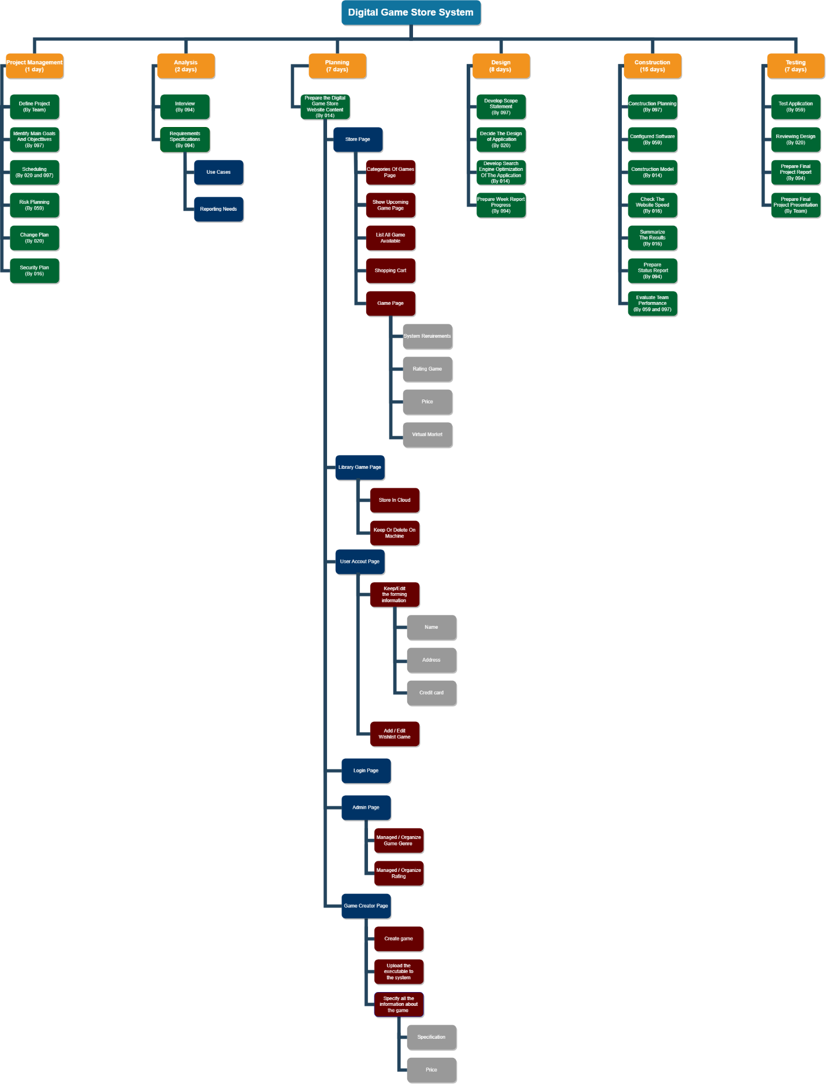

# **Identify Actor**

|  |  |
| --- | --- |
| **Actor** | **Role** |
| Customer | Customers can play the game in the store with their own profile, which they can manage on their own. They can also buy multiple games at once with a credit card, using a keyword search, add the game to wish list, edit their profile and sell item in the game to another player. |
| Administrator | An administrator sets a category to each game and adds game developers’ games so that they can manage games in the store. |
| Game creator | The game designer develops a game and uploads its executable file to the system. Include every information about the game, including its pricing and specifications. |

# **High-Level Use case diagram**

**Detail Use case Diagram**

# **Use case narrative #1**

|  |  |
| --- | --- |
| Use case name | Send game to sell |
| Goal in Context | The game creator uploads the game to sell after sending it to the application. |
| Primary Actor | Game creator |
| Secondary Actor | Admin |
| Precondition | The game has already been created by the game creator. |
| Trigger | When a game creator wants to sell a game, |
| Scenario (Type Flows of Events) | 1. The game creator creates a game. 2. The game creator sends their request to upload their game to the application. 3. Admin approved the game creator's request. 4. The game will be added to the application. |
| Exceptions | Exception 1: A game from the game's creator doesn't pass the criterion of game application. |
| Post-condition | Game creators earn funds from selling a game. |

# **Use case narrative #2**

|  |  |
| --- | --- |
| Use case name | Categorize type of game |
| Goal in Context | Games are categorized for users' convenience to explore. |
| Primary Actor | Game creator |
| Secondary Actor | Admin |
| Precondition | The game has already been created by the game creator and has been approved. |
| Trigger | Admin wants users to convenience to search for a game. |
| Scenario (Type Flows of Events) | 1. The game creator creates a game. 2. The game creator sends their request to upload their game to the application. 3. The admin approved the game creator's request. 4. The game will be added to the application. 5. Game creators inform the type of game. 6. Admins categorize the type of game. |
| Exceptions | Exception 1: A game from the game's creator doesn't pass the criterion of game application.  Exception 2: The game creator doesn’t inform their type of game. |
| Post-condition | Convenience to explore. |

# **Use case narrative #3**

|  |  |
| --- | --- |
| Use case name | Purchase by credit card |
| Goal in Context | The users purchase a game. |
| Primary Actor | User |
| Secondary Actor | - |
| Precondition | The user has already logged in and chosen their preferred game. |
| Trigger | The user has already chosen their preferred game. |
| Scenario (Type Flows of Events) | 1. A user has already logged in 2. A user searches for their preferred game. 3. A user selects their preferred game. 4. A user adds this game to their cart. 5. A user clicks to purchase this game. 6. A user confirms the transition of this game. |
| Exceptions | Exception 1: The user does not have credit to purchase the game.  Exception 2: The game creator doesn’t inform their type of game. |
| Post-condition | The user received their preferred game in the application store. |

# **Data Flow lv.0**

