

WEBTOON

Assignment #1

By

Mr. WARIS DAMKHAM 6388014

A Report Submitted in Partial Fulfillment of

the Requirements for

ITCS361 Management Information Systems

Faculty of Information and Communication Technology

Mahidol University

2021

Table of Contents

**Can You Run the Company with Your iPhone? 3**

**Case Study 4**

**Mazda business profile 6**

**Business structure and their IT Management 6**

**Rules of Mazda Motor Corporation 7**

**Culture of Mazda company 7**

**Executive Position and Hierarchy 8**

**Reference 9**

# **Can You Run the Company with Your iPhone?**

**Main ideas**

Smartphones and tablets have become all-in-one tools that help managers and employees work more efficiently. Mobile devices can access the Internet or serve as a telephone, camera, music or video player, e-mail and messaging machine, and a gateway into corporate systems. Network Rail uses a group of custom apps for its 22,000 iPhone and iPad devices to streamline maintenance operations. British Airways is the largest airline in the United Kingdom, with operations in more than 200 airports worldwide. The airline has created more than 40 custom apps for over 17,000 iPads for its workforce that have transformed the way it does business.

MyWork gives maintenance workers a simple overview of all of the jobs each team needs to complete during a specific shift. Using precise map coordinates, workers can find sites easily and finish jobs more quickly. iLoad Direct and the iPad have helped British Airways achieve an industry-leading benchmark for aircraft turnaround. Turnaround managers are able to monitor the aircraft loading process and share data with pilots and back-of-office staff in real time. Mobile devices are helping rank-and-file employees manage their work lives more effectively.

# **Case Study**

1. **What kinds of applications are described here? What business functions do they support?**

**How do they improve operational efficiency and decision making?**

**Answer:** Numerous applications, such as email, messaging, telephone, Close Call, and MyWork, are classified as case-specific applications. The case study focuses on apps that make it simpler for businesses, employees, and employers to connect with one another. Companies may interact with their colleagues across departments, making it simpler for them to cooperate and enhancing the efficiency of the business as a result. In the case study, for instance, the Close Call app supports staff in reporting risks and issues as soon as they are discovered, allowing for prompt resolution of the issues. The MyWork app assists employees by supplying them with all the information they want to initiate, fix, and complete assignments. Two applications that stated working in their favor, problems are handled swiftly, hence boosting operational efficiency and decision-making.

1. **Identify the problems that the business in this case solved by using mobile digital devices.**

**Answer:** In this case study, British Airways employed iPads and other mobile digital devices to handle issues such as long queues of passengers seeking assistance and language hurdles by utilizing specialized applications built for its workforce. For instance, the Flight React app utilized by the airline aids agents in scanning boarding cards, analyzing clients' bookings, researching other travel possibilities, and rebooking and reticketing passengers, all in a four-minute procedure. This allows agents to swiftly resolve disturbances caused by lengthy passenger queues, thus increasing their efficiency. Moreover, apps like iTranslate facilitate employee and agent communication with passengers who speak a different language. Additionally, British Airways employs proprietary applications called iLoad Direct and iBeacon to streamline aircraft turnover by enabling personnel to connect with one another throughout the process. This simplicity of communication enables the pilot to determine the optimal quantity of fuel and takeoff position. With more than 70 planes at a single terminal and five turning around simultaneously, a staff of around 30 employees is required. Communication is crucial for productivity.

1. **What kinds of businesses are most likely to benefit from equipping their employees with mobile digital devices such as iPhones and iPads?**

**Answer:** The businesses that are most likely to profit from supplying their staff with iPhones and iPads are those that require regular inter-office contact. As described in question 2, British Airways uses iPads to maintain continual contact during the aircraft turnaround procedure. As each agent is positioned in a separate area of the airport, it would be difficult for employees to interact without iPads.

1. **One company deploying iPhones has stated, “The iPhone is not a game changer, it’s an industry changer. It changes the way that you can interact with your customers” and “with your suppliers.” Discuss the implications of this statement.**

**Answer:** Mobile digital devices such as the iPhone have altered the way you communicate with your client base. They have made it easier to do business at any time of day, but they have also reduced the number of face-to-face business encounters that happened before their deployment

# **Mazda business profile**

Mazda Motor Corporation, or simply known as Mazda, was founded on January 30, 1920. Mazda's corporate headquarters were in Hiroshima, Japan. Mazda's main goal in business is to manufacture and sell passenger cars and commercial vehicles, with their main products being four-wheeled vehicles, gasoline reciprocating engines, diesel engines, and vehicle automatic and manual transmissions. Mazda was represented by Akira Marumoto, who is Representative Director, President, and CEO (Chief Executive Officer). He also expanded its sales companies to over 212 branches in Japan and 136 branches overseas.

# **Business structure and their IT Management**

Mazda has set up its business structure and IT management so that external corporate directors can take part in the decision-making process and use their knowledge, experience, and insights to improve and strengthen the auditing functions of the Board of Directors in Mazda's management activities.

Mazda is currently managed by Mazda President and CEO Akira Marumoto, and there are 31 other Mazda management members working under Marumoto. Moreover, the Mazda management department has cooperated with the board and advisors, Kiyotaka Shobuda, the representative director and chairman, and the other six board advisors.

Mazda uses IT and MIS to run its company by innovating new technologies for vehicles in order to gain consumers' confidence, and MIS will comprise both internal and external information relevant to the organization's past and future operations. MIS must also give the right information at the right time so that control planning decisions can be made by management.

**Corporate Governance Framework**

# **Rules of Mazda Motor Corporation**

Mazda has established the Mazda Corporate Ethics Code of Conduct, which states action guidelines for employees, the Finance Control Guidelines for global financial control, and other guidelines. Based on these guidelines, each department develops rules, procedures, manuals, etc. to promote the establishment of internal control.

For group companies, cooperative systems have been established in accordance with the Domestic Affiliates Administration Rules and the Overseas Affiliates Administration Rules. At Mazda, the department responsible for each group company supports training and system improvement at the respective group company.

# **Culture of Mazda company**

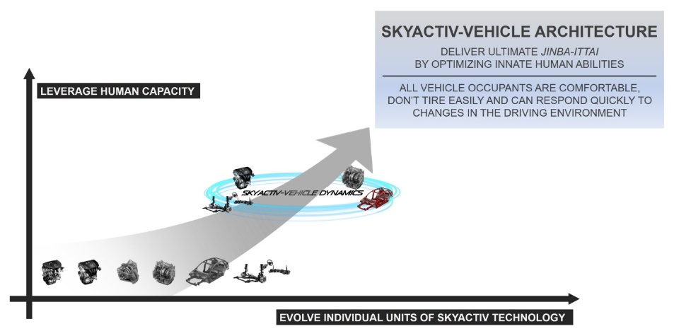Mazda has earned the confidence of consumers and customers seeking a car with user-friendly technology and meticulous attention to detail. Mazda's primary objective is to make the driver and passengers feel secure and comfortable. The human-centered design concept addresses optimal body fit for both seats and internal equipment inside the interior space. And another unique aspect is technology. sky active-technology In addition to a fuel-efficient and fun-to-drive engine, the car's body and driving have also been improved by reinforcing the vehicle's construction. In addition, it is crucial to reduce carbon dioxide emissions from the production line to the final product. In addition, the form and design are contemporary and accessible to all user groups, including the introduction of automobile models in demand in a competitive market in order to develop and give customers value when making selections.

**SKYACTIV-VEHICLE ARCHITECTURE**

**Executive Position and Hierarchy**

A hierarchical structure is an organizational structure that follows a chain of command from the top executives to regular employees. It resembles a pyramid. Mazda employs this management style, with its headquarters in Hiroshima overseen by Akira Marumoto, CEO of Mazda, and subdivided into positions such as senior director of managing and manager, but all positions are controlled by the CEO and president.

# **Reference**

[1] Corporation, Mazda Motor. “MAZDA NEWSROOM｜Organizational and Personnel Changes｜NEWS RELEASES.” *Mazda News Releases*, newsroom.mazda.com, 5 May 2019, <https://newsroom.mazda.com/en/publicity/release/2020/202003/200306a.html>.

[2] Corporation, Mazda Motor. “MAZDA: Technology | Innovation.” *MAZDA: Technology | Innovation*, www.mazda.com, 2021, <https://www.mazda.com/en/innovation/technology>.

[3] Corporation, Mazda Motor. “MAZDA: Company Information | Company Profile.” *MAZDA: Company Information | Company Profile*, www.mazda.com, 25 Feb. 2021, <https://www.mazda.com/en/about/profile/outline/>.

[4] Corporation, Mazda Motor. “MAZDA: Technology | Innovation.” *MAZDA: Technology | Innovation*, www.mazda.com, 2021, <https://www.mazda.com/en/innovation/technology.>

[5] Corporation, Mazda Motor. “MAZDA: SKYACTIV TECHNOLOGY | Technology.” *MAZDA: SKYACTIV TECHNOLOGY | Technology*, www.mazda.com, 2021, [https://www.mazda.com/en/innovation/technology/skyactiv/.](https://www.mazda.com/en/innovation/technology/skyactiv/.%20)

[6] Corporation, Mazda Motor. “MAZDA: SKYACTIV TECHNOLOGY | Technology.” *Mazda Annual Report 2015 | Technology*, www.mazda.com, 2021, <https://www.mazda.com/contentassets/5420a89ac1814782aa825f33023a246c/files_en/ar15_13e.pdf>.