**Lab 3: ARP, DHCP and DNS Protocols**

**Agenda**

* **Part1 Examine ARP**
* **Part2 Configure DHCP server at Router**
* **Part3 Examine DNS**

Part 1: Examine ARP

**Open the file Examine_ARP_Table.pka.**

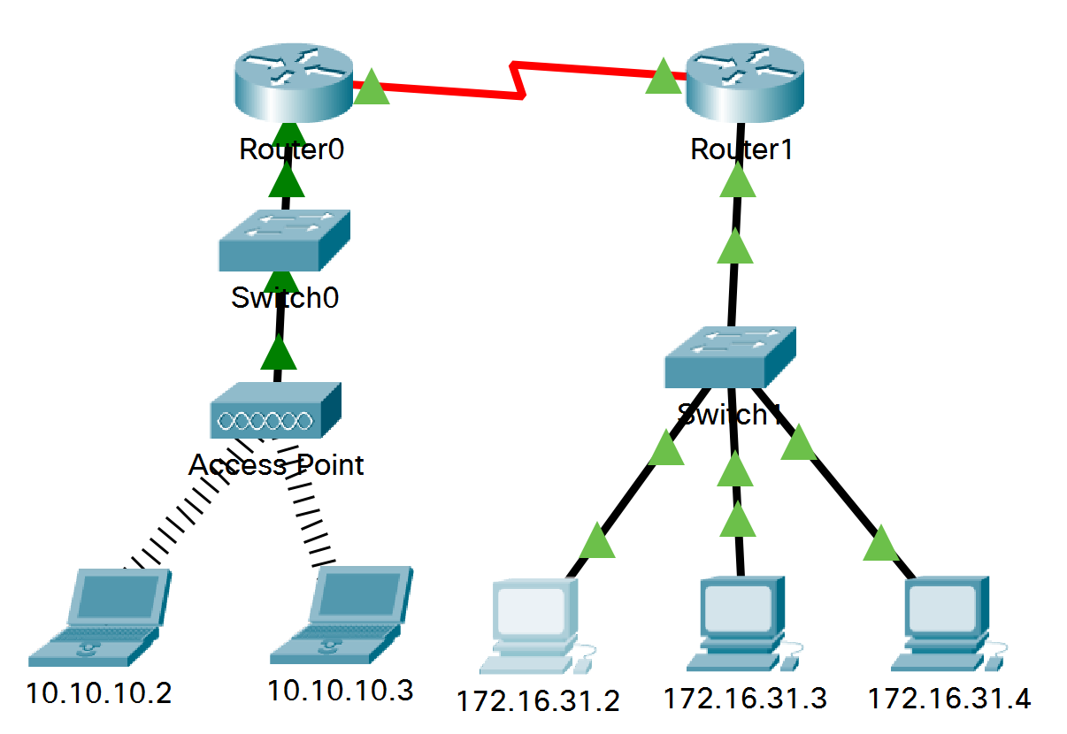

Addressing Table

| **Device** | **Interface** | **MAC Address** | **Switch Interface** |
| --- | --- | --- | --- |
| Router0 | Gg0/0 | 0001.6458.2501 | G0/1 |
| *Router0* | S0/0/0 | N/A | N/A |
| Router1 | G0/0 | 00E0.F7B1.8901 | G0/1 |
| *Router1* | S0/0/0 | N/A | N/A |
| 10.10.10.2 | Wireless | 0060.2F84.4AB6 | F0/2 |
| 10.10.10.3 | Wireless | 0060.4706.572B | F0/2 |
| 172.16.31.2 | F0 | 000C.85CC.1DA7 | F0/1 |
| 172.16.31.3 | F0 | 0060.7036.2849 | F0/2 |
| 172.16.31.4 | G0 | 0002.1640.8D75 | F0/3 |

*Blank Line, No additional information*

**Step 1: Generate ARP requests by pinging 172.16.31.3 from 172.16.31.2.**

*Open a command prompt*

*lose a command prompt*

1. Enter **Simulation** mode and set to filter only ICMP and ARP protocols.
2. Use Inspect tool to open the ARP table at **172.16.31.3** and **172.16.31.2.**
3. Use PDU to **ping 172.16.31.3 from 172.16.31.2**. Two PDUs will be generated.

**1.1 Fill in ARP table of 172.16.31.2, 172.16.31.3 and Router 1**

**ARP table of 172.16.31.2**

|  |
| --- |
|  |

**ARP table of 172.16.31.3**

|  |
| --- |
|  |

**ARP table of Router 1**

|  |
| --- |
|  |

d.     Click **Capture/Forward** once. The ARP PDU moves to **Switch1** while the ICMP PDU disappears, waiting for the ARP reply. Open the PDU and record the destination MAC address.

**1.2 What is the destination MAC address? Is this address listed in the table above?**

|  |
| --- |
| **DEST ADDR: FFFF.FFFF.FFFF** |

e.     Click **Capture/Forward** once to move the PDU to the next device.

Question:

**1.3 How many copies of the PDU did Switch1 make?**

|  |
| --- |
| **3 copies** |

**1.4 What is the IP address of the device that accepted the PDU?**

|  |
| --- |
| **172.16.31.3** |

f.      Open the PDU at the destination device and examine Layer 2.

Question:

**1.5 What happened to the source and destination MAC addresses?**

|  |
| --- |
|  |

g.     Click **Capture/Forward** until the PDU returns to **172.16.31.2**.

Question:

**1.6 How many copies of the PDU did the switch make during the ARP reply?**

|  |
| --- |
| **1 copy** |

### Step 2: Examine the ARP table.

1. Note that the ICMP packet reappears. Open the PDU and examine the MAC addresses.

#### 2.1 What are the source and destination MAC addresses? Do the MAC addresses of the source and destination align with their IP addresses?

|  |
| --- |
| 172.16.31.3 **to 172.16.31.3** |

**2.2 Fill in ARP table of 172.16.31.2, 172.16.31.3 and Router 1**

**ARP table of 172.16.31.2**

|  |
| --- |
|  |

**ARP table of 172.16.31.3**

|  |
| --- |
|  |

**ARP table of Router 1**

|  |
| --- |
|  |

## **Step 3: Examine the ARP Process in Remote Communications. Generate traffic to produce ARP traffic.**

*Open a command prompt*

1. Enter **Simulation** mode and set to filter only ICMP and ARP protocols.
2. Use Inspect tool to open the ARP table at **172.16.31.2, Router 1** and **Router 0.**
3. Use PDU to **ping 10.10.10.2 from 172.16.31.2**.

**3.1 Fill in ARP table of Router 0.**

**ARP table of Router 0**

|  |
| --- |
|  |

**3.2 How many PDUs appear? What protocol(s) do(es) the PDU(s) belong?**

|  |
| --- |
| **2, ICPM and ARP** |

*Close a command prompt*

f.      Click **Capture/Forward** until the packet arrives Router 0.

**3.3 What happens with the packets at the Router 0?**

|  |
| --- |
| **One of the packet drop at Router 0.** |

g.      Click **Capture/Forward** further until the end.

#### Question:

**3.4 Can we ping 10.10.10.2 from 172.16.31.2**. **successfully? Why?**

|  |
| --- |
| **Failed, they not know each other.** |

**3.5 Fill in ARP table of 172.16.31.2, Router 1 and Router 0.**

**ARP table of 172.16.31.2**

|  |
| --- |
|  |

**ARP table of Router 1**

|  |
| --- |
|  |

**ARP table of Router 0**

|  |
| --- |
|  |

h.  ping from the 172.16.31.2 to 10.10.10.2 again in simulation mode.

**3.6 Can we ping 10.10.10.2 from 172.16.31.2**. **successfully? Why?**

|  |
| --- |
| **Success, they 172.16.31.2 and 10.10.10.2 already know another MAC address** |

Part 2: Configure DHCP server at Router

**Open the file Implement_DHCPv4_DNS.pka.**

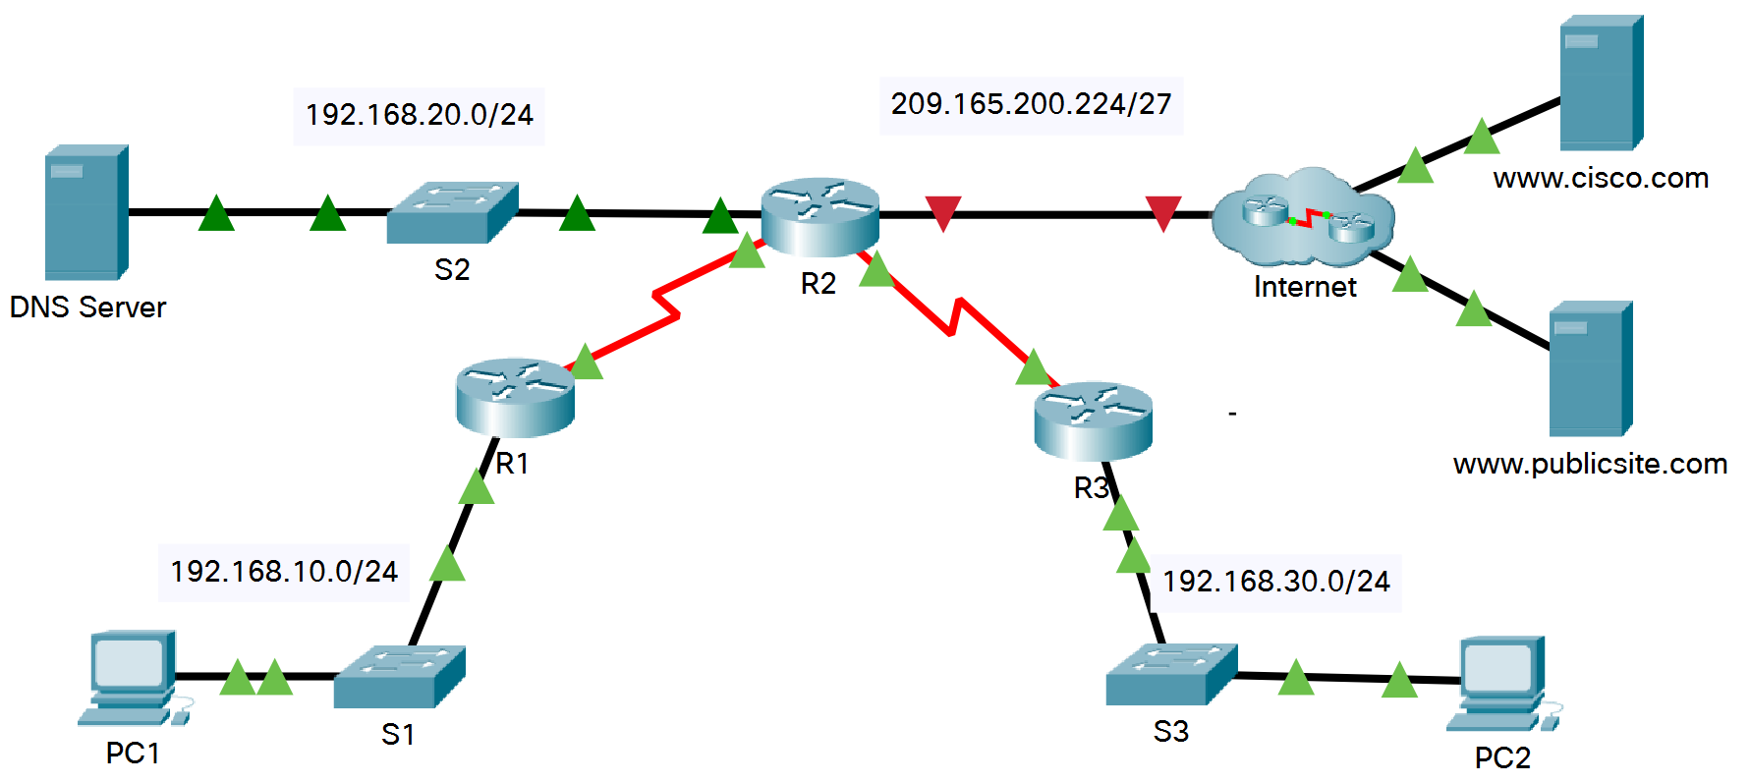

# Addressing Table

|  |  |  |  |  |
| --- | --- | --- | --- | --- |
| **Device** | **Interface** | **IPv4 Address** | **Subnet Mask** | **Default Gateway** |
| R1 | G0/0 | 192.168.10.1 | 255.255.255.0 | N/A |
| *R1* | S0/0/0 | 10.1.1.1 | 255.255.255.252 | N/A |
| R2 | G0/0 | 192.168.20.1 | 255.255.255.0 | N/A |
| *R2* | G0/1 | DHCP Assigned | DHCP Assigned | N/A |
| *R2* | S0/0/0 | 10.1.1.2 | 255.255.255.252 | N/A |
| *R2* | S0/0/1 | 10.2.2.2 | 255.255.255.252 | N/A |
| R3 | G0/0 | 192.168.30.1 | 255.255.255.0 | N/A |
| *R3* | S0/0/1 | 10.2.2.1 | 255.255.255.0 | N/A |
| PC1 | NIC | DHCP Assigned | DHCP Assigned | DHCP Assigned |
| PC2 | NIC | DHCP Assigned | DHCP Assigned | DHCP Assigned |
| DNS Server | NIC | 192.168.20.254 | 255.255.255.0 | 192.168.20.1 |

## **Configure a Router as a DHCP Server**

### Step 1: Configure the excluded IPv4 addresses.

Addresses that have been statically assigned to devices in the networks that will use DHCP must be excluded from the DHCP pools. This avoids errors associated with duplicate IP addresses. In this case the IP addresses of the R1 and R3 LAN interfaces must be excluded from DHCP. In addition, nine other addresses are excluded for static assignment to other devices such servers and device management interfaces.

1. Configure **R2** to exclude the first 10 addresses from the R1 LAN and to exclude the first 10 addresses from R3 LAN.

R2(config)# **ip dhcp excluded-address 192.168.10.1 192.168.10.10**

R2(config)# **ip dhcp excluded-address 192.168.30.1 192.168.30.10**

### Step 2: Create a DHCP pool on R2 for the R1 LAN.

a.     Create a DHCP pool named **R1-LAN** (case-sensitive).

R2(config)# **ip dhcp pool R1-LAN**

b.     Configure the DHCP pool to include the network address, the default gateway, and the IP address of the DNS server.

R2(dhcp-config)# **network 192.168.10.0 255.255.255.0**

R2(dhcp-config)# **default-router 192.168.10.1**

R2(dhcp-config)# **dns-server 192.168.20.254**

### Step 3: Create a DHCP pool on R2 for the R3 LAN.

1. Create a DHCP pool named **R3-LAN** (case-sensitive).

R2(config)# **ip dhcp pool R3-LAN**

1. Configure the DHCP pool to include the network address, the default gateway, and the IP address of the DNS server.

R2(dhcp-config)# **network 192.168.30.0 255.255.255.0**

R2(dhcp-config)# **default-router 192.168.30.1**

R2(dhcp-config)# **dns-server 192.168.20.254**

## **Configure DHCP Relay**

### Step 4: Configure R1 and R3 as a DHCP relay agent.

For DHCP clients to obtain an address from a server on a different LAN segment, the interface that the clients are attached to must include a **helper address** pointing to the DHCP server. In this case, the hosts on the LANs that are attached to R1 and R3 will access the DHCP server that is configured on R2. The IP addresses of the R2 serial interfaces that are attached to R1 and R3 are used as the helper addresses. DHCP traffic from the hosts on the R1 and R3 LANs will be forwarded to these addresses and processed by the DHCP server that is configured on R2.

a.     Configure the helper address for the LAN interface on R1.

*Open configuration window*

R1(config)# **interface g0/0**

R1(config-if)# **ip helper-address 10.1.1.2**

1. Configure the helper address for the LAN interface on R3.

R3(config)# **interface g0/0**

R3(config-if)# **ip helper-address 10.2.2.2**

### Step 5: Configure hosts to receive IP addressing information from DHCP.

1. Configure hosts PC1 and PC2 to receive their IP addresses from a DHCP server.
   * Click the PC1 -> IP Configuration -> click DHCP
   * Click the PC2 -> IP Configuration -> click DHCP

**5.1 Write down the IP addresses that the PC1 and PC2 get. Are these IP addresses from the correct DHCP pools?**

|  |
| --- |
|  |

## Observer the DHCP packets. Choose simulation mode then filter to see only DHCP.

## Click PC1 -> IP Configuration -> click Static -> click DHCP

**5.2 Fill in the following information from the packet at PC1.**

|  |
| --- |
| Type of DHCP message: Discover CLIENT ADDRESS: 0.0.0.0  “YOUR” CLIENT ADDRESS: 0.0.0.0 SERVER ADDRESS: 0.0.0.0  Source IP Address: 0.0.0.0 Destination IP Address: 255.255.255.255  Source Port: 68 Destination Port: 67 |

**5.3 What is the transport layer protocol that DHCP message use?**

|  |
| --- |
| **UDP** |

1. Click **Capture/Forward** two times (until the packet arrives **R1**). Observe the DHCP packet.

**5.4 What are the source and destination IP addresses of the inbound and outbound PDUs?**

|  |
| --- |
|  |

1. Click **Capture/Forward** further until the DHCP packet is sent back to PC1. Observe the DHCP packet.

**5.5 At inbound PDU, fill in the following information.**

|  |
| --- |
| Type of DHCP message: Offer CLIENT ADDRESS: 0.0.0.0  “YOUR” CLIENT ADDRESS: 192.168.10.11 SERVER ADDRESS: 10.1.1.2  Source IP Address: 192.168.10.1 Destination IP Address: 255.255.255.255  Source Port: 67 Destination Port: 68 |

**5.6 What is the IP address that the DHCP server offers to the PC1?**

|  |
| --- |
| **192.168.10.11** |

**5.7 At outbound PDU, fill in the following information.**

|  |
| --- |
| Type of DHCP message: Request CLIENT ADDRESS: 0.0.0.0  “YOUR” CLIENT ADDRESS 192.168.10.11 SERVER ADDRESS: 10.1.1.2  Source IP Address: 0.0.0.0 Destination IP Address: 255.255.255.255  Source Port: 68_ Destination Port: 67 |

1. Click **Capture/Forward** further until the end.

**5.8 Fill in the following information.**

|  |
| --- |
| Type of DHCP message: Request CLIENT ADDRESS: 0.0.0.0  “YOUR” CLIENT ADDRESS: 192.168.10.11 SERVER ADDRESS: 10.1.1.2  Source IP Address: 192.168.10.1 Destination IP Address: 255.255.255.255  Source Port: 67 Destination Port: 68 |

## **Verify DHCP and Connectivity**

### Step 6: Verify DHCP bindings.

R2# **show ip dhcp binding**

IP address Client-ID/ Lease expiration Type

Hardware address

192.168.10.11 0002.4AA5.1470 -- Automatic

192.168.30.11 0004.9A97.2535 -- Automatic

*Close configuration window*

### Step 7: Verify configurations.

**7.1 Can we ping from PC1 to PC2 successfully?**

|  |
| --- |
| **Successfully** |

Part 3: Examine DNS

**Step 1: Configure the Gigabit Ethernet 0/1 interface on R2 to receive IP addressing from DHCP and activate the interface.**

*Open configuration window*

R2(config)# **interface g0/1**

R2(config-if)# **ip address dhcp**

R2(config-if)# **no shutdown**

**1.1 What is the IP address that interface g0/1 of the R2 obtain?**

|  |
| --- |
| **209.165.200.254/27** |

**Step 2: Try to access www.cisco.com.**

1. Click PC1 -> click Web Browser -> type www.cisco.com

**2.1 Can we access the www.cisco.com? Why?**

|  |
| --- |
| **No, we haven’t configure DNS yet** |

1. Try using 209.165.202.158 at the Web Browser.

**2.2 Can we access the website now? Why?**

|  |
| --- |
| **Yes, we know the IP and website is running** |

**Step 3: Configure DNS service.**

1. Click on DNS Server 🡪 Services 🡪 DNS

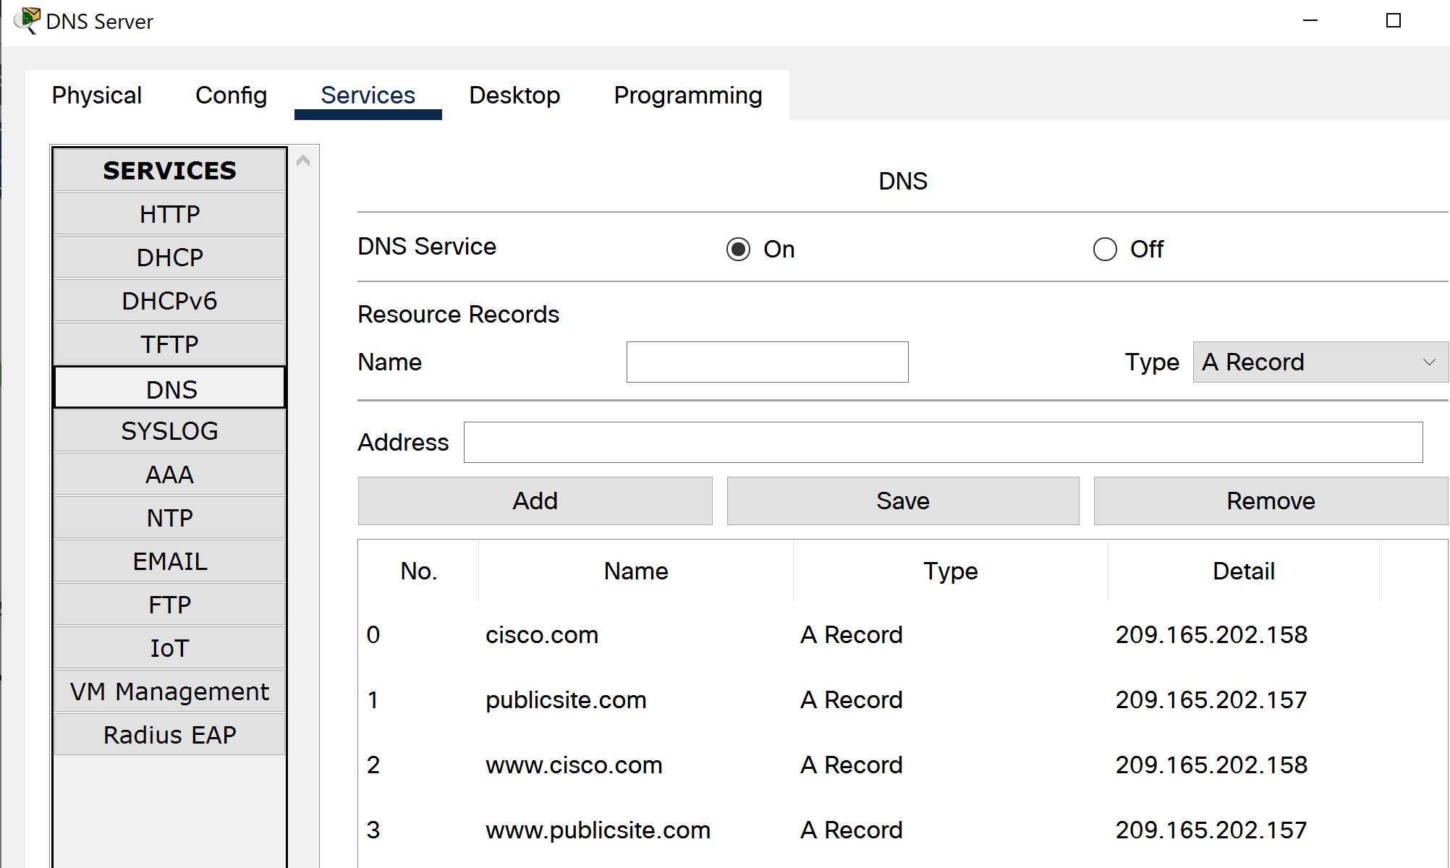

1. DNS or Domain Name System service provides a translation from **domain names 🡪 IP address**

* Turn on DNS service by clicking on On button
* Name: cisco.com
* Type: A Record
* Address: 209.165.202.158
* Click Add. This creates a mapping from cisco.com to 209.165.202.158

1. Do the same to add following:

* Name: www.cisco.com, Type: A Record, Address: 209.165.202.158
* Name: www.publicsite.com, Type: A Record, Address: 209.165.202.157
* Name: publicsite.com, Type: A Record, Address: 209.165.202.157

**Step 4: Examine DNS message.**

1. In simulation mode, filter to see only the DNS and HTTP.
2. Click PC1 -> click Web Browser -> type www.cisco.com
3. observe the DNS message at the PC1.

**4.1 Fill in the following information of DNS query message at PC1.**

|  |
| --- |
| Source IP Address: 192.168.10.11 Destination IP Address: 192.168.20.254  Source Port: 1027 Destination Port: 53  NAME: www.cisco.com |
|  |

* 1. **What is the transport layer protocol that DNS use?**

|  |
| --- |
| **UDP** |

1. Click **Capture/Forward** further until the DNS response arrives at PC1.

**4.3 Fill in the following information of DNS message at PC1.**

|  |
| --- |
| Source IP Address: 192.168.20.254 Destination IP Address: 192.168.10.11  Source Port: 53 Destination Port: 1028 |

* 1. **What is the answer that the DNS response?**

|  |
| --- |
| **209.165.202.158** |

1. Click **Capture/Forward** further once.

**4.5 What is the type of message created?**

|  |
| --- |
| **HTTP request** |

**Save your work as SecX-ID-Firstname-XXX.pka**