**Introduction to Application Layer and Basic Socket Programming**

**ITCS420 Computer Networks 1/2022**

**Lab 5: Work Sheet**

**Instructions:** Work on this sheet and save as PDF with the file name   
“Lab5-SecX-StudentID.pdf” by replacing SecX and Student ID with your Section ID and Student ID, and upload to MyCourses.

**Part 1: Basic Linux & networking commands**

* **Follow the instructions in Slide #3-6 to set up Ubuntu on Virtual Box**
* **Play with Linux commands in Slide #7-10**

1. Type **ip address** command on the Terminal in Ubuntu. Capture the result and put your screenshot here.

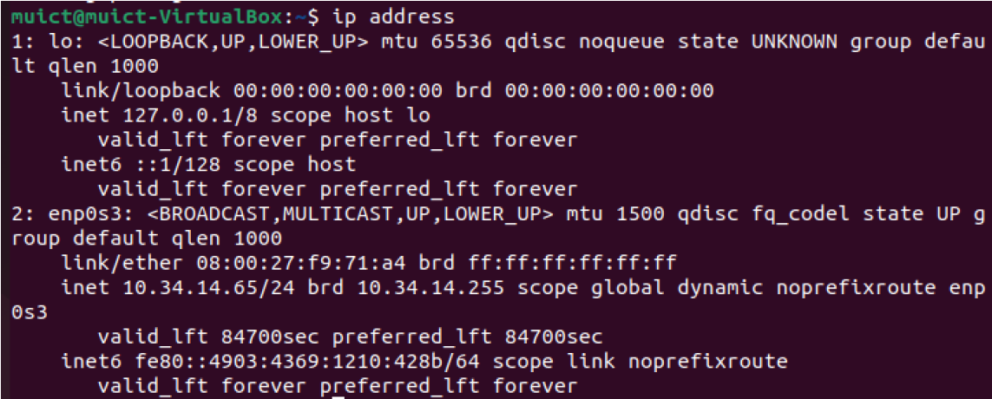

1. What are the HWaddr (ether) and the IP address (inet) of your computer. (Hints: *not* the loopback one)

HW Address: 08:00:27:f9:71:a4

IP Address: 10.34.14.65/24

The IP is private or public? **This is private**

1. Type below commands on the Terminal. Capture the result and put your screenshot here.

clear

date  
ifconfig

1. What are the results after executed the command **netstat -lu** in Ubuntu?



* + How many columns you see?

**Ans: 6 Columns**

* + What does each column mean? (Hints: use man command to see the explanation).

**- Proto** -> The protocol (tcp, udp, udpl, raw) used by the socket.

- **Recv-Q** -> The count of bytes not copied by the user program connected to this socket.

- **Send-Q** -> The count of bytes not acknowledged by the remote host.

- **Local Address** -> Address and port number of the local end of the socket.

- **Foreign Address** -> Address and port number of the remote end of the socket.

- **State** -> The state of the socket.

1. Use the command **cat** **/etc/hosts**. What are written inside this file? Explain.



**Part 2: Setting up and Configuring HTTP Server**

**Follow the instructions listed in Slide #13-14 to set up HTTP Server in Ubuntu**

1. Once the Apache2 installation is done, what are the results after executed the command **netstat -nlt** in Ubuntu? How is it different from using **netstat –lt**?

**netstat -nlt**



**netstat –lt**



**Ans: For netstat -nlt, it will change the name of the IP address that shows in netstat -lt to a numerical form such as localhost: ipp -> 127.0.0.1:631**

1. Open a Firefox web browser in Ubuntu and type in [**http://localhost**](http://localhost) in the URL tab. Capture the output screen.

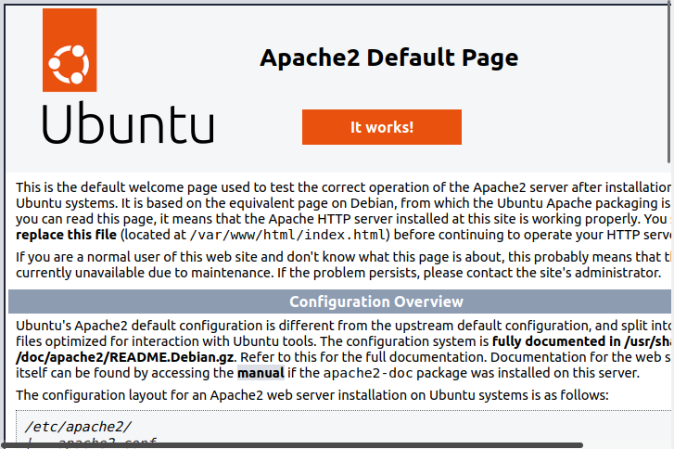

1. Now use the web browser on your host OS (e.g., Windows), type in the Ubuntu’s IP address you got from Q2. Capture the output screen? Is it different from the results in Q7?

**Ans: They are the same. There is no difference.**

1. Use a web browser on Windows, type in **http://[ip address]:95** with the Ubuntu’s IP address you have from Q2. Note that the number after colon is used to specify the server’s port number. What do you see? Explain why!

What do you see? **Ans: nothing**



Why?

**Ans: There is no result that is in port number 95.**

1. Try to change the number 95 on the previous question to 80.

What do you see? **Ans: Default page**

Why?

**Ans: Because the result has already been added to port 80.**

1. Open the configuration file **/etc/apache2/sites-available/000-default.conf** by using command **less**. Where is the *defaul*t DocumentRoot?

**Ans: DocumentRoot /var/www/html**

1. Use the command **cd** to go to the directory you answered in Q11. Then, type command **ls -alg**. List the files you see in that folder. And explain what DocumentRoot directory is used for.

**Ans: DocumentRoot is used to keep paths of the web server.**

**Follow the instructions listed in Slide #15-17 to configure Apache2 web server.**

1. After you changed the DocumentRoot, open a Firefox web browser and type in[**http://localhost**](http://localhost) in the URL tab. Capture the screen shot of your browser.

**Part 3: Understanding HTTP communication**

**We will use telnet from Ubuntu terminal to communicate with the server (through port 80). See Slide #18-19.**

1. Make **GET** request to **http://www.testingmcafeesites.com/index.html**  
   Answer following questions**.** Write down the **Telnet** commands you typed in.

**telnet www.testingmcafeesites.com**

Write down the **HTTP GET request and other parameters** you typed in to get the document. (Hints: Your answer must include two lines.)

**GET /index.html HTTP/1.1**

**Host www.testingmcafeesites.com**

Capture the screenshot of the **status line** and **the header lines** of the response you received from the GET request. Explain the status code. What is the server program used?

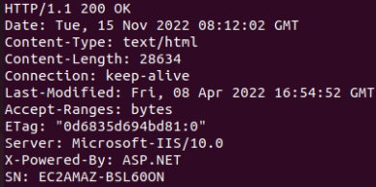

**Ans: It shows the status line as 200 and the server program as Microsoft-IIS/10.0.**

**Next, we will use Curl to get a web page using HTTPS. Follow the instructions in Slide 20**

1. Request a web page from <https://mahidol.ac.th>, capture the screenshot of the response header. What are the status code and the server being used?



**Status Code: 200**

**The server: nginx/1.10.3 (Ubuntu)**

**Part 4: Socket programming by Python**

**Learn the basic python and socket programing from Slide#27-36.**

1. Follow the instructions in Slide 37-38, and write a **tcpserver.py** and **tcpclient.py** programs

* Paste the source codes of both client and server programs here.

**Tcpserver.py**

**Tcpclient.py**

* Paste the screen output of server and client here. (Make sure your output looks like the provided example)

1. Change your Python programs from the previous task to support **UDP**, and named the programs as **udpserver.py** and **udpclient.py**. (See Slide 39)
   * Paste the source codes of both client and server programs here.

**Udpserver.py**

**Udpclient.py**

* + Paste the screen output of server and client here. (Make sure your output looks like the provided example)

