Lab 4: MPI Basics

Name: ID: Sec:

Save your file to “lab4_63xxxxxx.pdf” and upload it to MyCourses website.

**Q1.** helloworld.c

Output from running with 2 processes:

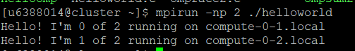

Output from running with 3 processes

Output from running with 4 processes:

Output from running with 5 processes:

Output from running with 6 processes:

**Q2.** integersum.c

Output of integersum



**Q3.** Modified integersum.c

Source Code:

Output

