**ITCS451, Semester 1/2022 Part II: Assignment #1**

**Constructing a Bayes net and performing inference**

This is an individual assignment.

**Due date:** 26 Sept 2022, 12:30pm (right after lunch)

**Directions:** Type or paste your answers into this file just below each question. Put this file and your Netica file into a folder called Part2_Assignment1_xxxxxx, where xxxxxxx is your ID number, zip it, and submit it to MyCourses using the submission link.

You will create a mini Bayes net to diagnose gallbladder disease. Use the following information to create your Bayes net.

Your main diagnostic hypothesis is Gallstones which has states present and absent. There are two demographic factors that influence Gallstones, Age and Sex. Age has states ≤37 and >37, while Sex has states Male and Female. The probabilities of Gallstones given Age and Sex are given in the following table:

Gallstones can be detected by a CT_Scan, which has states Positive and Negative. The probability a positive CT scan given Gallstones present is 0.79 and the probability given Gallstone absent is 0.003.

Gallstones can cause a further condition called Cholecystitis, which has states Present and Absent. The probability of Cholecystitis present given Gallstones present is 0.1 and the probability given Gallstones absent is 0.004. Cholecystitis can be detected by two ultrasound tests: US_Murphy_Sign and US_Thick_GB_Wall, which have states present and absent. The probability of US_Murphy_Sign given Cholecystitis present is 0.719 and the probability given Cholecystitis absent is 0.123. The probability of US_Thick_GB_Wall present given Cholecystitis present is 0.453 and the probability given Cholecystitis absent is 0.116. The results of the two ultrasound tests can be summarized as simply US_Cholecystitis with states present and absent. This node is a logical OR of the US_Murphy_Sign and US_Thick_GB_Wall nodes.

1. Create the Bayes net corresponding to the above description. Paste the screen shot here.

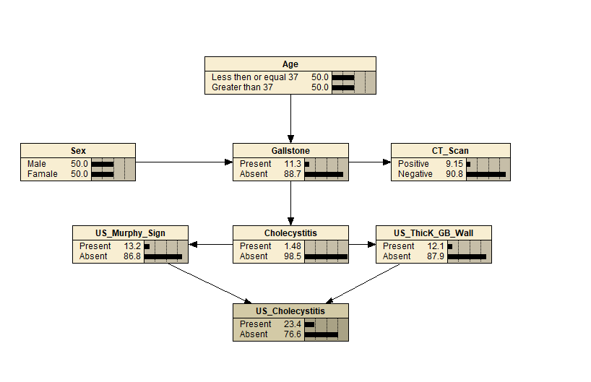

1. What is the prior probability of Gallstones before any evidence is entered?

Answer: Present: 5 % Absent: 95 %

1. Enter the evidence Age >37, Sex female. Now what is the probability?

Answer: Present: 20.0 % Absent: 80.0 %

1. What is the most informative test to diagnose Gallstones given the evidence you entered into the network? Use Netica’s “sensitivity to findings” function to determine it.

Answer: CT scan

1. Keeping the evidence from (3) in the network, what is the probability of Gallstones given US_Cholecystitis present?

Answer: Present: 76.1%

1. Consider the nodes US_Murphy_Sign and US_Thick_GB_Wall. For each question, indicate whether they are independent, dependent, or we can’t tell.
   1. Given no evidence.

US_Murphy_Sign: We can’t tell  
US_Thick_GB_Wall: We can’t tell

* 1. Given Cholecystitis = present

US_Murphy_Sign: Dependent  
US_Thick_GB_Wall: Dependent

* 1. Given Cholecystitis = present and US_Cholecystitis = present

US_Murphy_Sign: Independent  
US_Thick_GB_Wall: Dependent

1. Are Age and US_Cholecystitis dependent or independent?
   1. Answer: Dependent
   2. If they are dependent, what would make them independent (without change the network structure)?

Answer: Set Gallstone.