Swinburne University of Technology

Development Project 2 - Design, Planning and Management

(2020 S2) Doubtfire Submission

# 08 Pass Task 6.1P

|  |  |  |  |  |
| --- | --- | --- | --- | --- |
| *Submitted By:*  Monique Kuhn  101131147 |  | *Group Members:* |  | *Tutor:* Naurin Afrin |
|  | 101131147 | Monique Kuhn |  |  |
|  | 102259710 | Tien Phu Ngo |  |  |
|  | 102095118 | Jayden McQueen |  |  |
|  | 102079989 | David Stare |  |  |
|  | 101111372 | Jacob Scott |  |  |
|  | 101100655 | Lachlan Burns |  |  |

September 11, 2020



Produced by Doubtfire

## 101131147 | MONIQUE KUHN 101111372 | JAKE SCOTT 102259710 | TIEN PHU NGO 101100655 | LACHLAN BURNS 102095118 | JAYDEN MCQUEEN 102079989 | DAVID STARE

6.1

P GR

7



Naurin Afrin| Friday 12.30

SWE30010 Development Project 2: Design, planning and Management

**Project Proposal:** *PHP-SRePS*

*It is essential to refer to 4.3P Project Proposal” Deliverables as an accompanying document to this one.*

In this task, the team has performed a work breakdown structure (WBS) to better manage the first sprint and backlog items. The tasks have been assessed against the provided and justified criteria to mathematically predict its time scope and hierarchy of importance.

Tasks listed as “Could” and “Won’t” in task 4.3P have been excluded as they have already been assessed as low priority or not to be completed tasks.

The criteria have been divided into:

* Business Value
* Development Effort
* Feature Dependency
* Date Needed / Timeline

**Business Value**

Business value refers to the necessity of a feature for the target client. Using the numerical scale 0 - 3, a priority will be assigned to each feature. Features that are ranked 0 will have the lowest priority, meaning they may not have been requested specifically by the client but their inclusion was deemed to improve product quality.

Consequently, features ranked 3 are the highest priority, as they may have been specifically requested by the client. And individually, these features have a higher value to the client (their use can substantially aid in the client’s interests more so than other features).

**Development Effort**

The working time is set to be 8 hours per team member per week. Hence the total of 96 hours of work for our entire team.

Development effort refers to the required time for one team member to complete a backlog item

Numeric Measurement:

* 0 = 0-4 hours
* 1 = 4-8 hours
* 2 = 8-12 hours
* 3 = more than 12 hours

The sum of all the backlog items’ hours should be 96 hours

**Feature Dependency**

Feature dependency refers to what degree each item is dependent, or reliant, on one another. This will be rated on a scale of 0-3. Higher numbers (3 and 2) mean that, for a specific item in the backlog, a high degree of other items cannot be completed until the specific item is completed. (1 and 0) describe items that are fairly feature independent, and thus can be developed at any time throughout the sprint. This means that higher numbers should be developed first, with the lower numbers being developed last in the sprint. **Date Needed/Timeline**

Determining the importance of a task relies heavily on the scheduled completion date of that task. For this reason, it is fundamental to include a numeric method to assess the urgency of the task.

This document focuses on Sprint 1 tasks, and hence sprint 2 tasks have already been removed from the discussed list.

Numeric Measurement:

* 0 = No Scheduled time/Ongoing
* 1 = To be completed in week 3 of sprint 1
* 2 = To be completed in week 2 of sprint 1
* 3 = To be completed in week 1 of sprint 1

Below are some points of a quality control checklist that relate to the client’s needs and the above characteristics:

|  |  |  |  |  |  |  |  |
| --- | --- | --- | --- | --- | --- | --- | --- |
| No. | MSCW* | Description of Item | Business Value | Development Effort | Feature  Dependency | Date  Needed/Timeline | Total  Score/Priority |
| [3] | **M** | **Record, edit, and view sales**  **data for pharmaceutical products** | **3** | **3** | **2** | **3** | **11** |
| [6] | **M** | **Fully workable application and database system** | **3** | **3** | **3** | **1** | **10** |
| [7] | **M** | **Display Items**  **that are in**  **demand** | **3** | **0** | **1** | **2** | **5** |
| [8] | **M** | **Display stock numbers of all items in store** | **3** | **1** | **1** | **3** | **8** |
| [14] | **M** | **Local storage** | **3** | **0** | **3** | **3** | **9** |
| [15] | **S** | **Low resource demand** | **1** | **1** | **2** | **1** | **5** |
| [16] | **S** | **Exception Handling** | **2** | **2** | **1** | **0** | **5** |
| [17] | **S** | **Portable system** | **0** | **2** | **1** | **1** | **4** |
| [18] | **M** | **Report History** | **3** | **2** | **2** | **2** | **9** |
| [22] | **S** | **Startup** | **3** | **3** | **3** | **1** | **10** |

*MoSCoW represents MUST, SHOULD, COULD, and WON’T

**Sprint 2 tasks removed from list:**

[1], [2], [4], [5], [9], [12], [20]

**Could tasks removed from list:**

[10], [13], [19], [21], [23]

**WBS:**

The following work breakdown structure visually identifies the areas and products that must be developed in sprint #1. The three main areas, written with white headings, show the three main areas that must be developed satisfactorily.

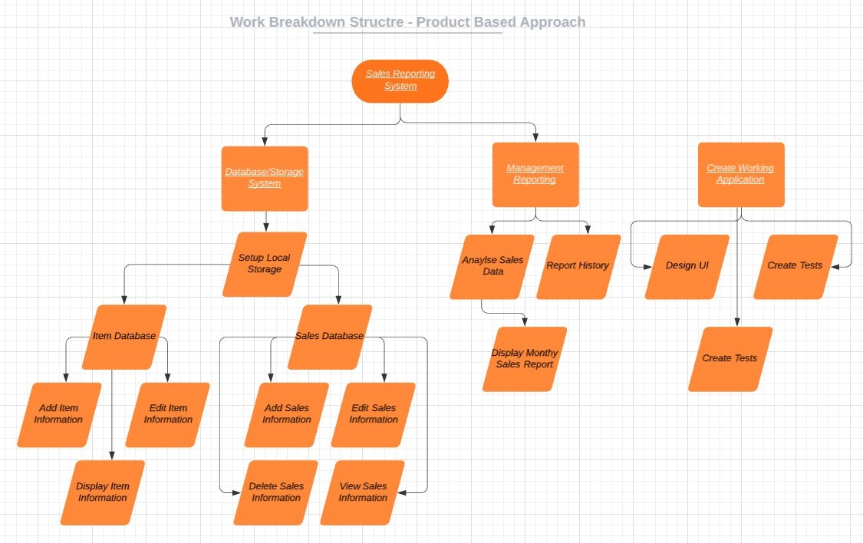

**Reflection**

### 101111372 | JAKE SCOTT

For 6.1 we split the tasks required to finalize the document into small tasks, and divided them among us. I generated the order of completion / due-dates for each task, which were used as part of a more cohesive value estimate for the tasks. The group communicated the requirements for the task early and clearly.h

### 102259710 | TIEN PHU NGO

The team went through the product backlog together and rate every item in terms of different criteria at the start of week five. I am responsible for considering development effort each item will take and put in the scale from 0 to 3 accordingly. Then my result was used to select an appropriate list of backlog items for print#1 at the end of week five.

### 101100655 | LACHLAN BURNS

The team has been successful in developing a work breakdown structure for the project to help with the first sprint. Business value, development effort, feature dependency and the scheduled completion time were all considered when calculating the priority of each point, this resulted ina few backlog items having the highest priorities for the team. I believe the team is now ready to begin working on the sprint.

### 102095118 | JAYDEN MCQUEEN

This week the team has been collaborating on the planning phase of the first sprint. We have given each item on the project backlog a score from zero to three based on various criteria. Using this numbering system, we were able to prioritize the items. This prioritization can also be seen in the WBS, which shows what tasks are needed to complete different subsections of the first sprint. As a team, I believe we are ready to begin programming (after setting up some tools). Organisation this week has been a bit more of a struggle than past weeks, as other unit’s work and real life interference has gotten in the way of this unit. Despite this, we have completed the work we wanted on time, and everyone has contributed.

### 101131147 | MONIQUE KUHN

This week the team chose to have a weekend break between our intermediate and usual meeting time. This was a great way to take a step back at the conclusion of our **Project Proposal** stage. Organising the tasks this week was a little bit messy but we managed to split responsibilities and delegate them in a concise fashion. This allowed for a smooth workflow and quality work. The numeric approach we took to evaluating the task hierarchy was effective and clarified what our next steps as a team should be.

### 102079989 | DAVID STARE

The group set out to thoroughly plan out the tasks need to be done for sprint 1. Accompanying this was a work-breakdown structure which provided some more detail for the features that needed to be done. The features were separated into two sprints by assessing each feature by their: business value, development effort, each feature’s dependencies on others, the date needed for each feature to be completed and any risks involved. The group worked well and have adequately decided on which features to focus on for sprint 1.