**Project Proposal:** *PHP-SRePS*

|  |  |
| --- | --- |
| 8.1P GR7 | **101131147 | MONIQUE KUHN**  **101111372 | Jake Scott**  **102259710 | Tien Phu Ngo**  **101100655 | Lachlan Burns**  **102095118 | Jayden McQueen 102079989 | david stare**  Naurin Afrin| Friday 12.30  SWE30010 Development Project 2: Design, planning and Management |

This document details the team’s progress mid sprint1. Evidence has been provided with screenshots from our Trello Board, Github, Burnup chart and Meeting Minutes/Discord. It should be noted that the midway check (7.1) was performed 3 days ago due to availability of members for a meeting. Hence only some progress has been made since then.

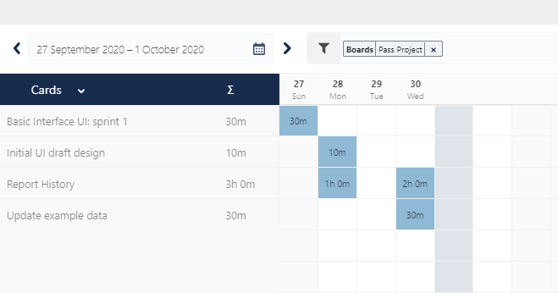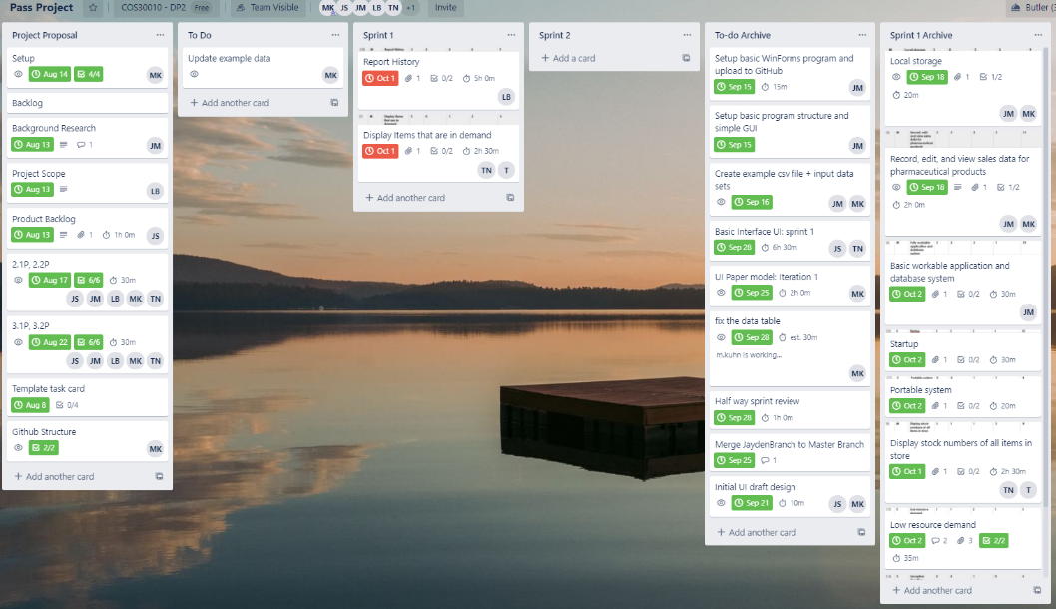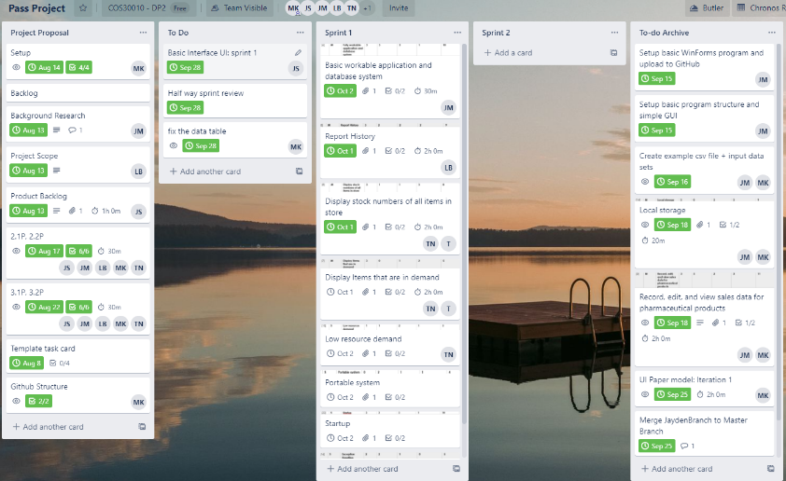**Trello Board613**

**Meeting Minutes**

**28/09/2020**

* Submitted week 7 midway check
* Delegated tasks for week 8
* Reflected on sprint 1 progress

**01/10/2020**

* Delegated submission tasks for Friday week 8 (8.1, 8.2, 8.3, 8.4)
* Discussed reporting formatting
* Performed retrospective as a team on whole of sprint 1
* Pushed task templates to git
* Clean up folder structure of git and pushed

**02/10/2020**

* Presented program to stake holder
* Confirmed finalization and wrap up of sprint 1 before sprint 2 planning stage on Monday

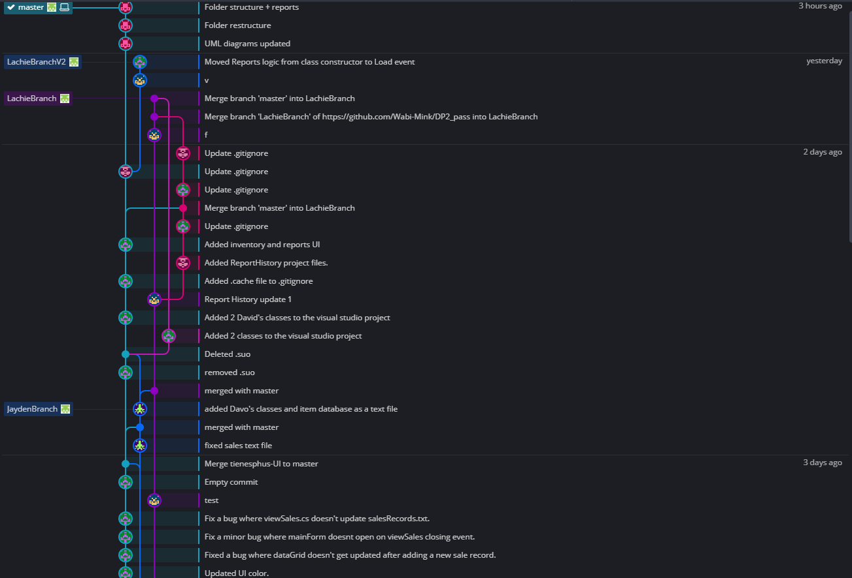**Github/Gitkraken**

# 

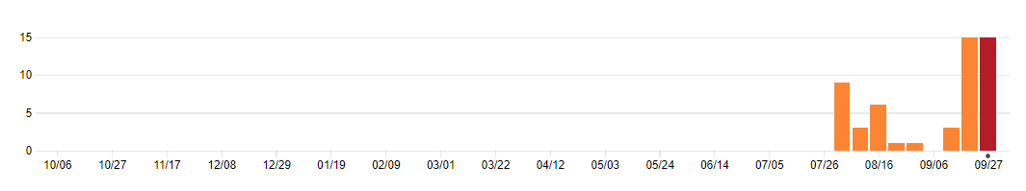

# Burnup Chart/Screenful progress

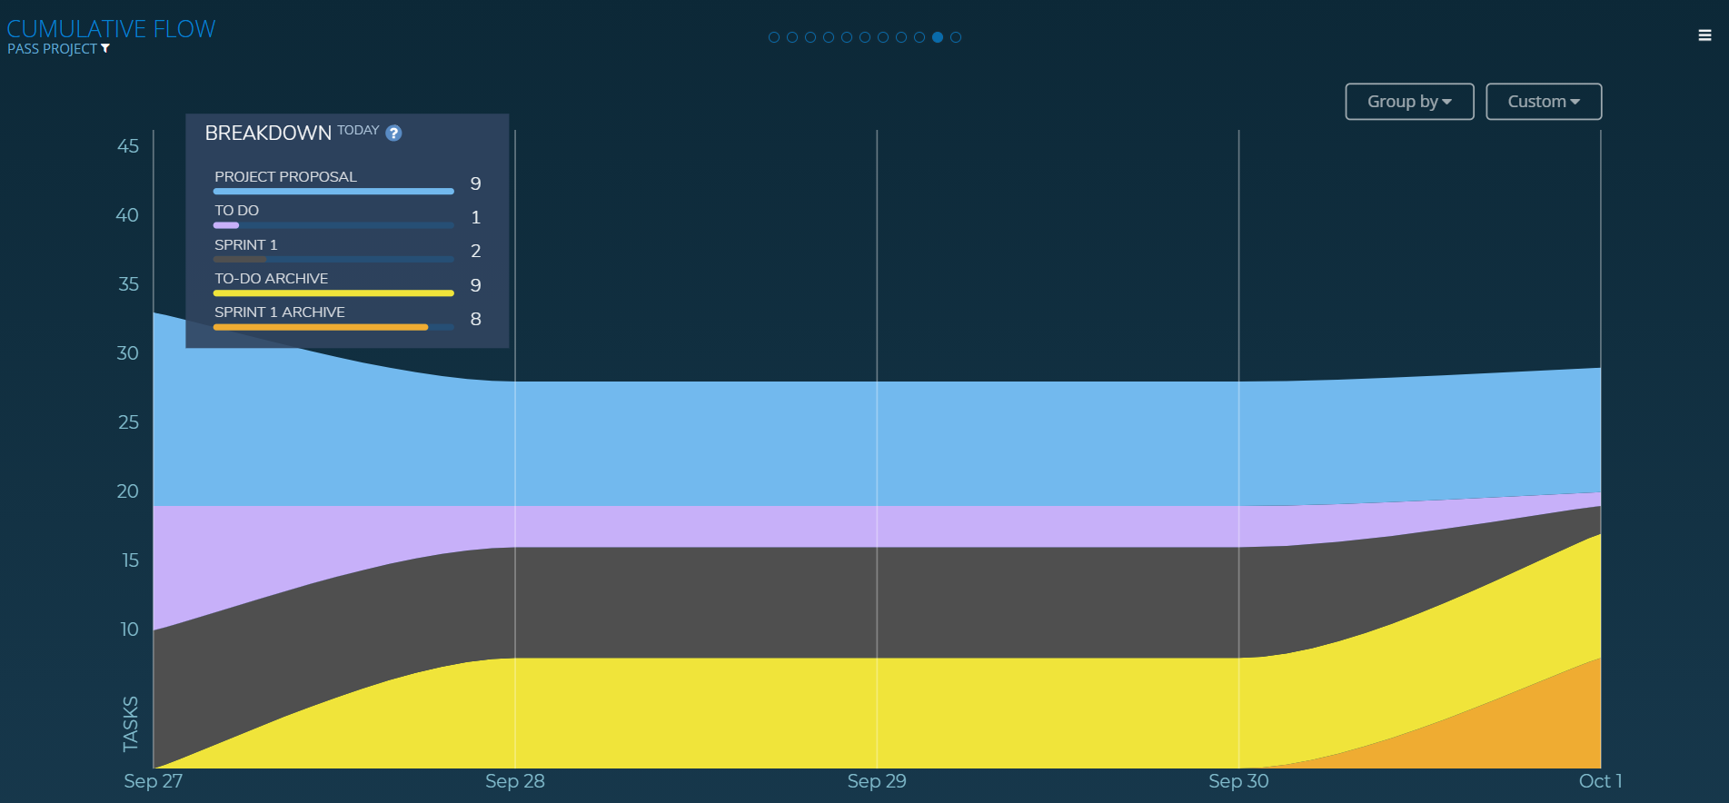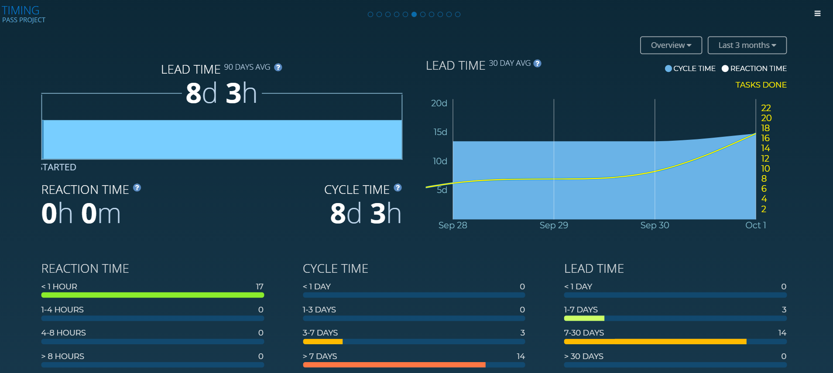

**Reflection**

**101111372 | Jake Scott**

This week we worked on completing Sprint 1 tasks, and recording more of our work on the Trello. We added a powerup called Chronos, but due to complications had to add a lot of time reports retroactively. I helped design and implement some UI, and fix some Git issues such as the .ignore, and merging problems. Progress seems to be going well.

**102259710 | Tien Phu Ngo**

I have been getting familiar of WinForms/C# language and working with Jake for building and testing the basic user interface. We have meetings on Monday and Friday to keep team member up to date. For this week I have been working on the UI backlog item: I created a few commits to project master branch and update github .ignore file. The next item I should be working on next week is "Displaying items that are in demand" and "Exception handling".

**101100655 | Lachlan Burns**

My first half of sprint 1 was spent on working on report history feature of our program. I was successfully able to import the sales records into SQL Server Reporting Services (SSRS) and begin creating graphs to represent the sales data. My next step is to integrate the reports into winforms which is what I will be working on the next half of the sprint, I have also been getting help from my team with understanding how Visual Studio can directly pull and push from GitHub which has been a great help. I think our progress in sprint 1 is going along well.

**102095118 | Jayden McQueen**

This week, we have been working on various programming tasks in order to create our sales system. My job this week was to create the local database, and set up the addition of new sales to the program. We have had a lot of small meetings this week to keep up to date with each other's work. A big aspect of work this week was to get all our work on the 'master' branch, as some of our team members have not had very much experience in using GitHub. We've also been attempting to keep track of our time spent on the project this week, to varying degrees of success. I believe we are well on track to finish all the assigned tasks for this first sprint.

**101131147 | MONIQUE KUHN**

Sprint 1 is going successful in terms of task completion and the development of the code. I have enjoyed having constant communication with the team and the ability to refer to other peoples work in the repository. Having said this, tracking the work flow of the team is a bit annoying and can get in the way of actually completing the work. The team has developed bit more of a pattern now though. The chronus powerup works really well for us and the Gitkraken visual tracking works great as well.

**102079989 | david stare**  
The team coordinated well with the tasks set out for sprint 1. The tasks were divided evenly and an adequate amount of work was done. Using Trello, Github and Discord the group communicated effectively and any confusing aspects of the project were addressed and resolved. The team could have been up to date with creating screenshots of the Trello board as we did not fully understand how to use it properly but we will endeavor to take more screenshots in the next sprint. I was assigned two tasks: creating a feature that displayed the quantity of all stock items and creating an alert when the quantity of stock for any item is too low.