**Project Proposal:** *PHP-SRePS*

|  |  |
| --- | --- |
| 8.2P GR7 | **101131147 |** **MONIQUE KUHN**  **101111372 | Jake Scott**  **102259710 | Tien Phu Ngo**  **101100655 | Lachlan Burns**  **102095118 | Jayden McQueen 102079989 | david stare**  Naurin Afrin| Friday 12.30  SWE30010 Development Project 2: Design, planning and Management |

This task details the product review that was conducted in the 12:30pm Friday tutorial on the 2nd of October. The purpose of this product review was to demonstrate the working condition of the product at the end of the first sprint.

**Meeting Minutes for the product review:**

**Attendees:** Jayden McQueen, Monique Kuhn, Jake Scott, Tien Phu Ngo, Lachlan Burns, David Stare

**Time/Day:** 12:45pm 2nd October

**Questions (Internal team review):**

**Q.1**

**Did your team under-estimate the level of complexity of the item in sprint planning meeting? How can your team get a better estimate on the level of complexity of an item in next sprint?**

Some items on the backlog were under-estimated by the team. For example, implementing the report history in the sales system proved to be trickier than planned, and was thus moved to the second sprint.

**Q.2**

**Did your team under-estimate the time required to complete the task? How can your team get a better estimate on the time required to complete a task in next sprint?**

As stated above, there were tasks that were moved to the second sprint because of our under-estimation of the complexity of these respective items. An under-estimation of the complexity leads itself to an under-estimation of the time needed for each item. We also did not account for the team’s unfamiliarity with using WinForms, as many of the problems in this sprint can be assigned to a lack of knowledge regarding WinForms. To better estimate the time needed for each task, we may need to do more planning before starting to program specific tasks and break them down into smaller items where possible. The smaller each item, the easier it is to predict the time needed to spend on it.

**Q.3**

**Is the task description of the item too vague for the work? How can your team achieve a better task description next time?**

Some of the task descriptions may be too vague for the work. For example, we had a task called “Low Resource Demand” that was misinterpreted by Jayden at the end of the sprint. He thought that the low resource demand referred to the actual processing power used to run the sales system, and not the actual requirement of alerting users of the system when an item was running out of stock (<10 in stock). A small description after the title of each item on the backlog would solve this problem and may be implemented in the next sprint.

**Q.4**

**Poor design of the program? How would your team improve on the design of the program in next sprint?**

The team was quite happy with the design of the product for this week’s sprint. In order to improve where we can for the next sprint, we may move some of the features to their own separate classes, as we have done with some of the features already, to improve the cohesion of the product further. This will entirely depend on how quickly we can work through the rest of the items on the backlog, as we will prioritize a working program before an elegantly designed one, although we hope to have both an elegant and working program by the end of next sprint. Another aspect to consider is the internal documentation of the program, which could be improved. This is important because it explains how features work to other members of the development team, if they ever need to replicate or further develop any parts of the system.

**Completed Items Shown in Product Review:**

* Local Storage
* Record, edit and view sales data for pharmaceutical products
* Basic workable application and database system
* Startup (program running as an .exe file)
* Portable system (similar vein to “Startup”)
* Exception handling
* Low resource remand (not 100% implemented yet in UI – programming done)
* Display stock numbers of all items in store (also not 100% implemented yet in UI – programming done)

**Comments by Stakeholder:**

The stakeholder was pleased to see the progress so far. She verified that we were working on the correct requirements for the program, and stated she was excited to see the final application in the next product review. We explained that some of the work done throughout this sprint could not be seen in the demonstration, because the features had yet to be implemented into the UI (even though the programming side of these features were completed), and we also explained to the stakeholder what everyone’s role was this week, and what they completed. She seemed happy with the progress we had made in this sprint.

**Image of Demonstration:**

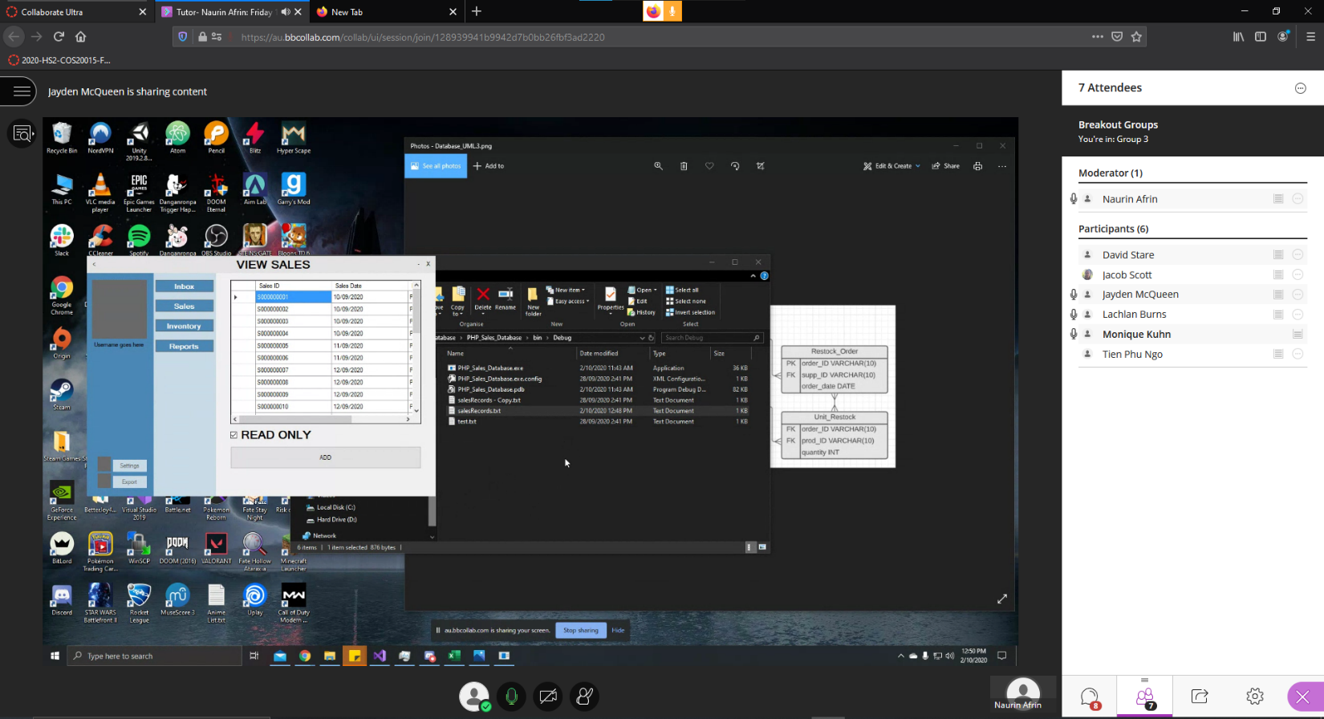

**Reflection**

**101111372 | Jake Scott**

The biggest limitation for completing sprint 1 was unfamiliarity with Git, and complications sharing and running each others code, since everyone in the group is competent at coding and design. This meant that we had a tendency to leave more work to specific members who had already made progress, rather than spend a lot of time synchronising.

**102259710 | Tien Phu Ngo**

Sprint#1 went as planned. However there are some problems where we underestimated the complexity of the database and how we are going store sale records and it took more time than expected. In the end, the team has decided to finish that features in sprint#2. Github is another problem as we also spent more time setting Git up than the estimation I made in P6.2.

**101100655 | Lachlan Burns**

It was quite evident that the team (me specifically) had a lot less experience on GitHub than other members. Eventually this was not an issue as other teams were more than willing to help explain and teach other members how to utilise the repository. However, again it did eat into the team’s sprint 1 progress, this maybe we should have addressed before the start of the first sprint.

**102095118 | Jayden McQueen**

Everyone agreed that the unfamiliarity of GitHub lead to some confusion and merge conflicts within the sprint one project. Thankfully, we had some members who could show the other members how to properly use GitHub, so this should be les of a problem next sprint. In the demonstration, we showed off our progress so far, which was approved of by the stakeholder. We re-affirmed what we did not get fully completed with the stakeholder and explained we would have all the required deliverables by the next product review (end of sprint two).

**101131147 | MONIQUE KUHN**

Most team members would agree that a lack of familiarity with Git was the source of most coding issues. I think we could've done a better job on reading ahead on tasks in order to better prepare ourselves for what we had to do. Additionally, assigning tasks at the start of the sprint didn't seem to work so well. It may be better to have members assign themselves as they see fit. This aside, the team did well at completing most of the sprint 1 tasks planned.

**102079989 | david stare**  
Myself having little experience with Github was more of a liability than I thought initially. I had to be shown by another member (Tien) how to pull, commit and push to the master branch. Having this knowledge before starting Sprint #1 would have saved time and I would have been able to properly test the features from the tasks assigned to me. Trello is a useful tool for displaying the pending tasks and their progress, however through fault of my own, I misread one and developed a feature that was not required. I also could have communicated with the group more as when I completed my features initially, they used an SQL database as a source instead of a CSV text file. This was changed in the update of those features.