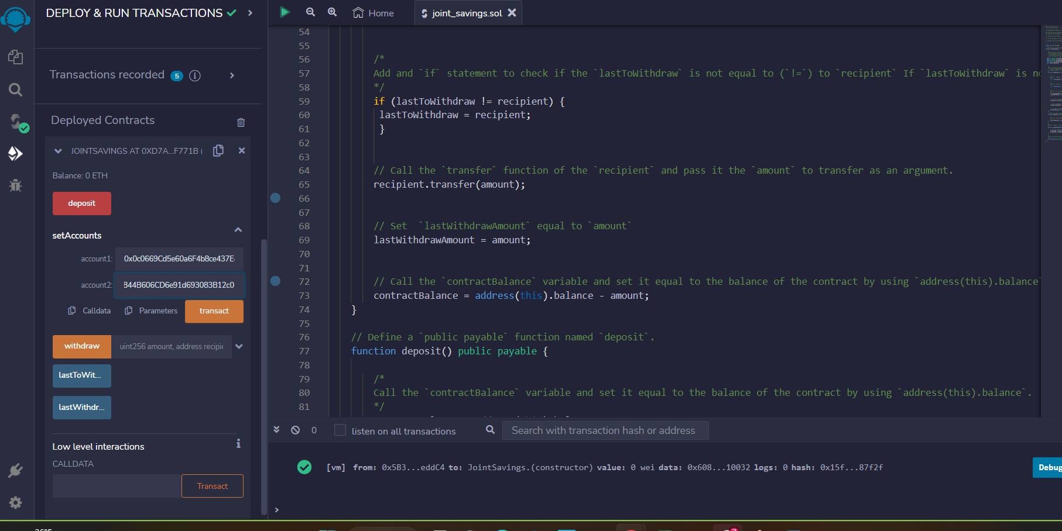

Setting the accounts

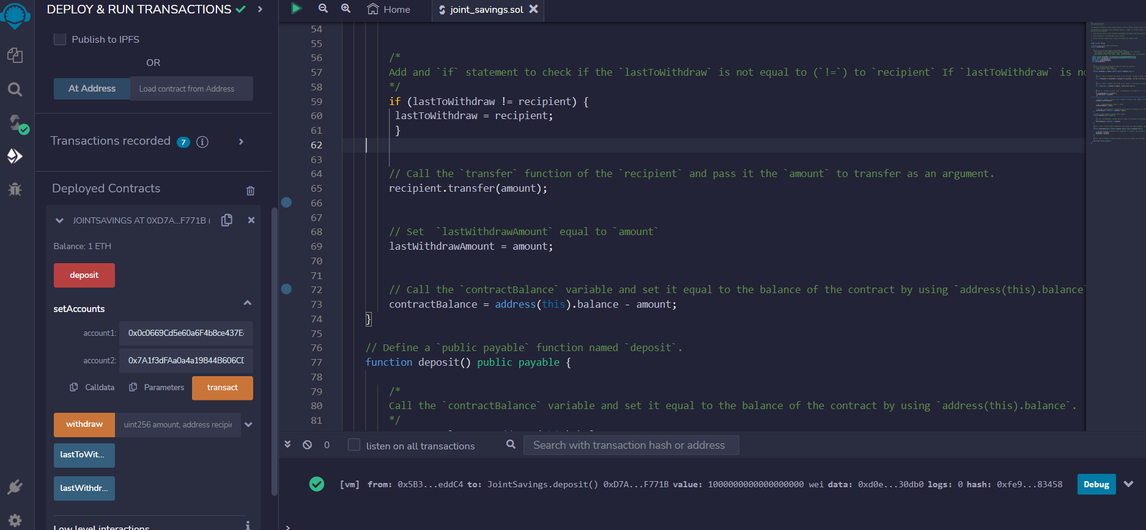

First deposit of 1 ETH in wei

Second deposit of 10 ETH in wei

Third deposit of 5 ETH (the two pics above)

Withdrawal pics below:

