Assignment 4.2: MySQL Install

Wade Eckert
Bellevue University
CSD 310: Database Development and Use
Dr. Mortoza Abdullah
January 14, 2025

Assignment 4.2: MySQL Install

1.) Initial Database Connection:

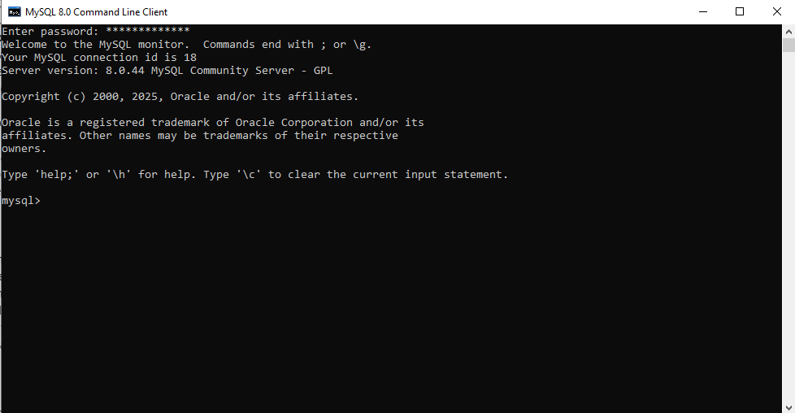

2.) Output From the Show Database Command:

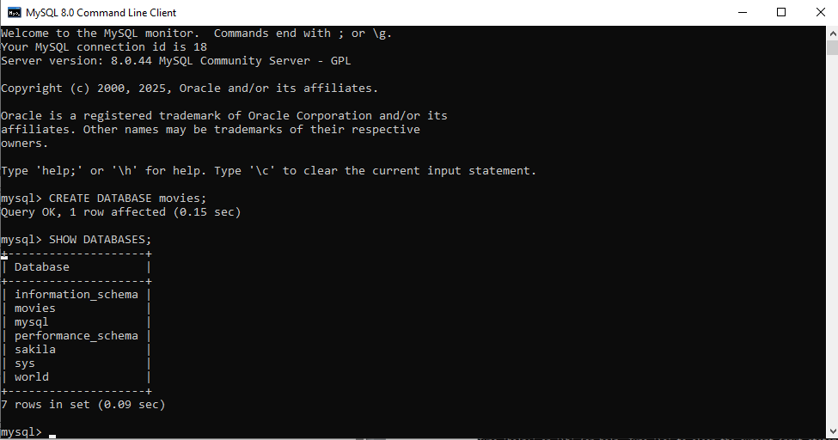
3.) Creating Movies Table in Movies Database for Experimentation
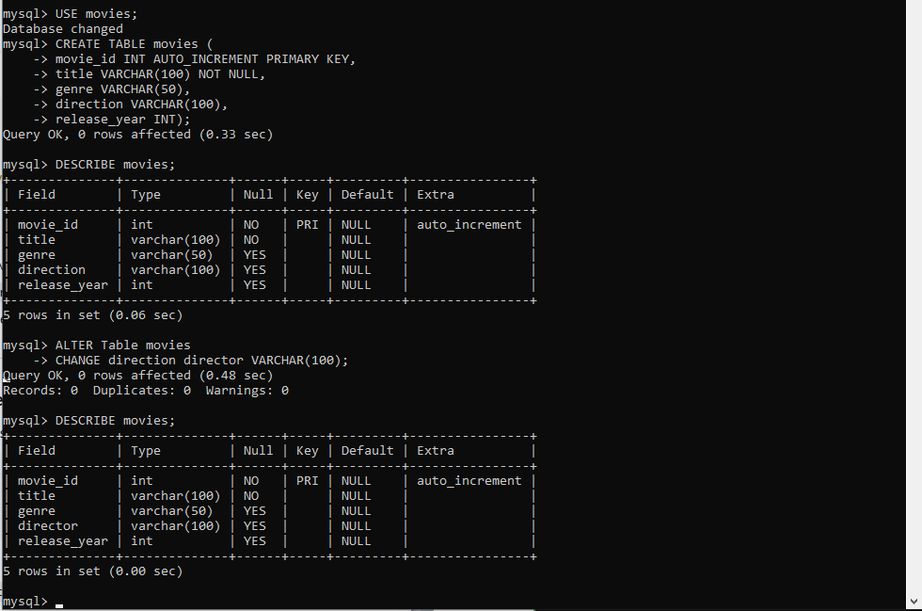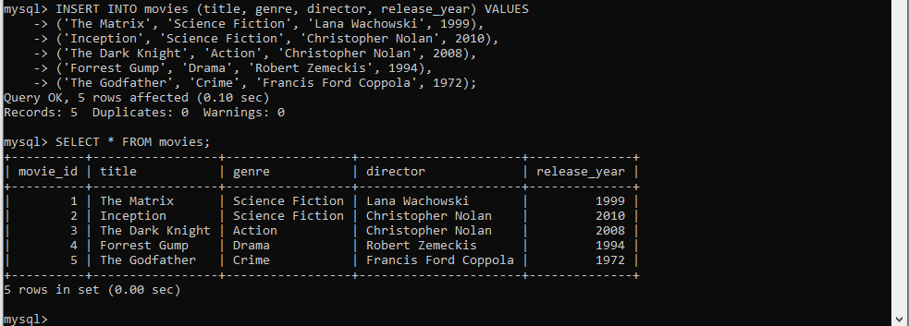

4.) Function Experimentation
A.) Concat( ) – Combining Multiple Text Fields Into On Readable Value
When You’d Use It:
The CONCAT() function is commonly used when you want to display multiple pieces of text as a single, more meaningful value. In a real database, information is often stored in separate columns for organization and normalization, but users usually want to see combined values in reports or query results.
In a movies database, this might be useful when you want to display the movie title along with the release year, or combine the director’s first and last name into a single “Director” column. Rather than changing how the data is stored, CONCAT() allows you to format the output at query time. This is especially useful for reports or exports where readability matters more than raw data structure.
Alias Used: Movie_Display
SQL Statement:
SELECT
movie_id AS Movie_ID,
CONCAT(title, ' (', release_year, ')') AS Movie_Display
FROM movies;
Screenshot:
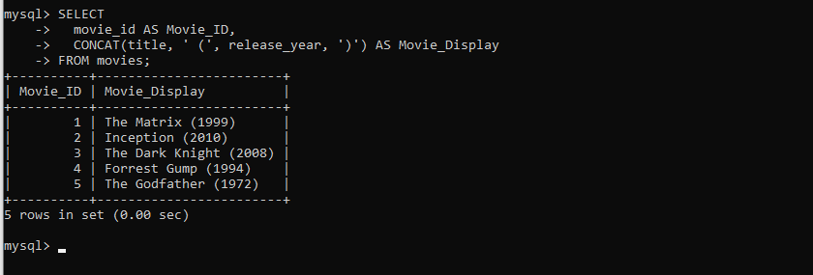

B.) Count ( ) – Counting How Many Records Meet A Certain Condition
When You’d Use It:
The COUNT() function is used whenever you need to know how many records exist in a table or how many records fall into a certain category. This is one of the most commonly used functions in SQL because counting records is fundamental to understanding your data.
In a movies database, COUNT() could be used to answer questions like how many movies are stored in the database, how many movies belong to each genre, or how many movies were released in a particular year. This type of query is useful for summary reports and analytics, and validating data, such as confirming that records were inserted correctly.
Alias Used: Movie_Count
SQL Statement:
SELECT
genre AS Genre,
COUNT(*) AS Movie_Count
FROM movies
GROUP BY genre;
Screenshot:
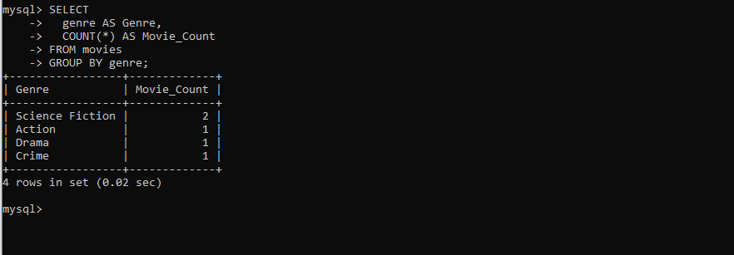
C.) Upper ( ) – Converting Text to Uppercase
When You’d Use It:
The UPPER() function is used when you want to standardize text data by converting all letters to uppercase. This is especially useful when data may have been entered inconsistently, for example, some movie titles or genres being stored in lowercase, uppercase, or mixed case. By using UPPER(), you ensure consistent formatting in your query results without changing the actual stored data in the table. In a movies database, UPPER() can be helpful for reports or displays where you want titles or genres to stand out visually, or when comparing text values in a case-sensitive environment.
Alias used: Genre_Uppercase
SQL Statement:
SELECT
movie_id AS Movie_ID,
UPPER(genre) AS Genre_Uppercase
FROM movies;
Screenshot:
