Assignment 5.2: Movies: Setup

Wade Eckert
Bellevue University
CSD 310: Database Development and Use
Dr. Mortoza Abdullah
January 24, 2026
Link to GitHub Repo: https://github.com/WadeEckert/CSD-310

Assignment 5.2: Movies: Setup

1.) Run the SQL Script:

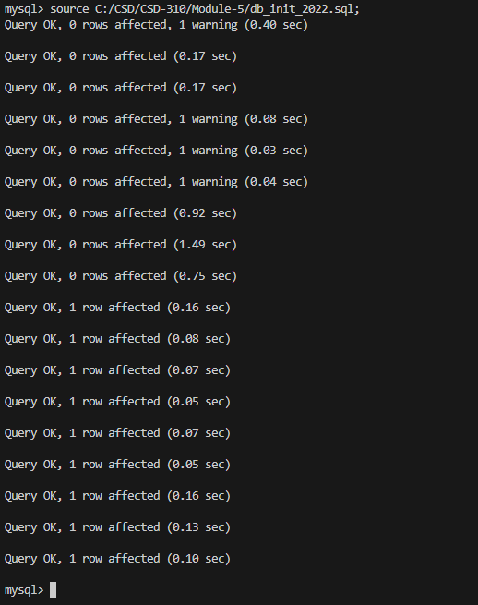

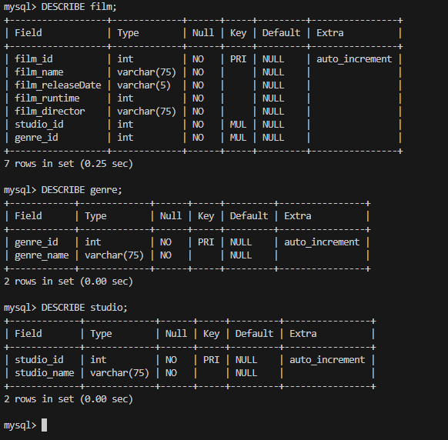

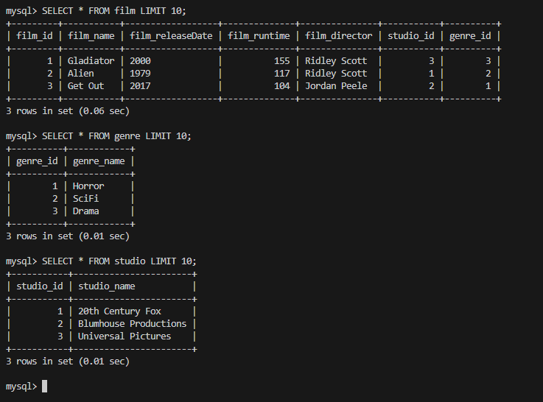

=====================================================================================

2.) Show a List of Database Tables:

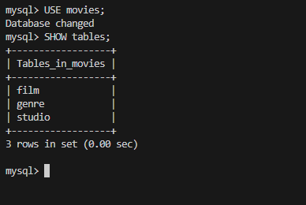
=====================================================================================

3.) My SQL: mysql_test.py:

