Assignment 2.3: Data Models

Wade Eckert
Bellevue University
CSD 310: Database Development and Use
Dr. Mortoza Abdullah
December 10, 2025

Assignment 2.3: Data Models

Entity Relationship Diagram (ERD):

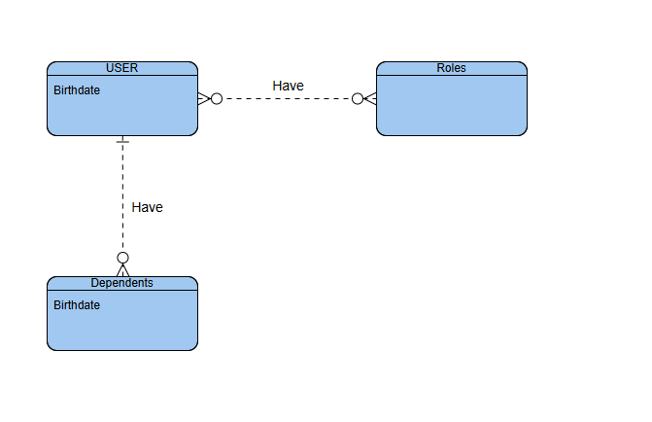

NoSQL Data Structure:

