Assignment 7.2: Movies: Update & Deletes

Wade Eckert
Bellevue University
CSD 310: Database Development and Use
Dr. Mortoza Abdullah
February 5, 2026
Link to GitHub Repo: https://github.com/WadeEckert/CSD-310

Assignment 7.2: Movies: Update & Deletes

- Call show_films() Function:
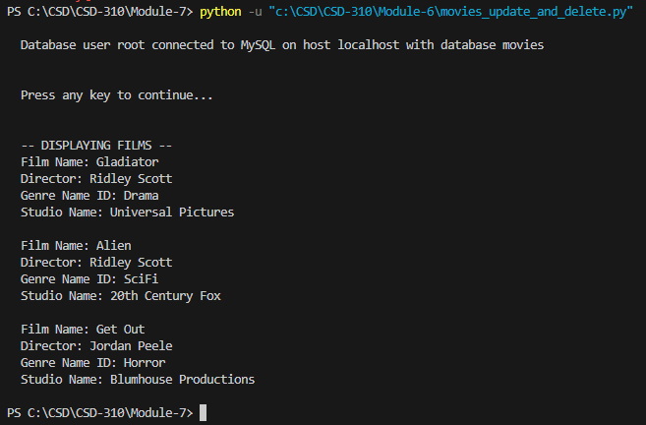

- Call show_films() Function After Insert:
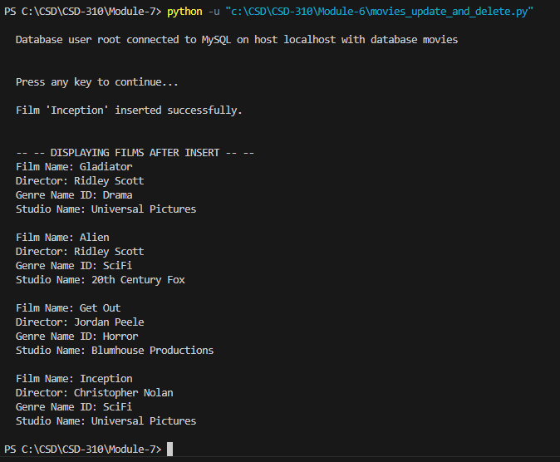

- Call show_films() Function After Update:
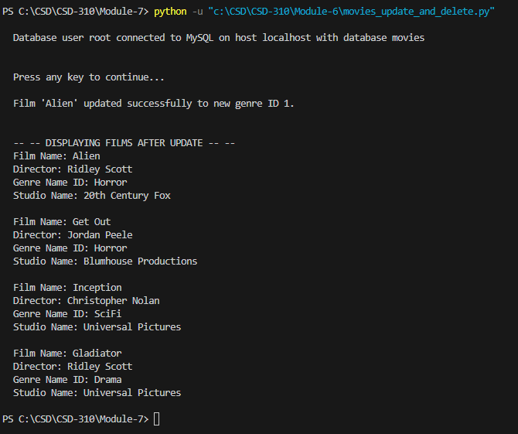

- Call show_films() Function After Delete:
