Assignment 9.2: APIs

Wade Eckert
Bellevue University
CSD 325: Advanced Python
Professor Ed Parks
February 21, 2026

Assignment 9.2: APIs
Tutorial API:
Test the Connection and Run with no Formatting:
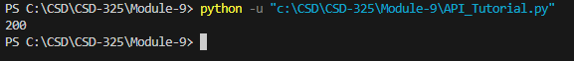
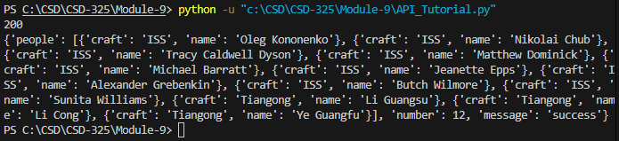
Running the Program with Formatted Output:
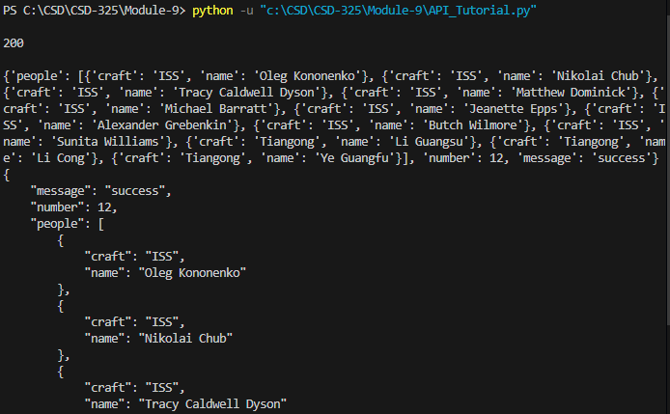
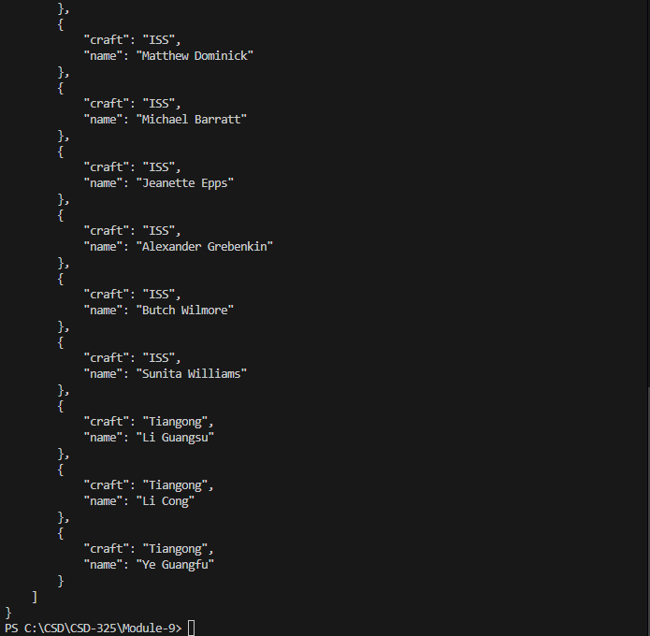

Custom API:
Test the Connection and Run with no Formatting:
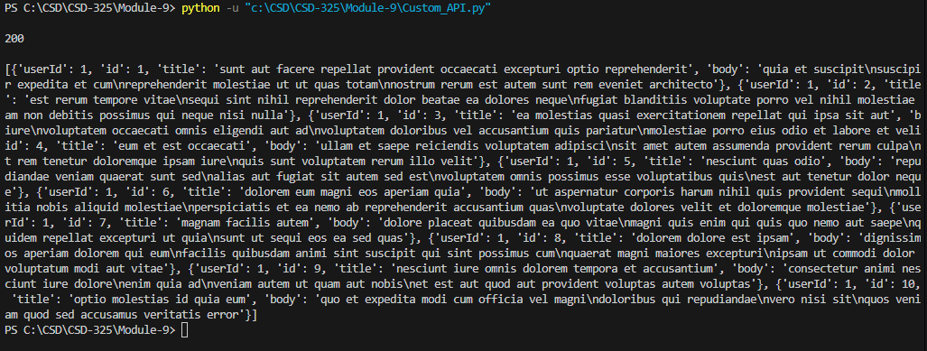
Running the Program with Formatted Output:
