Assignment 7.2: Test Cases

Wade Eckert
Bellevue University
CSD 325: Advanced Python
Professor Ed Parks
February 5, 2026

Assignment 7.2: Test Cases

- City and Country Function and Values in ‘city_functions.py’:
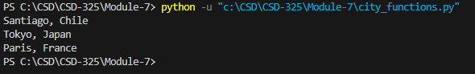

- Passed Test for test_city_country() in ‘test_cities.py’:
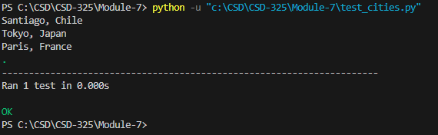

- Failed Test for test_city_country() After Population Parameter Added:
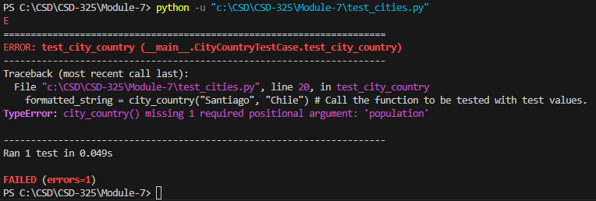

- Passed Test for test_city_country() After Population Made Optional:
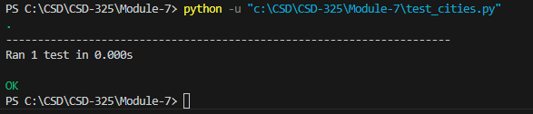

- Failed Test for test_city_country() After Language Parameter Added
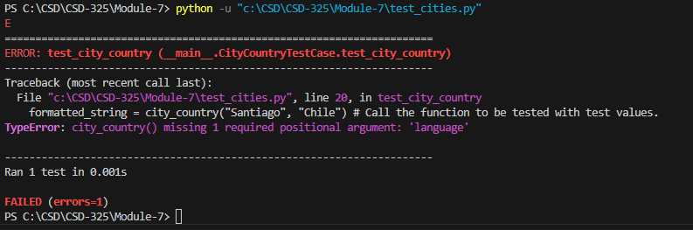

- Passed Test for test_city_country() After Language Made Optional:
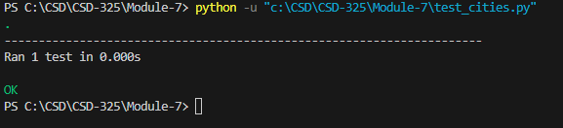
- Three Test Cases for ‘city_functions.py’:
