Assignment 8.2: JSON Practice

Wade Eckert
Bellevue University
CSD 325: Advanced Python
Professor Ed Parks
February 11, 2026

Assignment 8.2: JSON Practice
Flowchart:
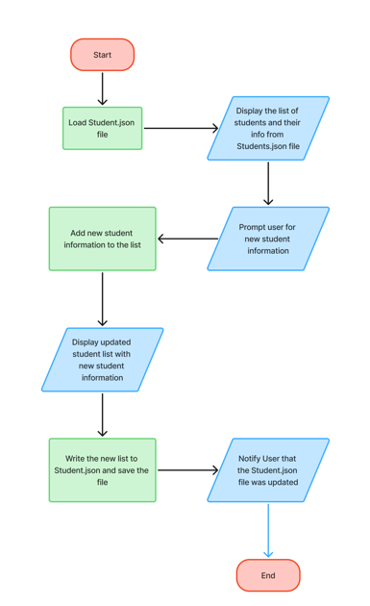

Program Results:
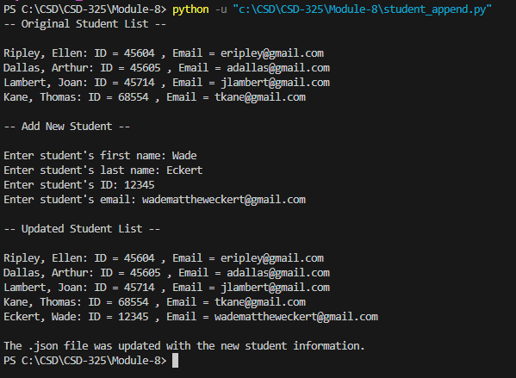
Windows Notification:
No matter what I tried, I could not get a similar notification to this to pop up:
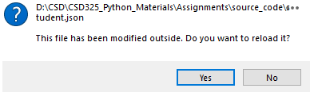
I tried running the python script in the command line, Powershell, and VS Code, and I never could get a notification like that to show up. The script runs correctly and appends/writes to the Student.json file, yet I get no notification. I’ve tried a few different fixes to no avail. My research shows it might be an issue with VS Code’s file watcher and there is no fix, but I am not technically sound enough to troublshoot this issue. I hope this small issue won’t affect my grade.
Updated Student.json Contents:
