Assignment 2.2: Documented Debugging

Wade Eckert
Bellevue University
CSD 325: Advanced Python
Professor Ed Parks
December 14, 2025

Assignment 1.2: Documented Debugging

1.) Start of the Debugging Process with Breakpoint:
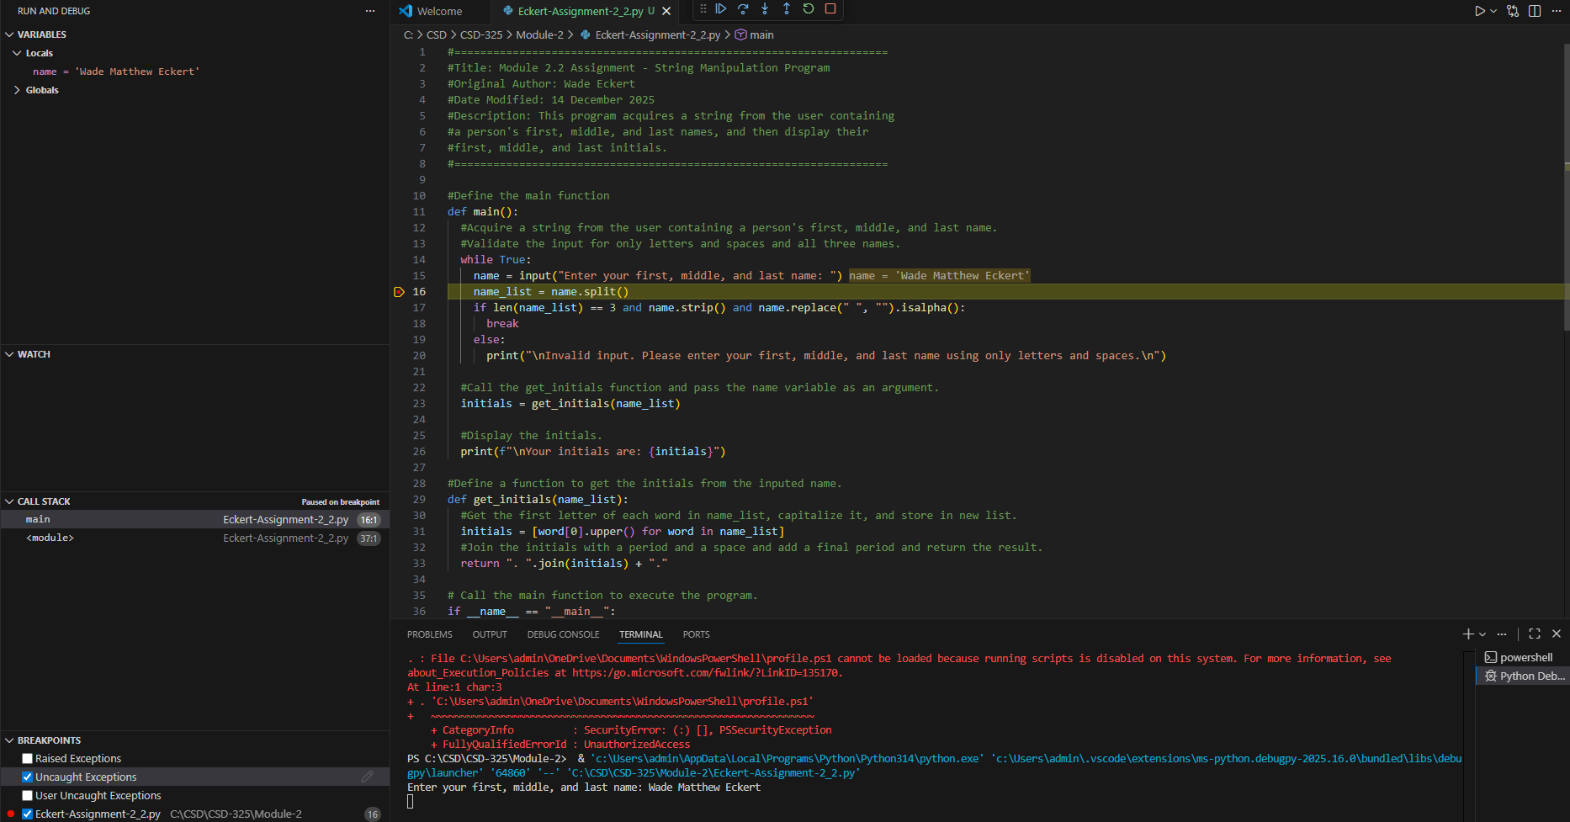

Breakpoint Location Explanation:
For the first debugging step, I placed the breakpoint on line 16, immediately after the user input is stored in the name variable. I chose this location so that the debugger would pause after the input had been collected, allowing the variable view panel to display the actual value entered by the user. This makes it easier to verify that the program is correctly capturing input before any validation or processing occurs. Placing the breakpoint here provides a clear snapshot of the program’s state at an important transition point, between user interaction and program logic, which is useful for understanding and debugging the overall flow of the program.
2.) Stepping Into the Function:

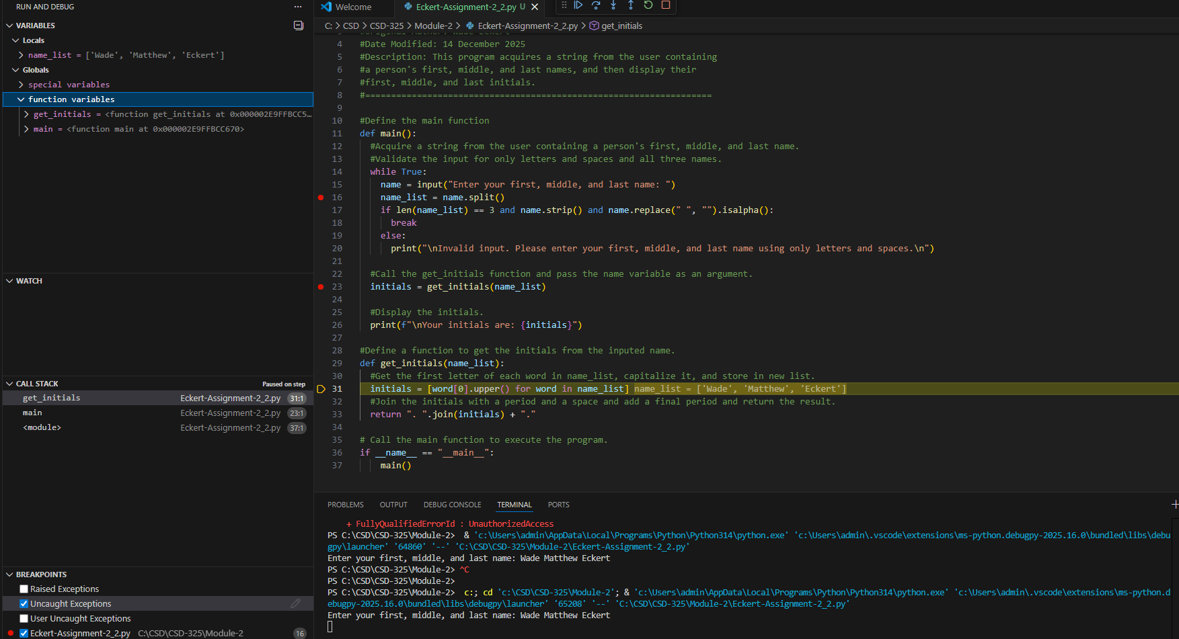

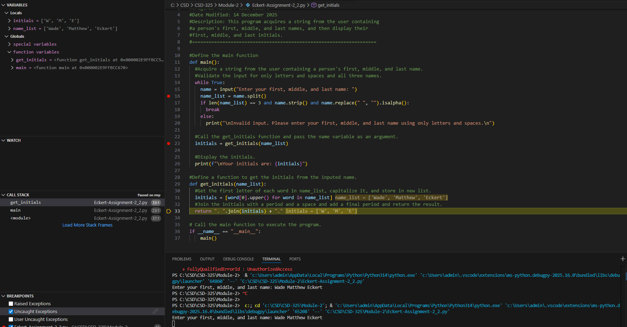
Explanation of My Use of Step Into:
For the second debugging step, I used the Step Into action to move execution from the main program into the get_initials function. I stepped into the function twice in order to observe the program at different points within the function. The first step allowed me to view the name_list parameter as it was passed into the function, confirming that the list of name parts was received correctly. The second step allowed me to observe the creation of the initials variable as the function processed the data. This approach helped show how the data flows from the main program into another function and how that data is transformed step-by-step.

3.) Adding Intentional Error to Capture Debugger Response:
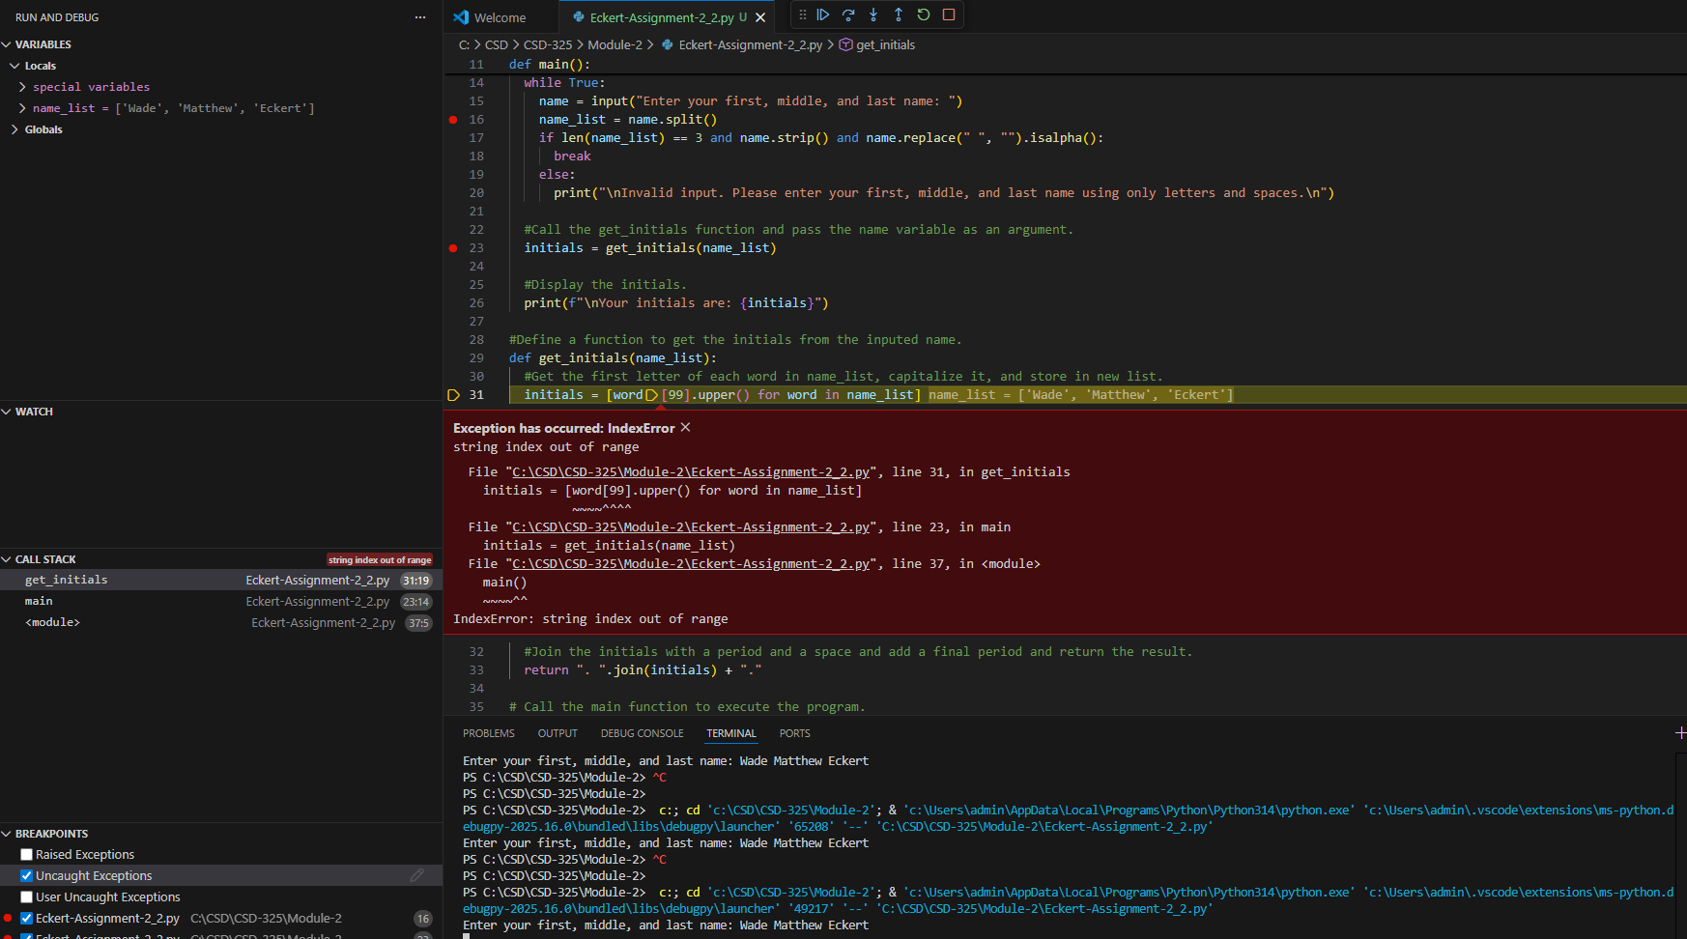

Explanation of Intentional Error for Debugging:
For the third debugging step, I intentionally introduced an index error within the get_initials function to observe how the debugger responds to a runtime error. By forcing an error to occur, the debugger paused execution at the exact line where the problem happened and displayed the associated error information. This is useful for debugging because it shows how the debugger can be used to quickly identify the source and location of an issue, rather than relying on trial and error or print statements. Intentionally creating this error helped demonstrate how debugging tools assist in diagnosing problems and understanding program flow.

