Assignment 4.2: High/Low Temperatures

Wade Eckert
Bellevue University
CSD 325: Advanced Python
Professor Ed Parks
January 17, 2026

Assignment 4.2: High/Low Temperatures

Flowchart before brownsfield update:
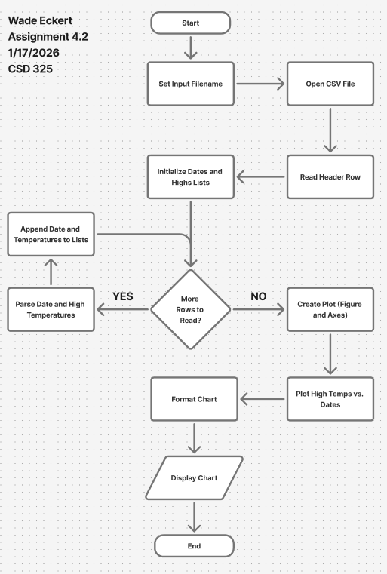
Flowchart after brownsfield update:
