Assignment 10.2: GUI To-Do

Wade Eckert
Bellevue University
CSD 325: Advanced Python
Professor Ed Parks
March 1, 2026

Assignment 10.2: GUI To-Do

Tutorial Code Output:
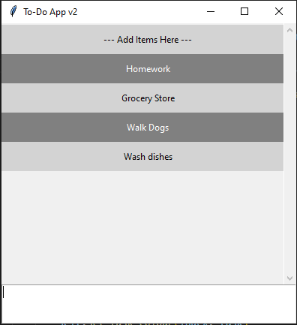

Ouput After Changes:
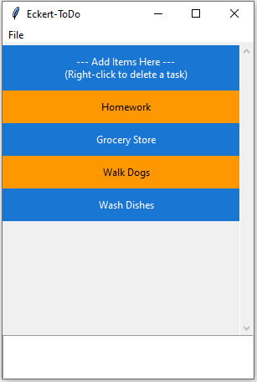

Deleting a Task:
