Assignment 1.2: GitHub Repository Setup

Wade Eckert
Bellevue University
CSD 325: Advanced Python
Professor Ed Parks
November 30, 2025

Assignment 1.2: GitHub Repository Setup

Link to GitHub Repository: https://github.com/WadeEckert/CSD-325
Screenshots of GitHub Repository:
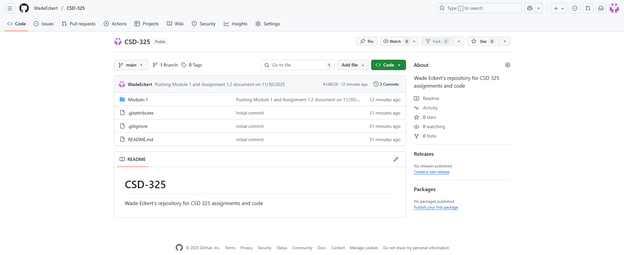
Screenshot of GitHub Repository with Module 1 Directory Pushed:
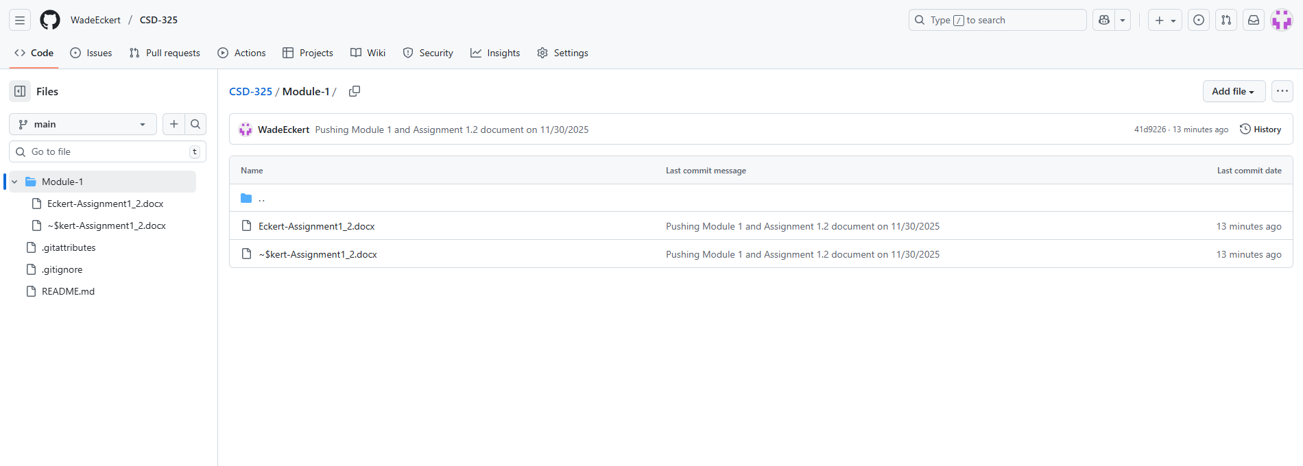
Screenshot of Local Directory:
