Assignment 1.3: Building a Web Page Exercise, Part 1

Wade Eckert
Bellevue University
CSD 340: Web Development with HTML and CSS
Dr. Mortoza Abdullah
March 18, 2026
https://github.com/WadeEckert/CSD-340

Assignment 1.3: Building a Web Page Exercise, Part 1

Initial Error Screen:
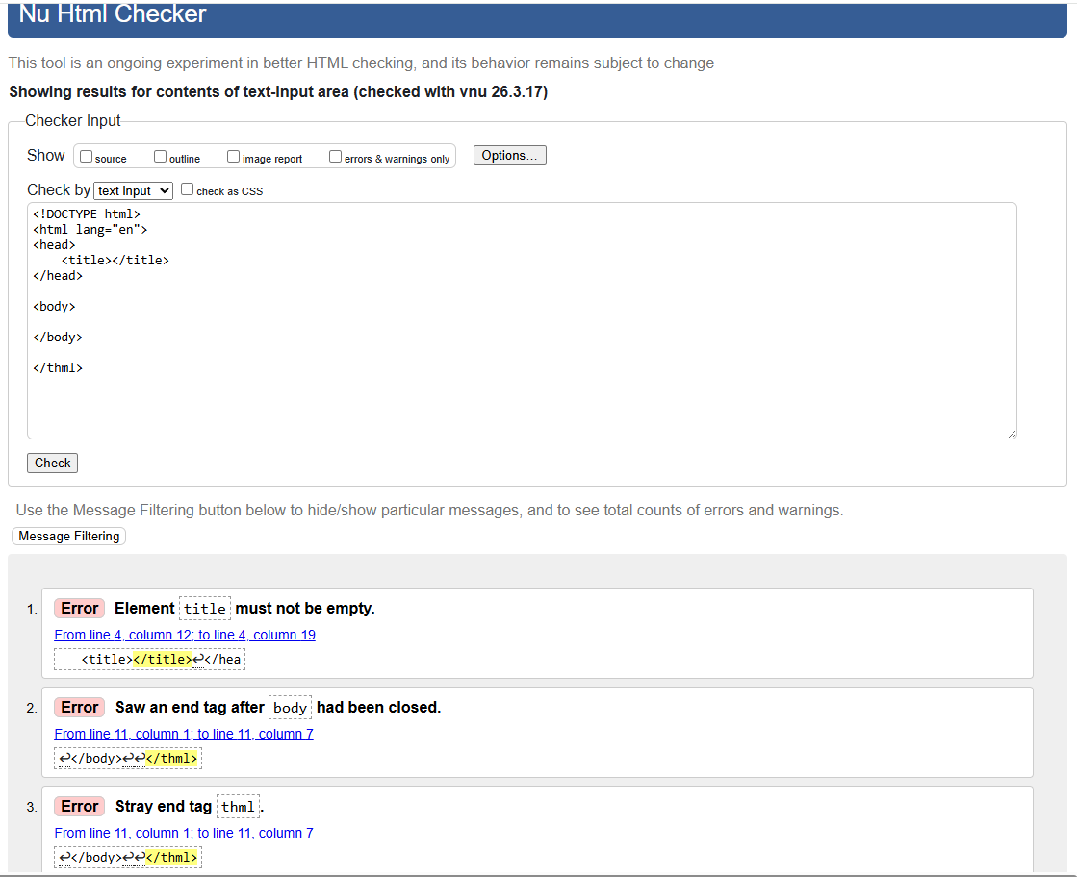

Corrected - No Errors Screen:
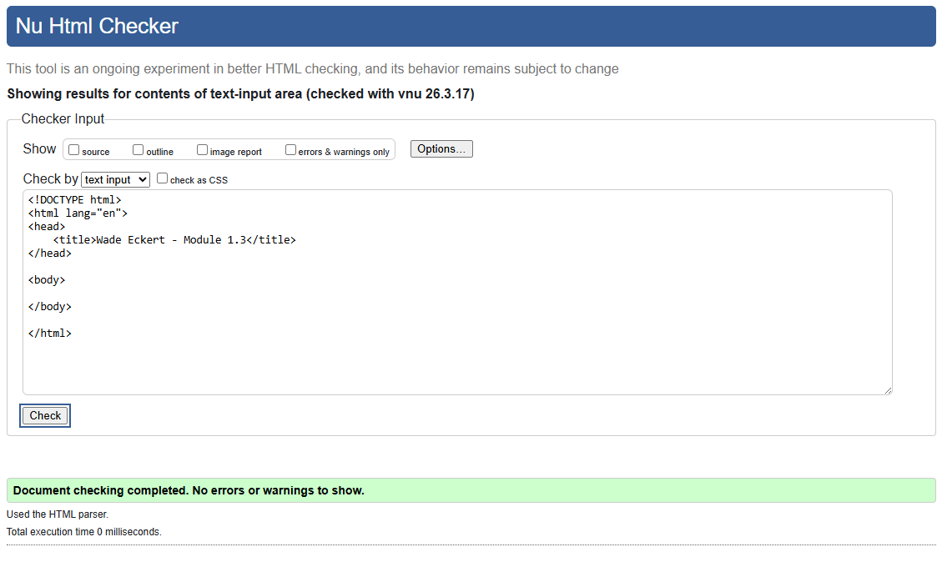
Validation After Updating:
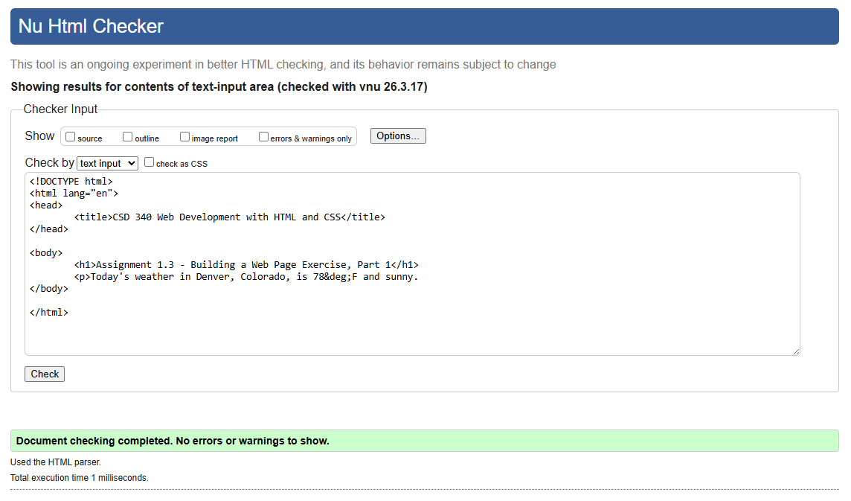
Browser Output:
