Assignment 1.2: GitHub Repository Setup

Wade Eckert
Bellevue University
CSD 340: Web Development with HTML and CSS
Dr. Mortoza Abdullah
March 14, 2026
https://github.com/WadeEckert/CSD-340

Assignment 1.2: GitHub Repository Setup

Link to GitHub Repository: https://github.com/WadeEckert/CSD-340
Local Directory Setup Instructions:
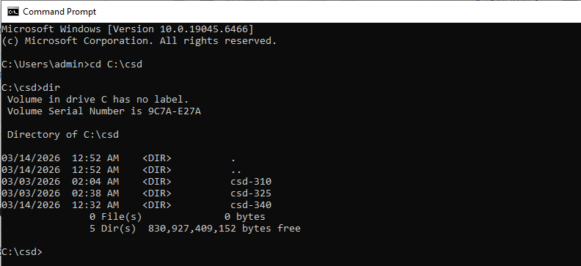
Modify README.md: 