Assignment 3.2: GitHub Pages

Wade Eckert
Bellevue University
CSD 340: Web Development with HTML and CSS
Dr. Mortoza Abdullah
April 1, 2026
https://github.com/WadeEckert/CSD-340

Assignment 3.2: GitHub Pages

W3C HTML Validator:

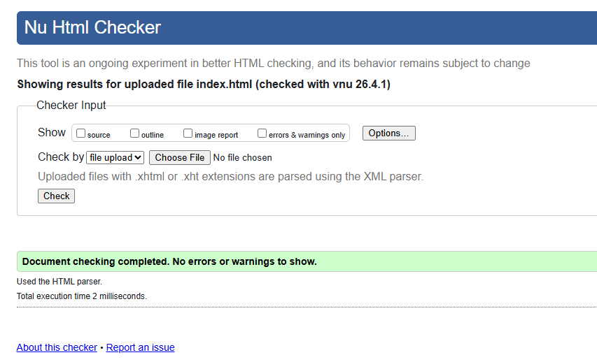

W3C CSS Validator:
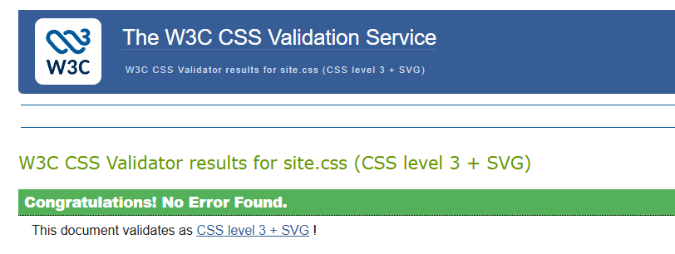

GitHub Pages Landing Page:
