Assignment 5.2: bioSite Ideas, Sketches, and Inspiration

Wade Eckert
Bellevue University
CSD 340: Web Development with HTML and CSS
Dr. Mortoza Abdullah
April 17, 2026
https://github.com/WadeEckert/CSD-340
https://wadeeckert.github.io/CSD-340/

Assignment 5.2: bioSite Ideas, Sketches, and Inspiration

Interview Questions and Answers with Leigh Barrera:
1. Can you tell me a little about your early life and what you were like growing up?
I was born in Dallas, Texas, and grew up in a pretty academically focused household since my parents ran a law office together. Even with that environment, I was always drawn to art. That was really my thing from a young age, drawing, creating, and just being in that kind of imaginative space. I think I was always a little introspective, but also very curious about how things worked, both creatively and logically.

2. How did your move to Las Vegas, New Mexico impact you during high school?
That move was a big shift. I went from a larger city to a much smaller, quieter place, and I think it gave me more space to reflect and focus on what I cared about. It also made me more independent. I graduated from high school there in 2008, and by that point I knew I wanted to pursue something creative, even if I didn’t fully know what that would look like yet.

3. You originally went to art school, what drew you to that path?
Art was always the thing that made the most sense to me. It felt natural, like something I didn’t have to force. Going to art school in Boston, and later Portland, was my way of fully committing to that. I wanted to build a life around creating things, whether that was visual art, design, or storytelling.

4. You faced some serious health challenges in your early 20s. How did that experience shape you?
That was probably one of the most defining periods of my life. I had degenerative bone disease in my hip, and it took years for doctors to really understand what was happening. During that time, I was dealing with a lot of uncertainty and pain, and it eventually led to a full hip replacement. It forced me to slow down and rethink my path, but it also made me more resilient and more aware of what actually matters to me.

5. After that period, how did you find your way into web design and development?
When I moved to Denver, I was trying to rebuild things and figure out a direction that was both creative and practical. I started teaching in different ways, substitute teaching and even teaching coding online to younger students, which helped me realize I enjoyed working with technology. Going back to school at Bellevue University for Web Design and Graphic Design felt like the right balance between creativity and structure.

6. What do you enjoy most about your current role as a front-end developer and graphic designer?
I like that it combines problem-solving with creativity. Front-end work lets me build things that people actually interact with, while design allows me to think about aesthetics and user experience. It feels like a natural extension of the artistic mindset I’ve always had, just applied in a different medium.

7. You’re also working on multiple writing projects. What draws you to storytelling?
Storytelling has always been there for me, even before I started writing things down seriously. I’ve had the Western story in my head since high school, and it just stayed with me. Writing feels like another form of art, but it’s more layered. I like building worlds, characters, and themes that explore darker or more psychological ideas.

8. Can you describe your Western series and what makes it unique?
It’s a three-part series set in an alternative version of history, with elements of the paranormal. It falls into the Weird West genre, so it blends historical settings with darker, psychological, and supernatural elements. I think what makes it unique is that it’s not just about the setting, it’s about the emotional and psychological experiences of the characters.

9. You’re also writing a medieval fantasy. How is that different from your Western?
The medieval fantasy is more of an epic story with a mystery aspect to it. It focuses more on world-building and unfolding a larger narrative over time. Compared to the Western, it leans more into traditional fantasy elements, but still keeps that darker, more introspective tone that I tend to write with.

10. How would you describe yourself in your own words?
I would say I’m intellectual, creative, and empathetic. I like understanding things deeply, whether that’s ideas, people, or systems. At the same time, I’m always drawn to creating something, and I try to stay aware of how others experience the world.

11. Outside of work and writing, what do you enjoy doing in your free time?
I like spending time at home watching shows or anime with Wade, taking our dogs on walks, and going out to places like art museums or comedy shows. I also really enjoy driving into the mountains and visiting small towns. It’s a nice way to disconnect and reset.

12. You’re known for being a great cook. What do you enjoy about cooking?
Cooking feels a lot like another form of creativity. I like being able to adjust things intuitively, especially based on smell or taste. It’s satisfying to bring everything together, especially during holidays when I’m cooking for family. I tend to enjoy making things like roasts, stews, Hispanic dishes, and bread.

13. What are some of your current goals moving forward?
Right now, I really want to improve my back-end programming skills so I can become more well-rounded as a developer. At the same time, finishing my novels is a big goal. Those stories have been with me for a long time, and I want to actually bring them to life.

14. How did you and Wade meet, and what stands out about your relationship?
We met in January 2022, and one of the funny things is that we share the exact same birthday, March 9th. It’s a small detail, but it always stood out to me. What I value most is how easy it is to just spend time together, whether we’re at home or out doing something simple.

Formal Bio:
Leigh Barerra is a front-end developer and graphic designer whose work blends creativity with technical problem-solving. Born on March 9, 1990, in Dallas, Texas, she grew up in a family that valued both intellectual rigor and professional discipline, as her parents operated a law office together. Despite this environment, Leigh developed an early passion for art, which became a defining influence throughout her life.
During her high school years, Leigh relocated with her parents to Las Vegas, New Mexico, where she graduated in 2008. She initially pursued her artistic interests through formal education, attending art school in both Boston and Portland. However, her academic path was interrupted by a prolonged and challenging medical condition. After years of uncertainty and misdiagnosis, she was diagnosed with degenerative bone disease in her hip, which ultimately required a full hip replacement. This experience significantly shaped her perspective, reinforcing her resilience and prompting her to reevaluate her career direction.
After relocating to Denver, Colorado, Leigh began rebuilding her path by exploring both teaching and technology. She worked as a substitute teacher and also taught coding to younger students online, which helped spark a deeper interest in digital development. She later completed her degree in Web Design and Graphic Design at Bellevue University, where she developed a strong foundation in both visual design and front-end development.
Leigh currently works at RTI (Research Triangle Institute), where she applies her skills to create engaging and functional digital experiences. Beyond her professional work, she is an active writer, developing multiple works of fiction, including a three-part Weird West series and a medieval epic fantasy. Her writing often explores psychological depth, alternative history, and immersive world-building.
In her personal life, Leigh enjoys spending time with her husband, Wade, as well as their two dogs, exploring art museums, cooking, and traveling to small mountain towns. She is driven by a desire to continue growing both creatively and technically, with goals of expanding her back-end programming skills and completing her long-developed literary projects.

Portrait:


Hobby Images:

Outside of her professional life, Leigh’s creativity shows up in more personal ways, especially in the kitchen. Cooking has become one of the ways she takes care of the people around her, whether it’s preparing everyday meals or cooking for family during the holidays. She has a natural instinct for it, often relying on smell and experience rather than strict measurements. From slow-cooked roasts to homemade bread and traditional Hispanic dishes, cooking is both a creative outlet and a way she brings people together.
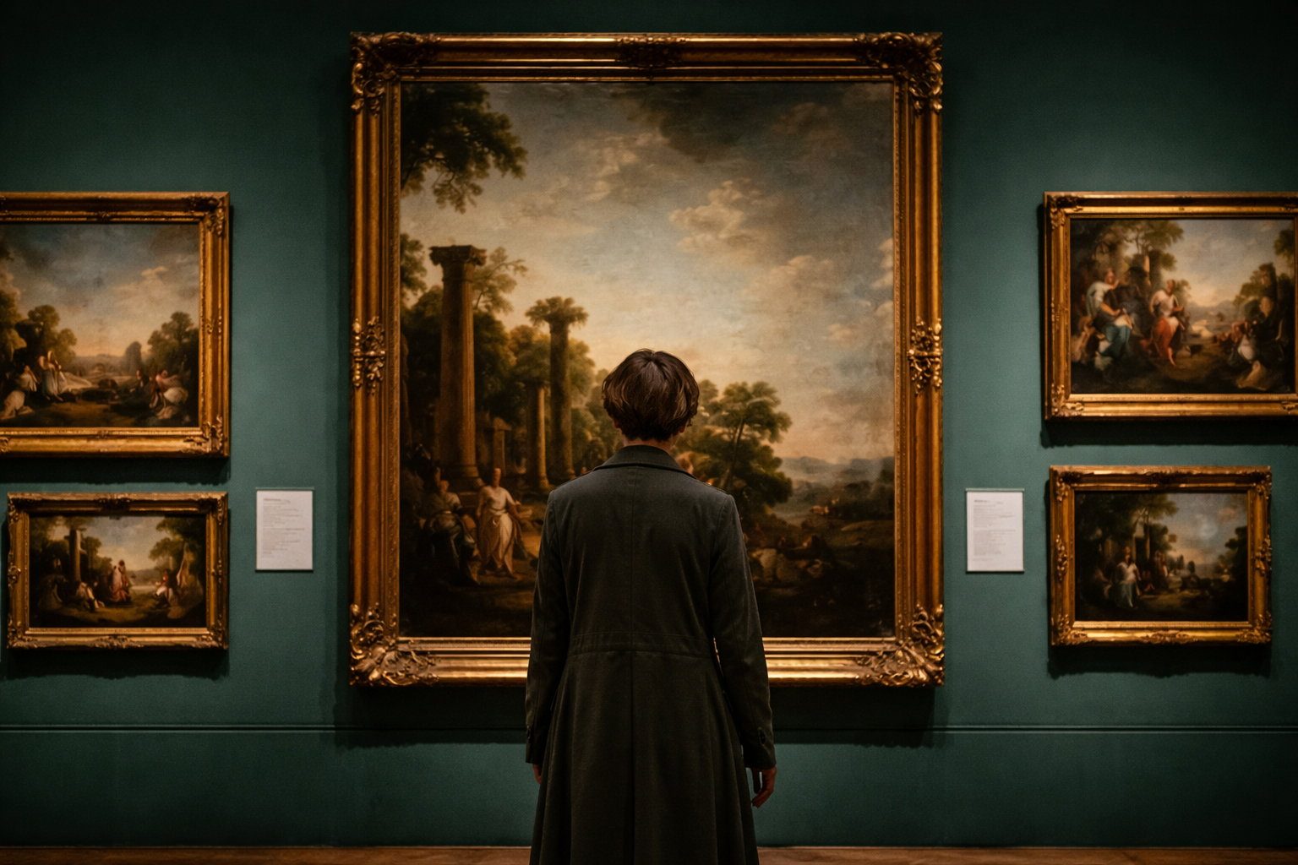
Even as her career has moved into the digital world, Leigh has never lost her connection to traditional art. Visiting museums is something she continues to enjoy, not just for inspiration but for appreciation. Seeing the work of other artists, across different styles and time periods, keeps her connected to the creative world that first inspired her. It also influences how she approaches her own work, reminding her that creativity is always evolving.
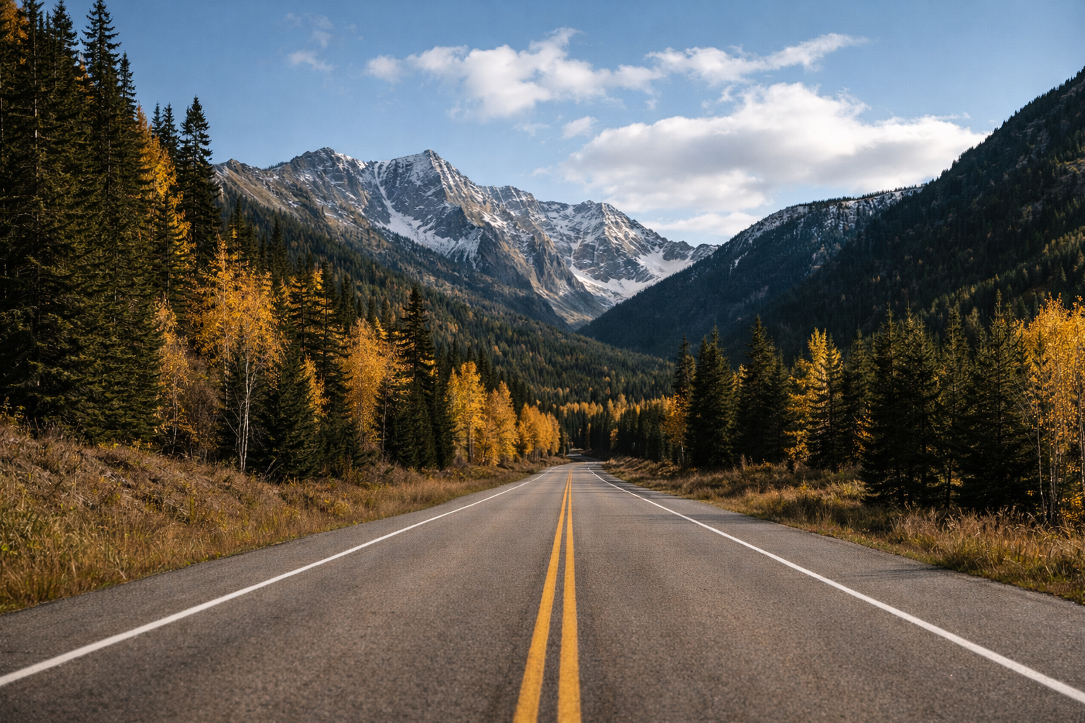
Some of Leigh’s favorite moments are the simplest ones, like driving through the mountains and visiting small towns. These trips give her a chance to slow down and step away from the structure of daily life. Surrounded by nature, she’s able to reset, reflect, and enjoy the quiet in a way that contrasts with her busy work and creative projects. It’s a reminder of how important balance is in her life.

Goals/Personal Accomplishments Images:
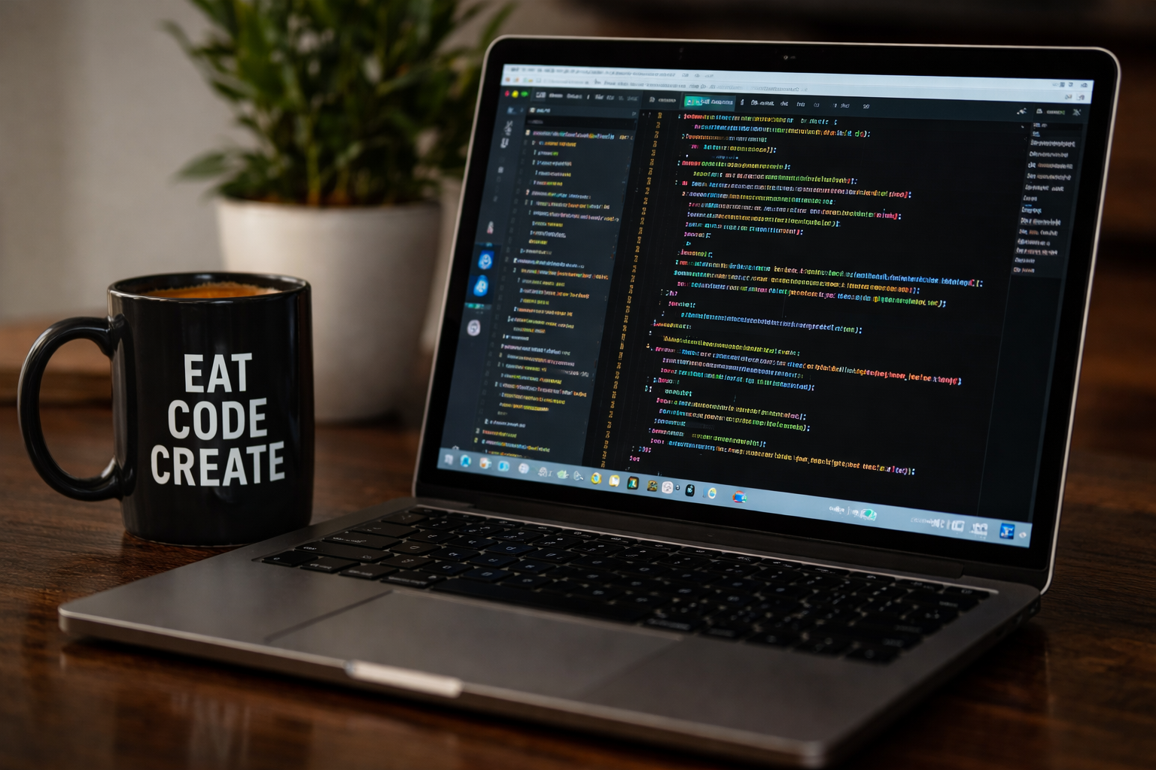
As her path evolved, Leigh found a way to carry that same creativity into a new medium. After facing health challenges that forced her to step away from art school, she shifted her focus toward web design and development. Through her studies at Bellevue University, she learned how to combine visual creativity with technical problem-solving. Today, she brings those skills together in her work as a front-end developer and graphic designer, using code as another form of creative expression. She is currently working hard to become more proficient in her back-end development skills to add to her all-around skill set.
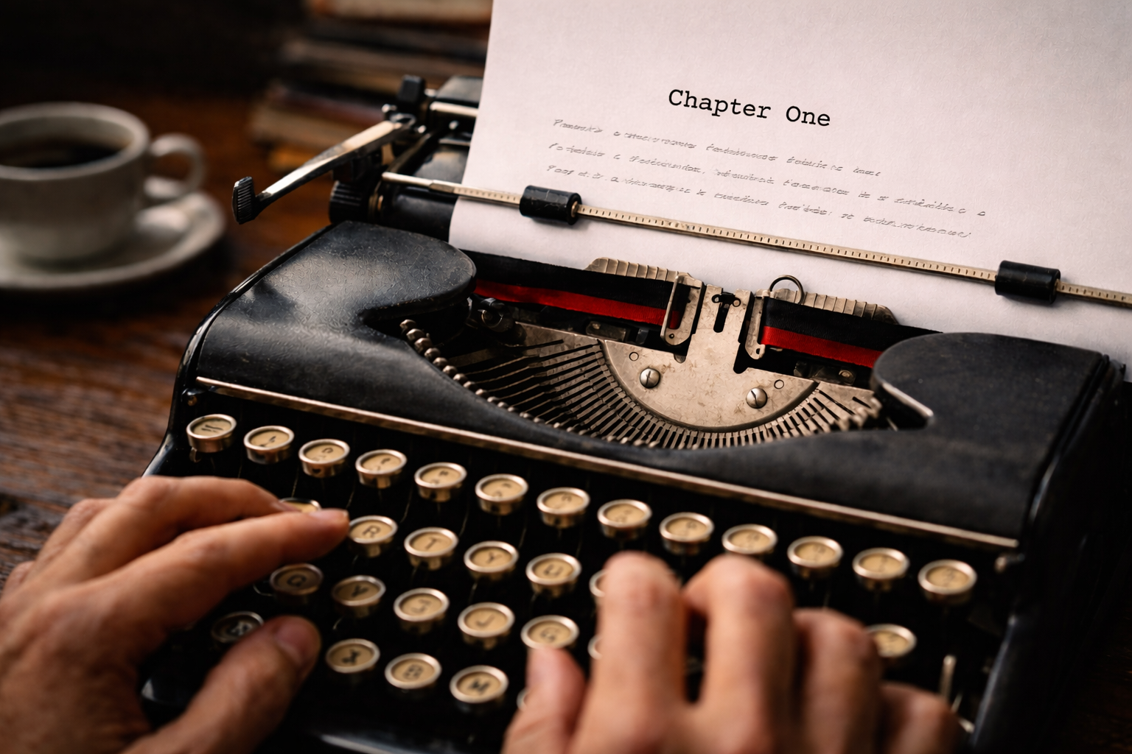
One of the most personal parts of Leigh’s creative life is her writing. Since high school, she has been developing stories that she is now actively working to bring to life. Her projects include a three-part Weird West series with dark, psychological, and paranormal elements, as well as a medieval fantasy with a mystery aspect. While these stories are still in progress, they represent a long-term goal she has carried with her for years, and a commitment to telling stories in her own voice.
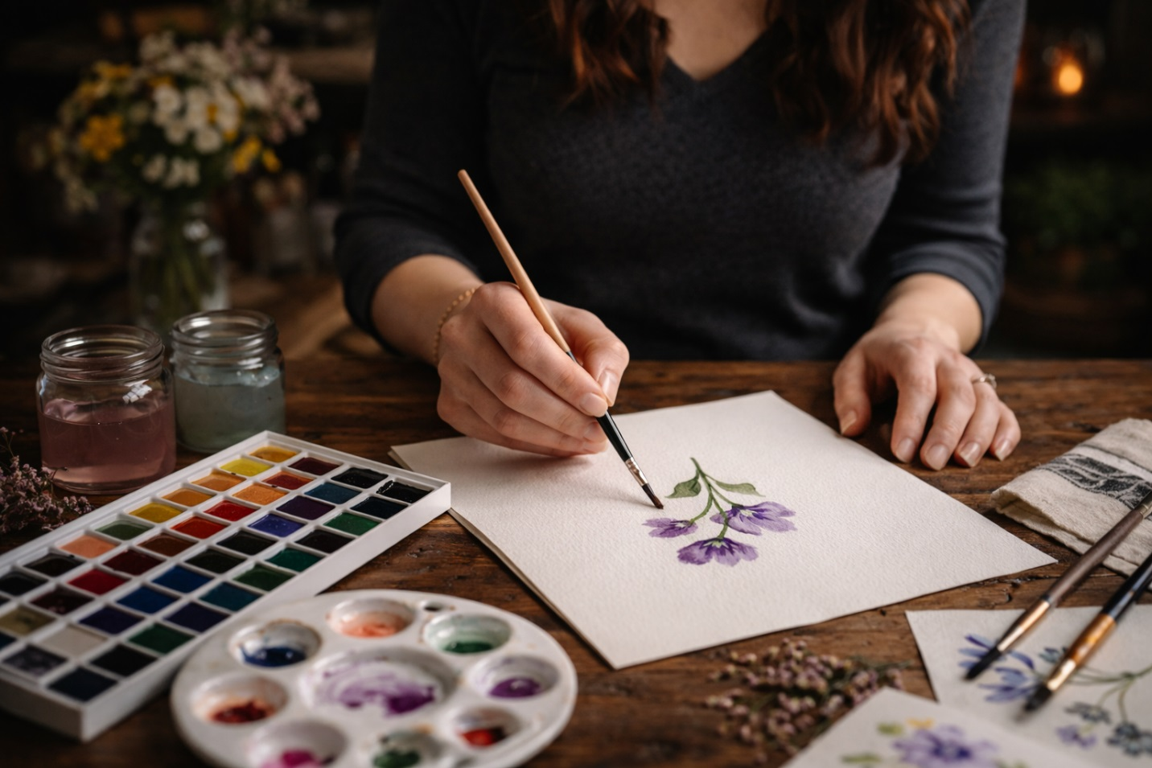
Art has always been at the center of Leigh’s life. From a young age, she was drawn to painting and other creative outlets as a way to express herself and make sense of the world around her. It wasn’t just something she enjoyed, it was something that shaped how she thought and who she wanted to become. That early passion for art would eventually guide many of her decisions, influencing both her education and her career path.

External Link (LinkedIn Profile):
https://www.linkedin.com/in/leigh-m-barrera?trk=people-guest_people_search-card

Front-end Style Guide:

1. Overall Design Direction:
The visual style I am aiming for with this site is centered around warmth, creativity, and clarity. Leigh’s story blends together art, technology, and personal life, so the design reflects that balance by combining the following aspects:
- Warm, natural tones (art, cooking, mountains)
- Clean structure (web design, professionalism)
- Soft contrasts (to keep it readable and inviting)
The goal is to create a site that feels personal and artistic, but still structured and modern.

2. Color Palette:
I choose this color palette as these colors are close to the tones in the images (wood tones, greenery, neutral backgrounds, and soft highlights).

Primary Colors:
- Deep Forest Green: #2F4F4F
  - Used for headers, accents, and navigation
- Warm Cream: #F5F1E8
  - Main background color (soft and easy on the eyes)

Secondary Colors:
- Muted Terracotta: #C97C5D
  - Accent color (buttons, highlights)
- Soft Sage Green: #A3B18A
  - Secondary accents (hover states)

Neutral Colors:
- Charcoal Gray: #333333
  - Main text color
- Light Gray” #E0E0E0
  - Borders, dividers

3. Typography:
The typography for this site was chosen to reflect Leigh’s balance between creativity and structure. The combination of a serif and sans-serif font allows the design to feel both personal and professional, supporting readability while still maintaining an artistic tone.

Primary Heading Font (H1, H2, H3):
Playfair Display (Serif):
- Elegant and expressive, which reflects Leigh’s artistic background
- Works well for storytelling sections like the About page
- Adds personality without overwhelming the layout
Usage:
- Page titles (H1)
- Section headers (H2, H3)
- Featured quotes
Example Styling:
- H1: 40–48px
- H2: 28–32px
- H3: 22–24px
- Font weight: 600–700

Body Font (Paragraphs, General Content):
Open Sans (Sans-serif):
- Clean and highly readable
- Keeps the site modern and structured looking
- Balances out the decorative serif headings
Usage:
- Paragraph text
- Image descriptions
Example Styling:
- Font size: 16–18px
- Line height: 1.6–1.8
- Font weight: 400

Accent / UI Font (Navigation):
Montserrat (Sans-serif):
- Slightly more geometric and modern
- Helps distinguish interactive elements from body text
Usage:
- Navigation menu
- Buttons
- Links
- Labels
Example Styling:
- Font size: 14–16px
- Font weight: 500–600
- Letter spacing: 0.5px–1px

Layout/Spacing Notes:
Here are the various spacing guidelines I will try and follow when developing the layout of the site:
- Use consistent margins (40–80px) between sections
- Max content width: 1000–1200px
- Use whitespace intentionally (don’t crowd content)
- Keep text aligned left for readability
- Images should be:
  - consistent size
  - evenly spaced
  - aligned with text

Wireframes:
