CSD 380 - GitHub Repository Setup

Wade Eckert
Bellevue University
CSD 380: DevOps
Professor Nathan Braun
June 6, 2026
https://github.com/WadeEckert/CSD-380

CSD 380 - GitHub Repository Setup

Link to GitHub Repository: https://github.com/WadeEckert/CSD-380
Screenshot of GitHub Repository:
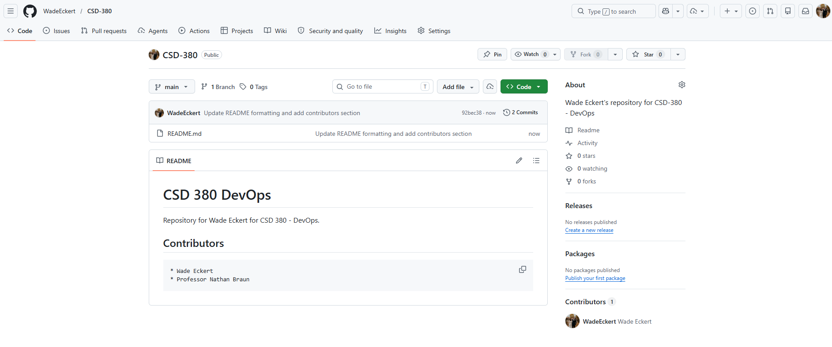
Screenshot of Local Directory:
