Test Case Plan
Todo Application Test Plan
Name | Zak Nizam
Assignment | Module 4.2 Assignment - Test Plan Discussion
Project | Todo Application Test Plan
Course | CSD380-T301 DevOps (2267-1)
Description | Functional test plan for the Todo application based on the Todo Business Requirements document. The plan covers URL access, task list viewing, task creation, task editing, task deletion, form validation, invalid URL handling, and mobile/tablet views.
Date | 2026/07/02

Table of Contents
Test 1: Website Access and Task List View 2
Test 2: Create Todo Task and Add Form Validation 3
Test 3: Edit Todo Task and Edit Form Validation 4
Test 4: Delete Todo Task 5
Test 5: Invalid URL and Responsive Device Views 6

Testing note: Peer tester fields and screenshots should be completed by the assigned peer tester after they execute the same steps. Developer pass/fail values should be updated if an observed result differs from the expected result.

Test 1: Website Access and Task List View
Test Objective |  | Verify users can access the Todo website through the standard URL and view the list of todo task items. Covers requirements 10 and 1.
Developer |  | Zak Nizam |  | Peer tester |  | Wade Eckert
Date tested |  | 2026/07/02 |  | Date tested |  | 2026/07/04
Step | Action |  | Expected results |  | Developer pass/fail |  | Tester pass/fail + Screenshot
1 | Visit https://buwebdev.github.io/todo/. |  | The Todo application loads without a browser or application error. |  | Yes |  | Yes  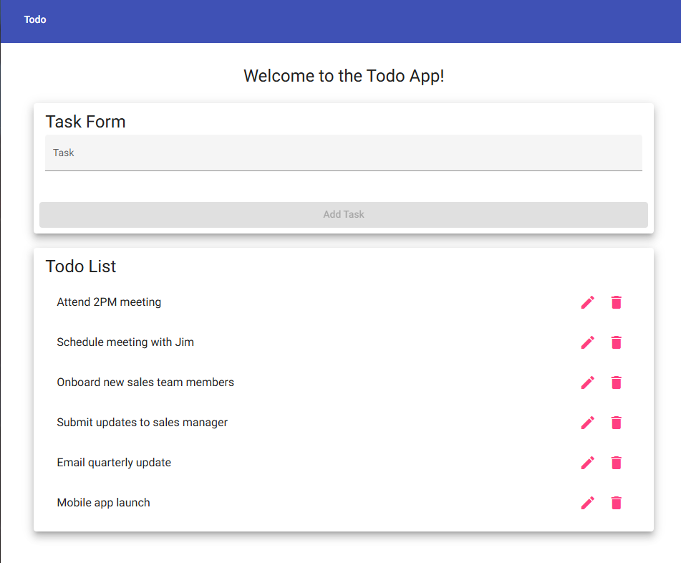
2 | Confirm the page header/navigation displays Todo and the welcome message is visible. |  | The landing page content is visible and readable. |  | Yes |  | Yes  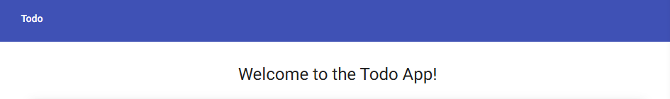
3 | Confirm the Task Form area displays a Task input field and Add Task button. |  | The task entry form is present on the landing page. |  | Yes |  | Yes  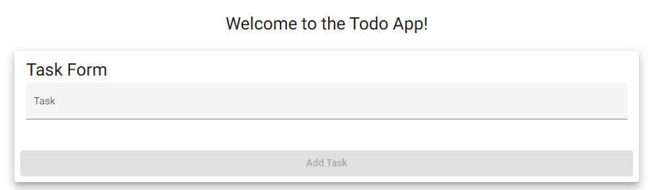
4 | Confirm the Todo List section displays multiple task items. |  | The task list is visible with existing todo items and edit/delete controls. |  | Yes |  | Yes  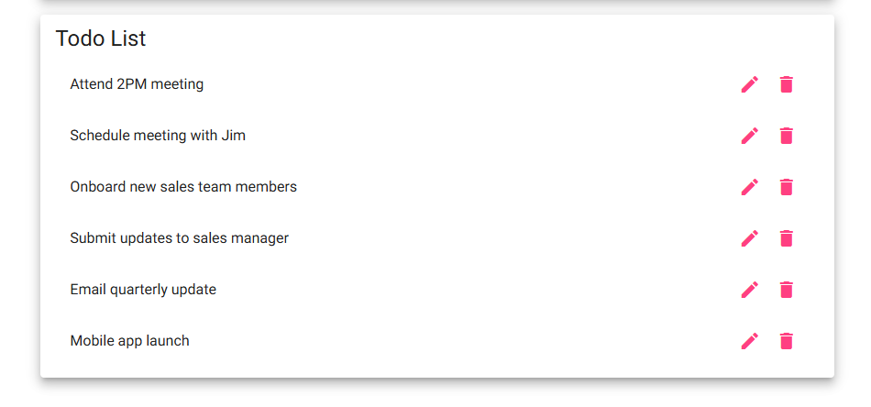
5 | Refresh the browser window. |  | The application reloads at the same URL and the Todo List view remains available. |  | Yes |  | Yes  
Comments |  |  | The application loaded successfully from the provided URL without any browser or application errors. All required page elements, including the navigation bar, welcome message, task entry form, and Todo List, were displayed correctly, and refreshing the page reloaded the application as expected. –Wade Eckert

Test 2: Create Todo Task and Add Form Validation
Test Objective |  | Verify a user can create a new todo task item and cannot submit the add task form without entering a todo item. Covers requirements 2 and 6.
Developer |  | Zak Nizam |  | Peer tester |  | Wade Eckert
Date tested |  | 2026/07/02 |  | Date tested |  | 2026/07/04
Step | Action |  | Expected results |  | Developer pass/fail |  | Tester pass/fail + Screenshot
1 | Open the Todo application and leave the Task input field blank. |  | The task form is displayed and no task text has been entered. |  | Yes |  | Yes  
2 | Attempt to submit the blank form or confirm the Add Task button is disabled. |  | The blank task is not added to the Todo List. |  | Yes |  | Yes  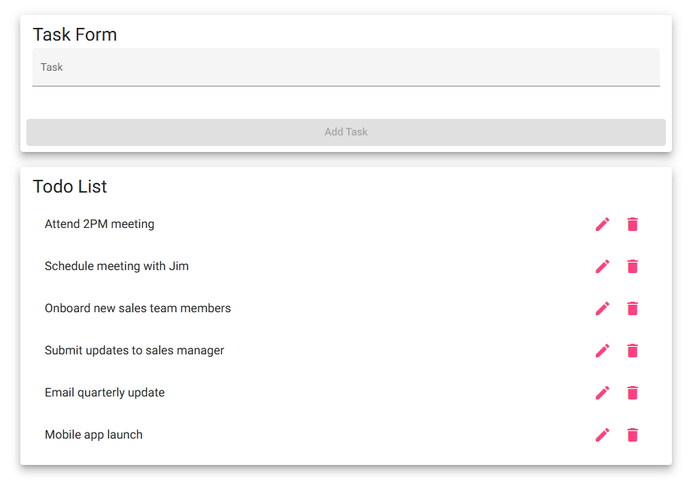
3 | Enter a unique task name such as Test task - Module 4.2. |  | The task text appears in the Task input field. |  | Yes |  | Yes  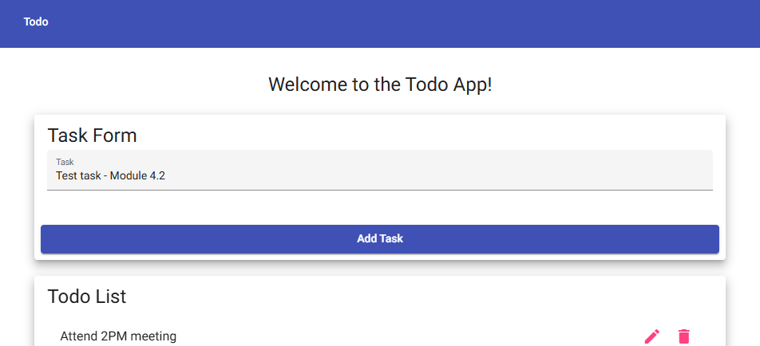
4 | Click the Add Task button. |  | The new task appears in the Todo List. |  | Yes |  | Yes  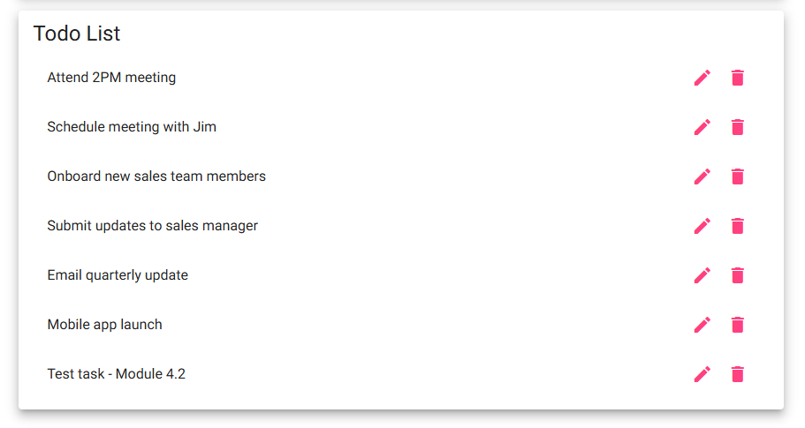
5 | Confirm the form is ready for another entry and no duplicate/error message appears. |  | The application remains usable after the task is added. |  | Yes |  | Yes  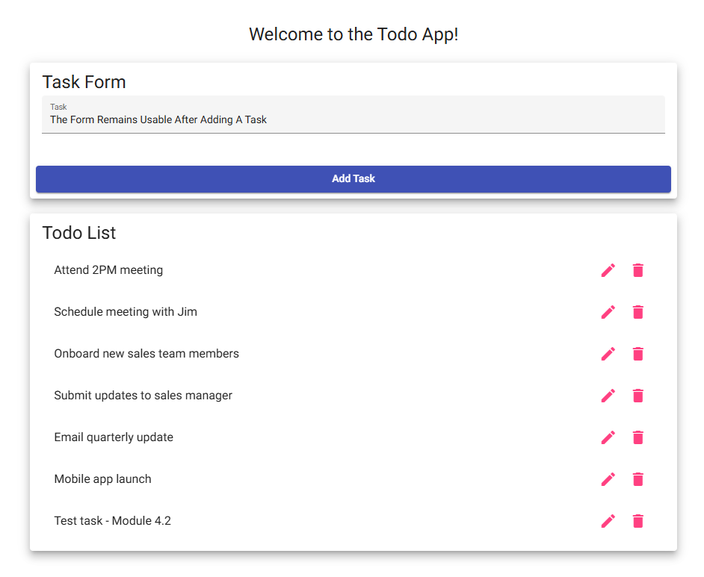
Comments |  |  | All steps passed successfully. A new task was created and displayed correctly, and the application prevented submission of an empty task by keeping the Add Task button disabled until valid input was entered. –Wade Eckert

Test 3: Edit Todo Task and Edit Form Validation
Test Objective |  | Verify a user can edit a todo task item and cannot submit the edit form without entering a todo item. Covers requirements 3 and 7.
Developer |  | Zak Nizam |  | Peer tester |  | Wade Eckert
Date tested |  | 2026/07/02 |  | Date tested |  | 2026/07/04
Step | Action |  | Expected results |  | Developer pass/fail |  | Tester pass/fail + Screenshot
1 | Locate Test task - Module 4.2 or another existing task and click the edit/pencil icon. |  | The edit form opens for the selected task. |  | Yes |  | Yes  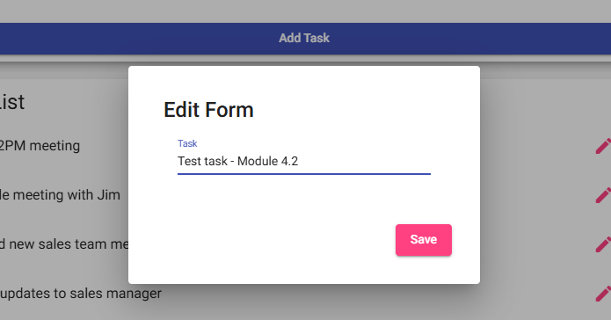
2 | Confirm the edit form displays the current task text. |  | The selected task text is populated in the edit input field. |  | Yes |  | Yes  
3 | Delete all text from the edit field and attempt to save, or confirm the Save button is disabled. |  | The blank edit is not saved and no empty task is created. |  | Yes |  | No  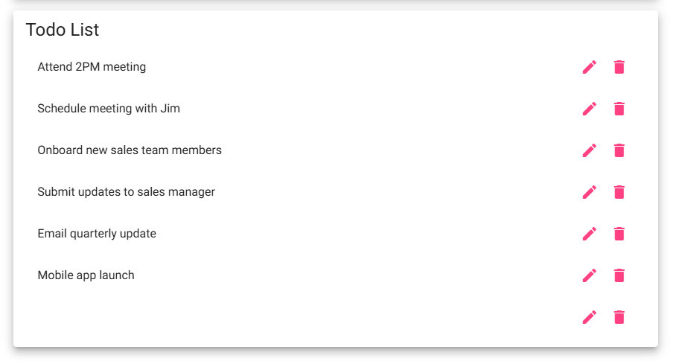
4 | Enter Updated test task - Module 4.2 and click Save. |  | The edit form saves the updated task text. |  | Yes |  | Yes  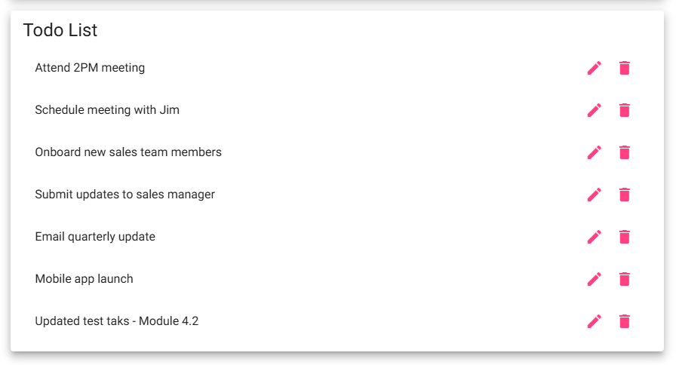
5 | Return to the Todo List and confirm the updated task is displayed. |  | The Todo List shows the updated task and no blank task item appears. |  | Yes |  | Yes  
Comments |  |  | Most editing functionality worked as expected, including opening the edit form and updating an existing task. However, the application did not prevent a blank edit from being submitted as described in Step 3, so that step was marked as a failure. The validation for empty edits should be reviewed. –Wade Eckert

Test 4: Delete Todo Task
Test Objective |  | Verify a user can delete a todo task item from the Todo List. Covers requirement 4.
Developer |  | Zak Nizam |  | Peer tester |  | Wade Eckert
Date tested |  | 2026/07/02 |  | Date tested |  | 2026/07/04
Step | Action |  | Expected results |  | Developer pass/fail |  | Tester pass/fail + Screenshot
1 | Confirm a disposable test task exists, or create one named Delete me - Module 4.2. |  | A task is available to delete without relying on default tasks. |  | Yes |  | Yes  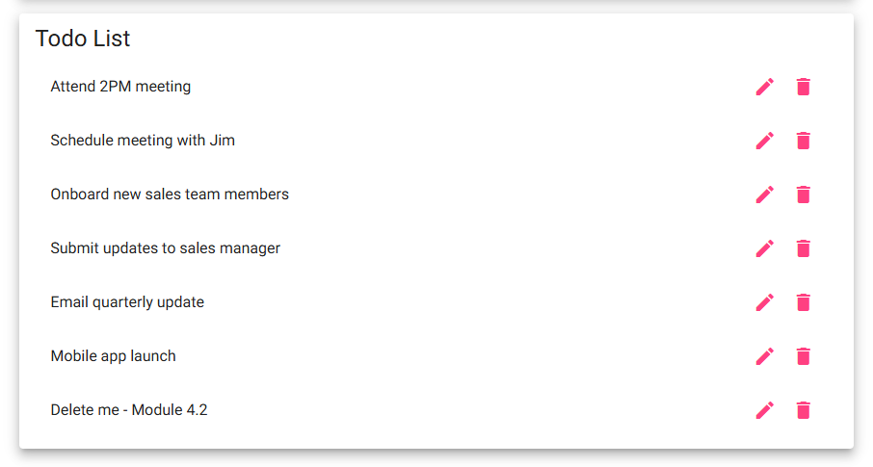
2 | Click the trash/delete icon for the disposable test task. |  | The delete action is accepted by the application. |  | Yes |  | Yes  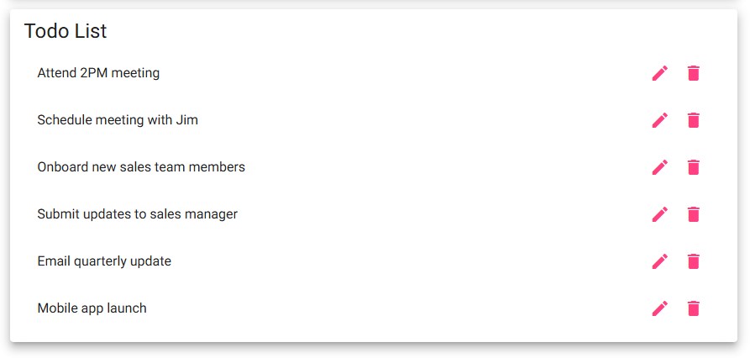
3 | Confirm the selected task is removed from the Todo List. |  | The deleted task no longer appears in the list. |  | Yes |  | Yes  
4 | Confirm the other Todo List items are still visible. |  | Only the selected task is removed; unrelated tasks remain unchanged. |  | Yes |  | Yes  
5 | Continue using the page after deletion. |  | The application does not display an error and remains usable. |  | Yes |  | Yes  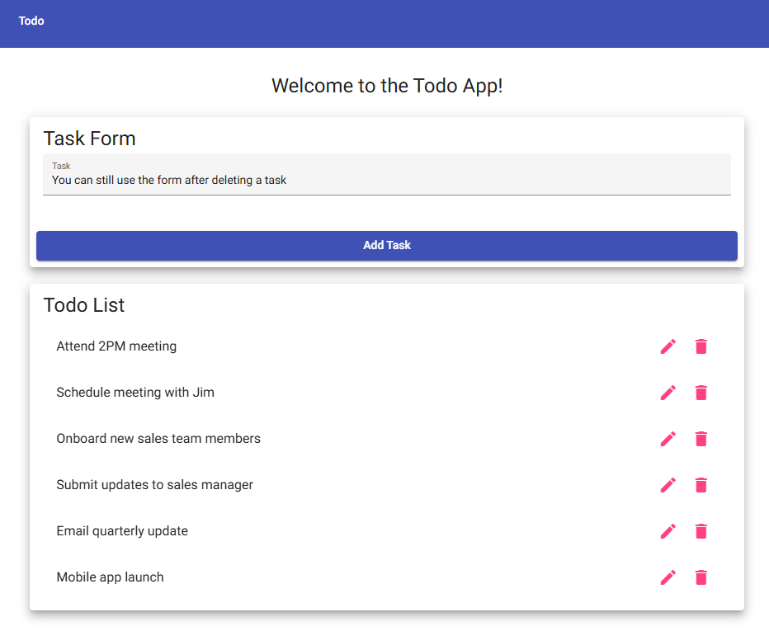
Comments |  |  | The delete functionality worked as expected. The selected task was removed from the Todo List while all remaining tasks stayed in the correct order, and the application continued functioning normally after deletion. –Wade Eckert

Test 5: Invalid URL and Responsive Device Views
Test Objective |  | Verify invalid URLs show a custom 404 page and confirm the application provides usable mobile and tablet views. Covers requirements 5, 8, and 9.
Developer |  | Zak Nizam |  | Peer tester |  | Wade Eckert
Date tested |  | 2026/07/02 |  | Date tested |  | 2026/07/04
Step | Action |  | Expected results |  | Developer pass/fail |  | Tester pass/fail + Screenshot
1 | Visit https://buwebdev.github.io/todo/invalid-test-page. |  | A custom 404 error page is displayed instead of an unstyled browser or server error. |  | Yes |  | Yes  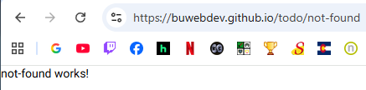
2 | Return to https://buwebdev.github.io/todo/. |  | The standard Todo application landing page loads again. |  | Yes |  | Yes  
3 | Open browser developer tools and switch to a mobile viewport such as iPhone or approximately 390 x 844. |  | The Task Form and Todo List remain visible and usable on a mobile-sized screen. |  | Yes |  | Yes  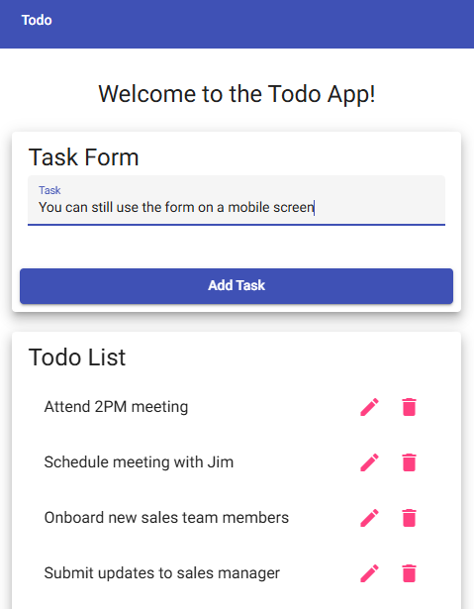
4 | Confirm the Add, Edit, and Delete controls are accessible in the mobile viewport without horizontal scrolling. |  | The mobile layout supports the main task actions. |  | Yes |  | Yes  
5 | Switch to a tablet viewport such as iPad or approximately 768 x 1024. |  | The tablet layout remains readable and supports the task form and Todo List controls. |  | Yes |  | Yes  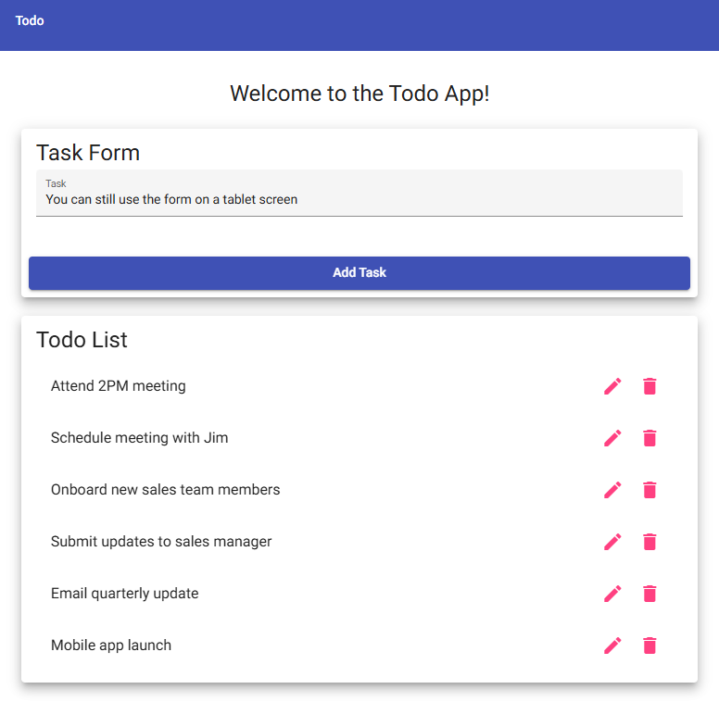
Comments |  |  | The invalid URL displayed the expected custom 404 page, and the application remained fully usable in both mobile and tablet viewports. All primary controls were accessible without layout or usability issues. –Wade Eckert

