Name: | Chanceller Waters
Assignment: | Module 4.2 Test plan
Project: | Todo App Test plans
Course: | CSD-380 : Devops
Description | Functional test plan for the Todo Application based on the document listing business requirements. Requirements include: URL access, Task list viewing, task creation, task editing, task deletion, form validation, invalid URL handling, and mobile/tablet aesthetics.
Date: | 2026/01/07

.
TABLE OF CONTENTS
Test 1:.. 2
Test 2:.. 4
Test 3:.. 5
Test 4.. 7
Test 5:.. 9

Test 1 | Website access and task list view
 | Test Objective: verify that users can access the todo application through its associated URL and view existing items. | Developer: Chanceller Waters  Date tested: 2026/1/07 | Peer tester: Wade Eckert  Date tested: 2026/07/04
Step | Action | Expected results: | Developer pass/fail | Tester pass/fail  + Screenshot
1 | Visit  https://buwebdev.github.io/todo/ | Todo App loads without error | Yes | Yes  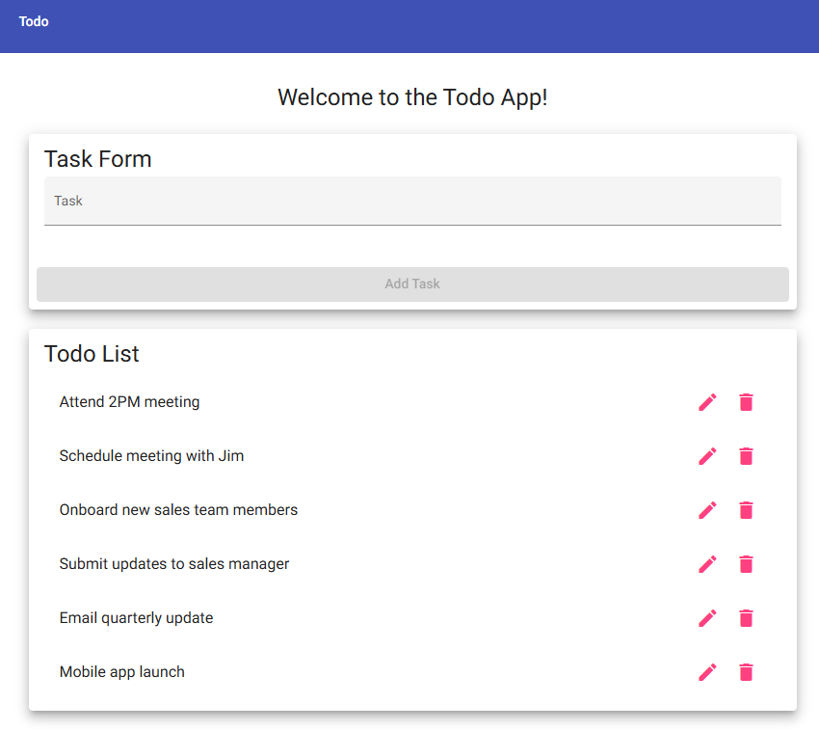
2 | Verify that the page header/navigation displays Todo and the welcome message is visible | Landing page content is visible and readable | Yes | Yes  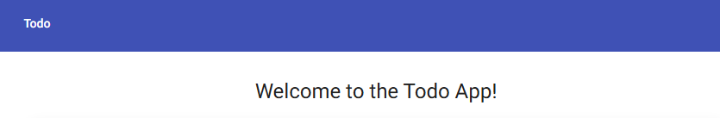
3 | Verify that the Task form section displays an input field for new tasks and an " Add Task " button to submit those tasks | The task entry field is present on the page | Yes | Yes  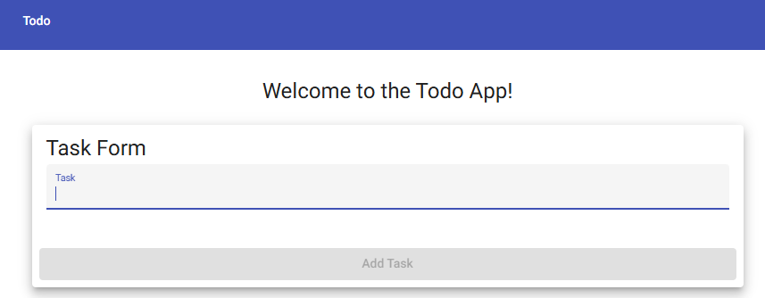
4 | Verify that Todo List is populated with several sample task items | Task list is visible with preexisting todo items that can be edited or deleted | Yes | Yes  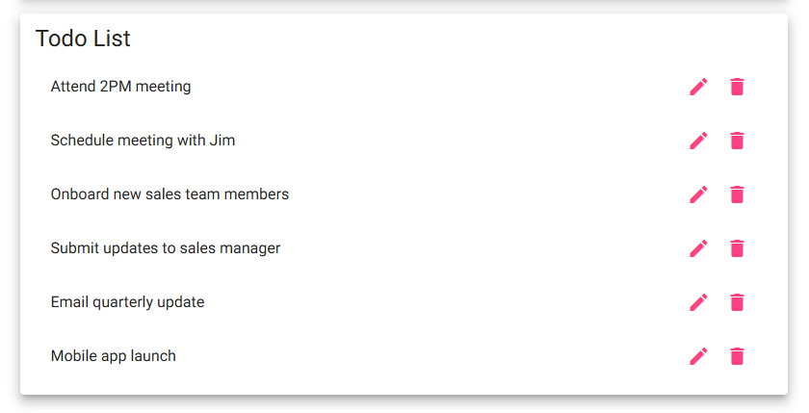
5 | Refresh or F5 to reload the browser window | Application reloads to the same URL, and the preexisting Todo list is visible in its original state | Yes | Yes  
Comments | The Todo application loaded successfully from the provided URL without any visible errors. The navigation bar, welcome message, task entry form, sample task list, and refresh functionality all operated as expected and displayed correctly throughout testing. –Wade Eckert

Test 2 | “Add” form Validation
 | Test Objective: Verify that a new task form cannot be submitted without a todo item in the field | Developer: Chanceller Waters  Date tested: 2026/1/07 | Peer tester: Wade Eckert  Date tested: 2026/07/04
Step | Action | Expected results: | Developer pass/fail | Tester pass/fail
1 | Open the todo application and leave the task input field empty | The task form is displayed, but the task text field remains empty | Yes | Yes  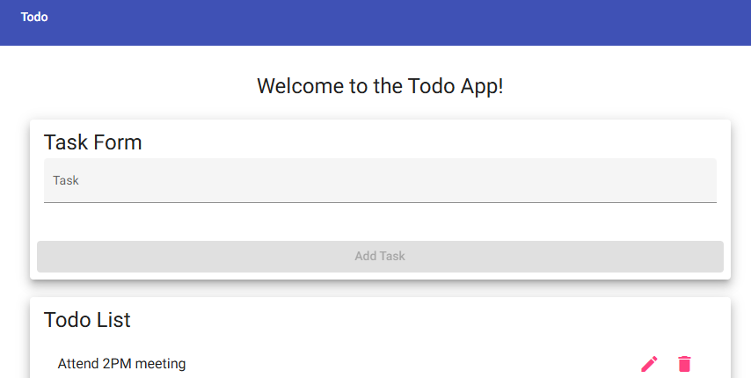
2 | Attempt to add the blank task form or verify that the add task button is still inactive | Blank task is not added to the Todo list | Yes | Yes  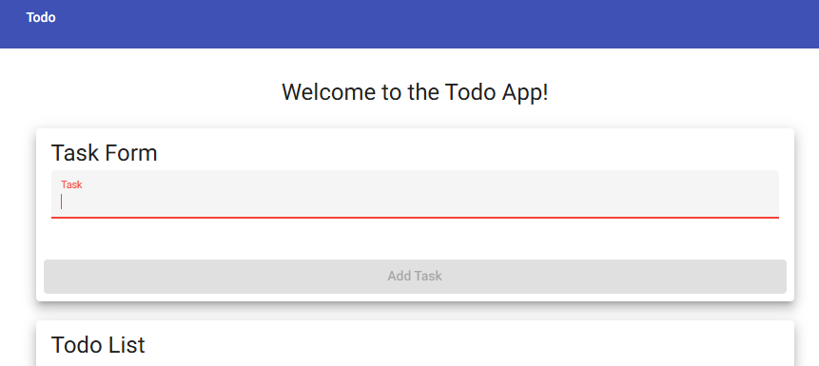
Comments | The application correctly prevented an empty task from being submitted and kept the Add Task button disabled while no valid input was entered. This confirms that the basic form validation is functioning properly and prevents accidental submission of completely empty tasks. –Wade Eckert

Test 3 | Create a Todo task
 | Test Objective: Verify that a user can create a new to-do list item | Developer: Chanceller Waters  Date tested: 2026/01/07 | Peer tester: Wade Eckert  Date tested: 2026/07/04
Step | Action | Expected results: | Developer pass/fail | Tester pass/fail
1 | Travel to  https://buwebdev.github.io/todo/  And Enter a task with a length of 4 or more characters into the task input field | Task text appears in the task input field | Yes | Yes  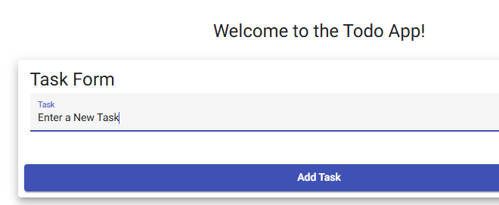
2 | Click on the add task button | The new task is populated in the to-do list | Yes | Yes  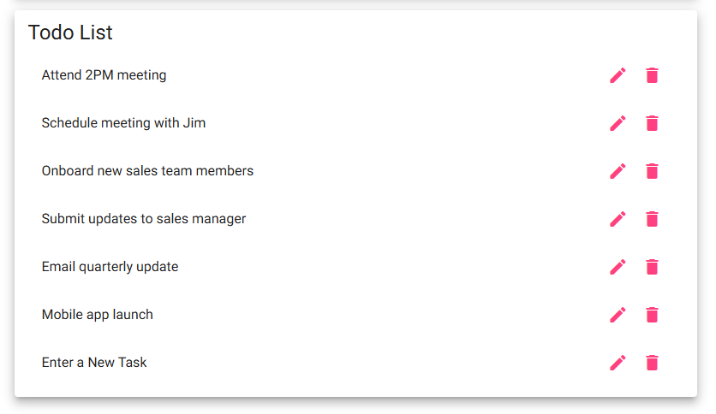
3 | Verify that the todo is updated and the task form is available for another submission | The application allows for subsequent submissions | Yes | Yes  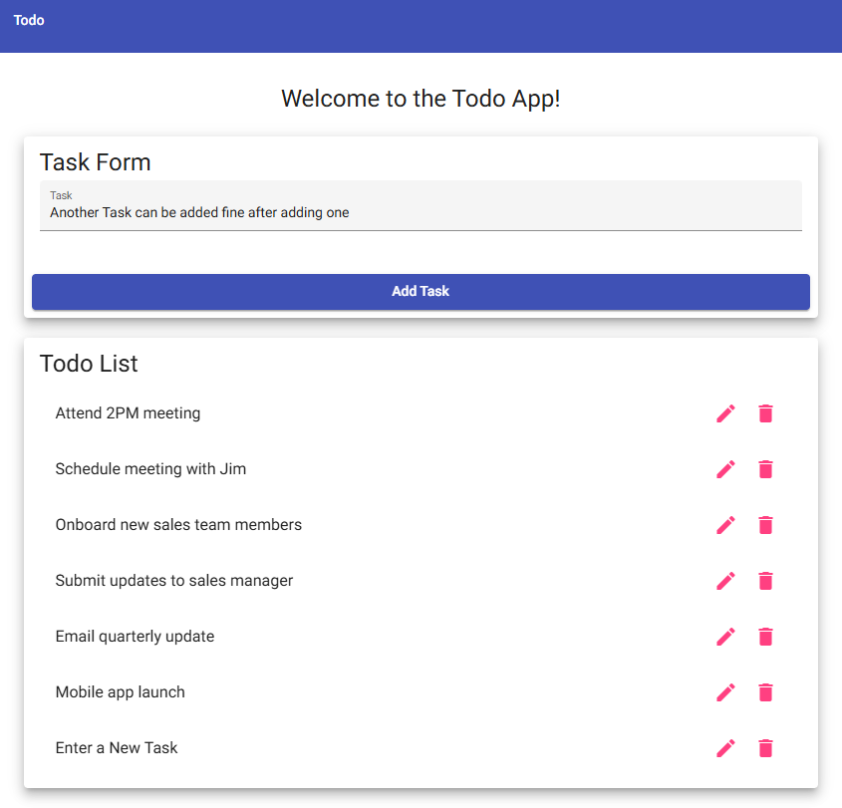
4 | Enter a todo task with fewer than 4 characters | The add task button remains inactive | Yes | Yes  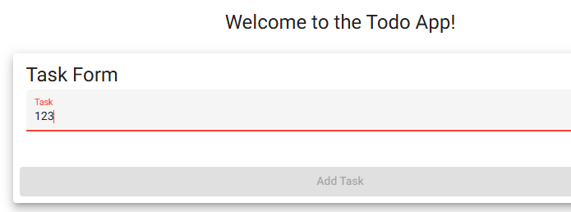
5 | Enter blank spaces numbering 4 or more into the task input field and click " Add task” | The application should leave the add task button inactive. The application should reject the empty todo item  No empty todo item should populate the list | No | No  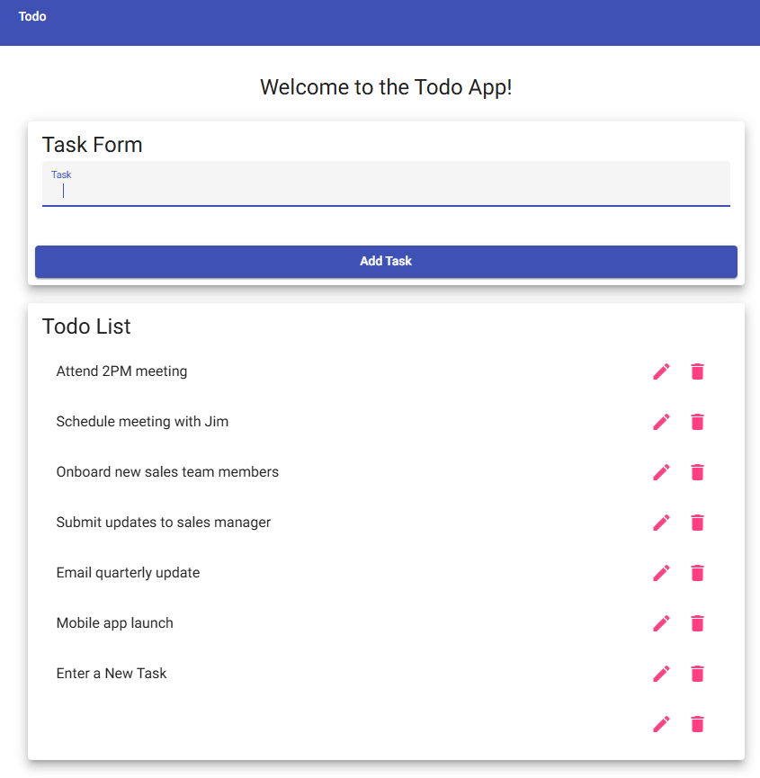
Comments | The application successfully allowed valid tasks containing four or more characters to be added to the Todo List while preventing shorter task names from being submitted. However, the application incorrectly accepted four blank spaces as valid input and created an empty task, indicating that whitespace-only input is not properly validated and should be trimmed before submission. –Wade Eckert

Test 4 | Edit Todo Task
 | Test Objective: test edit function for the todo application. Tests whether uses can edit items and save them without changing the list order | Developer: Chanceller Waters  Date tested: 2026/01/07 | Peer tester: Wade Eckert  Date tested: 2026/07/04
Step | Action | Expected results: | Developer pass/fail | Tester pass/fail
1 | Travel to https://buwebdev.github.io/todo/ | Landing page loads without issue | Yes | Yes  
2 | Click the edit icon next to a sample or added task | The edit form opens and displays the selected task for editing | Yes | Yes  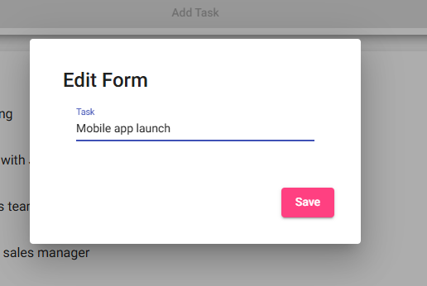
3 | Edit the task input | Changes to the todo list item are reflected in the edit form input section. | Yes | Yes  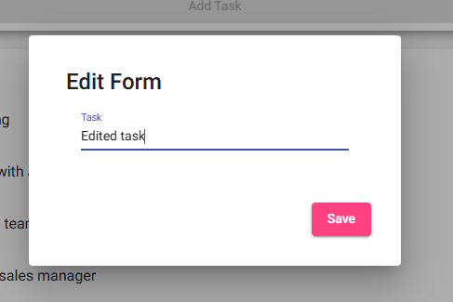
4 | Click “Save” | Edit form closes, and the todo list is updated with the edited task | Yes | Yes  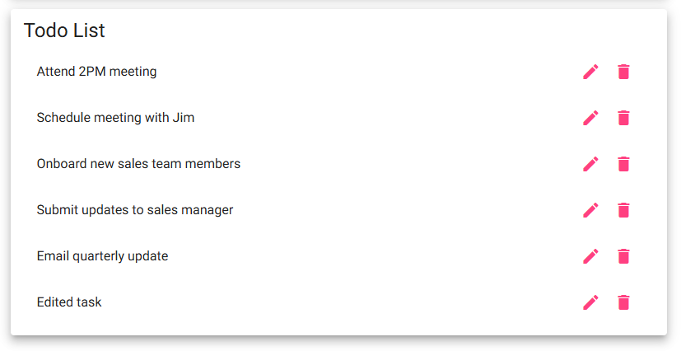
5 | Verify list is updated with new changes | Edited task takes the place of the previous one in the same position | Yes | Yes  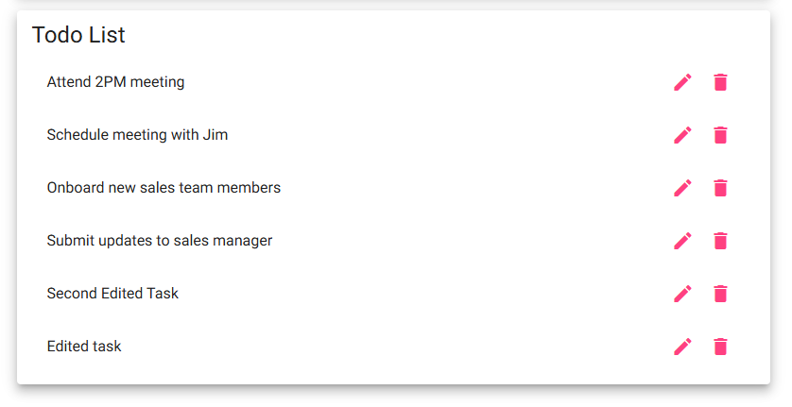
Comments | The edit functionality worked correctly throughout testing. Existing tasks could be opened, modified, saved, and updated in the Todo List while maintaining their original position, confirming that editing does not affect the overall ordering of tasks. –Wade Eckert

Test 5 | Delete Todo task
 | Test Objective: verify that users can delete existing or added tasks from the todo list | Developer: Chanceller Waters  Date tested: 2026/01/07 | Peer tester: Wade Eckert  Date tested: 2026/07/04
Step | Action | Expected results: | Developer pass/fail | Tester pass/fail
1 | Travel to https://buwebdev.github.io/todo/ | Application loads successfully | Yes | Yes  
2 | Select a task, either preexisting or recently added | All tasks are visible and readable | Yes | Yes  
3 | Click the delete icon | Selected item is removed from the list | yes | Yes  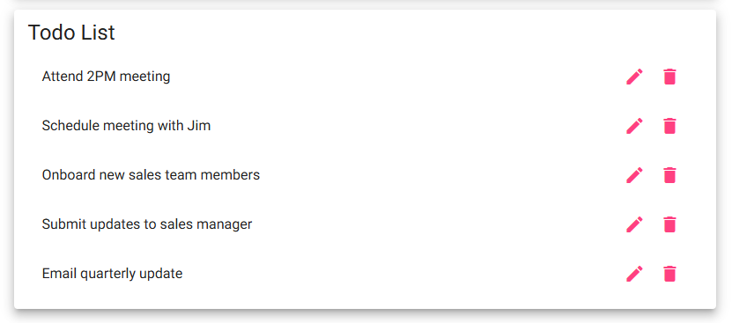
4 | Verify that the selected item was removed from the to-do list | The item is no longer visible, and the list spacing is adjusted to reflect this change | Yes | Yes  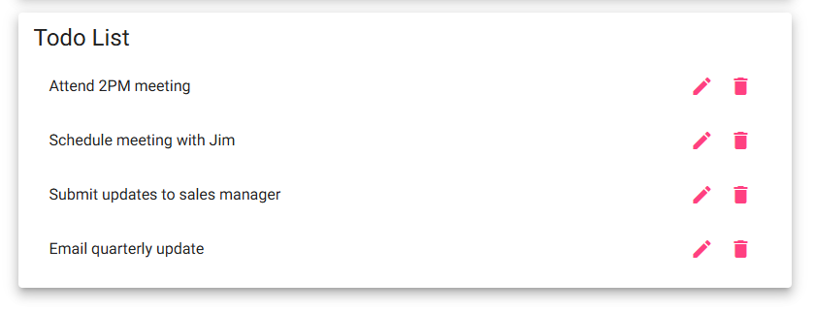
5 | Refresh the page to see if preexisting items will return | Sample items should be repoulated, and added items will be removed. List returns to the sample state | Yes | Yes  
Comments | The delete functionality removed the selected task immediately and adjusted the remaining list without affecting other tasks. Refreshing the page restored the default sample tasks as expected, confirming that the application reloads its original data rather than preserving temporary changes after a refresh. –Wade Eckert

