Value Stream Mapping (VSM): Optimizing My Weekly Programming Assignment Workflow

Wade Eckert
Bellevue University
CSD 380: DevOps
Professor Nathan Braun
July 8, 2026

Introduction

Value Stream Mapping (VSM) is a Lean management technique used to visualize the sequence of activities required to complete a process from beginning to end. By mapping each step, it becomes easier to identify where time is spent, where delays occur, and where improvements can be made. Although Value Stream Mapping is widely used in software development and DevOps to improve the software delivery lifecycle, the same principles can also be applied to everyday workflows to reduce waste and increase efficiency.
For this project, I applied Value Stream Mapping (VSM) to my weekly programming assignment workflow. As a full-time employee who is simultaneously taking three university courses, managing time effectively is essential to consistently completing assignments before their deadlines. My current workflow begins when a new programming assignment is released and concludes once the completed assignment has been submitted. By mapping this process, analyzing the associated lean metrics, and identifying opportunities for optimization, I can better understand my workflow and identify practical improvements that enhance both productivity and quality.

Current Workflow Overview

My weekly programming assignment workflow begins when a new school week begins and a new assignment becomes available in Blackboard. The overall objective of the process is to complete a high-quality programming assignment that satisfies all assignment requirements and is submitted on time. To manage this workflow effectively while balancing a full-time job and three university courses, I follow a structured schedule that divides the work into separate planning and implementation phases.
The first day of the workflow is dedicated to planning activities. During this phase, I carefully review the assignment instructions, read the required course materials, research any concepts that are unfamiliar, and complete the week's discussion board assignment. Separating these tasks from the development work allows me to fully understand the assignment requirements before writing any code and reduces interruptions during implementation.
The second day focuses on development, verification, and delivery. During this phase, I design the solution, develop the required code, compile and test the application, correct any issues that are identified, and complete any required documentation before submitting the finished assignment. While most programming assignments can be completed within this two-day workflow, more complex assignments may require a third day to allow additional time for development, testing, and refinement. This structured approach allows me to maintain a consistent schedule across multiple courses while minimizing last-minute work and reducing the need for weekend study sessions.
The workflow described above serves as the basis for the Value Stream Map presented in the next section, which illustrates each phase of the process from assignment release through final submission.

Value Stream Map (VSM)

This graphic illustrates the current-state Value Stream Map for my weekly programming assignment workflow. The map identifies each major phase of the process, highlights the external constraints that influence the workflow, and provides an overview of the estimated active time associated with each phase.

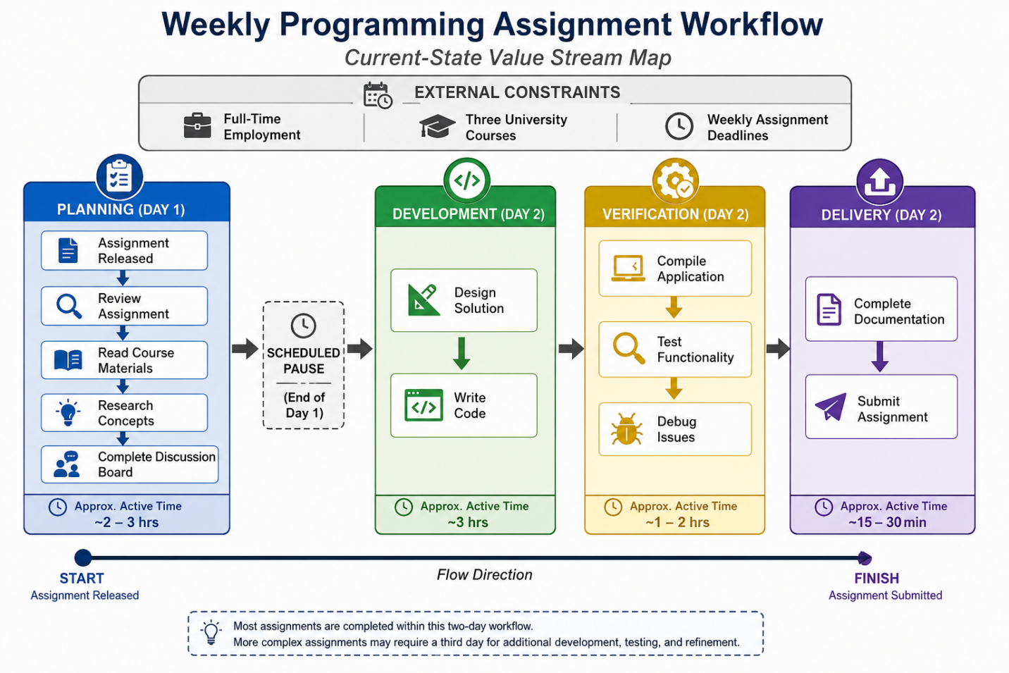

Lean Metrics

After creating the Value Stream Map, the next step is to evaluate the workflow using lean metrics. These measurements provide insight into how time is distributed throughout the process and help identify opportunities for improvement. For this workflow, the primary metrics analyzed are Flow Time, Cycle Time, and Wait Time, as they best represent the structure of my weekly programming assignment process.
Flow Time measures the amount of active work performed during each phase of the workflow. In this process, the Planning phase typically requires two to three hours, Development requires approximately three hours, Verification requires one to two hours, and Delivery requires approximately fifteen to thirty minutes. These estimates represent the average amount of time actively spent completing each phase rather than the total elapsed time from beginning to end.
Cycle Time measures the total amount of time required to complete the workflow from the moment a programming assignment is released until it is submitted. Most assignments are completed within a structured two-day workflow. However, more advanced programming assignments occasionally require a third day to allow additional time for development, testing, and refinement.
Wait Time represents intentional pauses between phases of the workflow. In this process, the scheduled pause between the Planning and Development phases is not considered wasted time. Instead, it reflects a deliberate scheduling decision that allows coursework to be balanced with full-time employment and multiple university courses while maintaining a consistent weekly routine.

Estimated Lean Metrics

Workflow Phase | Estimated Active Time
Planning | 2–3 hours
Development | ~3 hours
Verification | 1–2 hours
Delivery | 15–30 minutes

Lean Metric | Estimated Value
Flow Time | Active work distributed across each workflow phase
Total Active Work | Approximately 6–8.5 hours
Cycle Time | Typically 2 days (3 days for more complex assignments)
Wait Time | Scheduled pause between Day 1 planning and Day 2 implementation

Workflow Analysis

The Value Stream Map and associated lean metrics demonstrate that my current workflow is well organized and intentionally structured to balance competing responsibilities. Rather than attempting to complete every aspect of an assignment in a single session, the workflow separates planning activities from development and testing. This approach allows me to thoroughly understand the assignment requirements before writing code, reducing unnecessary interruptions and improving focus during implementation.
The analysis also highlights several factors that influence the overall workflow. The most significant external constraints are maintaining a full-time job while simultaneously taking three university courses, which requires careful scheduling of available study time. The scheduled pause between the Planning and Development phases is not a source of waste but instead represents a deliberate decision to organize coursework into manageable two-day cycles. This structure helps maintain a consistent workload throughout the week while minimizing last-minute work and reducing the need for weekend study sessions.
Although the workflow is generally effective, the analysis identifies Development and Verification as the most time-intensive phases of the process. These phases naturally require the greatest amount of effort because they involve designing solutions, writing code, testing functionality, and resolving programming issues. More complex programming assignments may occasionally extend into a third day, particularly when additional debugging or refinement is required. Overall, the Value Stream Map demonstrates that the workflow already functions efficiently while also revealing several opportunities for continuous improvement that can further increase productivity and consistency. These opportunities for improvement provide the foundation for the process optimization recommendations discussed in the following section.

Process Optimization

The purpose of Value Stream Mapping is not only to visualize a process but also to identify opportunities for continuous improvement. Based on the workflow analysis and lean metrics, my current process is already well structured; however, several incremental improvements could further increase efficiency, reduce unnecessary effort, and improve consistency. These improvements focus on eliminating waste, improving workflow organization, and establishing simple governance practices that support assignment quality.

Eliminating Waste
Several opportunities exist to reduce unnecessary work throughout the programming assignment process. Recording important assignment requirements during the initial review can reduce the need to repeatedly reference the assignment instructions while developing the solution. Maintaining reusable project templates for common programming assignments, documentation, and GitHub repositories can also reduce repetitive setup tasks. Additionally, testing small portions of code throughout development instead of waiting until implementation is complete can reduce debugging time and simplify troubleshooting.

Workflow Orchestration
The current two-day workflow already provides an effective balance between coursework and full-time employment, but it can be further strengthened through consistent scheduling practices. Continuing to separate planning activities from implementation reduces context switching and allows development work to begin with a clear understanding of the assignment requirements. Establishing small milestones within the Development phase, such as completing and testing one major feature before beginning the next, can improve progress tracking and reduce the likelihood of larger issues being discovered late in the process. This structured workflow also makes it easier to manage assignments across multiple courses while avoiding unnecessary weekend work whenever possible.

Governance
Simple governance practices can help ensure that assignments are completed consistently and submitted with fewer errors. Before submission, each assignment should be reviewed using a standardized checklist that verifies all assignment requirements have been satisfied, the application compiles and functions correctly, required documentation has been completed, and any necessary files have been uploaded successfully. Following the same quality verification process each week reduces the likelihood of avoidable mistakes while promoting consistency across programming assignments.
Overall, these improvements do not require major changes to the existing workflow. Instead, they represent continuous, incremental improvements that align with Lean and DevOps principles by reducing waste, improving workflow efficiency, and promoting consistent delivery of high-quality work.

Conclusion

Creating this Value Stream Map provided a better understanding of how my weekly programming assignment workflow functions from assignment release through final submission. Mapping each phase of the process and evaluating the associated lean metrics highlighted how time is distributed throughout the workflow while also demonstrating the importance of intentional scheduling. Although my current workflow is already effective, the analysis identified several opportunities to further improve efficiency, reduce unnecessary work, and promote greater consistency.
This exercise also demonstrated that Value Stream Mapping extends beyond software development and manufacturing processes. The same Lean principles can be applied to everyday workflows to better understand how work is completed and where meaningful improvements can be made. By continuously evaluating and refining my programming assignment workflow, I can better balance the demands of full-time employment and multiple university courses while consistently producing high-quality work.

