Assignment 1.2: CSD 402 - GitHub Repository Setup

Wade Eckert
Bellevue University
CSD 402: Java for Programmers
Professor Darrell Payne
June 6, 2026
https://github.com/WadeEckert/CSD-402

Assignment 1.2: CSD 402 - GitHub Repository Setup

Link to GitHub Repository: https://github.com/WadeEckert/CSD-402
Screenshot of GitHub Repository:
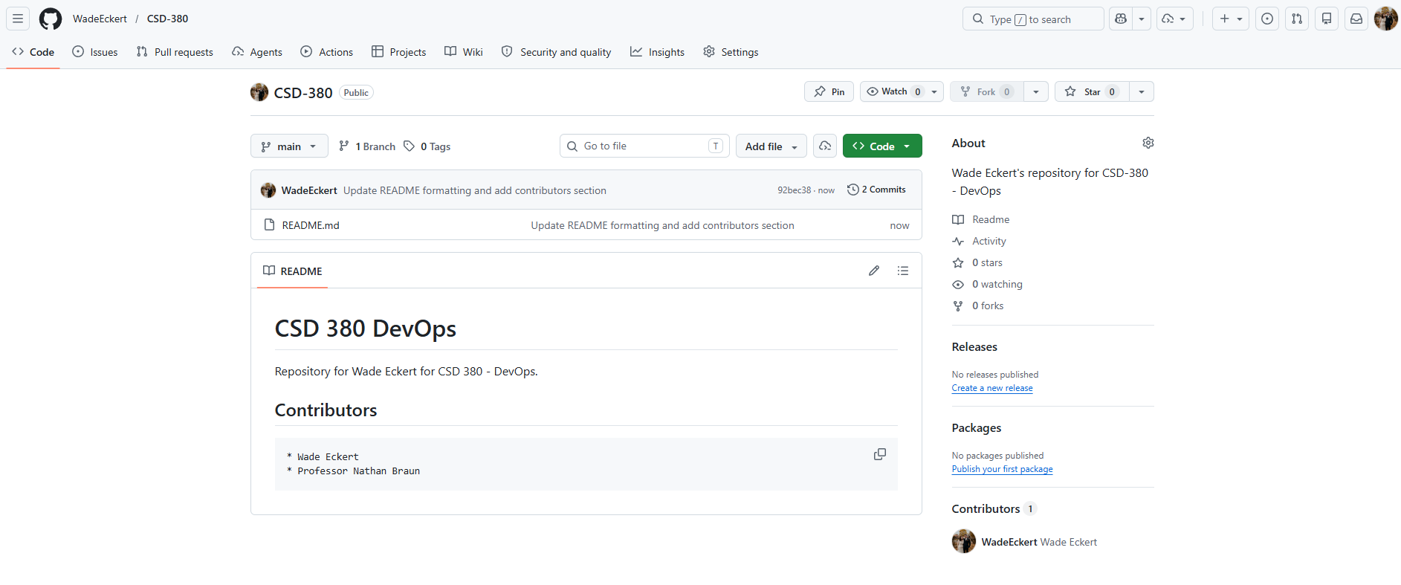
Screenshot of Local Directory:
