Assignment 10.2: Creating Custom Tags

Wade Eckert
Bellevue University
CSD 430: Server Side Development
Professor John Woods
August 12, 2026
https://github.com/WadeEckert/CSD-430

Introduction
Jakarta Server Pages (JSP) provides developers with a way to generate dynamic web content through server-side processing. As I have learned more about JSP development, I have seen that placing too much Java code directly inside a page can make the file difficult to read and maintain. Custom tags provide one way to reduce this problem. A custom tag resembles an HTML element when it is used in a JSP page, but its behavior is defined by server-side code. Developers can use custom tags to place repeated presentation features or processing behind a simpler and more descriptive syntax. Custom tags can therefore improve reuse, consistency, and separation of responsibilities, but they should be created only when these benefits justify the additional files, configuration, and testing they require.

Understanding Custom Tags
A custom tag is an application-defined JSP action that performs a particular server-side task. Multiple related tags can be organized into a tag library. Unlike an ordinary HTML element, a custom tag is processed by the JSP container before the completed response is returned to the browser. It may generate output, evaluate its body, use attributes, create server-side objects, or control whether other content is processed (Oracle, n.d.).
A Java-based custom tag normally relies on three connected components. The first is a Java tag-handler class containing the tag’s behavior. The second is a Tag Library Descriptor (TLD), which is an XML file that defines the library and associates the tag’s name with its Java class. The third is the JSP page that imports the library and invokes the tag. According to Oracle (n.d.), a JSP page imports a tag library with the taglib directive, which assigns a prefix that identifies the library. A developer can then combine the prefix with a tag name, such as <wade:greeting>, to invoke the associated handler.
Custom tags are different from the tags provided by the Jakarta Standard Tag Library. Standard tags already support many common operations, such as conditions and iteration. A custom tag is more appropriate when an application needs reusable behavior that is not already provided clearly by JSP, Expression Language, or a standard tag library.

Advantages of Custom Tags
One significant advantage of a custom tag is code reuse. When several JSP pages require the same presentation-related behavior, the developer can implement it once and invoke it wherever it is needed. Changes can then be made in the tag handler instead of being repeated across every JSP page. This reduces duplication and helps keep the application’s output consistent.
Custom tags can also improve the readability of JSP pages. A descriptive tag such as <wade:greeting name="Wade" /> communicates its general purpose without exposing all the Java instructions that produce the greeting. This makes the page easier to understand because the JSP primarily contains page structure and tag invocations, while the Java class contains the processing. The Jakarta Server Pages Team (2022) explains that simple tag extensions support the development of JSP pages without requiring scriptlets or scriptlet expressions.
Attributes make tags more flexible without duplicating their implementation. For example, a greeting tag can receive a different name each time it is used. Other custom tags could accept attributes controlling a message, label, color, or formatting option. The TLD also documents which attributes are available and whether they are required. This gives the JSP container information that it can use to detect certain mistakes while translating the page.

Disadvantages and Limitations
Despite these advantages, custom tags also introduce additional complexity. Even a basic Java-based tag may require a handler class, a TLD file, a compiled class in the correct package, a tag-library directive, and a JSP invocation. A developer who is troubleshooting the tag may need to examine Java, XML, and JSP files to understand how the entire feature is connected. An incorrect URI, package name, class name, or attribute definition may prevent the JSP container from locating or executing the handler.
Custom tags can also make a project more difficult for someone unfamiliar with its tag libraries. Although the tag’s use may appear simple in a JSP page, its actual behavior is hidden behind another layer of abstraction. Clear names, comments, documentation, and focused responsibilities are therefore important. A custom tag that performs too many unrelated tasks could become harder to understand than the code it was intended to replace.
Another disadvantage is the possibility of unnecessary development. Creating a custom tag for behavior used only once may require more work than it saves. A custom tag may also be unnecessary when an existing standard tag, Expression Language expression, JSP include, or JavaBean already provides a clear solution. In addition, custom tags should not become a place to hide database operations or major business rules. Those responsibilities are more appropriately handled by servlets, service classes, JavaBeans, or data-access classes. The tag should remain focused on a limited server-side or presentation-related task.

Requirements for Developing a Custom Tag
The first requirement is to identify a task that is appropriate for reuse. Once that task has been selected, the developer creates a tag-handler class. Oracle (n.d.) explains that tag handlers may use classic tag interfaces or the simpler SimpleTag interface. For a basic tag, extending SimpleTagSupport provides the supporting implementation and allows the developer to concentrate on the tag’s behavior.
The handler overrides the doTag() method, which the JSP container calls when it processes the custom tag. The SimpleTagSupport API identifies this class as a base for simple tag handlers and provides access to the current JspContext (Eclipse Foundation, n.d.). Through that context, the handler can obtain the page’s writer and add content to the response. If the tag accepts attributes, the handler also needs fields and setter methods corresponding to those attributes. Before calling doTag(), the container supplies the attribute values through these setter methods.
The developer must then create the TLD file. This file defines information such as the library version, short name, URI, tag name, fully qualified handler class, body-content type, and accepted attributes. The tag name in the TLD becomes the name used in the JSP page, while the handler-class entry connects that name to the Java implementation. If the tag does not contain content between opening and closing tags, its body content can be declared as empty. The Jakarta Server Pages specification explains that declaring an empty body also allows better translation-time error checking (Jakarta Server Pages Team, 2022).
Finally, the JSP page imports the library with a taglib directive containing a URI and prefix. The URI must correspond to the one defined for the library, and the prefix becomes the label placed before the tag name. The handler must be compiled into the proper package structure, the TLD must be placed where the JSP container can locate it, and the application must be deployed on a compatible server. Testing should confirm that the library is found, required attributes are accepted, and the expected content appears in the browser.

Evaluation of Custom Tags
Based on what I have learned, I would consider creating a custom tag when the same view-related behavior appears on multiple JSP pages and cannot be handled clearly by a standard feature. For example, an application that repeatedly displays the same type of formatted status message could use a custom tag to keep the markup and processing consistent. A tag could accept attributes for the message and status while allowing each JSP page to use a short, readable invocation.
I would avoid creating a custom tag for a single small section of markup or for functionality already available through JSTL, Expression Language, or a JSP include. I would also avoid placing database access or complex application logic inside a tag handler. Custom tags appear most useful when they provide a clear name for repeated behavior, reduce duplicate code, and remain focused on one responsibility.

Conclusion
Custom JSP tags offer a structured way to create reusable server-side actions that can be invoked through readable, HTML-like syntax. Their main advantages include reduced duplication, consistent output, and cleaner separation between JSP markup and Java processing. However, they also introduce additional files, configuration requirements, and hidden dependencies that can make development and troubleshooting more complicated. For these reasons, custom tags should be created selectively. When a tag represents repeated presentation-related behavior and is supported by clear documentation, it can make a JSP application easier to organize and maintain.

References
Eclipse Foundation. (n.d.). SimpleTagSupport: Jakarta Server Pages API v3.1.0. https://jakarta.ee/specifications/pages/3.1/apidocs/jakarta.servlet.jsp/jakarta/servlet/jsp/tagext/simpletagsupport
Jakarta Server Pages Team. (2022, April 21). Jakarta Server Pages specification, version 3.1. Eclipse Foundation. https://jakarta.ee/specifications/pages/3.1/jakarta-server-pages-spec-3.1
Oracle. (n.d.). Understanding and creating custom JSP tags. Oracle WebLogic Server 15.1.1 documentation. https://docs.oracle.com/en/middleware/standalone/weblogic-server/15.1.1/taglb/quickstart.html

Appendix A: Coding Example and Implementation

A.1 GreetingTag.java:

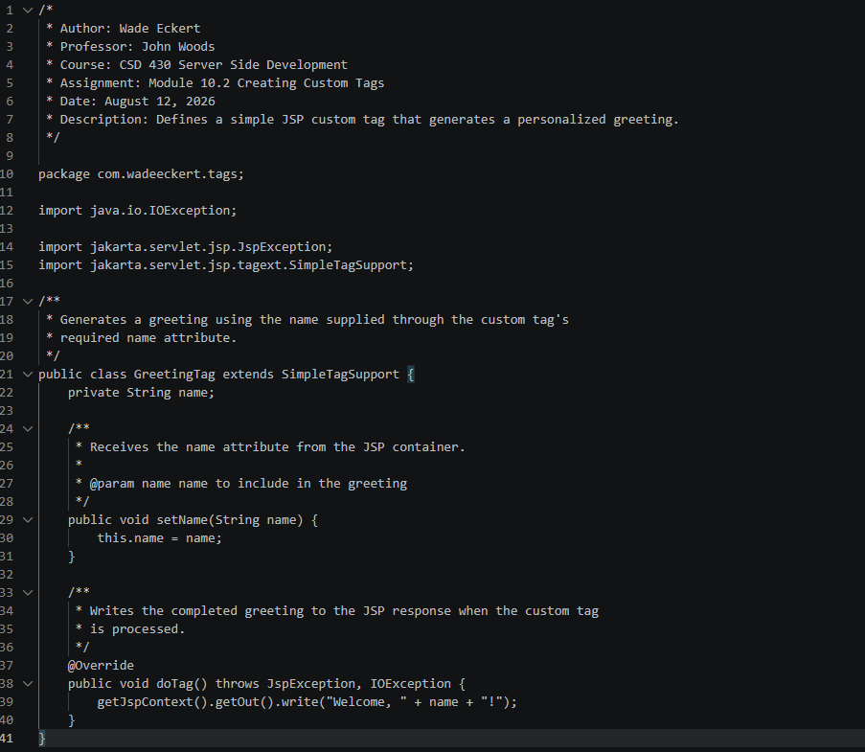

This custom class extends SimpleTagSupport, which supplies the basic functionality required by a simple tag handler. The setName() method receives the value of the tag’s name attribute. Tomcat, for example, calls doTag() when it encounters the custom tag, and the method writes the personalized greeting to the JSP response.

A.2 wade-tags.tld:

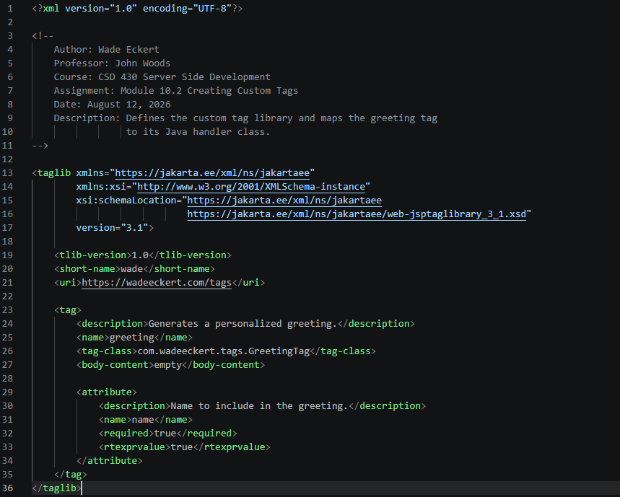

The TLD identifies the library with a URI and defines a tag named greeting. The tag-class element contains the complete package and class name of the handler. The tag has an empty body and requires a name attribute. Allowing a runtime expression value means that the attribute can later receive either a literal value or a JSP Expression Language expression.

A.3 wadeCustomTag.jsp:

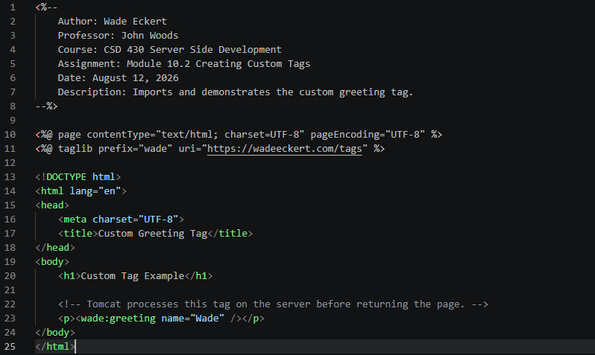
The taglib directive imports the library and assigns it the wade prefix. The <wade:greeting> element invokes the tag named greeting in the TLD and supplies "Wade" as its required attribute.
When the page is requested, Tomcat follows this sequence:
- It matches the URI in the JSP directive to the URI in wade-tags.tld.
- The TLD maps the greeting tag to GreetingTag.
- Tomcat passes "Wade" to the class through setName().
- Tomcat calls doTag().
- The handler writes the greeting into the JSP response.

