Modules 5.2 & 6.2: Working with CRUD-READ, JDBC & JavaBeans Project Part 1

Wade Eckert
Bellevue University
CSD 430: Server Side Development
Professor John Woods
July 12, 2026
https://github.com/WadeEckert/CSD-430

Project Overview:
This project is the foundation for a multi-module CRUD (Create, Read, Update, Delete) application that will be developed throughout Modules 5 through 9 of CSD 430 – Server Side Development. The goal of this portion of the project is to design a relational database table, populate it with meaningful data, and prepare it for future interaction through JSP and Java.
Rather than using a simple demonstration table, this project uses a comprehensive dataset containing information for all 50 United States. The table will serve as the central data source for the remainder of the CRUD project and will later be accessed through JSP pages using Java Database Connectivity (JDBC).
The project consists of three SQL scripts:
- wadeCreateTable.sql – Creates the CSD430 database (if necessary) and creates the project table.
- wadePopulateTable.sql – Inserts records for all 50 U.S. states into the table.
- wadeDropTable.sql – Removes the table after testing has been completed.

The database table contains the following fields:
Field | Description
state_id | Auto-incrementing primary key
state_name | Full state name
state_abbreviation | Official two-letter postal abbreviation
capital | State capital city
population | Estimated state population
population_year | Year associated with the population estimate
state_bird | Official state bird
state_flower | Official state flower

The table was designed using normalized database principles and includes a primary key, unique constraints, and appropriate data types to maintain data integrity.
Population values were obtained from StatsAmerica, using 2025 population estimates based on data from the U.S. Census Bureau. Using a single authoritative source ensures consistency across all records.
This database will be used throughout the remainder of the CRUD project as JSP pages are developed to create, read, update, and delete records using Java and JDBC.
Run the Create Table Script:
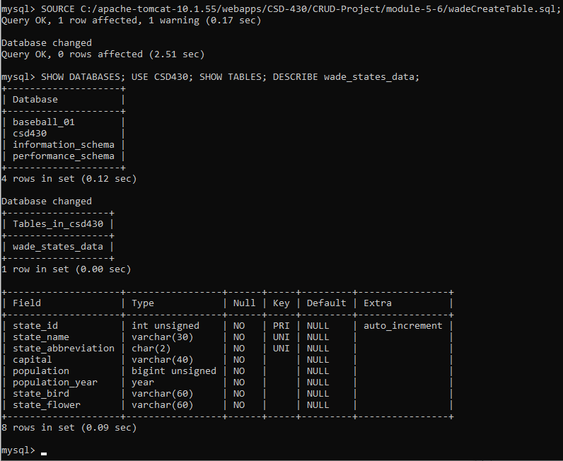
The script successfully created the CSD430 database (if necessary) and generated the wade_states_data table. The displayed warning is expected because the script uses CREATE DATABASE IF NOT EXISTS, allowing it to execute safely if the database already exists.

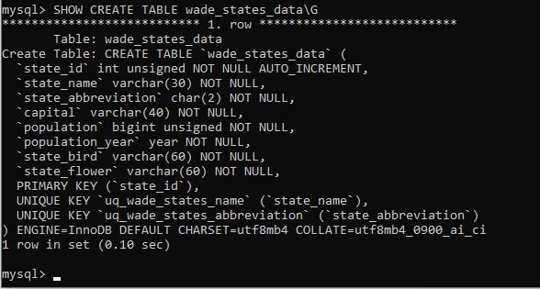
The SHOW CREATE TABLE command confirms that the table was created with the correct fields, data types, primary key, unique constraints, storage engine, character set, and collation as defined in the SQL script.

Populate the Table:
The populate script inserted records for all 50 U.S. states into the wade_states_data table using a single SQL INSERT statement. Population values are based on the 2025 estimates published by StatsAmerica using U.S. Census Bureau data.
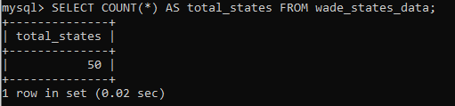
The SELECT COUNT(*) query confirms that all 50 U.S. state records were successfully inserted into the table, verifying that the populate script executed correctly.
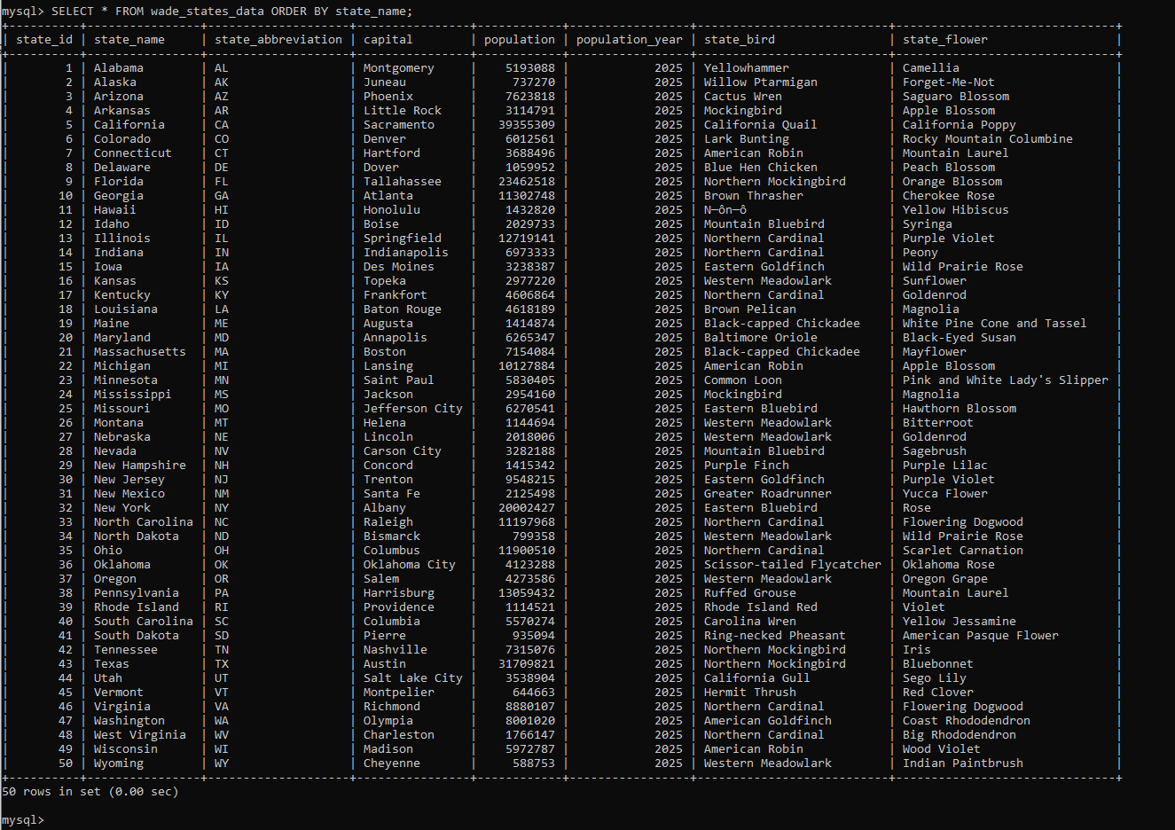
The query results demonstrate that each state record was inserted successfully and that the table contains the expected values for every field defined in the database schema.
Drop the Table:
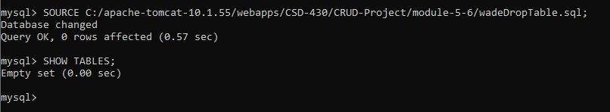
The drop script removed the wade_states_data table from the CSD430 database using the DROP TABLE IF EXISTS statement, allowing the script to execute safely even if the table has already been removed. The SHOW TABLES command confirms that the wade_states_data table no longer exists in the CSD430 database, completing the cleanup process for this portion of the project.

Conclusion:
The SQL scripts were successfully executed and verified, demonstrating the creation, population, and removal of the wade_states_data table within the CSD430 database. Completing these tasks establishes a reliable database foundation for the remaining CRUD project modules, where Java, JSP, JDBC, and JavaBeans will be used to implement create, read, update, and delete functionality.

