Assignment 11.2: Coding Standards in Corporate Software Development

Wade Eckert
Bellevue University
CSD 430: Server Side Development
Professor John Woods
August 20, 2026
https://github.com/WadeEckert/CSD-430

Introduction
A computer program can produce the expected result while still being difficult for another developer to understand, test, or maintain. This becomes a larger concern in corporate software development, where many developers may contribute to the same codebase over several years. Coding standards provide shared rules and guidelines for how source code should be written, organized, documented, reviewed, and protected. Some standards are mandatory requirements, while others are recommendations that allow developers to use their judgment. Although individual rules vary between programming languages and organizations, their general purpose remains similar. Effective coding standards improve readability, consistency, maintainability, collaboration, and security. They are most useful when an organization clearly documents them, reinforces them through tools and code review, and updates them as its technology and needs change.

Scope of Coding Standards
Coding standards are sometimes viewed as rules about indentation, spacing, and the placement of braces. These formatting decisions are part of coding standards, but the complete subject is much broader. Standards can establish naming conventions for files, variables, functions, classes, database objects, and other parts of an application. Descriptive and consistent names help readers understand the purpose of a component without having to examine every detail of its implementation.
The exact naming rules that are used may differ among programming languages. One language or organization may prefer camel case, while another may prefer snake case. The important point is not that one convention is always better. Rather, the greater benefit comes from selecting a convention and applying it consistently throughout the codebase. When names, formatting, and file structures follow familiar patterns, developers can spend more time understanding what the code does and less time interpreting how it is presented.
Coding standards can also address the organization and complexity of source code. Examples include limiting a function to one clear responsibility, avoiding duplicated logic, separating unrelated tasks, and replacing unexplained values with named constants. These practices make individual components easier to test and modify. Standards may also identify language features that require caution because they are difficult to use correctly or could introduce unexpected behavior.
Comments and documentation are another important part of coding standards. Comments should clarify purpose, assumptions, or decisions that are not already obvious from the code. A comment that merely repeats a simple statement adds little value and can make the file harder to read. Documentation for classes, functions, application programming interfaces, and configuration requirements should explain how a component is intended to be used. It must also be updated when the related code changes.

Applying Coding Standards in Corporate Development
A company must do more than publish a document for its coding standards to be effective. The standards need to become part of the normal development process. An organization may maintain a company-wide engineering guide and allow individual teams to add rules for their own technologies or projects. New developers can learn these expectations during onboarding, while experienced developers can refer to the guide when they encounter an unfamiliar situation.
Many routine standards can be enforced automatically. Integrated development environments can apply formatting rules as code is written or saved. Linters can identify inconsistent naming, unused variables, unreachable statements, and other common problems. Static-analysis tools can examine source code for possible defects, unsafe practices, or excessive complexity. These checks can also be included in a continuous integration pipeline so that violations are reported before code is merged or released.
Automation is also useful because it applies predictable rules consistently and reduces the time developers spend discussing minor formatting differences. However, automated tools cannot fully determine whether a design is understandable, whether a function has too many responsibilities, or whether a comment accurately explains a decision. Human code review still remains necessary for evaluating these areas.
These coding standards can also be applied within coding reviews. During a code review, another developer examines a proposed change before it becomes part of the main codebase. The reviewer can check whether the code follows established standards, handles expected conditions, includes suitable tests, and remains understandable to someone other than its original author. Certain changes may require additional review from someone with specialized knowledge in security, databases, accessibility, or another technical area. This combination of automation and human review allows a company to enforce simple rules efficiently while still applying professional judgment to more complicated decisions.

Importance of Coding Standards
Readability is one of the main reasons coding standards matter. Corporate source code is read many times after it is originally written. Developers read it while reviewing changes, correcting defects, adding features, performing security analysis, and responding to production problems. Clear and predictable code lowers the amount of time required to understand an unfamiliar section of an application.
Maintainability is also closely related to readability. A well-organized program with focused functions and descriptive names is generally easier to change without damaging unrelated behavior. Consistent practices can also make refactoring and automated code modifications safer because tools can expect similar patterns throughout the project. When an organization ignores maintainability, rushed or confusing code can accumulate as technical debt. Later changes may then require more time because developers must first understand and repair the existing structure.
Coding standards also improve collaboration. Developers come from different educational backgrounds and may have different personal preferences. Without shared rules, teams can repeatedly debate naming, formatting, and organization. A documented standard provides a common answer and keeps reviews focused on functionality, design, reliability, and user needs. Consistency also helps employees move between projects because they do not have to learn an entirely different development style each time.
Along the lines of improved collaboration, another benefit of coding standards is continuity. Corporate applications may remain in use long after their original developers have changed roles or left the company. The organization must still be able to maintain those applications. Clear code, current documentation, and consistent structure reduce dependence on one person’s memory. These standards therefore support both the technical health of the application and the organization’s ability to continue operating it.
It is important to note that coding standards cannot guarantee that a program is correct. Code can be perfectly formatted and still contain a serious logic error. However, understandable and testable code makes errors easier to identify. Standards create conditions that support quality, but they must work together with appropriate design, testing, monitoring, and review to be effective.

Security Within Coding Standards
Security requirements should be included within an organization’s coding standards rather than treated only as a final check before release. Secure coding rules may require input validation, limited access to sensitive information, appropriate error handling, protection of credentials, approved external libraries, and safe database access. Developers may also be required to avoid placing passwords or private keys directly in source code.
Input validation is especially important for server-side applications because information received from a user, another service, or an uploaded file cannot automatically be trusted. During the server-side development work in this course, validation was used to prevent incomplete or invalid records from reaching the database. Prepared statements were also used to keep user-supplied values separate from the SQL command itself. Although the exact implementation differs among languages and technologies, the broader standard remains the same: external input should be treated cautiously and processed through an approved method.
Security standards should be supported by training, code review, automated analysis, testing, and dependency management. Addressing security throughout development is more effective than waiting until an application is complete. Early standards can prevent unsafe patterns from being repeated throughout the project and reduce the number of problems that must be corrected later.

Balanced Application of Standards
Coding standards are valuable, but adding more rules does not automatically produce better software. Every rule requires developers to learn it, reviewers to enforce it, and the organization to maintain it. A useful standard should support a recognizable goal such as readability, safety, compatibility, or maintainability. Rules that provide little value may create unnecessary work and distract developers from more important concerns.
Organizations should also recognize that different languages and projects have different requirements. A convention that is appropriate for one language may conflict with the normal practices of another. Performance requirements, compatibility with an outside system, generated source code, or an older application may also justify an exception. A good standards process distinguishes mandatory rules from flexible guidance and provides a reasonable method for approving exceptions.
Standards must change over time as well. New language features, development tools, security threats, and business requirements can make an older rule unnecessary or incomplete. Companies should review their standards periodically and explain the reasoning behind important decisions. Automated formatters should handle minor style issues when possible, allowing developers and reviewers to concentrate on decisions that require judgment.

Conclusion
Coding standards provide a common foundation for developing software in a corporate environment. Their purpose extends beyond making files look consistent. They guide naming, organization, documentation, complexity, error handling, security, testing, and review. When standards are integrated into development tools, continuous integration, and human code review, they make software easier to understand, maintain, and protect. They also support collaboration and allow an organization to preserve knowledge as employees and projects change. The most effective standards are clear enough to guide developers, practical enough to follow, and flexible enough to evolve with different languages and business needs.

References
Bergmann, D. (2026, April 14). What is code quality? IBM. https://www.ibm.com/think/topics/code-quality
GitLab. (n.d.). Code review guidelines. https://docs.gitlab.com/development/code_review/
Microsoft. (n.d.). Security Development Lifecycle practices. https://www.microsoft.com/en-us/securityengineering/sdl/practices
Winters, T., Manshreck, T., & Wright, H. (2020). Software engineering at Google: Lessons learned from programming over time. O’Reilly Media. https://abseil.io/resources/swe-book/html/ch08.html

Appendix A: Coding Example and Implementation

Java Coding Standards Example:

The following Java class demonstrates several coding standards through a simple validation utility related to the state-record CRUD project I completed in this course.

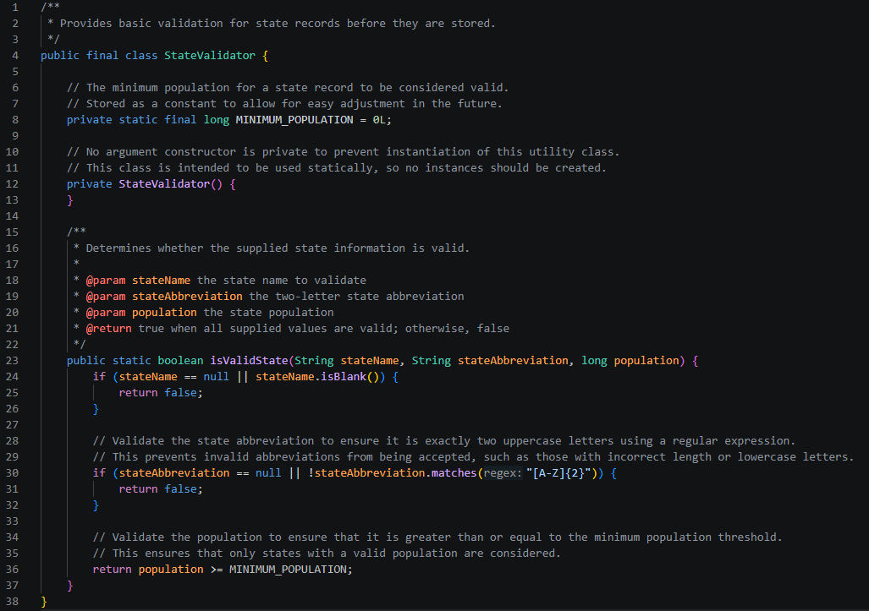

The StateValidator class uses Pascal case for the class name, camel case for the method and parameters, and uppercase letters for the constant. Each identifier communicates its purpose without requiring an additional explanation. The class is declared final and has a private constructor because it is intended to provide a utility method rather than create objects.

The isValidState method has one clear responsibility and validates each type of information separately. Consistent indentation, spacing, and brace placement make the control flow easy to follow. The Javadoc comments describe the purpose and use of the class and method without explaining every individual statement. Although another programming language might use different naming or formatting conventions, the underlying principles of clarity, consistency, validation, and focused responsibility apply broadly.

