Assignment 1.3: Programming Assignment

Wade Eckert
Bellevue University
CSD 430: Server Side Development
Professor John Woods
June 7, 2026
https://github.com/WadeEckert/CSD-430

Assignment 1.3: Programming Assignment

Java Successfully Installed:
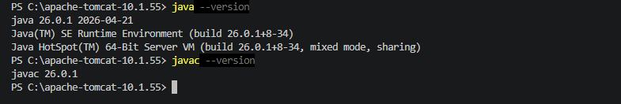
Jakarta-Tomcat Successfully Installed:
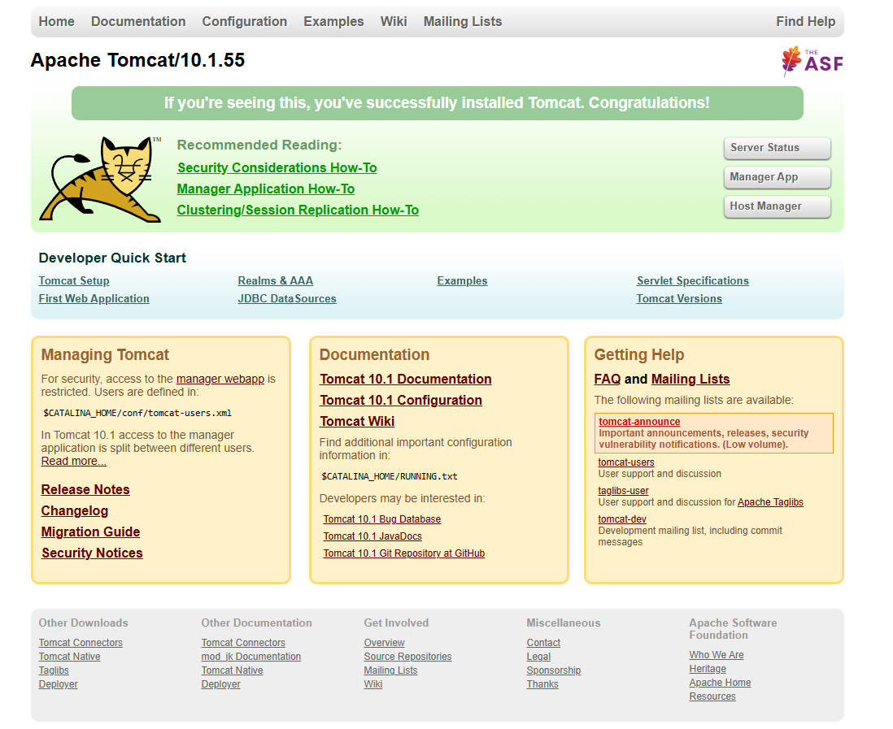
VS Code IDE:
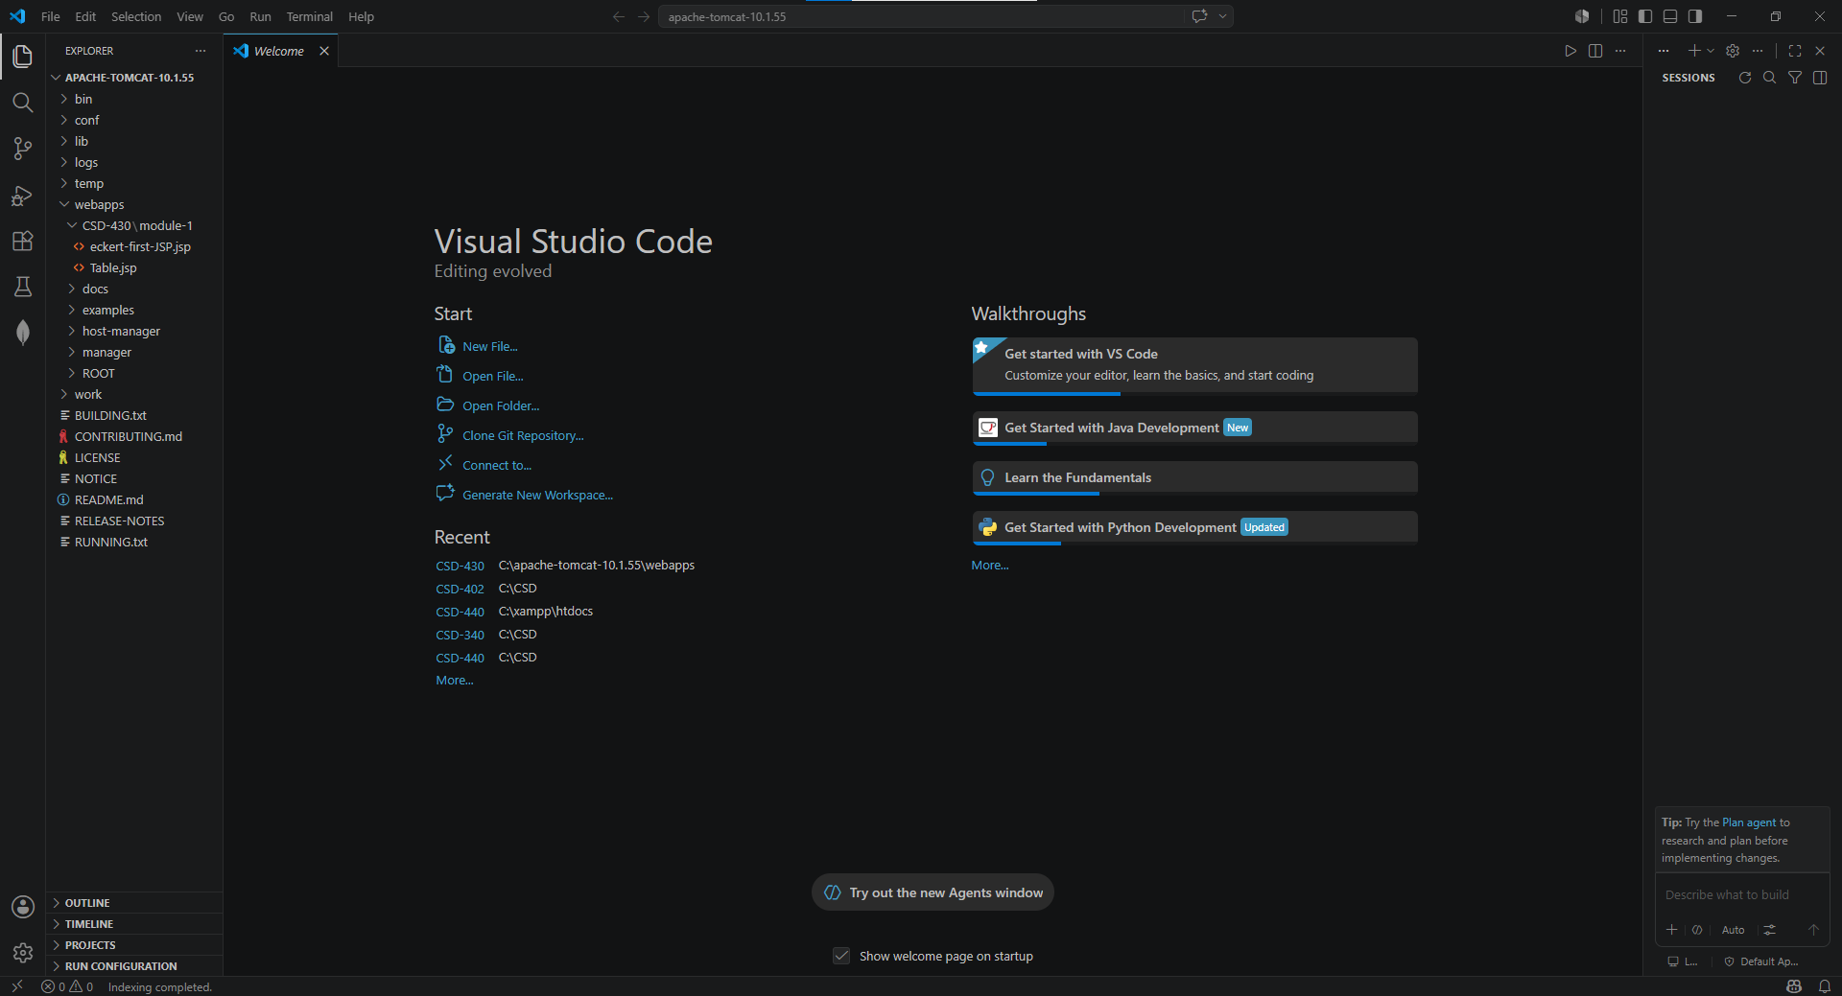
JSP File Code:
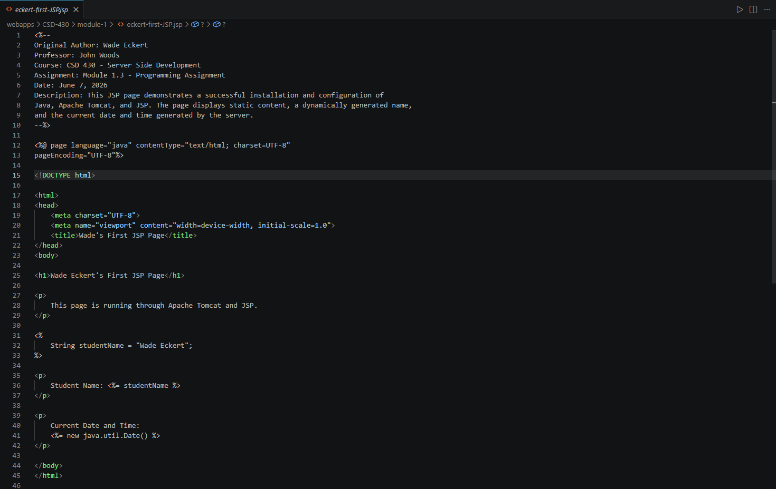
JSP File Running in Browser:
