Assignment 1.2: GitHub Repository Setup

Wade Eckert
Bellevue University
CSD 440: Server-Side Scripting
Professor Darrell Payne
March 14, 2026
https://github.com/WadeEckert/CSD-440

Assignment 1.2: GitHub Repository Setup

Link to GitHub Repository: https://github.com/WadeEckert/CSD-440
Screenshot of Local Directory:
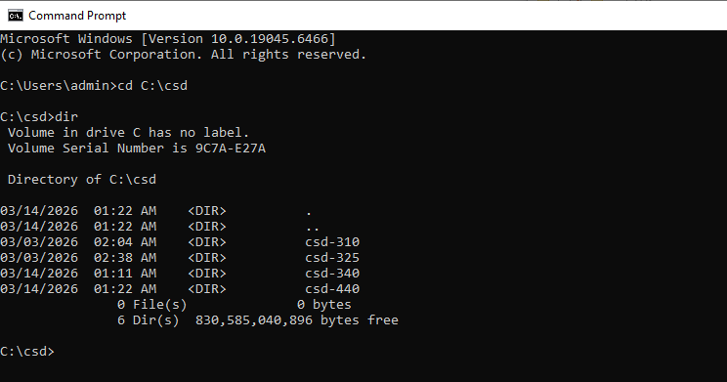
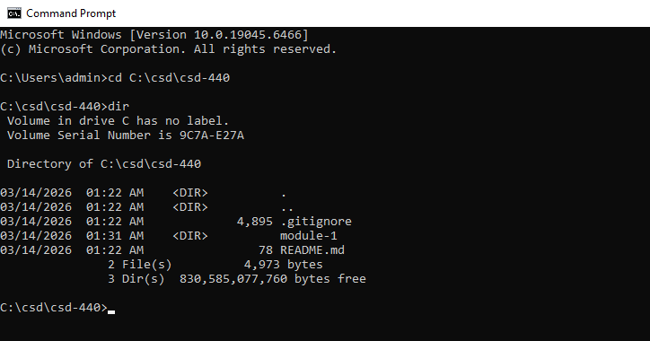
Screenshot of GitHub Repository:
