Assignment 1.3: Programming Assignment

Wade Eckert
Bellevue University
CSD 440: Server-Side Scripting
Professor Darrell Payne
March 19, 2026
https://github.com/WadeEckert/CSD-440

Assignment 1.3: Programming Assignment

Installation and Configuration of XAMPP:
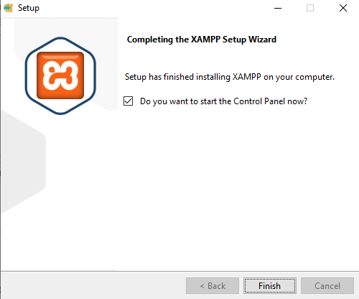
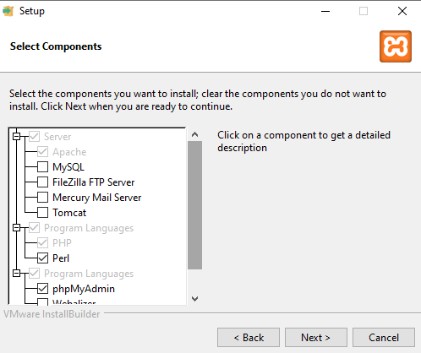
XAMPP Control Panel:
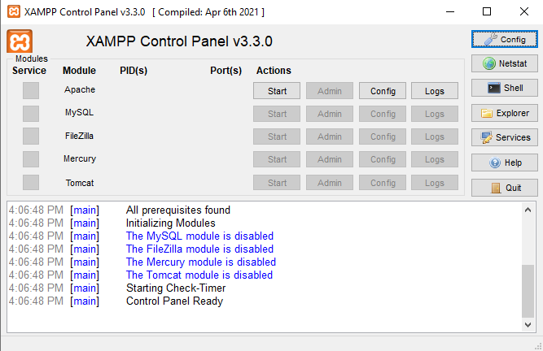

Apache Start:
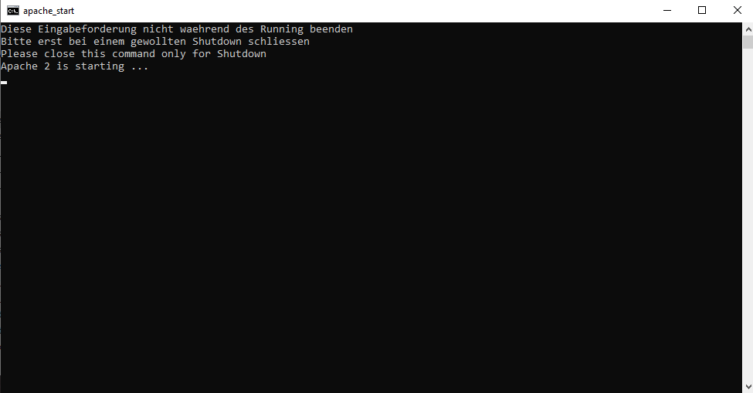
XAMPP Localhost Dashboard:
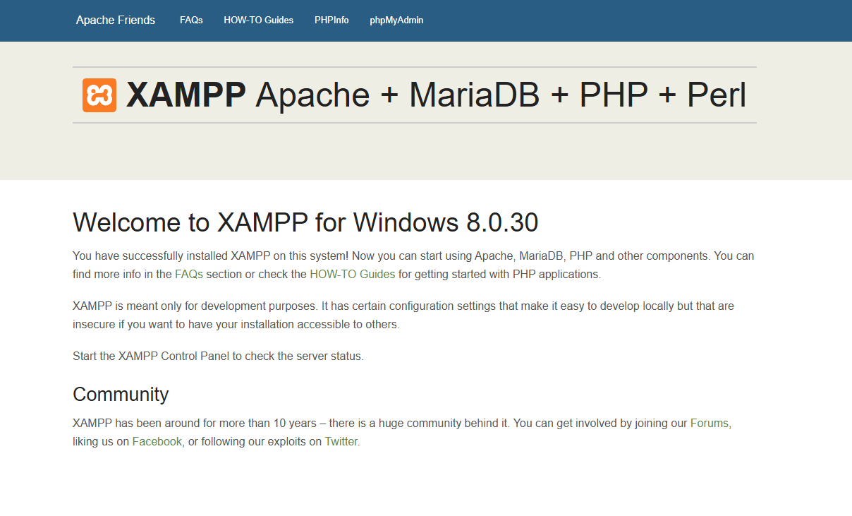

Apache Directory Listing (Localhost/module_1):
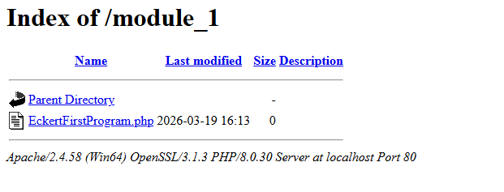

PHP Script Output Displayed via Apache:
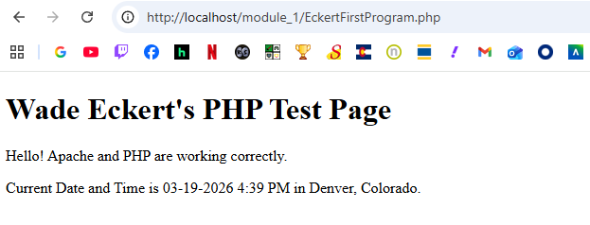

PHP Script:
