Assignment 2.2: Programming Assignment

Wade Eckert
Bellevue University
CSD 440: Server-Side Scripting
Professor Darrell Payne
March 28, 2026
https://github.com/WadeEckert/CSD-440

Assignment 2.2: Programming Assignment

1st View of Table:
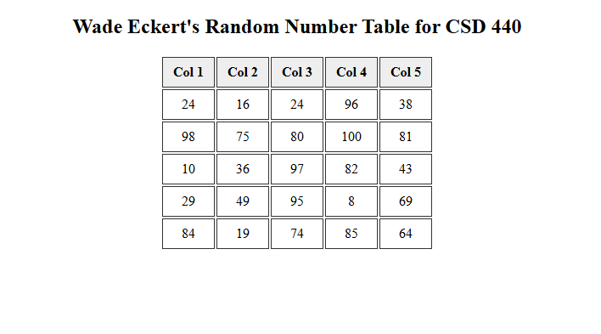
Refreshed View of Table with New Random Numbers:
