電腦網路概論HW1

1.

(1)

Frame and error definitions include details of the frame and error types used in HTTP/2.

(2)

The primary goal of the TLS protocol is to provide privacy and data integrity between two communicating applications.

The protocol is composed of two layers:

the TLS Record Protocol and the TLS Handshake Protocol

The connection is private.

The connection is reliable.

(3)

The Internet Protocol is designed for use in interconnected systems of

packet-switched computer communication networks. Such a system has

been called a "catenet" [[1](https://tools.ietf.org/html/rfc791#ref-1)].

This protocol is called on by host-to-host protocols in an internet

environment.

The internet protocol provides for

transmitting blocks of data called datagrams from sources to

destinations, where sources and destinations are hosts identified by

fixed length addresses.

(4)

**The internet protocol provides for**

**transmitting blocks of data called datagrams from sources to**

**destinations, where sources and destinations are hosts identified by**

**fixed length addresses.**

2.

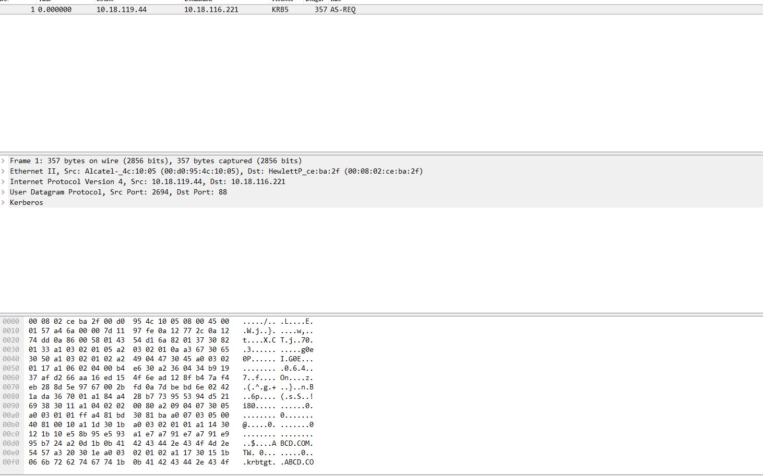

(1)

Source: 10.18.119.44

Distination:10.18.116.221

(2)

8byte

(3)

KRB5

**Kerberos is a computer network authentication protocol that works on the basis of tickets to allow nodes communicating over a non-secure network to prove their identity to one another in a secure manner.**

3.

(1)

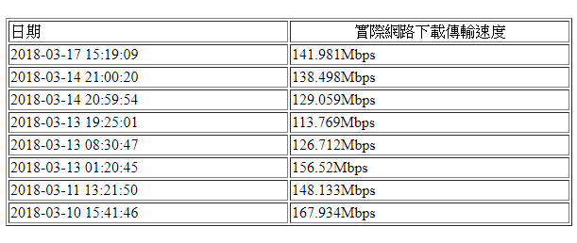

08.30 126.712 Mbps

01.20 156.52 Mbps

19.25 113.769 Mbps

網卡上傳下載極速是1500Mbps，實際上還是跟所測值有差異

(2)

差異原因:主機回傳速度，提供頻寬被其他使用者分散掉

4.

1 <1 ms <1 ms <1 ms 10.123.222.250

2 3 ms 3 ms 9 ms 140.123.243.250

3 <1 ms <1 ms <1 ms 140.123.9.251

4 <1 ms <1 ms <1 ms hero1.ccu.edu.tw [140.123.5.5]

5.

nodal processing:

決定封包目的尋找路線等所需要的時間

queueing delay:

排隊發送等所需要的時間

transmission delay:

受頻寬所限，每一字最多可重送的資料量所造成的延遲時間

propagation delay:

點到點傳(在網路線上)送所需要的時間

6.

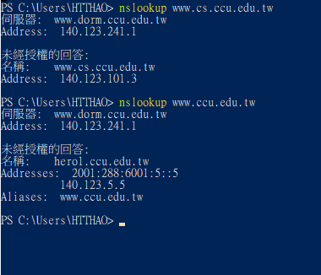

[www.cs.ccu.edu.tw](http://www.cs.ccu.edu.tw) 140.123.101.3

[www.ccu.edu.tw](http://www.ccu.edu.tw) 140.123.5.5

7.

(1)2017-證券商集體遭DDOS攻擊勒索

(2)使交易停擺，進而勒索錢財

(3)ISP和行政院資安處對流量監控及維護

8.

Ifconfig: 主要是可以手動的啟動、觀察與修改網路介面的相關參數，可以修改的參數很多，包括 IP 參數以及 MTU 等等都可以修改

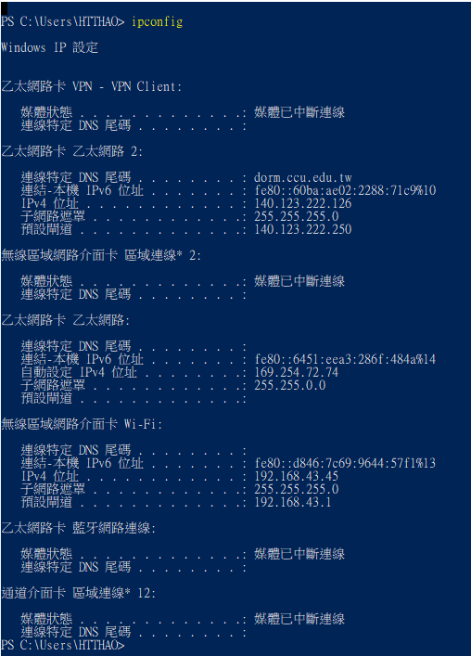

Ping: 主要透過 [ICMP 封包](http://linux.vbird.org/linux_server/0110network_basic.php#tcpip_network_icmp) 來進行整個網路的狀況報告

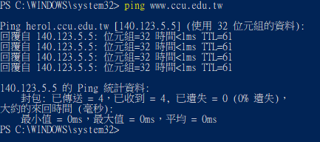

Tcpdump:

