1.

(1) The User-Agent request-header field contains information about the user agent originating the request.

(2) The Host request-header field specifies the Internet host and port number of the resource being requested, as obtained from the original URI given by the user or referring resource (generally an HTTP URL, as described in section 3.2.2).

(3) The Referer[sic] request-header field allows the client to specify, for the server’s benefit, the address (URI) of the resource from which the Request-URI was obtained (the “referrer”, although the header field is misspelled.)

(4) The Location response-header field is used to redirect the recipient to a location other than the Request-URI for completion of the request or identification of a new resource. For 201 (Created) responses, the Location is that of the new resource which was created by the request.

(5) The Transfer-Encoding general-header field indicates what (if any) type of transformation has been applied to the message body in order to safely transfer it between the sender and the recipient.

2.

(1)

HTTP2 adds a number of features to manage the streams

HTTP/2 supports queries multiplexing, headers compression, priority and more intelligent packet streaming management.

(2)

QUIC provides multiplexing and flow control equivalent to HTTP/2, security equivalent to TLS, and connection semantics, reliability, and congestion control equivalentto TCP.

3

many IP addresses correspond to one name

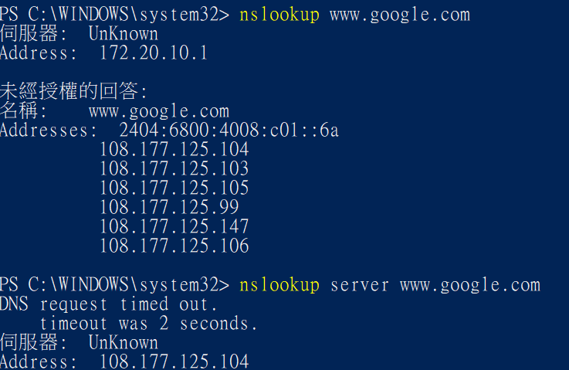

4

(1).in=印度

(2)

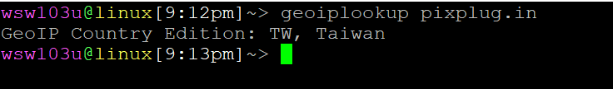

Taiwan



60.199.248.176

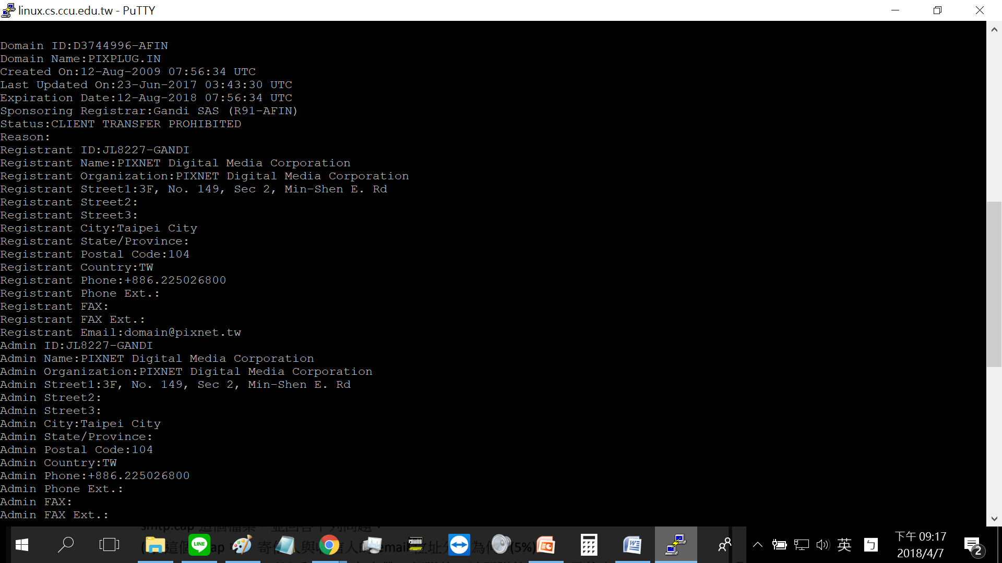

PIXNET Digital Media Coporation

5.



1. IPv4: 204.152.190.12 IPv6: 2001:4f8:4:7:2e0:81ff:fe52:9a6b



1. CNAME: [www.l.google.com](http://www.l.google.com)

Time to live:0.016538

6.



1. from: [gurpartap@patrios.in](mailto:gurpartap@patrios.in) to:raj_deo12002in@yahoo.co.in
2. 
3. Gurpartp Singh