1



(1)

client: initial sequence number = 0

server: initial sequence number = 0

(2)

Client: 1460

Server: 1452

(3)

一條連線

Port:3827

2.

Server code

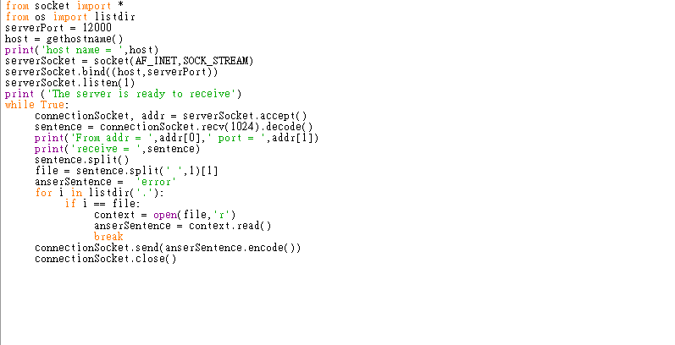

Client code

Exist file

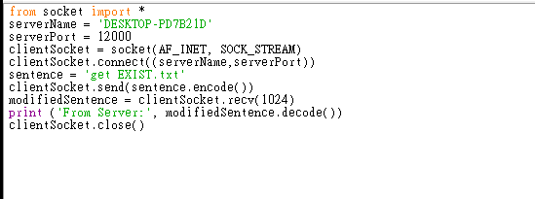

No exist file

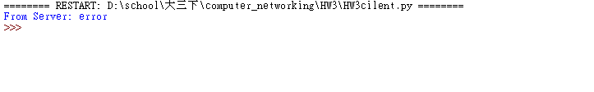

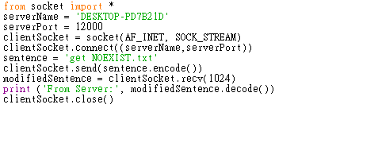

Workspace

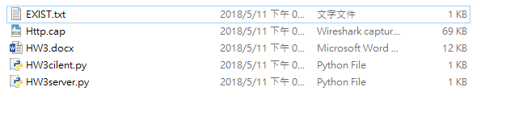

File context

