
Department of Information Technology
A8520- SOFTWARE ENGINEERING
Name of the Student:  Batch No:  ROLL NO: | Cherish Yepuru  Pavani Rangineni  Varun Sandesh  6  24881A1264, 24881A1253, 24881A1229 | Project Title: | Online Student Management System
Name of the Student:  Batch No:  ROLL NO: |  | Activity: | SRS Documentation
Year-Sem: | 3rd - 1st | Date: | 1-7-26
Branch-Section: | IT-A | Course Instructor: | Ravi Kumar

SOFTWARE REQUIREMENTS SPECIFICATION
Online Student Management System (OSMS) | Version 1.0 | IEEE Std 830-1998 structure

1. Introduction

1.1 Purpose
This document specifies the requirements of the Online Student Management System (OSMS), a web platform that replaces paper registers and scattered spreadsheets with one secure system for student records, course enrollment, attendance, grading and fee payment. It is written for the course instructor, the project team and reviewers who will evaluate the design.

1.2 Scope
OSMS serves one institution with several departments and three user roles: Student, Faculty and Administrator. This SRS covers requirements and design views only; building the software is not part of this course project.
In scope | Out of scope
Login and role-based access  Student and academic records  Course enrollment with waitlist  Attendance, grading and transcripts | HR, payroll, library, hostel and transport  Alumni management  Multi-institution (SaaS) deployment  Native mobile apps (responsive web only)
Fee payment and receipts  Email / SMS notifications and timetable updates | Biometric or hardware-based attendance

1.3 Definitions and Abbreviations
SRS | Software Requirements Specification | RBAC | Role-Based Access Control
REST API | Web interface exchanging JSON over HTTPS | SSO | Single Sign-On with institutional account
ER diagram | Diagram of data entities and relationships | TLS | Transport Layer Security (encryption in transit)
FR / NFR | Functional / Non-Functional Requirement | Add/Drop | Period in which enrollment may be changed

1.4 References
• IEEE Std 830-1998, Recommended Practice for Software Requirements Specifications
• ISO/IEC/IEEE 29148:2018, Systems and software engineering: Requirements engineering
• Existing systems reviewed for benchmarking: see Section 2.5

2. Overall Description

2.1 Product Perspective
OSMS is a new, self-contained three-tier web application (Section 3). It may optionally connect to the institution's single sign-on, a payment gateway and an email/SMS service. It does not replace HR, library or alumni systems.

2.2 Product Functions
Module | What it does | Main users
Authentication & Access | Secure login, role-based dashboards, password reset | All users
Student & Academic Records | Student profiles and a historical academic record | Admin, Student
Course Enrollment | Course catalogue, live seat count, enroll / drop, waitlist | Student
Attendance & Grading | Per-session attendance, grade entry, transcripts | Faculty, Student
Fee Management | Fee structure, balance, online payment, receipts | Student, Admin
Notices & Timetable | Email / SMS alerts, announcements, timetable updates | All users

2.3 User Classes and Characteristics
User class | Description | Technical expertise
Student | Enrolls in courses, views attendance and grades, pays fees, receives notices | Basic computer literacy
Faculty | Marks attendance, enters grades, manages course schedules | Basic to moderate
Administrator | Manages users, courses, departments, fee structures and system settings | Moderate to advanced

2.4 Operating Environment, Constraints and Assumptions
Operating environment | Design constraints | Assumptions and dependencies
Modern browsers (Chrome, Firefox, Edge, Safari) on desktop or mobile  Linux server running a REST API (Node.js, Java or Python)  MySQL or PostgreSQL database | Secure coding; passwords stored as salted hashes  Must follow institutional data-privacy policy  Release 1 is single-institution, not multi-tenant | Users have stable internet and a valid institutional email  Payment and email/SMS gateways stay available within agreed service levels

2.5 Related Systems Study
Existing products were reviewed to confirm which features a student management system must have (descriptions follow each project's public documentation).
System | Typical scope | Idea reused in OSMS
Moodle | Open-source learning management system: courses, activities, gradebook | Course enrollment with capacity limits and a gradebook
Google Classroom | Free class workspace for assignments, grading and announcements | Simple role-based dashboards and announcements
openSIS | Open-source student information system: records, scheduling, attendance | Student record and attendance structure
Fedena | School/college ERP with attendance, timetable, exams and fee modules | Fee collection and timetable alongside academics
Ellucian Banner | Enterprise higher-education ERP: registration, billing, academic records | Registration-to-transcript workflow at institution scale
OSMS combines these proven ideas in one lightweight system sized for a single college.

3. System Architecture and Use Cases
Figure 1 shows who uses OSMS and what each role can do. Figure 2 shows how the system is split into three tiers so that screens, business rules and data can change independently.
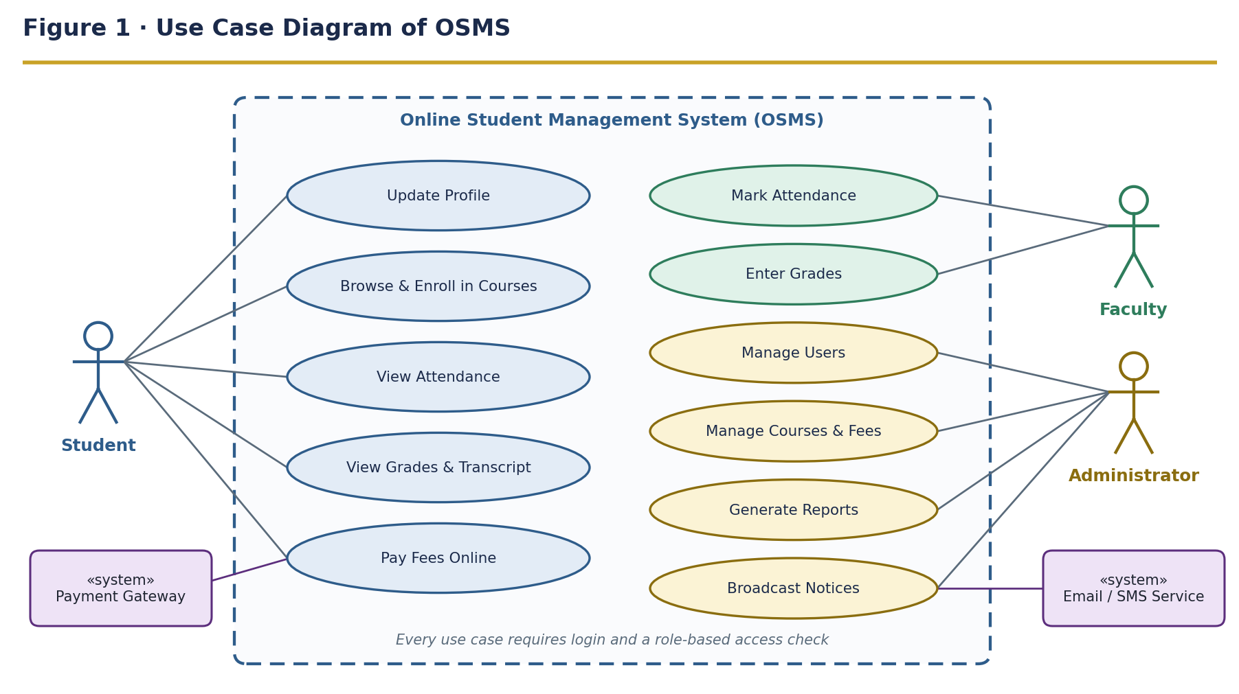
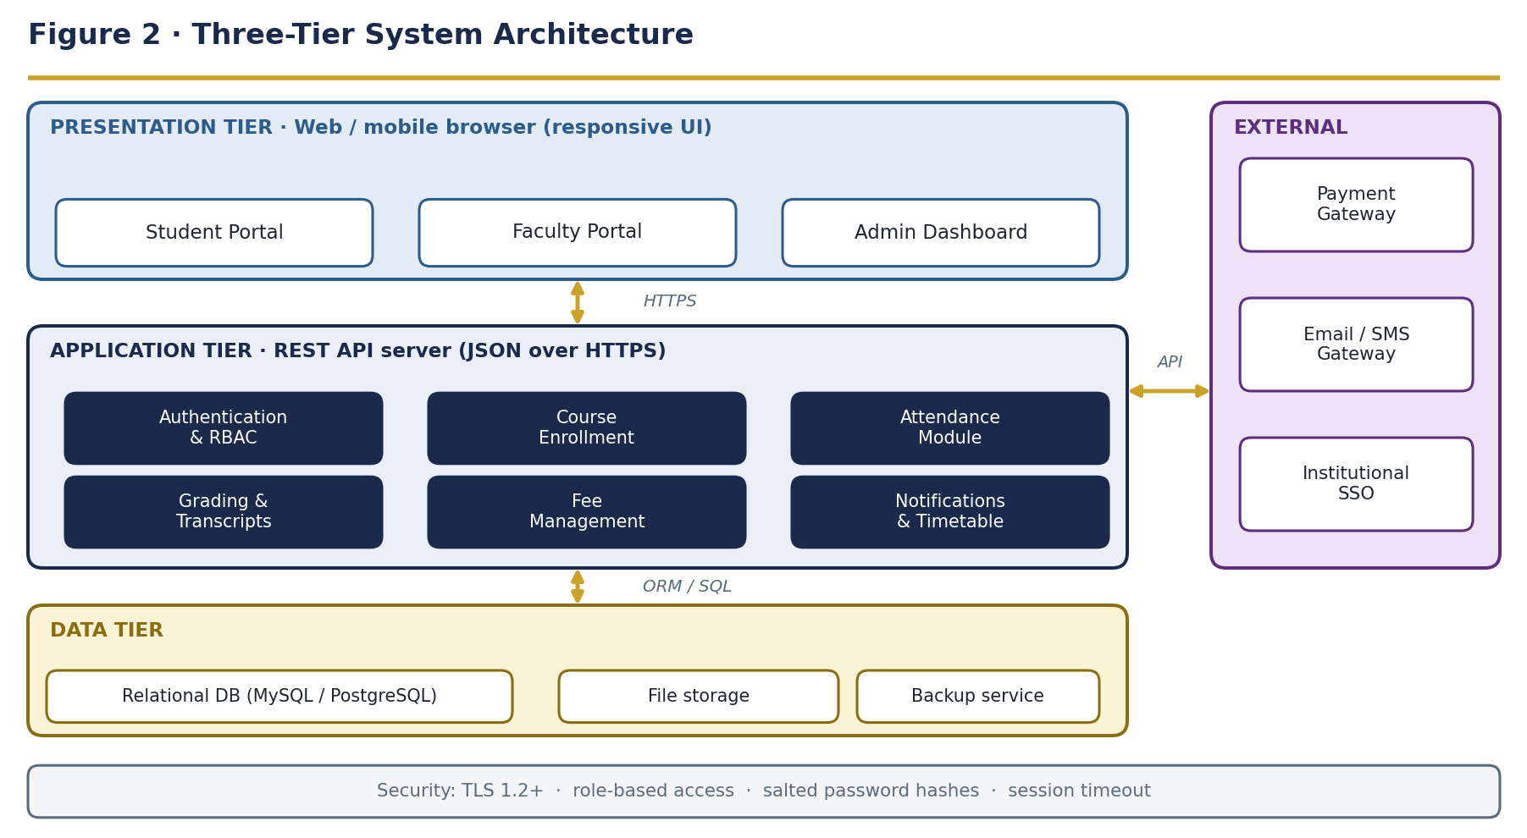

4. Functional Requirements
High-priority requirements are shaded; each requirement is identified as FR-group.number for traceability.
ID | Requirement (the system shall…) | Actor | Priority
4.1 Authentication & Access Control
FR-1.1 | allow registered users to log in with email / ID and password | All users | High
FR-1.2 | enforce role-based access control for Student, Faculty and Admin views | All users | High
FR-1.3 | let users reset a forgotten password through email verification | All users | Medium
4.2 Student & Academic Records
FR-2.1 | allow Admins to create, update and deactivate student profiles | Admin | High
FR-2.2 | allow students to view and update permitted personal details | Student | Medium
FR-2.3 | maintain a historical academic record for every student | System | High
4.3 Course Enrollment
FR-3.1 | display available courses with seat availability in real time | Student | High
FR-3.2 | allow students to enroll in or drop a course within the add/drop window | Student | High
FR-3.3 | place a student on a waitlist when a course reaches capacity | System | Medium
4.4 Attendance & Grading
FR-4.1 | allow faculty to mark and edit attendance for each session | Faculty | High
FR-4.2 | allow faculty to enter and update grades for each assessment component | Faculty | High
FR-4.3 | calculate final grades automatically and generate a transcript PDF | System | Medium
4.5 Fee Management & Notifications
FR-5.1 | display a student's fee structure and outstanding balance | Student | High
FR-5.2 | process online fee payments and issue a digital receipt | Student | High
FR-5.3 | send email / SMS notifications for deadlines, results, announcements and timetable changes | System | Medium

4.6 Process Flows
Figure 3 traces login and course enrollment, including the error and waitlist paths. Figure 4 shows how the roles hand work to each other during a typical academic cycle.
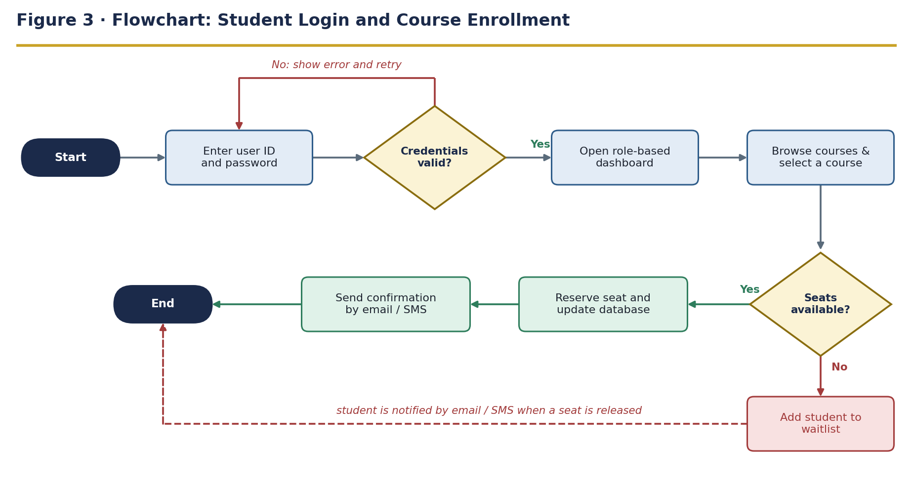
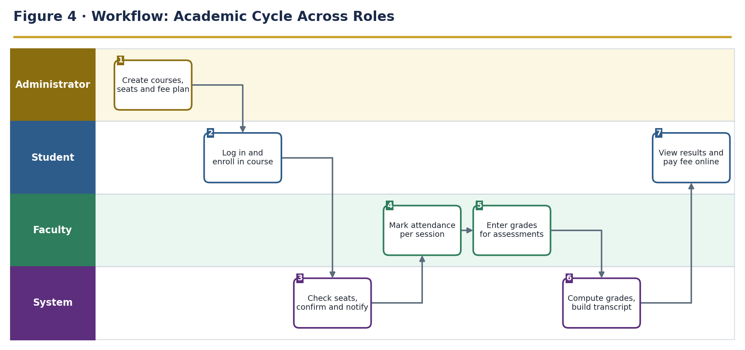

5. Non-Functional Requirements
Category | Requirement | Target
Performance | Search and list pages respond quickly under normal load | 2 seconds or less with up to 500 concurrent users
Security | Salted, industry-standard password hashing (e.g. bcrypt); idle sessions expire | Configurable timeout; TLS 1.2+
Reliability | System is available throughout the academic term | 99.5% uptime excluding planned maintenance
Usability | A first-time user completes an enrollment without outside help | 5 minutes or less
Maintainability | Modular code so each module can be updated independently | No change to other modules
Scalability | Application tier scales horizontally as load grows | Add servers without redesign

6. External Interface Requirements
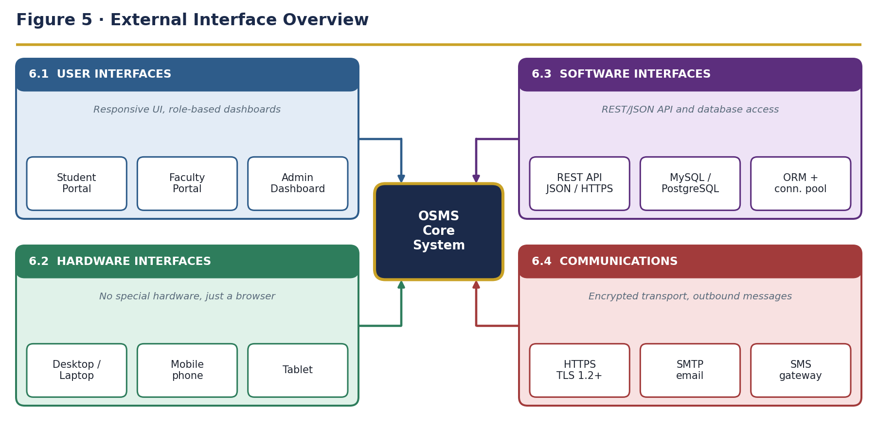
Interface | Requirement
6.1 User | Responsive web UI with separate Student, Faculty and Admin dashboards; consistent navigation, accessible colour contrast and validation on every form
6.2 Hardware | No special hardware; any desktop, laptop, tablet or phone with a modern browser
6.3 Software | REST API (JSON over HTTPS) between client and server; relational database accessed through an ORM with connection pooling
6.4 Communications | HTTPS with TLS 1.2 or higher for all traffic; SMTP and SMS gateway integration for outbound notifications

7. Data Model
Figure 6 gives the database schema (entities, keys and relationships). Figure 7 shows the same domain as classes: Student, Faculty and Administrator inherit login behaviour from the abstract User class.
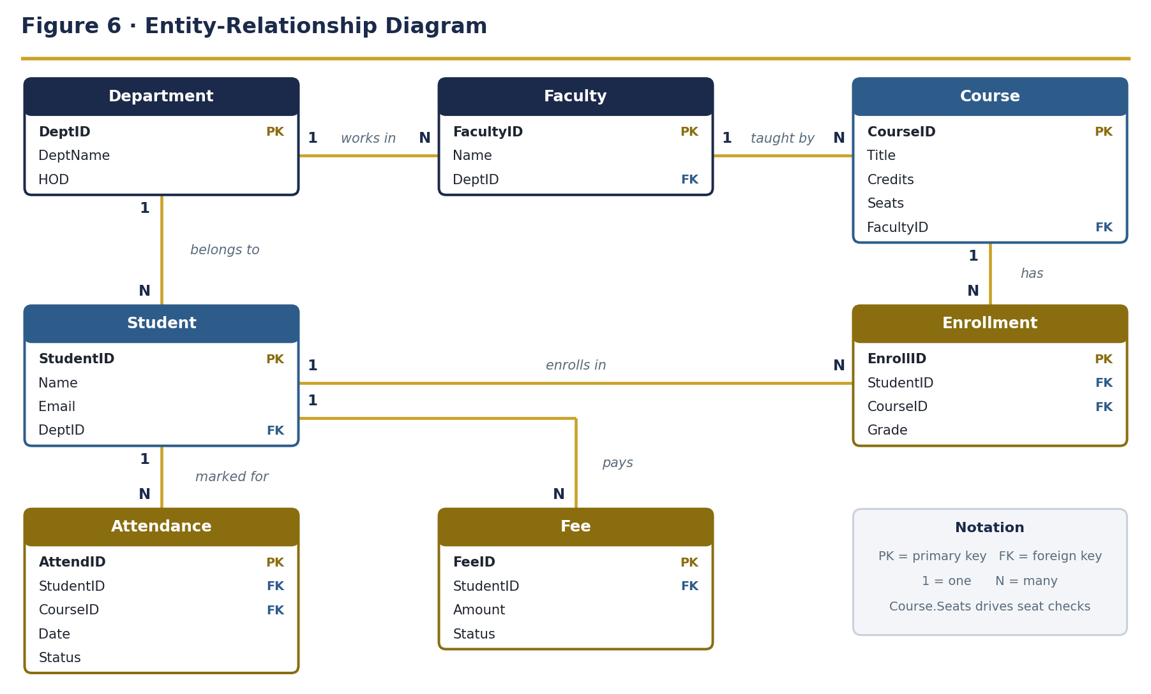
• Students and faculty each belong to one department; every course is taught by one faculty member.
• An enrollment links one student to one course; Course.Seats drops as students enroll and a waitlist applies at zero.
• Attendance and fee records always reference a student; attendance also references the course.
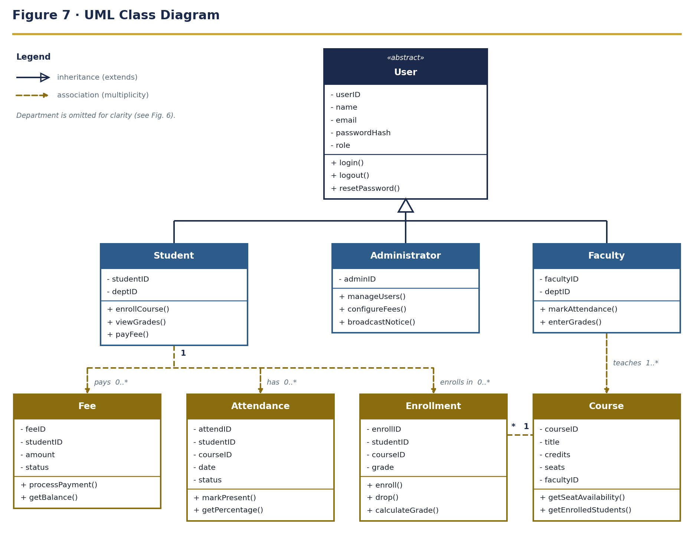

8. Appendix

8.1 Requirements Traceability
Module | Requirements | Use cases (Figure 1) | Data entities (Figure 6)
Authentication & Access | FR-1.1 to 1.3 | Login check for every use case | Student, Faculty
Student Records | FR-2.1 to 2.3 | Update Profile, Manage Users | Student, Department
Course Enrollment | FR-3.1 to 3.3 | Browse & Enroll in Courses | Course, Enrollment, Faculty
Attendance & Grading | FR-4.1 to 4.3 | Mark Attendance, Enter Grades, View Attendance, View Grades | Attendance, Enrollment
Fees & Notifications | FR-5.1 to 5.3 | Pay Fees Online, Broadcast Notices | Fee

8.2 Document Approval
Role | Name | Signature / Date
Course Instructor | Ravi Kumar
Team Lead
Reviewer

